3.6.4: Homeostasis and control of blood glucose
Name: ____Teacher booklet_____________________
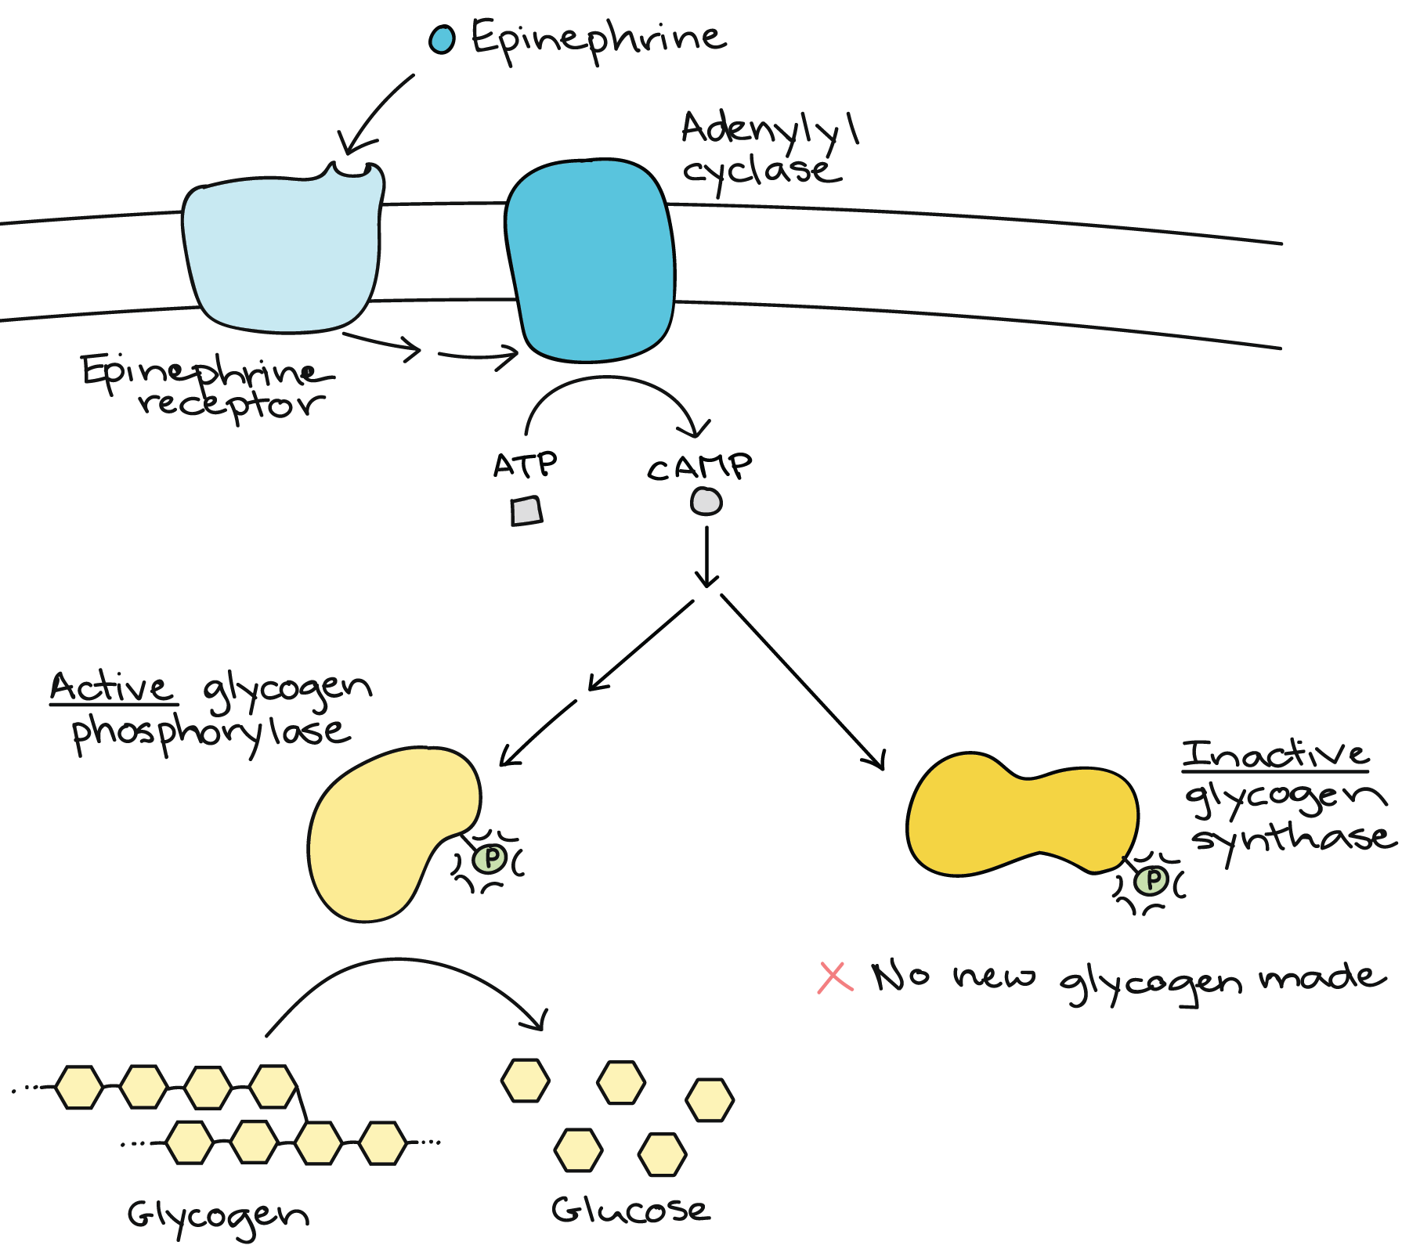
Reflection on Learning objectives | or | Targets
Define what homeostasis is
Describe some factors which are maintained by the body within restricted limits and explain why it is important that it is maintained within restricted limits and the consequences of not doing so
Explain what is meant by negative and positive feedback
Explain the general stages involved in negative feedback, and why these are used in homeostatic mechanisms
Explain the benefit of having separate mechanisms for different departures from the original level
Explain the factors which can influence blood glucose levels.
Explain how hormones work to bring about a response
Explain the role of the pancreas, specifically the α and β cells of the Islets of Langerhans, in regulating blood glucose concentration
Explain what is meant by the term’s glycogenesis, glycogenolysis and gluconeogenesis
Explain what triggers and stages in the release and action of insulin
Explain the role of the liver in glycogenesis, glycogenolysis and gluconeogenesis
Explain what triggers and stages involved in the release of glucagon
Explain what triggers the release of adrenaline and the second messenger model related to adrenaline and glucagon action
Explain the stages involved in the action of adrenaline (linked to blood glucose concentration)
Describe the role of adenyl cyclate, cyclic AMP and protein kinase in the second message model.
Explain the causes and controls of type 1 and type 2 diabetes
Evaluate the positions of health advisers and the food industry in relation to the increased incidence of type II diabetes
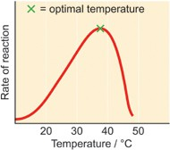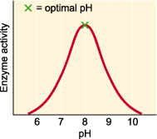
Describe | Explain
pH 8 | - Optimum pH  - More successful collisions  - Between substrate and active site  - More ESC’s  - Quicker reaction
Increasing pH from 6-8 and 8-10 | - Enzyme has denatured  - Change in shape/charge of active site  - H, ionic bonds broken  - In tertiary structure  - Substrate no longer complementary/less ESCs formed

Describe | Explain
Increasing temp from 0-37c | - Increase in kinetic energy  - More successful collisions  - Between substrate and active site  - More ESC’s  - Quicker reaction
Increasing temp from 37c | - Enzyme has denatured  - Change in shape of active site  - H, disulphide bridges broken  - In tertiary structure  - Substrate no longer complementary/less ESCs formed

Principles of homeostasis
Outcomes:
- Define what homeostasis is
- Describe some factors which are maintained by the body within restricted limits and explain why it is important that it is maintained within restricted limits and the consequences of not doing so


Definition:
Homeostasis: The maintenance of a constant internal environment in the body
Within restricted limits
Despite external changes.
Factors which are maintained by the body within restricted limits:
Factor | Importance of maintaining in restricted limits
Core temperature | Body temp is optimum temp for enzyme  Excess heat denatures enzymes by altering tertiary structure  Alters shape of active site  Reactions slowed;  Too little reduces kinetic energy of molecules  Fewer collisions  Fewer ES complexes formed  Prevents named chemical reactions / metabolic pathways;
Blood pH | Blood pH is optimum for enzymes/proteins  Increase or decrease in pH will denature enzymes by altering tertiary structure  Alters shape or charge of active site breaking Ionic bonds  Reactions slowed  Fewer collisions  Fewer ESC formed  Prevents named chemical reactions/ metabolic pathways
Water potential of blood. | Lower WP of blood increase blood pressure  More water forced out of capillary into tissue fluid at arteriole end  Less water is returned to capillary from tissue fluid at venule end  Tissue fluid collects
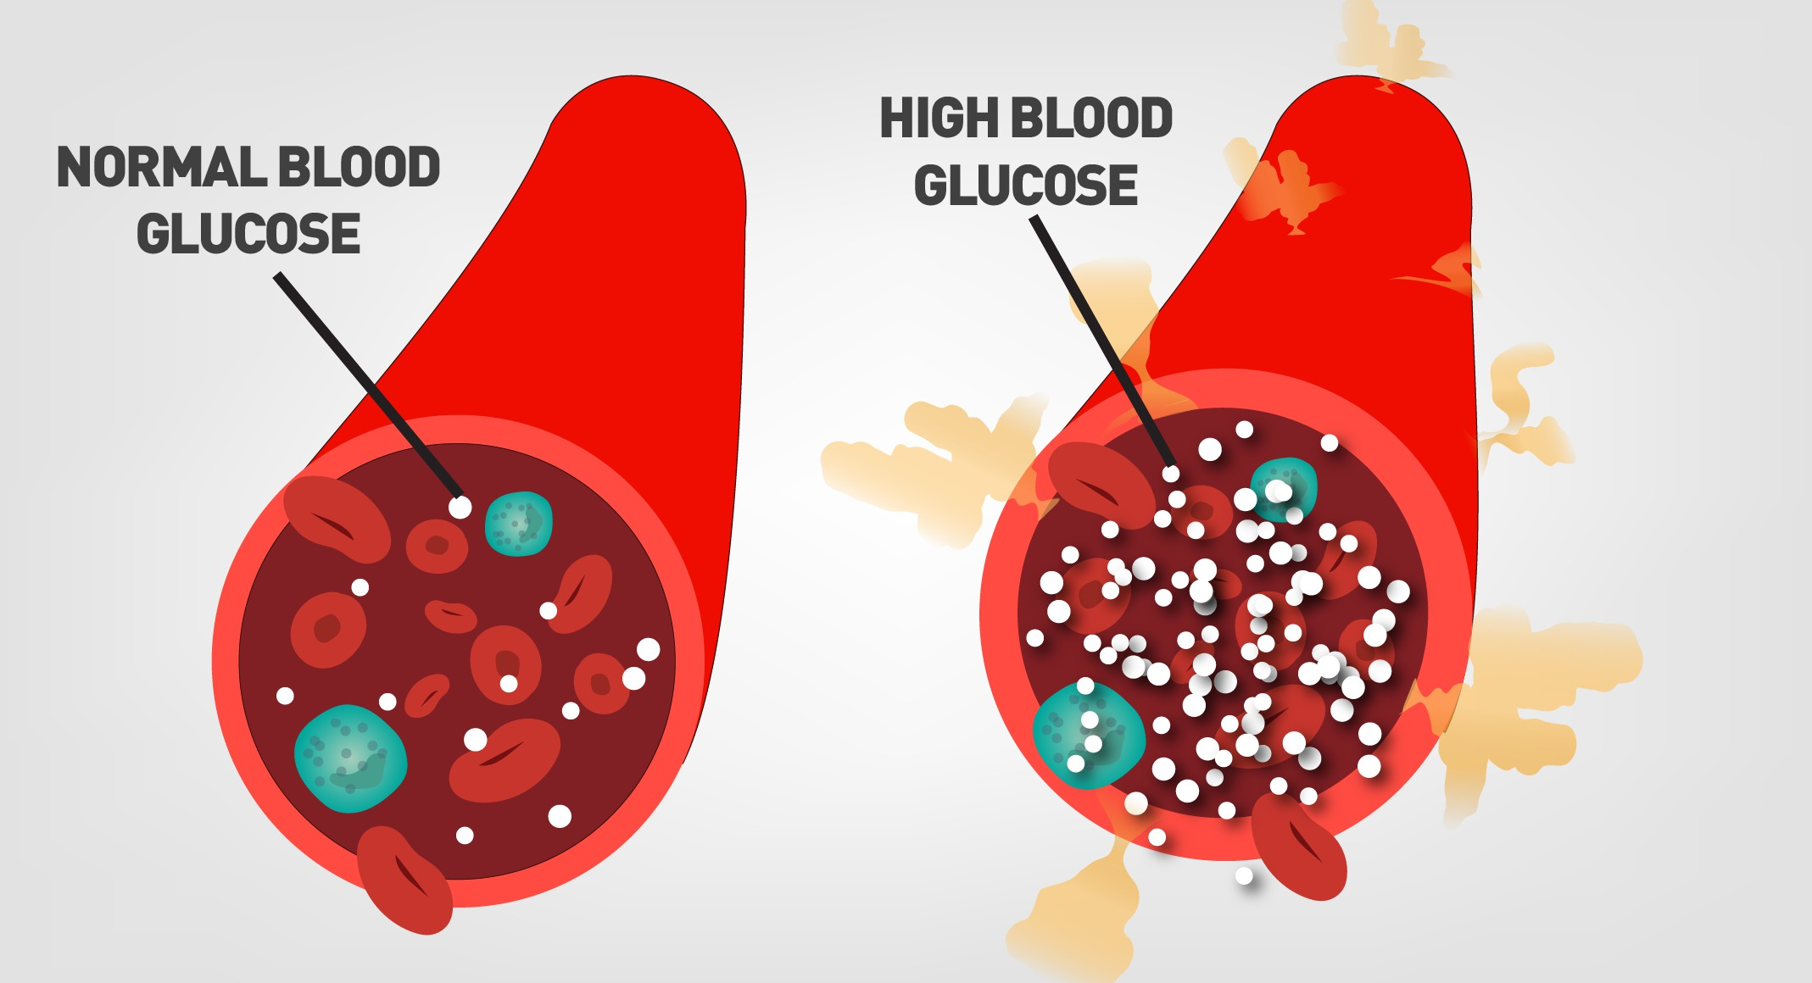
Higher solute conc, Low er WP
More Glucose molecule
Log practice
- What is pH a measure of?
Proton/H+ conc
- Why do we use a log scale?
RANGE of values is too big to plot on one graph
- What is the unit for measuring pH?
mol dm⁻³
- Draw a diagram to represent log scales.
- A patient has a blood sample has a hydrogen ion concentration of 5.50 x 10⁻⁸ mol dm^{-3.} Show your working

pH = -log10[H⁺]
= -log10[5.5 x 10⁻⁸ ]
= 7.26

- Calculate the pH of a solution has a hydrogen ion concentration of 0.01mol dm^{-3.} Show your working
pH = -log10[H⁺]
= -log10[0.01]
= 2

Principles of positive and negative feedback
Outcomes:
- Explain what is meant by negative and positive feedback
- Explain the general stages involved in negative feedback, and why these are used in homeostatic mechanisms
- Explain the benefit of having separate mechanisms for different departures from the original level

Feedback mechanism use receptors to detect a change in the system and effectors to bring about the appropriate response. You do NOT need to learn these terms but they are useful to understand and apply to new examples given in the questions.
In your exam they can give you ANY example of negative and positive feedback, you will need to apply these definitions to each example.
Term | Definition
Optimum point | Normal level
Receptor | Detects stimulus away from norm
Coordinator | Coordinates info from different sources
Effector | Brings about corrective measure back to norm

Negative feedback
Definition:
Negative feedback: A change to the normal level triggers a response which reverses / reduces the effect of, the change.
Apply the definition above and your knowledge of thermoregulation to annotate the graph below.
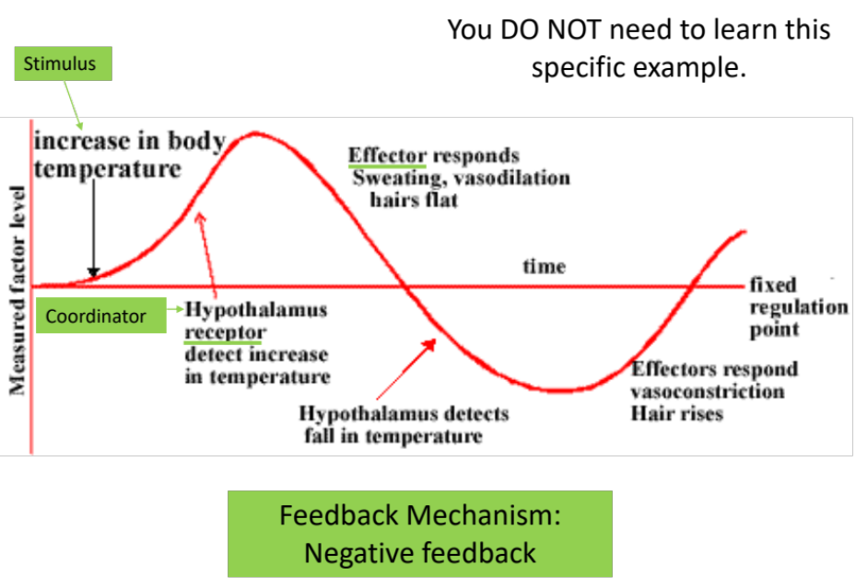
Positive feedback
Definition:
Positive feedback: A change to the normal level triggers a response which increases the effect of, the change.

For the Oxytocin example on the powerpoint can you fill in the table different the different terms.
Term
Stimulus | Head of baby pushing on Cervix
Receptor | Nerve impulses from cervix to brain
Coordinator | Brain stimulates pituitary gland to secrete oxytocin
Effector | Uterus
Effect | Uternine contractions and push baby towards cervix
Feedback Mechanism | Positive feedback

Exam Questions:
Q1. (a) (i) What is meant by homeostasis?
maintaining a constant internal environment;
(ii) Giving one example, explain why homeostasis is important in mammals.
one mark for example of factor kept constant; one mark for
explaining its importance;
e.g.temperature / pH; optimum for enzymes / effect of pH /
temperature on enzyme activity;
OR
water potential / blood glucose;
effect of osmotic / blood glucose imbalance on cells;
(b) Cross-channel swimmers may suffer from muscle fatigue during which the contraction mechan`ism is disrupted. One factor thought to contribute to muscle fatigue is a decrease in the availability of calcium ions within muscle fibres. Explain how a decrease in the availability of calcium ions could disrupt the contraction mechanism in muscles.
cannot interact with / move tropomyosin from binding sites on actin;
(reject active sites)
myosin(heads) do not bind / actinomyosin not formed;
does not activate ATPase / energy not released from ATP;

Q2. Interferon gamma is a substance secreted by some types of white blood cells, including helper T cells. It regulates the production of a number of proteins by target cells. Which protein is produced depends on the type of target cell.

The diagram shows how interferon gamma regulates three genes.

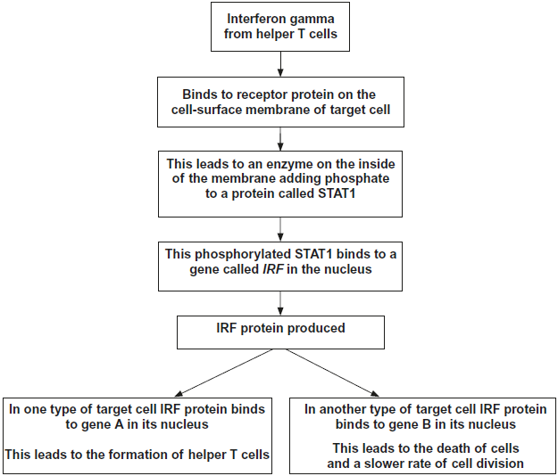

(a) Use information in the diagram to suggest how the binding of interferon gamma to its receptor protein leads to the production of phosphorylated STAT1.

1. Binding (of interferon gamma) changes shape/tertiary structure of receptor (protein);

2. This activates/switches on the enzyme;

3. Use of ATP (to phosphorylate STAT1);

1. Accept reference to second messenger mechanism/process

3. Context is important

(c) The regulation of the formation of helper T cells by interferon gamma is an example of positive feedback. Explain why it is an example of positive feedback.
1. Causes more helper T cells to form;
2. (So) more interferon (gamma) production (by helper T cells);
1. and 2. require idea of more
Outcome:
- Explain how hormones work to bring about a response.
- Explain the factors which can influence blood glucose levels
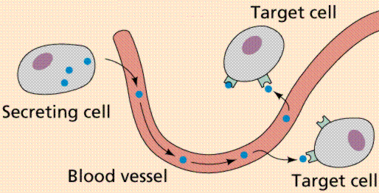

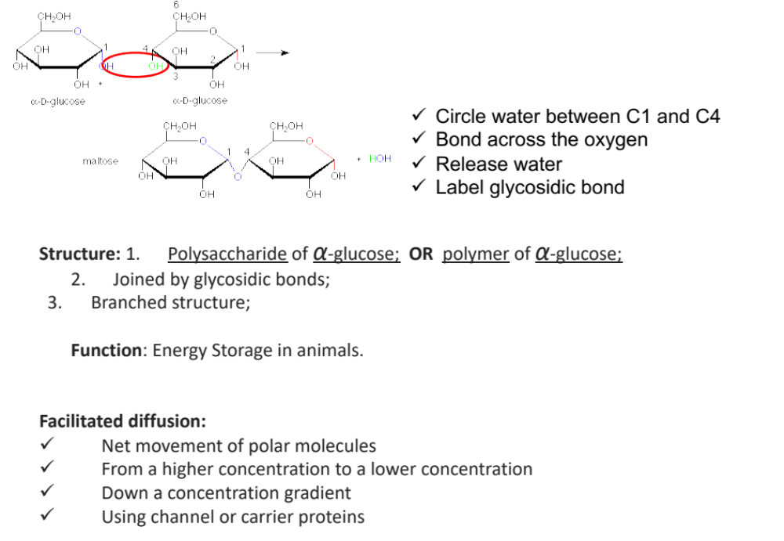

Characteristics of hormones.
Use the words in the box below to complete the gaps
- Produced in GLANDS
- Which secrete them directly into BLOOD
- Carried in BLOOD PLASMA to the cells where they act = TARGET CELLS
- These cells have specific RECEPTOR on their cell surface MEMBRANES that are COMPLMENTARY to the specific hormone
- This causes a sequence of events inside cells, using different messengers.
- They are effective in very LOW CONC but have WIDE SPREAD and LONG_ LASTING effects.

Receptors | Complementary | Blood | Target cells
Blood plasma | Glands | Membranes | Wide spread
Low concentrations |  | Long-lasting

Controlling Blood Glucose Concentration- Factors
Briefly explain why it is so important to regulate blood glucose concentration. Here are some prompts to help you : Respiration, ATP, death of cell, brain cells
Glucose is respiratory substrate for cells
Respiration provides ATP for cell
If no/little glucose then the cell has no ATP
Cell cannot carry out metabolic reactions (Always give an examples)
Causing cell death
Exam questions are usually application questions based on these factors. You need to learn the table but also be able to APPLY the table to different experiments. BGC = Blood Glucose Concentration.
Factor | How does it influence blood glucose concentration?
From diet, e.g. starch hydrolysed to maltose.  From cells, e.g. glycogen hydrolysis, in small intestine, stored in liver and muscle cells | BGC will increase from carbohydrate hydrolysis inside the cells and be released into the blood
Production of glucose from other sources. | BGC will increase. When carbohydrate sources are not available. Glucose is produced from glycerol/amino-acids inside cells.
Increase in mental and physical activity/ used in respiration. | Decrease BGC with increased uptake of glucose into the cells from blood by facilitated diffusion
Not eating | Decreases BGC as glucose/stores inside cells is used but not being replaced through diet.

T/F quiz- Identify the mistakes and correct them.
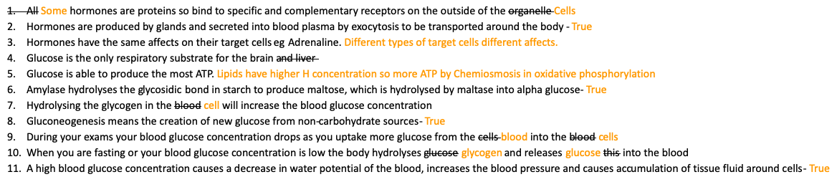

Odd one out- Identify which word doesn’t fit the pattern then explain why you picked this word.
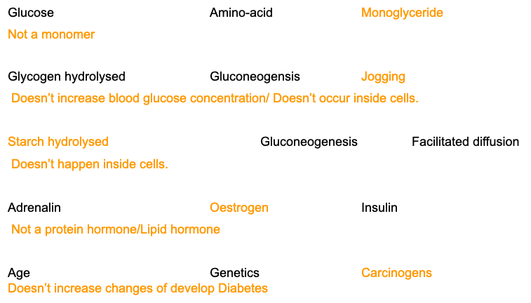

Outcomes:
- Explain the role of the pancreas, specifically the α and β cells of the Islets of Langerhans, in regulating blood glucose concentration,
- Explain what is meant by the term’s glycogenesis, glycogenolysis and gluconeogenesis.
- Explain the role of the liver in glycogenesis, glycogenolysis and gluconeogenesis
Role of the pancreas in regulation of blood glucose concentration
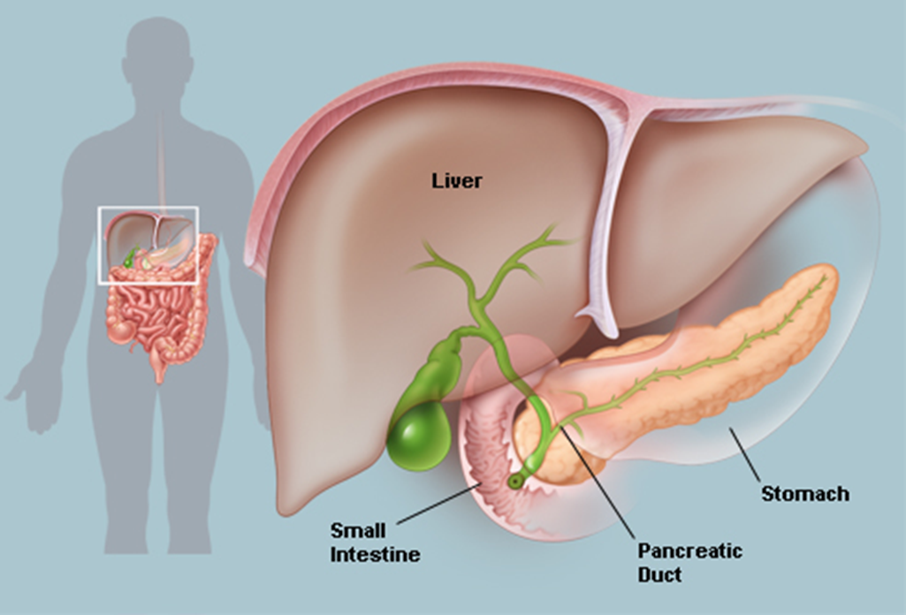
Islets of Langerhans.
The Islets are a tissue. From Year 1 define tissue.
A GROUP OF SPECIALISED CELLS WORKING TOGETHER
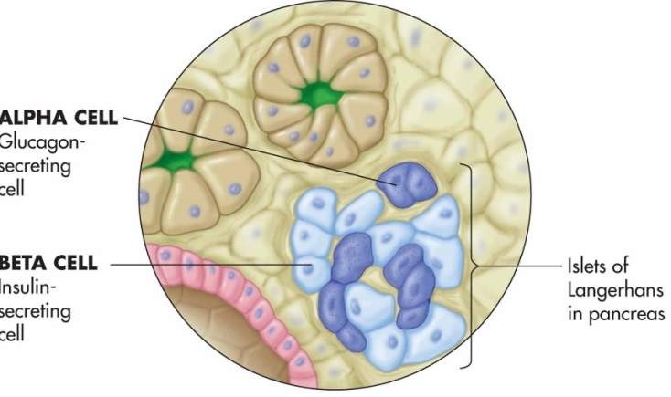
There are 2 types of cells
INSULIN is produced by beta cells and LOWERS. blood glucose concentration
GLUCAGON is produced by alpha cells and _INCREASES_ blood glucose concentration

Memory aid:

The alpha and beta cells are specialised to produce huge quantities of protein hormones insulin and glucagon. Describe and explain 3 adaptions would you expect to see in the cell.
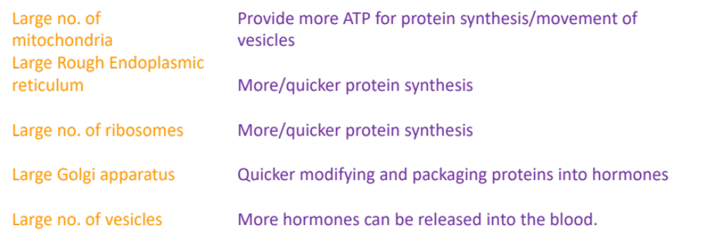
Role of Liver in regulation of blood glucose concentration
Hormones produced by pancreas have their effects in the liver; there are 3 important processes which occur:
- Glycogenesis: the conversion of glucose to glycogen,
Occur when BGC is HIGHER than normal,
Causes Liver to removes GLUCOSE from BLOOD,
Converted to GLYCOGEN inside liver cells.
- Glycogenolysis: the breakdown of glycogen. to glucose,
Occurs when BGC is LOWER than normal,
Causes Liver to HYDROLYSES GLYCOGEN to GLUCOSE,
GLUCOSE diffuses into BLOOD from liver cells.
- Gluconeogenesis: the production of glucose from glycerol/amino-acids,
Occurs when BGC is LOWER than normal,
Causes Liver to produces GLUCOSE from GLYCEROL/AMINO-ACIDS,
GLUCOSE diffuses into blood from liver cells.

Annotate the 3 terms on the images below, add arrows to name and show the reactions.

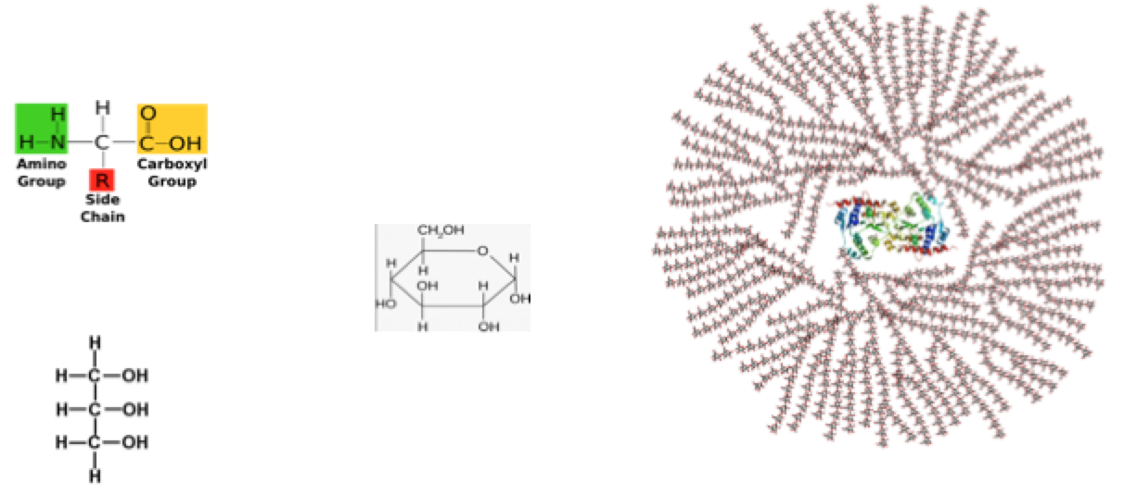

Important note: Insulin and Glucagon cause these processes to occur, the hormones are not enzymes so cannot carry out the processes.
Outcomes:
- Explain what triggers the release of insulin
- Explain the stages involved in the action of insulin
- Explain what triggers and stages involved in the release of glucagon
The action of Insulin and Glucagon
What triggers insulin and glucagon release?
Insulin |  | Glucagon
- Detected by ___________  - Secretes ______________  - Binds to ______________ | Trigger for release | - Detected by _______________  - Secretes __________________  - Binds to __________________
- Increase in no. of glucose transport channel proteins in plasma membrane  - So more glucose into cell by facilitated diffusion  - Activation of enzymes that convert glucose to glycogen (glycogenesis) and fat. | Action | - Decrease in no. of glucose transport channel proteins in plasma membrane  - So more glucose out cell by facilitated diffusion  - Activation of enzymes that convert glycogen to glucose (glycogenolysis) and conversion of amino-acids/glycerol to glucose (gluconeogenesis).
- Absorption of glucose into (muscle/liver) cells as membrane more permeable  - Increased respiration  - Conversion of glucose into glycogen (glycogenesis) in muscle and liver cells | Consequences | - Less absorption of glucose into (liver/muscle) cells as membrane less permeable  - Increased gluconeogenesis  - Increased glycogenolysis
- Decrease in BGC | Result | - Increase in BGC

Revision poster for how blood glucose concentration is controlled (pages 11-13)

Exam questions:
Q1. Homeostatic mechanisms maintain a constant environment in the body.
(a) The graph shows changes in plasma glucose concentration that occurred in a person who went without food for some time.
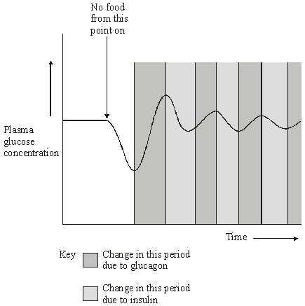
Use evidence from the graph to explain the role of negative feedback in the control of plasma glucose concentration.
(a) 1. Deviation of a value from norm initiates corrective mechanisms;
2. fluctuations in plasma glucose concentration detected by hypothalmus / islet cells in pancreas;
3. initial decrease, no food given (in plasma glucose) stimulates (increased) secretion of glucagon;
4. increases (in plasma glucose) stimulate (increased) secretion of insulin from β cells as secretors;
5. correct ref. to interconversion of glycogen / glucose / increased / decreased uptake of glucose by cells (as appropriate) / correct ref to change in membrane permeability;
(b) How does maintaining a constant body temperature allow metabolic reactions in cells to proceed with maximum efficiency?
(b) 1. Body temp. / 37 °C is optimum temp for enzymes;
2. excess heat denatures enzymes / alters tertiary structure / alters shape of active site / enzyme so substrate cannot bind / eq;
3. reactions cease / slowed;
4. too little reduces kinetic energy of molecules / moleculesmove more slowly;
5. fewer collisions / fewer ES complexes formed’

Q2. (a) Describe how insulin reduces the concentration of glucose in the blood.
insulin binds to specific receptors (on membranes);
insulin activates carrier proteins / opens channels / causes more
channels to form;
insulin increases the permeability of liver / muscle cells / tissues to glucose;
insulin action results in glucose conversion to glycogen / glycogenesis;
Some people produce no insulin. As a result they have a condition called diabetes. In an investigation, a man with diabetes drank a glucose solution. The concentration of glucose in his blood was measured at regular intervals. The results are shown in the graph.
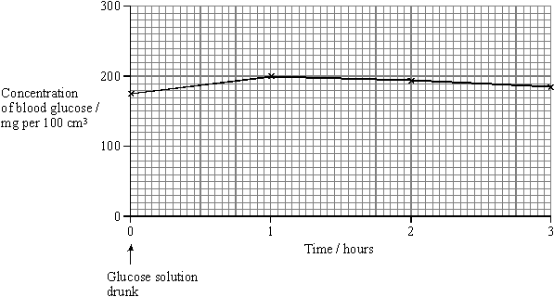
(b) Suggest two reasons why the concentration of glucose decreased after 1 hour even though this man’s blood contained no insulin.
(b) glucose is used in cell respiration / as energy source / in metabolism;
(must qualify how glucose is used)
glucose enters cells / converted to glycogen in cells;
glucose is excreted / in urine;
(c) The investigation was repeated on a man who did not have diabetes. The concentration of glucose in his blood before drinking the glucose solution was 80 mg per 100 cm³. Sketch a curve on the graph to show the results you would expect.
(1)
(d) The diabetic man adopted a daily routine to stabilise his blood glucose concentration within narrow limits. He ate three meals a day: breakfast, a midday meal and an evening meal. He injected insulin once before breakfast and once before the evening meal.
The injection he used before breakfast was a mixture of two types of insulin. The mixture contained slow-acting insulin and fast-acting insulin.
(i) Explain the advantage of injecting both types of insulin before breakfast.
(i) fast acting insulin reduces blood glucose from breakfast;
slow acting insulin reduces blood glucose from other meals
before the evening meal / eliminates the need to inject at lunch;
(must be a reference to the meals)
(one mark if neither of the above but a clear reference is
made to glucose conversion to glycogen);
(ii) One day, the man did not eat a midday meal. Suggest one reason why his blood glucose concentration did not fall dangerously low even though he had injected himself with the mixture of insulin before breakfast.
ii) glucagon is still active;
glycogen converted to glucose / glycogenolysis;
insulin injected at breakfast causes cells to take up glucose
too slowly for levels to become dangerously low;
person is not active so little glucose used in respiration;
(do not credit statements about consuming large breakfasts)

Outcomes:
- Explain what triggers the release of adrenaline and the second messenger model related to adrenaline and glucagon action
- Explain the stages involved in the action of adrenaline (linked to BGC)
- Describe role of adenyl cyclase, cyclic AMP, protein kinase in the second messenger model

Action of Adrenaline
Mechanism of hormone action (the second messenger model)
Definitions:
First messengers: Molecules that bind to receptors in the plasma membranes of target cells and cause changes to happen inside the target cell.
Second messengers: Molecules found inside the target cell that are affected by the binding of a first messenger to a receptor.
Adrenaline is a protein hormone (first messenger) released by the adrenal gland and is triggered by stress or excitement

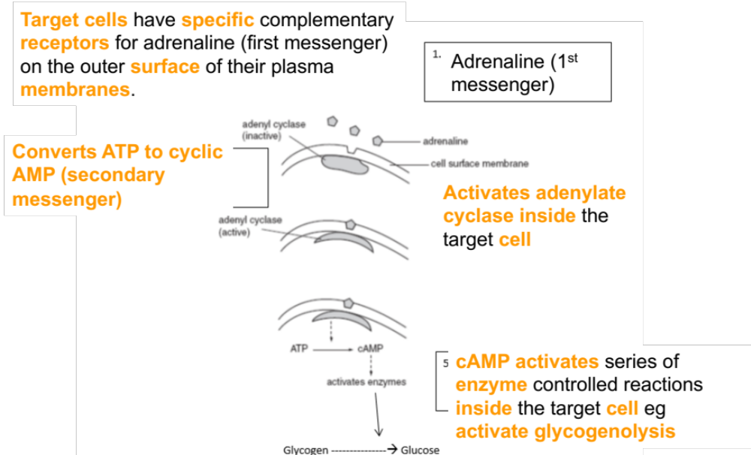

Note: Adenylate cyclase and adenyl cyclase are the same enzyme, both names can be used in the exam
Diabetes Mellitus
Causes of diabetes
Outcome:
- Explain the causes and controls of type 1 and type 2 diabetes
- Evaluate the positions of health advisers and the food industry in relation to the increased incidence of type II diabetes

Diabetes is a disease where the body cannot control its blood glucose concentration. This may lead to either very high blood glucose concentrations - hyperglycaemia. or very low blood glucose concentrations - hypoglycaemia
There are 2 types of Diabetes Mellitus:- Type 1 (Insulin dependent) and Type 2 (Non-insulin dependent)
Type 1 (Insulin dependent) | Type 2 (Non-insulin dependent)
Starts at an early age / in childhood (juvenile onset) | Develops with increasing age (usually above 40)
Develops quickly | Develops slowly
Signs and symptoms usually obvious | Signs and symptoms are less severe and may go unnoticed
Causes: Beta cells do not make insulin | Causes: Beta cells still secrete insulin but at low concentrations
Causes: Not linked to obesity, poor diet and sedentary lifestyle | Causes: Linked to obesity, poor diet and sedentary lifestyle
Causes: May be due to an autoimmune response where the immune system attacks its own beta cells | Causes: Glycoprotein receptors on target cells lose their responsiveness to insulin

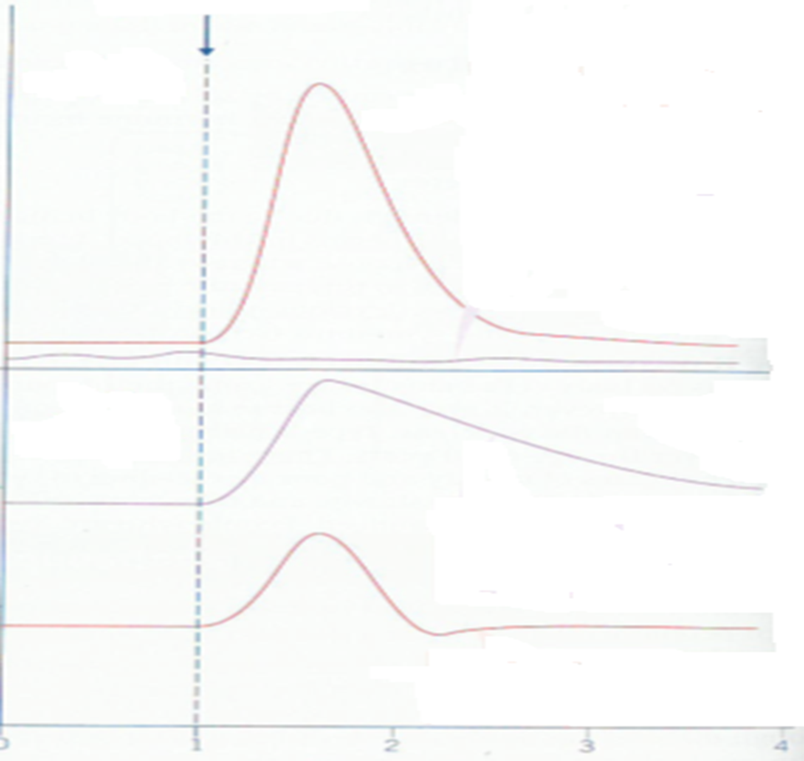
Line D
Line C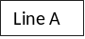
Line A
Line B
Line A | - Beta cells release insulin in response to high blood glucose conc  - This stimulates glycogenesis  - Increased respiration of glucose  - Increased number and increased number of open glucose transporters in target cell membranes
Line B | - Beta cells don’t produce insulin so no response to glucose
Line C | - No insulin produced by beta cells so takes a long time for blood glucose concentration to drop after glucose taken up in diet  - This drop is eventually caused by respiration of glucose
Line D | - Insulin produced by beta cells in response to increased glucose concentration in blood which rapidly returns blood glucose concentrations to normal by negative feedback mechanisms

Key skills to remember when interpreting data in an exam:
If you have 2 command words in the question then split your answer into a table to help see if you have answered both parts.
Describe means saying what you see
Explain means giving the biology behind WHY this has happened on the graph
Control of Diabetes
Diabetes cannot be cured (currently) but can be successfully treated – type of treatment depends on type of diabetes. Read Page 391 of the text book. Comprehension task. Answer the questions below.
Type 1 diabetes: treated by insulin injections.
- Why can insulin not be taken by mouth?
Insulin is a protein and would be digested
- What is the dose matched to?
Carbohydrate intake and exercise
- What happens if too much insulin is taken?
Low blood glucose conc/hypoglycaemia/unconscious/coma
- What is used to ensure the correct dose?
Biosensors
- What else does a diabetic have to do to lead a normal life?
Inject insulin/manage carbohydrate intake/exercise carefull
Type 2 diabetes:
Controlled by regulating the intake of _CARBOHYDRATES
Matching to the amount of EXERCISE
Supplemented by INJECTIONS OF INSULIN
Note: In your exam you will be given information about food manufacturers, health visitors, the government ect in the form of a comprehension or data. You will need to read the information and answer specific questions, you do not need to learn specific information about this specification point.
______________________________________________________________________________________________
Exam questions:
Q1. (a) Explain how insulin lowers the concentration of blood glucose.
Binds to receptor on target/liver/muscle cell;
Reject reference to insulin as an enzyme
Causes more transport/carrier proteins to become active/
move to (plasma) membrane;
Glucose (diffuses) into cells (and lowers blood glucose);
(Enzymes in cells) convert glucose to glycogen;
Stimulates fatty acids/lipid/fat formation (from glucose);
Raises rate of respiration (in cells), using more glucose;
(b) Doctors studied a large group of people. They recorded the death rates for non-diabetic people, undiagnosed diabetics and diagnosed diabetics. They gave the death rates as deaths per 1000 years lived by people. The graph shows these death rates.
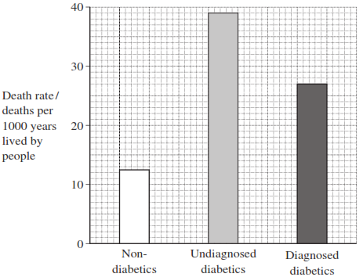
(i) Calculate the ratio of the death rate of diagnosed diabetics to undiagnosed diabetics.
27 : 39; 1 : 1.44;
2 marks for 1 : 1.44
Accept 0.69 : 1
Accept 9 : 13
(ii) People with undiagnosed diabetes were not receiving treatments, such as insulin injections. Suggest one reason for the difference in death rates for undiagnosed and diagnosed diabetics.

One suitable reason; with explanation;

e.g. undiagnosed
Diabetic coma/brain cells not enough respiration;
Due to low blood glucose/acidosis/dehydration;

Heart attacks/coronary heart disease;
Due to faster atheroma formation/damage to arteries;

Kidney failure;
Due to damage to blood vessels;

Q2. (a) Adrenaline binds to receptors in the plasma membranes of liver cells. Explain how this causes the blood glucose concentration to increase.
1. Adenylate cyclase activated / cAMP produced / second messenger produced;
2. Activates enzyme(s) (in cell so) glycogenolysis / gluconeogenesis occurs / glycogenesis inhibited;
2. Neutral: ‘glucose produced’ as given in the question stem
Accept: correct descriptions of these terms

Q3. A glucose biosensor is an instrument used to measure glucose concentration. It contains an enzyme called glucose oxidase.

(a) A glucose biosensor detects only glucose. Use your knowledge of the way in which enzymes work to explain why.

Enzyme / active site has a (specific) tertiary structure;

Only glucose has correct shape / is complementary / will bind / fit to active site;

(Forming) enzyme-substrate complex;

Q Allow second mark if candidate refers to correct shape or complementary in terms of the enzyme. Do not allow ‘same’ shape

Q Do not allow third mark if active site is described as being on substrate.

(b) It is better to use a biosensor than the Benedict’s test to measure the concentration of glucose in a sample of blood. Suggest two reasons why.

(Only detects glucose whereas) Benedict’s detects (all) reducing sugars / named examples;

Provides a reading / is quantitative / Benedict’s only provides a colour / doesn’t measure concentration / is qualitative / semiquantitative;

Is more sensitive / detects low concentration;

Red colour / colour of blood masks result;

Can monitor blood glucose concentration continuously;

Q Do not credit quicker / more accurate unless qualified.

Q Allow Benedict’s detects monosaccharides for first mark point.

(c) (i) Diabetes mellitus is a disease that can lead to an increase in blood glucose concentration. Some diabetics need insulin injections. Insulin is a protein so it cannot be taken orally. Suggest why insulin cannot be taken orally.

Broken down by enzymes / digested / denatured (by pH) too large to be absorbed;

(ii) A drug company produced a new type of insulin. Scientists from the company carried out a trial in which they gave this new type of insulin to rats. They reported that the results of this trial on rats were positive. A newspaper stated that diabetics would benefit from this new drug. Suggest two reasons why this statement should be viewed with caution.
Study not carried out on humans / only carried out on rats;
Long-term / side effects not known;
Scientists have vested interest;
Study should be repeated / further studies / sample size not known;

