Reflection on Learning outcomes | or | Target
Explain the meaning of the key terms: gene; allele; genotype; phenotype; homozygous; and heterozygous.
Define what is meant by dominant and recessive alleles, and describe how to represent these
Explain the principle underlying dominant and recessive alleles
Define what is meant by co-dominant alleles, and describe how to represent these
Describe how to represent alleles in multiple allele crosses

Explain what is meant by sex-linked alleles, and describe how to represent these
Draw dominant/ recessive, co-dominant, multiple alleles, sex-linked monohybrid crosses to predict offspring genotypes and phenotypes
Apply knowledge to calculate the predicted ratios of genotypes and phenotype of offspring when supplied with appropriate information for all crosses
Interpret pedigree analysis diagrams, citing evidence from them in support of explanations for all crosses
Draw dihybrid, epistasis, autosomal linkage crosses to predict offspring genotypes and phenotypes
Apply knowledge to calculate the predicted ratios of genotypes and phenotype of offspring, using fully labelled diagrams, when supplied with appropriate information
Explain what the chi-squared test is used for

Set a null hypothesis

Use the chi-squared test to compared observed values against those predicted from genetic crosses
Interpret chi-squared tests in terms of probability and chance

Define what is meant by the term population

Describe and explain the mathematical equations used to express allele and genotype frequencies.
Explain what the Hardy Weinberg principle predicts

Explain the conditions under which Hardy Weinberg principle applies
Apply knowledge of Hardy Weinberg to the context of a question to calculate the frequency of an allele or genotype.
3.7.1- Inheritance

Name: TEACHER
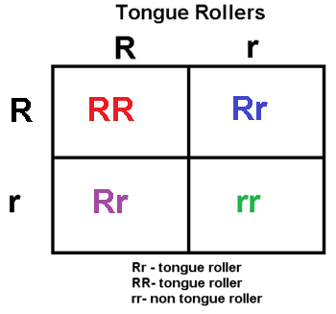
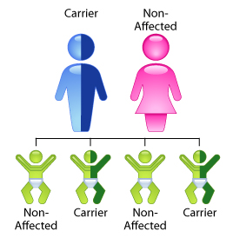

Outcomes:
- Explain the meaning of the key terms: gene; allele; genotype; phenotype; homozygous; and heterozygous.
- Define what is meant by dominant and recessive alleles, and describe how to represent these
Term |   Definition
Chromosome | Made of proteins and DNA containing hereditary information which is physically passed on to the next generation
Gene | A length of DNA which codes for a protein or polypeptide
Allele | Different forms of a gene
Genotype | The genetic constitution (makeup) of an organism
Phenotype | The observable (physical) characteristics of an organism, resulting from its genotype and interaction with the environment
Homozygous | The two alleles of a gene are the same
Heterozygous | The two alleles of a gene are different
Dominant | The allele is always expressed in the phenotype, even if a different allele for the same gene is present
Recessive | The allele which is only expressed in the phenotype, in absence of a dominant allele or homozygous
Monohybrid | Genetic diagrams involving the inheritance of a single gene
Codominance | Both alleles have an effect on the phenotype of the offspring
Sex-linkage | Gene may have more than two alleles. Only two can be present in one individual remember!
Dihybrid | The inheritance of 2 characteristics controlled by two separate genes inherited independently
Epistasis | One gene locus masks or suppresses the expression of another gene locus.
Autosomal linkage | Genes are linked if they are inherited on the same chromosome.
Null hypothesis | The null hypothesis states that there is NO SIGNIFICANT DIFFERENCE between the observed and expected values.

Quick fire questions:
- How do you represent a dominant allele?
Capital letter
- How do you represent a recessive allele?
Lower case letter
Exam questions:

(a) (i) Explain what is meant by a recessive allele.
Only expressed when homozygous / two (alleles) are present / when no dominant allele / is not expressed when heterozygous;

(b) What is meant by the term phenotype?
1.(Expression / appearance / characteristic due to) genotype / allele(s) combination;
2.(Expression / appearance / characteristic due to) environment;

Genetic diagrams- FOLLOW THE RULES

Genetic diagrams allow us to predict and explain the characteristics of the offspring produced by 2 parents.

Learn these rules and apply them to ALL genetic cross questions.

Identify the interaction between alleles

- Give alleles symbols
Dominant = Capital, recessive = lower case

3. State parents’ phenotype

4. State parents genotype

5. Possible gametes from each parent– always draw in circles

6.Punnet square to show the random fertilisation of the gametes

7.Offspring phenotypes linked to the Punnet square

8. Phenotypic ratio
Monohybrid Inheritance
Outcomes:
- Explain the principle underlying dominant and recessive alleles,
- Draw dominant/ recessive monohybrid crosses to predict offspring genotypes and phenotypes.
- Apply knowledge to calculate the predicted ratios of genotypes and phenotype of offspring when supplied with appropriate information for all crosses
Definition:
Monohybrid: Genetic diagrams involving the inheritance of a single gene.

Type 1: Monohybrid inheritance involving dominant & recessive alleles
Pea plant height.
- Pure breeding (homozygous) tall pea plants crossed (bred) with pure breeding dwarf pea plants produce all tall pea plants in the first generation of offspring (F₁).
- Crossing the F₁ plants (first offspring) produced a ratio of 3 tall plants to 1 dwarf plant in the F₂ generation.
- Explain the F2 ratio using a genetic diagram, applying the rules, and showing all steps
Parental Phenotype: Tall x Dwarf
Parental Genotype: TT tt
Gametes: T T t
Punnet:
 | t | t
T | Tt | Tt
T | Tt | Tt
F1 Genotype Tt
F1 Phenotype Tall
Ratio 100%

F1 Phenotype Tall x Tall
F1 Genotype Tt Tt
Gametes T t T t
Punnet:
 | T | t
T | TT | Tt
t | Tt | tt
F2 Genotype TT Tt tt
F2 Phenotype Tall Dwarf
Ratio 75% 25%
Why does it not matter which of the F1 you chose to bred again?
ALL F1 have the same genotype/allele combination
Type 1: Monohybrid inheritance involving test cross
To identify the genotype of a parent.
- Cross the unknown parent (Tall) with a homozygous recessive plant (dwarf).
- Observe the phenotype of the offspring
- If any of the offspring show the recessive phenotype i.e. dwarf, the original plant must be heterozygous. If all offspring are tall, parent must be homozygous
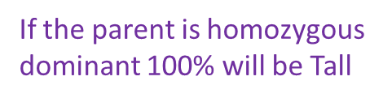
- Prove this using 2 punnet squares
 | T | T
t | Tt | Tt
t | Tt | Tt
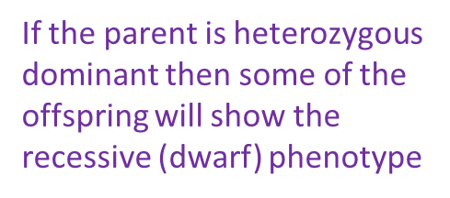
 | T | t
t | Tt | tt
t | Tt | tt

Expected ratios and actual observed numbers of offspring will be different because:
- Fertilisation of gametes is random
- Fusion of gametes is random
- Small population size
- Selective advantage to alleles

Exam Question:
A student investigated the monohybrid inheritance of eye shape in fruit flies. Two fruit flies with bar (narrow) eyes were crossed. Of the offspring, 1538 had bar eyes and 462 had round (normal) eyes.

(a) Using suitable symbols, give the genotypes of the parents. Explain your answer.
Genotypes 1. Bb / suitable equivalent;
Reject sex linkage or superscripts
2. Both parents have bar eyes, but have some offspring with round eyes, so parents must be carriers of recessive allele for round eyes;

(b) The ratio of bar-eyed flies and round-eyed flies in the student’s results were not the same as the ratio she had expected. What ratio of bar-eyed to round-eyed flies was the student expecting?

3:1

(c) Suggest two reasons why observed ratios are often not the same as expected ratios.
Fertilisation is random
OR
Fusion of gametes is random;
2. Small / not large population / sample;
3. Selection advantage / disadvantage / lethal alleles;

Outcomes:
- Define what is meant by co-dominant alleles, and describe how to represent these.
- Draw co-dominant monohybrid crosses to predict offspring genotypes and phenotypes.
- Apply knowledge to calculate the predicted ratios of genotypes and phenotype of offspring when supplied with appropriate information for all crosses

Type 2: Monohybrid Inheritance involving Co-dominance

Definition:
Co-dominance: Both alleles have an effect on the phenotype of the offspring

Words to fill in the gaps:
Dominant | Gene | Superscript

- Capital letter represents gene- Called a locus
- Superscript the alleles
- ALL dominant alleles have own capital letter
- Recessive alleles have lower case letter.

Genotype | Phenotype
C^{R}C^{R} | Red
C^{W}C^{W} | White
C^{W}C^{R} | Pink
Use a genetic diagram to predict the genotypes and phenotypes of the offspring when a red flowering plant is crossed with a pink flowering plant. What are the rules for setting out crosses?

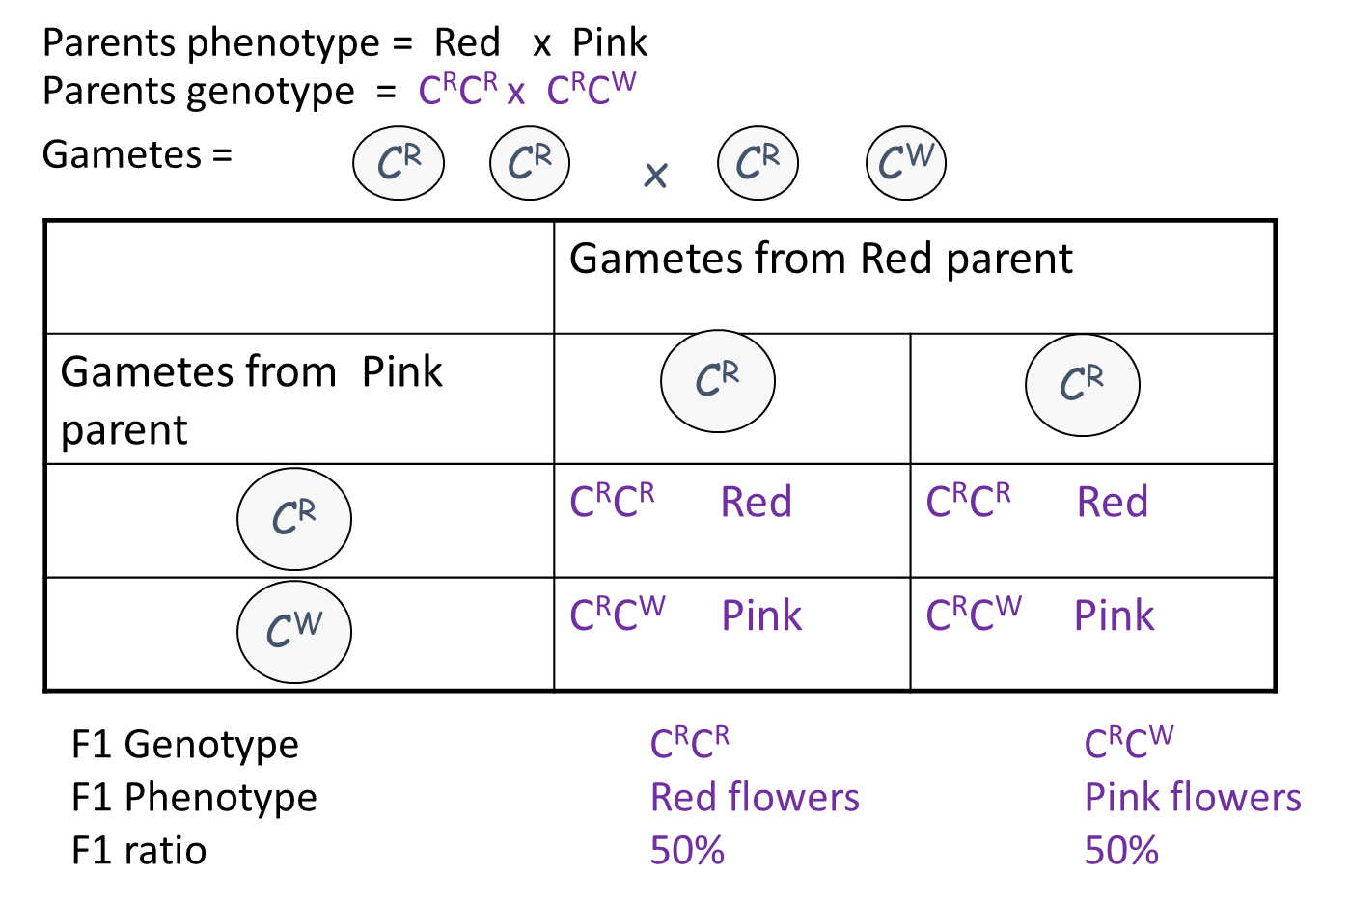

Practice question:
Red Poll cattle are homozygous for an allele which gives red coat colour. White shorthorns are homozygous for an allele which gives white coat colour. When crossed, the offspring all have a mixture of red and white hairs in their coats producing a colour called Roan.

- Suggest suitable symbols for the two alleles of the coat colour gene.
C^{R} = Red poll cattle, C^{W} = White shorthorn, C^{R}C^{W} = Roan cattle.

- List the three possible genotypes for the coat colour gene and their phenotypes.

C^{R}C^{R}= Red Poll (Homozygous)
C^{W}C^{W} = White shorthorn (Homozygous)
C^{R}C^{W} = Roan (heterozygous)

- Draw genetic diagrams to show the offspring expected from the following matings:
- a red poll with a roan;
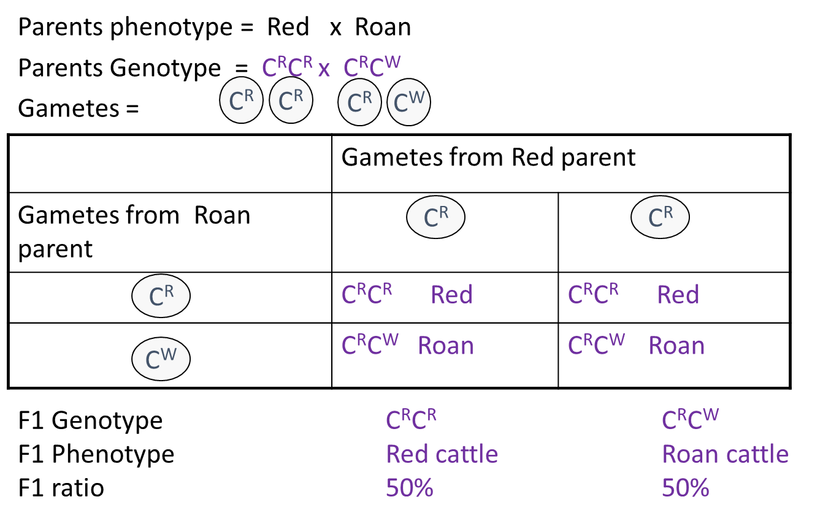
(ii) two roans.
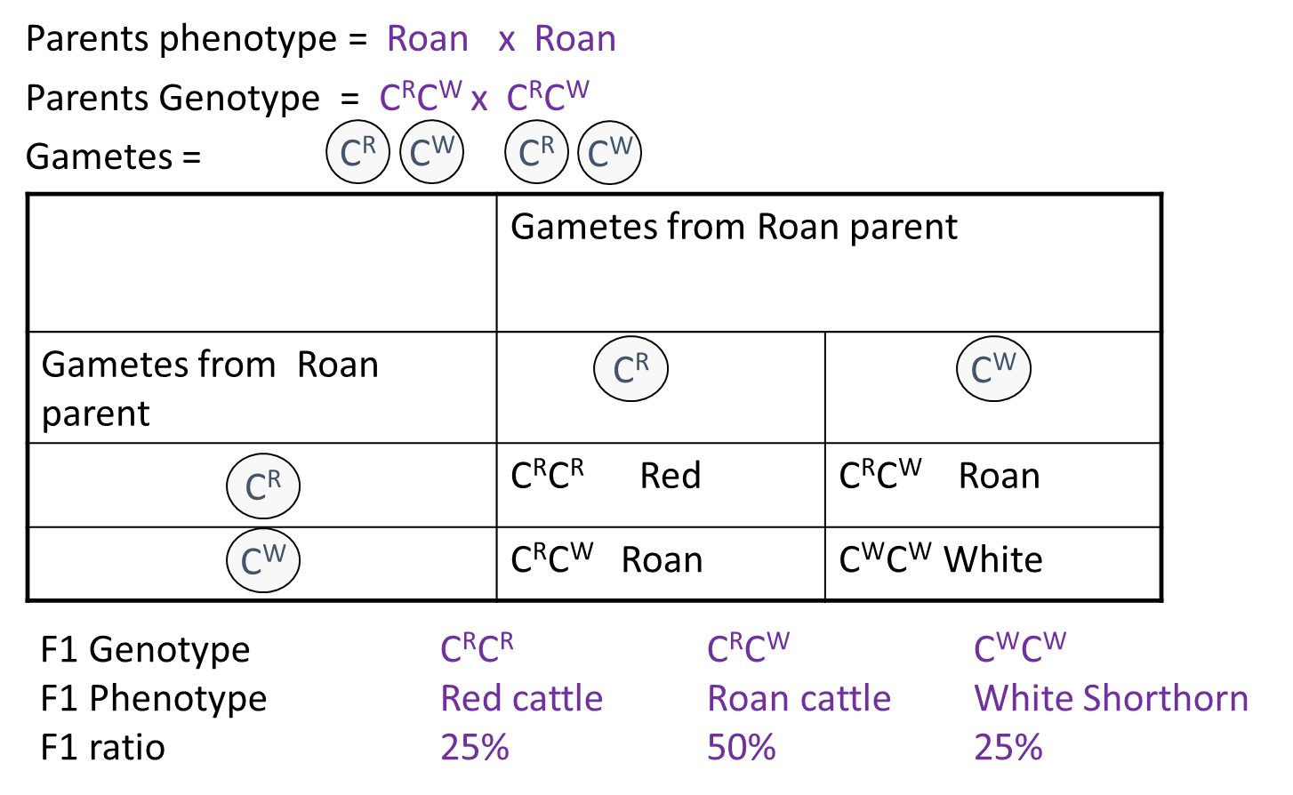
Outcomes:
- Describe how to represent alleles in multiple allele crosses
- Draw multiple alleles monohybrid crosses to predict offspring genotypes and phenotypes.
- Apply knowledge to calculate the predicted ratios of genotypes and phenotype of offspring when supplied with appropriate information for all crosses

Type 3:Monohybrid Inheritance involving Multiple alleles.
Definition:
Multiple alleles: Gene may have more than two alleles. Only two can be present in one individual remember!

Blood Groups: I represent the gene. The superscripted letter represents the allele.

I^{A} and I^{B} are codominant.
I^{O} is recessive to both.

Phenotype | Genotype
A | I^{A} I^{A} I^{A} I^{O}
B | I^{B} I^{B} I^{B} I^{O}
AB | I^{A} I^{B}
O | I^{O} I^{O}

Use a genetic diagram to show why a cross between an individual of blood group O and one of blood group AB only produce offspring of the other two groups (A and B).
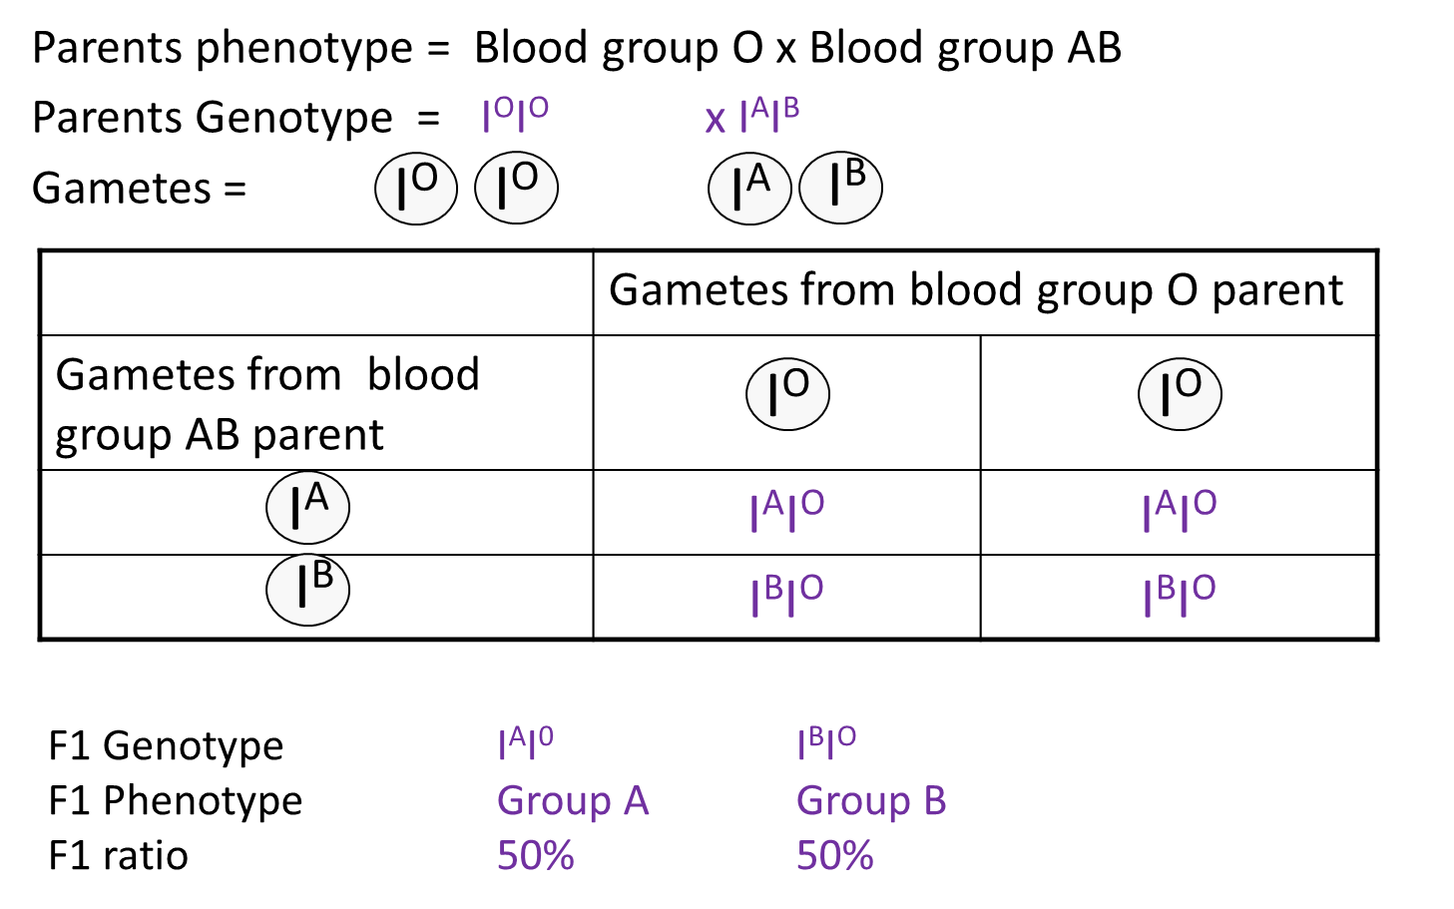
Exam question

A breeder crossed a black male cat with a black female cat on a number of occasions. The female cat produced 8 black kittens and 4 white kittens.

(a) (i) Explain the evidence that the allele for white fur is recessive.

1. Parents are heterozygous; Accept carriers / carries white allele

2. Kittens receive white allele from parents / black cat

(ii) Predict the likely ratio of colours of kittens born to a cross between this black male and a white female.

1:1;_(1)

(b) The gene controlling coat colour has three alleles. The allele B gives black fur, the allele b gives chocolate fur and the allele b^{i} gives cinnamon fur.

(i) Complete the table to show the phenotypes of cats with each of the genotypes shown.

Genotype | Phenotype
Bb^{i} | Black
bb^{i} | Chocolate,
Bb | Black;

(ii) A chocolate male was crossed several times with a black female.

They produced • 11 black kittens • 2 chocolate kittens • 5 cinnamon kittens.

Using the symbols in part (b), complete the genetic diagram to show the results of this cross.

(ii) Parental phenotypes Chocolate male Black female

1. Parental genotypes bb^{i} Bb^{i};

Both genotypes needed for the mark.

2. Parental gametes b b^{i} B b^{i};

Allow credit if gametes are correctly derived from candidate’s incorrect parental genotypes.

3. Offspring genotypes Bb, Bb^{i} bb^{i} b^{i}b^{i};

Genotype(s) must be with correct phenotype.

Allow credit if symbols other than B / b / b^{i} have been used correctly.

Ignore genetic diagrams unless clearly annotated.

Offspring phenotypes Black Chocolate cinnamon;

(iii) The breeder had expected equal numbers of chocolate and cinnamon kittens from the cross between the chocolate male and black female. Explain why the actual numbers were different from those expected.

1. Offspring ratios are a probability / not fixed / arise by chance /

2. gametes may not be produced in equal numbers /

3. fertilisation / fusion of gametes is random /

4. small sample;

(iv) The breeder wanted to produce a population of cats that would all have chocolate fur. Is this possible? Explain your answer.
1. Possible if parents homozygous / bb;
2. Don’t know genotype of chocolate cat / chocolate cat could be homo- or heterozygous / chocolate cat could be bb or bb^{i};
3. Two chocolate cats could give cinnamon kittens;

Space for Comprehension practice answers.
- Y-chromosome is short so does not carry the allele for the gene found on the X-chromosome
- Males more likely to have the disease, will not carry a second allele to cancel out affect of recessive allele
- Male only carry 1 allele, females more likely to die from haemophilia especially with onset of puberty.
- Haemophilia disadvantageous allele so organisms less likely to survive and reproduce . Will not be able to pass on disadvantageous allele to the next generation . Frequency of allele in population reduces. Frequency of phenotype reduces.
- Change in DNA base sequence . Change in amino-acid sequence/primary structure. Alters position of hydrogen/ionic/disulphide bonds. Change in tertiary structure. Active site no longer complementary to substrate.
- X and Y used to represent Sex-linked genes. Haemophilia allele only located on X chromosome
- Male sex chromosome = XY. Y can only be inherited from father . X is inherited from mother. X carries the haemophilia allele.

Type 4: Monohybrid Inheritance involving Sex linkage
Outcomes:
- Explain what is meant by sex-linked alleles, and describe how to represent these
- Draw sex-linked monohybrid crosses to predict offspring genotypes and phenotypes.
- Apply knowledge to calculate the predicted ratios of genotypes and phenotype of offspring when supplied with appropriate information for all crosses

Definition:
Sex linkage: Any gene carried on either the X or Y chromosome is said to be sex-linked.
Males will only have one allele of a sex-linked gene.
Females need to be homozygous recessive to have the condition.

Possible Genotypes for Haemophilia | Phenotype
X^{H}X^{H} | Unaffected female
X^{H}X^{h} | Carrier female
X^{h}X^{h} | Lethal combination
X^{H}Y | unaffected male
X^{h}Y | Haemophiliac male

Draw a genetic diagram to show the expected offspring of a male haemophiliac and a female carrier. Do you remember the specific rules?
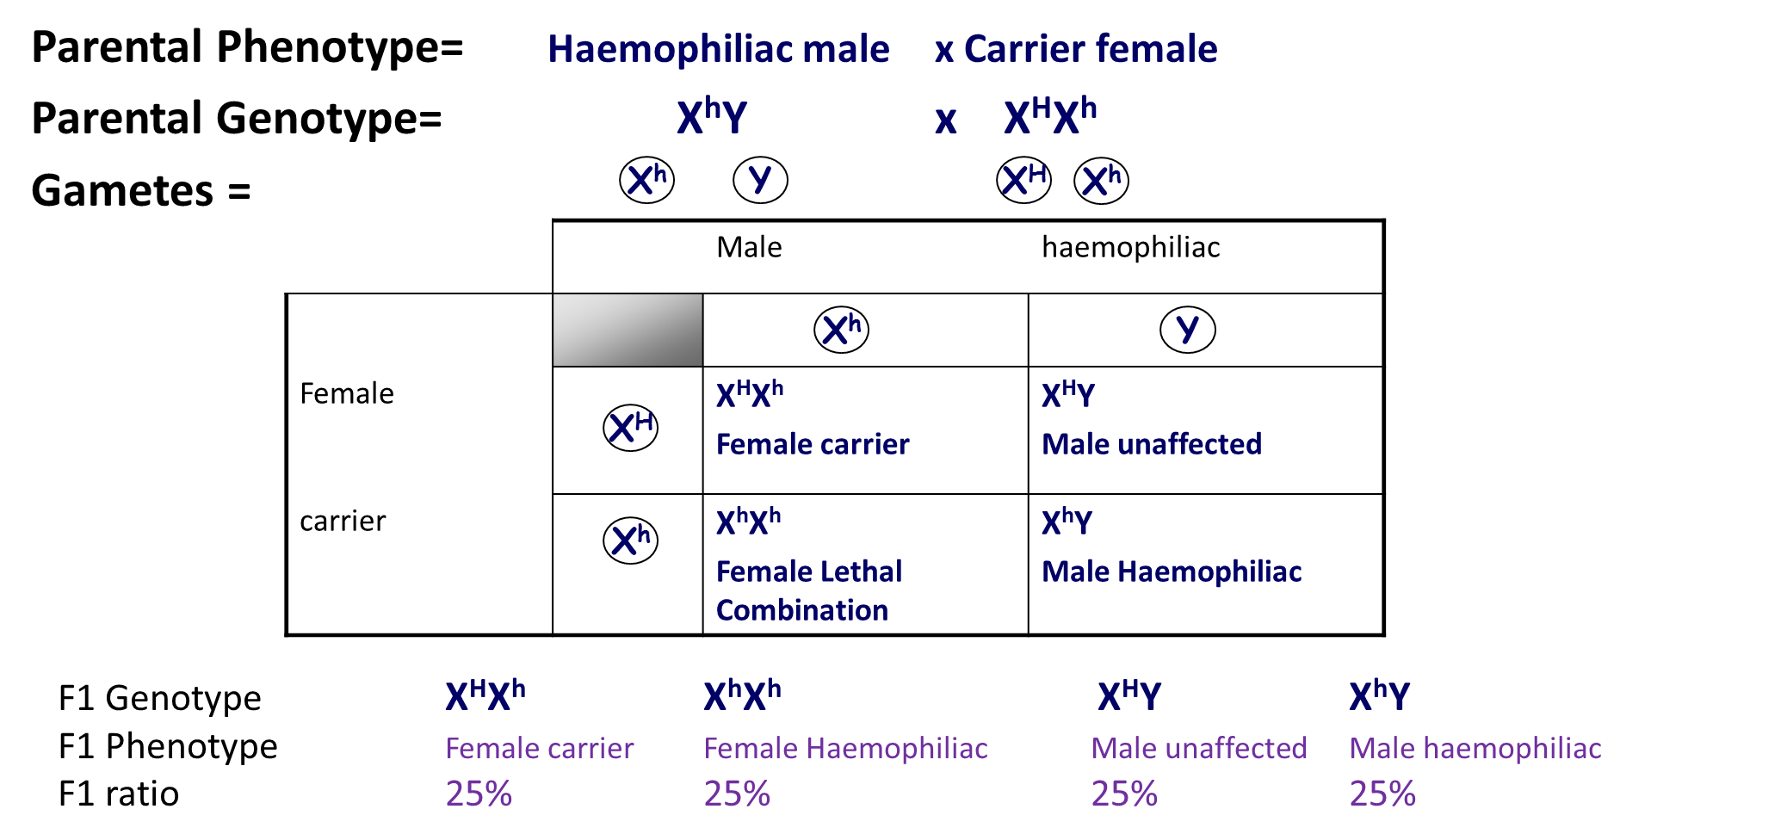

Exam Question:
Q1. In cats, males are XY and females are XX. A gene on the X chromosome controls fur colour in cats. The allele G codes for ginger fur and the allele B codes for black fur. These alleles are codominant. Heterozygous females have ginger and black patches of fur and their phenotype is described as tortoiseshell.

(a) Explain what is meant by codominant alleles.
Both alleles are expressed / shown (in the phenotype).
Accept: both alleles contribute (to the phenotype)
Neutral: both alleles are dominant

(b) Male cats with a tortoiseshell phenotype do not usually occur. Explain why.
Only possess one allele / Y chromosome does not carry allele / gene / can’t be heterozygous.
Accept: only possess one gene (for condition)
Neutral: only 1 X chromosome (unqualified)

Q2. In a species of snail, shell colour is controlled by a gene with three alleles. The shell may be brown, pink or yellow. The allele for brown, C^{B}, is dominant to the other two alleles. The allele for pink, C^{P}, is dominant to the allele for yellow, C^{Y}.

(a) Explain what is meant by a dominant allele.
Is always expressed / shown (in the phenotype);
Reject ‘is always present’ without further qualification

(b) Give all the genotypes which would result in a brown-shelled snail.
C^{B}C^{B}, C^{B}C^{P} and C^{B}C^{Y};
All three are required for the mark
Or
C^{B}C^{B}, C^{P}C^{B} and C^{Y}C^{B};
Accept C^{B}C^{B}, C^{B}C^{P}, C^{B}C^{Y},
C^{Y}C^{B} and C^{P}C^{B}
Accept BB, BP and BY or
BB, BP, BY, YB and PB

(c) A cross between two pink-shelled snails produced only pink-shelled and yellow-shelled snails. Use a genetic diagram to explain why.
1. Two genotypes (as parents) shown as C^{P} C^{Y}
Award one mark maximum for candidates who have misread the question and complete a correct genetic cross between a pink snail, C^{P}C^{Y} and a yellow snail, C^{Y}C^{Y} to give pink and yellow offspring
Or
Two sets of gametes shown as C^{P} and C^{Y};
2. Genotypes of offspring shown as C^{P} C^{Y}, C^{P} C^{P} and C^{Y} C^{Y};
3. Above genotypes of offspring correctly linked to phenotypes i.e. pink and yellow;
Accept ratio (or equivalent) of 3 pink: 1 yellow for mark point 3

Outcomes:
- Interpret pedigree analysis diagrams, citing evidence from them in support of explanations for all crosses
Pedigrees
MOST COMMON EXAM QUESTION STYLE FOR MONOHYBRIDS
Definition:
Pedigree: Family tree of GENETICALLY related people used to identify simple inheritance patterns
Dominant allele:
- Only 1 parent needs to be carrier for allele to be inherited.
- Recessive phenotype shown in offspring not parents.
- STATE evidence from pedigree. Look at last 2 generations
X-linked allele:
- More common in males
- Parents not showing disease but offspring do
- STATE evidence from pedigree. Look at last 2 generations.

Recessive allele:
- Both sexes affected
- Both parents needs to have allele/heterozygotes for allele to be inherited
- STATE evidence from pedigree. Look at last 2 generations.

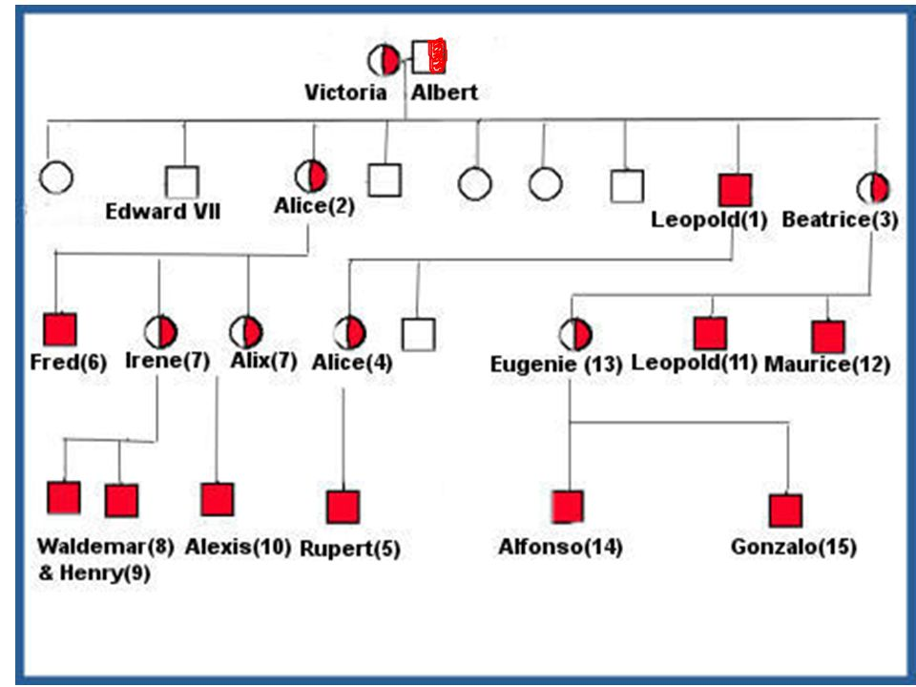
- What evidence is there that haemophilia is sex linked?
Females who carry the disease have affected males
More common in males
Irene is known carrier has 2 sons with disease

- Using appropriate symbols give the genotypes for
- Irene: X^{H}X^{h}

- Edward VII: X^{H}Y

- Gonzalo: X^{h}Y

3. What evidence is there that haemophilia is caused by a recessive allele?

Parents do not have the condition and their children do.
Parents must be heterozygous
Victoria and Albert do not have the disease but Leopold does.

Exam Questions:

Q1. (a) (i) Explain what is meant by a recessive allele.
Only expressed when homozygous / two alleles are present / when no dominant allele / is not expressed when heterozygous;

(ii) Explain what is meant by codominant alleles.
Both alleles are expressed / shown (in the phenotype);
Allow both alleles contribute (to the phenotype).

(b) The Rhesus blood group is genetically controlled. The gene for the Rhesus blood group has two alleles. The allele for Rhesus positive, R, is dominant to that for Rhesus negative, r. The diagram shows the inheritance of the Rhesus blood group in one family.

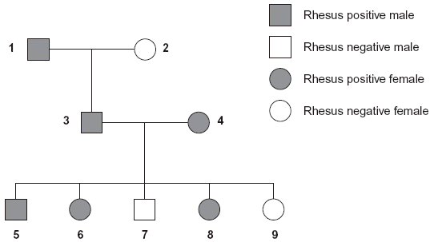

(i) Explain one piece of evidence from the diagram which shows that the allele for Rhesus positive is dominant.
3 and 4 / two Rhesus positives produce Rhesus negative child / children / 7 / 9;
Both Rhesus positives / 3 and 4 carry recessive (allele) / are heterozygous / if Rhesus positive was recessive, all children (of 3 and 4) would be Rhesus positive / recessive;
Answers including correct and incorrect evidence = zero marks evidence and explanation.

(ii) Explain one piece of evidence from the diagram which shows that the gene is not on the X chromosome.
3 would not be / is Rhesus positive / would be Rhesus negative;
3 would receive Rhesus negative (allele) on X (chromosome) from mother
3 could not receive Rhesus positive (allele) from mother
3 would not receive Rhesus positive (allele) / X (chromosome) from father /
1 or 3 will receive Y (chromosome) from father/ 1;
OR
9 would be Rhesus positive /
would not be/ is Rhesus negative)
8 and 9 / all daughters of 3 and 4 would be Rhesus positive;
As 9 would receive X chromosome / dominant allele from father / 3;
One mark for evidence and one mark for explanation linked to this evidence.
Any reference to allele being on Y chromosome negates mark for explanation.

In birds, males are XX and females are XY.

(a) Use this information to explain why recessive, sex-linked characteristics are more common in female birds than in male birds.
(Recessive) allele is always expressed in females
Or females have one (recessive) allele
Or males need two recessive alleles
Or males need to be homozygous recessive
Or males could have dominant and recessive alleles /be heterozygous / carriers;
Accept: Y chromosome does not carry a dominant allele. Other answers must be in context of allele not chromosome or gene.

(b) In chickens, a gene on the X chromosome controls the rate of feather production.The allele for slow feather production, F, is dominant to the allele for rapid feather production, f. The following figure shows the results produced from crosses carried out by a farmer.

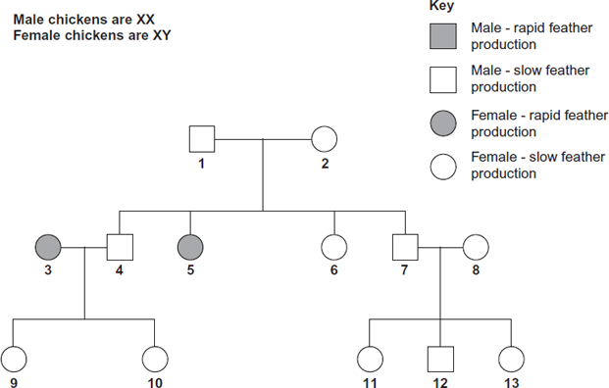

(i) Explain one piece of evidence from the figure which shows that the allele for rapid feather production is recessive.
1. 1, (2) and 5;
Accept: for 1 mark that 1 and 2 have slow (feather production) but produce one offspring with rapid (feather production).
Neutral: any reference to 3 being offspring of 1.
2. 1 must possess / pass on the recessive allele / 1 must be a carrier / heterozygous / if slow (feather production) is recessive all offspring of (1 and 2) would be slow (feather production) / if rapid (feather production) was dominant 1 would have rapid (feather production);
Reject: both parents must be carriers / possess the recessive allele.
Reject: one of the parents (i.e. not specified) must be a carrier / heterozygous.

(ii) Give all the possible genotypes of the following chickens from the figure.
5 = X^{f}Y / X^{f}Y⁻ / f / f- / fY ;
7 = X^{F}X^{f} and X^{F}X^{F} (either way round)
or X^{f}X^{F} and X^{F}X^{F} (either way round)
or X^{F}X^{f}, X^{f}X^{F} and X^{F}X^{F}(in any order);
Note: allow 5 = X^{f}Y, X^{f}Y.
Accept: for both 5 and 7 a different letter than F. However, lower case and capital letter must correspond to that shown in the answer. For example accept 7 = X^{R}X^{r} and X^{R}X^{R}.
Dihybrid Inheritance- General
Outcome:
- Draw dihybrid crosses to predict offspring genotypes and phenotypes.
- Apply knowledge to calculate the predicted ratios of genotypes and phenotype of offspring, using fully labelled diagrams, when supplied with appropriate information.
- Dihybrid crosses involve 2 genes at 2 locus on 2 chromosome.
- Each gene has a different letter.
- You inherit 1 allele for each gene from each parents.
- You inherit 1 letter from each gene.
- You have 2 alleles for each gene.
- For dihybrid crosses you have 4 letters in your genotype.

Dihybrid Inheritance- Non-linked
Definition:
Dihybrid: The inheritance of 2 characteristics controlled by two separate genes inherited independently.

Mendel had observed that the seeds of his pea plants round or wrinkled and whether they were green or yellow. Mendel discovered:
- that the allele for yellow colour was dominant to that for green.
- that the allele for round peas was dominant to the allele for wrinkled peas.

Yellow allele colour = Y green allele colour = y
Round allele shape = R wrinkled allele shape = r

Genotype | Phenotype
RRYY | Round & Yellow
RrYy | Round & Yellow
rrYY | Wrinkled & Yellow
RRyy | Round & Green

State the genotype of:
- A seed heterozygous for colour & homozygous recessive for shape RrYy

- A seed homozygous recessive for colour & homozygous recessive for shape rryy

List the possible gametes produced from the following individuals: -
Genotype | Possible gametes ( in circles)
RRYY | RY
rryy | ry
rrYy | rY ry
RRyy | Ry
Rryy | Ry ry
RrYy | RY Ry rY ry

Mendel crossed homozygous round, yellow seed plants with homozygous wrinkled, green seed plants.
The F₁ offspring all had round yellow seeds (RrYy). When he crossed these individuals the phenotypic ratio of the F₂ offspring was:-

9 round/yellow : 3 round/green : 3 wrinkled/yellow : 1 wrinkled/green

Words to use to fill in the gaps:
Heterozygous Both Dominance
9:3:3:1 ratio is typical of a dihybrid cross between two parents
- who are heterozygous at both gene loci
- and the alleles show complete dominance

Draw a cross to predict the ratio of offspring produced from this F₁ generation (RrYy).

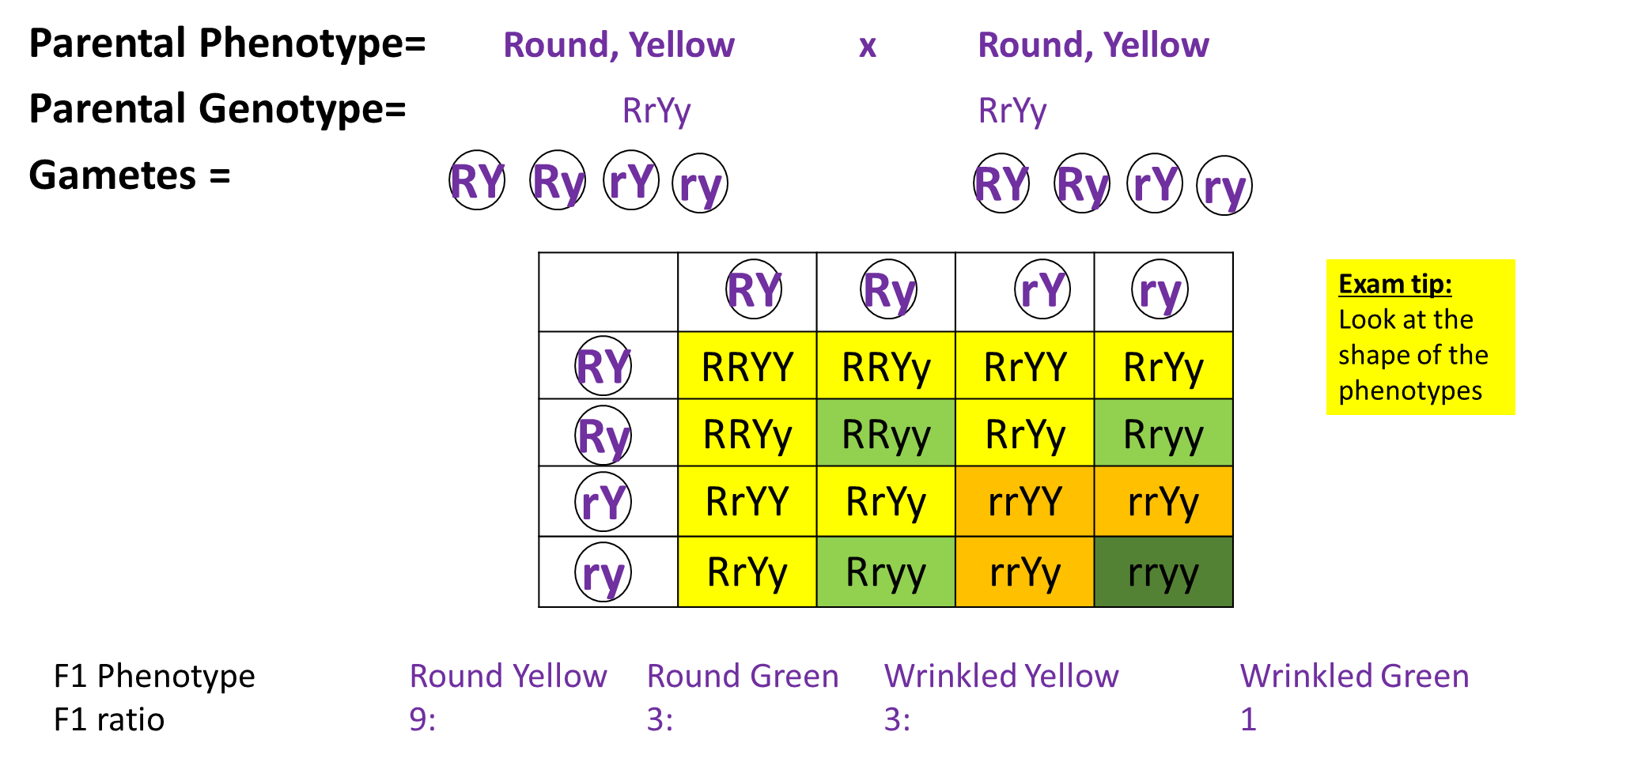

Practice question
Draw a genetic diagram to explain the result of a cross between two parents who are heterozygous for both characteristics.
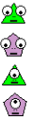
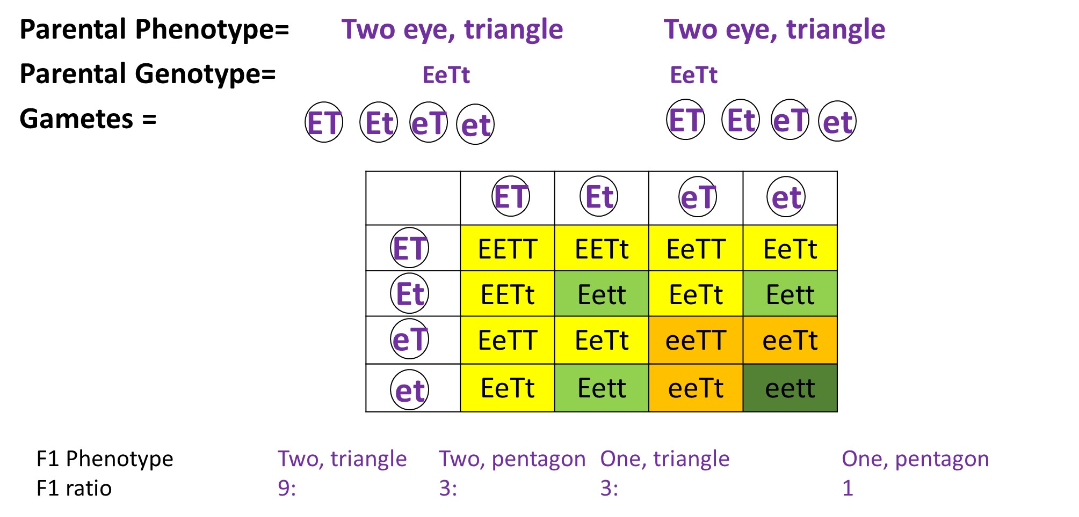

Exam Question:

Q1. In a breed of cattle the H allele for the hornless condition is dominant to the h allele for the horned condition. In the same breed of cattle the two alleles C^{R} (red) and C^{W} (white) control coat colour. When red cattle were crossed with white cattle all the offspring were roan. Roan cattle have a mixture of red and white hairs.
- Explain what is meant by a dominant allele.

is always expressed(in the phenotype) / produces (functional) proteins;

(b) Name the relationship between the two alleles that control coat colour.

codominance

(c) Horned, roan cattle were crossed with white cattle heterozygous for the hornless condition. Compete the genetic diagram to show the ratio of offspring phenotypes you would expect.

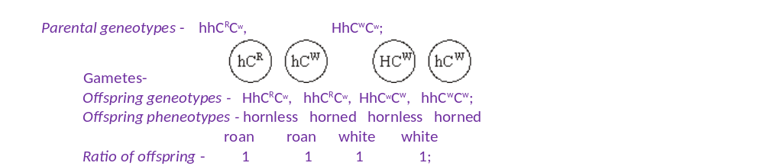

(d) The semen of prize dairy bulls may be collected for in vitro fertilisation. The sperms in the semen can be separated so that all the calves produced are of the same sex. The two kinds of sperms differ by about 3% in DNA content.

(i) Explain what causes the sperms of one kind to have 3% more DNA than sperms of the other kind.

sperm(with more DNA) have X chromosome;
X is larger / has more genes than Y;
- Suggest one reason why farmers would want the calves to be all of the same sex.

female for milk / males for meat / male or female for breeding

Q2. In fruit flies, the allele for grey body, G, is dominant to the allele for ebony body, g, and the allele for normal wings, N, is dominant to the allele for vestigial wings, n. Vestigial-winged flies, heterozygous for grey body colour, were crossed with ebony-bodied flies, heterozygous for normal wings.Complete the genetic diagram to show the genotypes and phenotypes in this cross.

Parental genotypes: Gg nn gg Nn ;
Gamete genotypes Gn gn gN gn ;

 | gN | gn
Gn | Gg Nn  Grey, normal | Gg nn  Grey, vestigial
gn | gg Nn  Ebony, normal | gg nn  Ebony, vestigial

All offspring genotypes correct;

All offspring genotypes correctly derived;

Dihybrid Inheritance- Epistasis
Outcome:
- Draw epistasis crosses to predict offspring genotypes and phenotypes.
- Apply knowledge to calculate the predicted ratios of genotypes and phenotype of offspring, using fully labelled diagrams, when supplied with appropriate information.

Definition:
Epistasis: One gene locus masks or suppresses the expression of another gene locus.

Three types:
- A dominant allele at one locus masks the expression of alleles at the second locus
- Homozygous recessive alleles at one locus masks the expression of alleles at the second
- 2 enzymes coded for by 2 genes act sequentially in a metabolic pathway
ALL epistasis questions will be application questions.

Epistasis type 1: A dominant allele at one locus masks the expression of alleles at the second locus.

Fruit colour in butternut squash.
Inheritance of fruit colour in butternut squash involves interaction between 2 gene loci D/d and E/e. Individuals with dominant D allele have white fruit regardless of the E/e locus. In homozygous dd individuals, E allele produces yellow fruit and ee produces green fruits.

Genotypes | Phenotype
DdEe | White
DDee | White
ddEE | Yellow
ddEe | Yellow
ddee | Green

If 2 double heterozygotes are crossed :
F1 Phenotypic ratio: 12 white : 3 yellow : 1 green
Draw a genetic cross to show this outcome.
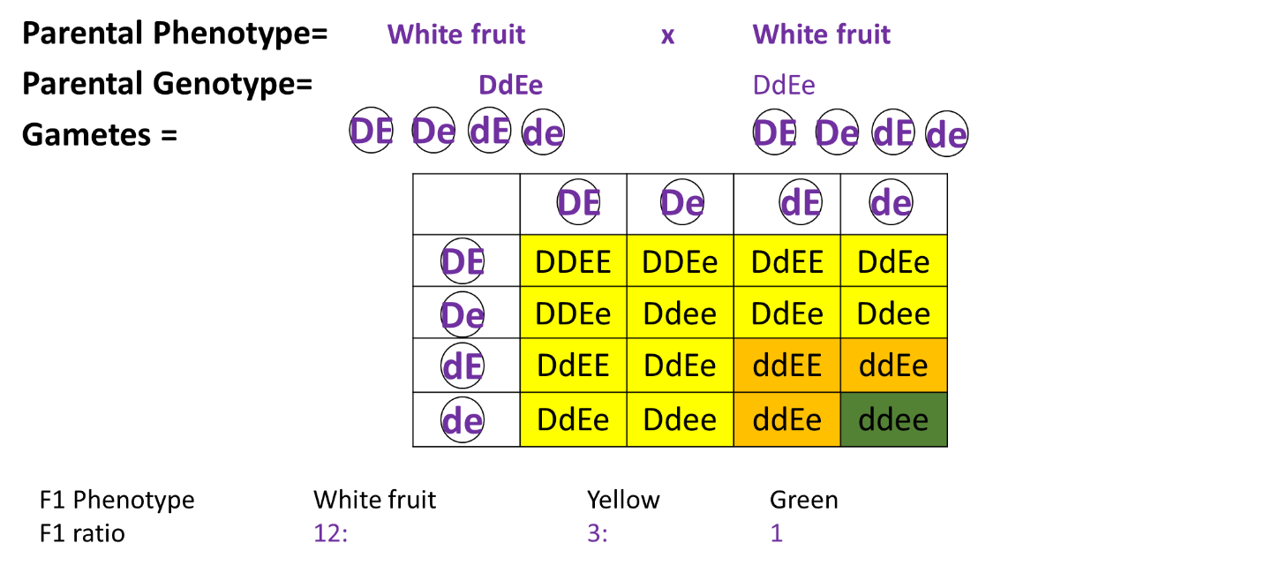
Epistasis type 2: Homozygous recessive alleles at one locus masks the expression of alleles at the second.

Salvia flower colour.
The 2 loci involved are A/a and B/b. The homozygous aa is epistatic to B/b locus. Neither the dominant allele B for purple flowers or b for pink flowers can be expressed in the absence of the dominant A allele, i.e. in the presence of aa (if no colour gene expressed flower = white).

Genotypes | Phenotype
A-B- | Purple
A-bb | Pink
aaB- | White
aabb | White

If 2 double heterozygotes are crossed:
F1 phenotypic ratio: 9 Purple : 3 Pink : 4 White.
Draw a genetic diagram to show this cross.
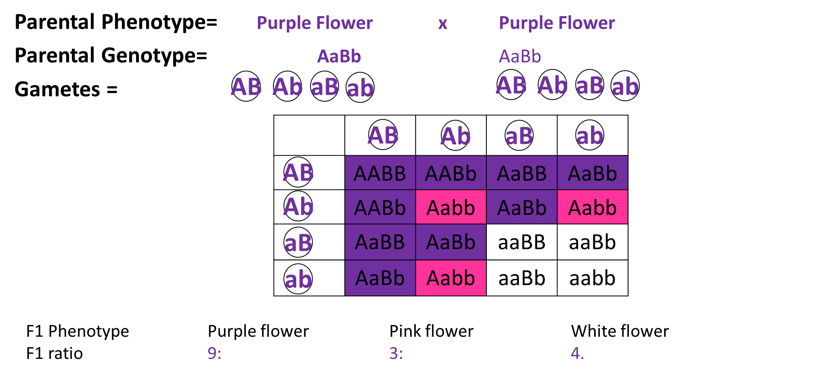

Epistasis type 3: 2 enzymes coded for by 2 genes act sequentially in a metabolic pathway

A plant produces a red pigment in its petals like this:

Enzyme A Enzyme B
Starting molecule intermediate molecule red pigment

Enzymes A and B are coded for by genes A and B.
Dominant alleles code for a functional enzyme.
Recessive alleles code for a non-functioning enzyme.
If either gene is homozygous recessive, that enzyme will be non-functional and the pathway will not be completed, regardless of whether the other enzyme in functioning normally.

Exam Question:
Q1. Coat colour in Labrador dogs is controlled by two different genes. Each gene has a dominant and a recessive allele. The two genes are inherited independently but the effects of the alleles interact to produce three different coat colours. The table gives four genotypes and the phenotypes they produce.

(a) What colour coat would you expect each of the following genotypes to give?

(i) BBEe _Black

(ii) bbEE Chocolate

Genotype | Phenotype
BbEe | black
bbEe | chocolate
Bbee | yellow
bbee | yellow

(b) A BbEe male was crossed with a bbee female. Complete the genetic diagram to show the ratio of offspring you would expect.

Parental phenotypes Black male × Yellow female

Parental genotypes BbEe bbee

Gametes BE, Be, bE, be and be;

Offspring genotypes BbEe, Bbee, bbee, bbEe;

Offspring phenotypes
Ratio of offspring 1 black: 2 yellow: 1 chocolate

Phenotypes (3)
(c) The yellow coat colour of Labrador dogs is due to the presence of the pigment phaeomelanin in the hairs. The black and chocolate coat colours are due to different amounts of another pigment, eumelanin, deposited in these hairs. The more eumelanin there is, the darker the hair. The diagram shows the action of genes E and B in producing the different coat colours.

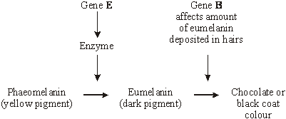

Use this information to explain how

(i) the genotype bbee produces a yellow coat colour;

no enzyme coded for when no dominant / E allele;

phaeomelanin not converted – (remains yellow);

(ii) the genotype BbEe produces a black coat colour.

E allele results in enzyme producing eumelanin;

B allele - more eumelanin deposited in hairs;

Q2. Coat colour in mice is controlled by two genes, each with two alleles. The genes are on different chromosomes. One gene controls the pigment colour. The presence of allele A results in a yellow and black banding pattern on individual hairs, producing an overall grey appearance called agouti. Mice with the genotype aa do not make the yellow pigment and are, therefore, black. The other gene determines whether any pigment is produced. The allele D is required for development of coat colour. Mice with the genotype dd produce no pigment and are called albino.

(a) What type of gene interaction is occurring between the two genes? Explain your answer.

epistasis;
one gene influences the expression of another / description
using example in question;

(b) Give all the possible genotypes for a black mouse.

aaDD, aa Dd (or DDaa, Ddaa);

(c) An agouti mouse of unknown genotype was crossed with an albino mouse of unknown genotype. Their offspring included albino, agouti and black mice.

(i) What was the genotype of the agouti parent?

AaDd (or DdAa)

(ii) Give two possible genotypes for the albino parent.

aadd, Aadd (or ddaa, ddAa)

(iii) Suggest how the actual genotype of the albino parent could be determined.

cross with black individual / genotype aaDd or aaDD;
genotype is Aadd if agouti offspring / genotype is aadd if no
agouti offspring;
Accept;
repeat cross using original parents many times;
ratio is 4 albino : 3 agouti : 1 black if Aa, or 2 albino : 1 agouti :
1 black if aa

Q3. The production of pigment in rabbit fur is controlled by two genes. One gene controls whether any pigment is made. This gene has three alleles. Allele A codes for the production of one form of the enzyme tyrosinase, which converts tyrosine into a black pigment. Allele A^{h} codes for the production of a second form of the enzyme, which becomes inactive at temperatures close to a rabbit’s core body temperature, so only the face, ears, legs and tail are pigmented. A third allele, a, fails to code for a functional tyrosinase. The other gene controls the density of pigment in the fur. This gene has two alleles. Allele B is dominant and results in the production of large amounts of pigment, making the fur black. Allele b results in less pigment, so the fur appears brown.

(a) How do multiple alleles of a gene arise?

mutations;
which are different / at different positions in the gene;

(b) The table shows some genotypes and phenotypes.

Genotype | Phenotype
A–B– | all fur black
aaB– | all fur white (albino)
A^{h}abb | white body fur with brown face, ears, legs and tail (Himalayan)

(i) What do the dashes represent in the genotype of the black rabbit?

either dominant or recessive allele

(ii) Give all the possible genotypes for a Himalayan rabbit with black face, ears, legs and tail.

A^{h}A^{h} BB, A^{h}aBB, A^{h}A^{h} Bb, A^{h}aBb;

(iii) Suggest an explanation for the pigment being present only in the tail, ears, face and legs of a Himalayan rabbit.

temperature lower at extremities;
enzyme active / not denatured;

(c) Using the information given, explain why the phenotypes of rabbits with AABB and AA^{h}BB genotypes are the same.
if allele A is present (normal) tyrosinase / enzyme is produced, so it does
not matter what other allele is present / explanation of why heterozygote is
same phenotype as double dominant in terms of enzyme produced;
phenotype / rabbit is black as both have alleles A and B;

Dihybrid Inheritance- Autosomal Linkage
Outcome:
- Draw autosomal linkage crosses to predict offspring genotypes and phenotypes.
- Apply knowledge to calculate the predicted ratios of genotypes and phenotype of offspring, using fully labelled diagrams, when supplied with appropriate information.
Definition:
Autosomal linkage: Genes are linked if they are inherited on the same chromosome.
This means the alleles are inherited together. The alleles are on the same chromosome so cannot assort independently.
If there is no independent assortment, does this mean there is more or less genetic variation?
Less
Does this mean that the offspring are more likely or less likely to have the same allele combination and so the same phenotype as their parents?
More likely

Linked Unlinked (all previous examples)
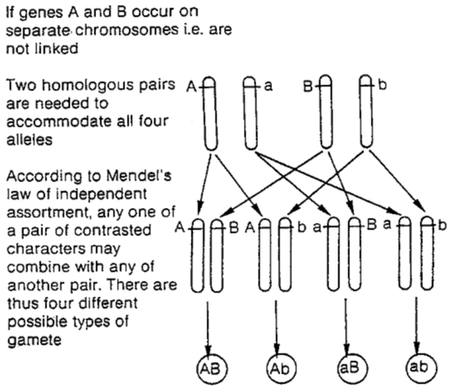
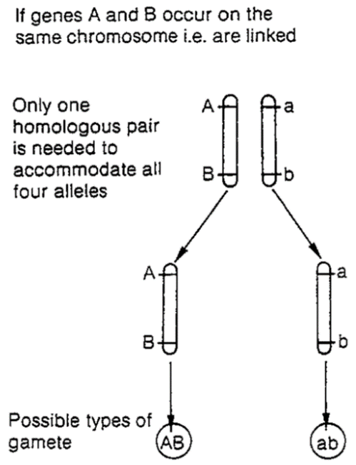

Linked: Only two different gametes produced as no independent assortment even though the parental genotype is AaBb
Explain the effect of linkage:
- Alleles are linked
- State common gametes produced
- Crossing over will produce other gametes
- State other gametes
- Fewer specific individuals will be produced

Draw a cross to show how the ratio changes if linked parents are crossed.

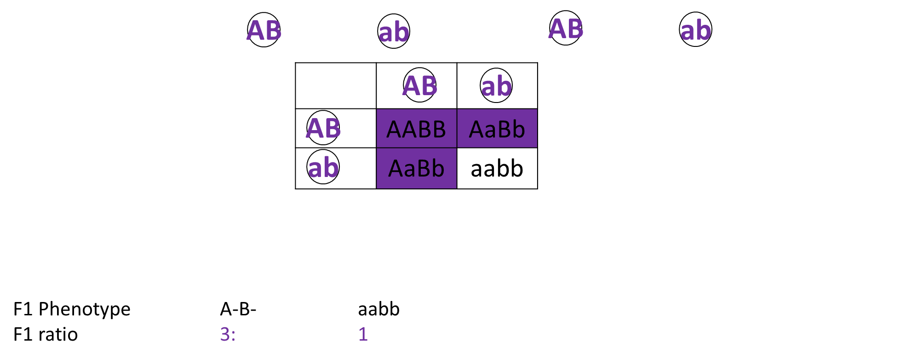

Exam Question:

(a) In fruit flies, the genes for body colour and wing length are linked. Explain what this means. (1)

(Genes / loci) on same chromosome

A scientist investigated linkage between the genes for body colour and wing length.H e carried out crosses between fruit flies with grey bodies and long wings and fruit flies with black bodies and short wings. Figure 1 shows his crosses and the results.

• G represents the dominant allele for grey body and g represents the recessive allele for black body.

• N represents the dominant allele for long wings and n represents the recessive allele for short wings.
 | Phenotype of parents |  | grey body,  long wings |  | × |  | black body,  short wings
Genotype of parents |  | GGNN |  |  |  | ggnn
Genotype of offspring |  | GgNn
Phenotype of offspring |  | all grey body, long wings

These offspring were crossed with flies homozygous for black body and short wings. The scientist’s results are shown in Figure 2.
 | GgNn | crossed with | ggnn
 | Grey body,  long wings | Black body,  short wings | Grey body,  short wings | Black body,  long wings
Number of  offspring | 975 | 963 | 186 | 194

(b) Use your knowledge of gene linkage to explain these results.(LEARN THIS MARKSCHEME!)

1. GN and gn linked;

2. GgNn individual produces mainly GN and gn gametes;

3. Crossing over produces some / few Gn and gN gametes;

4. So few(er) Ggnn and ggNn individuals.

(c) If these genes were not linked, what ratio of phenotypes would the scientist have expected to obtain in the offspring?

(Grey long:grey short:black long:black short) =1:1:1:1

Quick Check! - True or False, then correct the mistakes

- Phenotype describes how the amino acids alleles are expressed.
- In the condition haemophilia, males cannot be carriers. T
- In a co-dominant cross, 3 2 alleles exert an affect on the phenotype.
- Autosomal linkage is when genes are inherited on the same chromosome. T
- Autosomal linkage reduces phenotypic variation. T
- A diploid organism has 2 alleles for each characteristic. T
- The expected ratio from a dihybrid cross, where both parents are heterozygous is 9:3:3:1. T
- Epistasis is where genes on sex chromosomes affect the expression of genes on other chromosomes.
- Multiple alleles is where there are more than two alleles for a gene. T
- Crossing over is when pairs of non-sister chromatids form chiasmata during Prophase 1.

Outcomes:
- Explain what the chi-squared test is used for.
- Set a null hypothesis.
- Use the chi-squared test to compared observed values against those predicted from genetic crosses.
- Interpret chi-squared tests in terms of probability and chance
Chi Squared Test

Definitions
Chi-squared test: Used to compared expected and observed data

Student t- test: Used to compare means from 2 sets of data

Correlation co-efficient: Used to compare data from 2 different variables that have been sampled

What do statistical tests do? These test the probability of the difference in the values is due to chance or if the difference in the values is statistically different.
The Chi Squared Test is used for categorical data.
To test if the difference between the observed and expected data is due to chance or significantly different so due to another factor.

The Null Hypothesis
Definition:
Null hypothesis: The null hypothesis states that there is NO SIGNIFICANT DIFFERENCE between the observed and expected values.
We can then either accept or reject the null hypothesis.

Simple example!
Toss a coin 100 times.
Expected results: Heads 50, tails 50.
Observed results: Heads 55, tails 45
We now use these Expected and Observed figures in the Χ² test.

The formula is:
X² = sum of (O-E)²
E

Class | O  (Observed) | E  (Expected) | O-E | (O-E)² | (O-E)²  E
Heads | 55 | 50 | +5 | 25 | 0.5
Tails | 45 | 50 | -5 | 25 | 0.5
Sum of (=X²) |  |  |  |  | 1.0

What does it mean?
- Work out the degrees of freedom (df)
df = n-1 (where n = no of different phenotypes or phenotypic classes)
Here we have 2 phenotypic classes so df = 2-1 = 1

- Find calculated Value
Use the provided X² table that the examiner will provide. Biologists always compare against the probability of 0.05 (p value).

- Find P (probability) value
Look along the row showing 1 df for our calculated value of 1.0. Between which P values does it fall?

- Compare value and draw conclusion
Is this greater or smaller than our P value of 0.05 (5%) which we always compare against?

If our p-value is greater than 5% or 0.05:
The probability that the difference between the observed and expected values is due to chance is more than 5%
The differences between the observed and expected values is not significant so is due to chance
We accept the null hypothesis.
Always re-state the null hypothesis.

If our p-value is less than 5% or 0.05:
The probability that the difference between the observed and expected values is due to chance is less than 5%
The differences between the observed and expected values is significant so is not due to chance
We reject the null hypothesis.
Another factor must be effecting the results.
Give an example of the other factor.

So in our example, 0.25 and 0.50 are greater than 0.05.What would we write?
The probability that the difference between the observed and expected values is due to chance is more than 5%
The differences between the observed and expected values is not significant so is due to chance
We accept the null hypothesis.
The coin has not been tampered with.

Practice question:
Dihybrid cross with heterozygous parents. The cross was carried out and the actual (observed - O) phenotypes are:-
- 169 round yellow seeds
- 54 round green seeds
- 51 wrinkled yellow seeds
- 14 wrinkled green seed

Total offspring = 288
Expected ratio= 9:3:3:1. Calculate the expected values.
9/16 x 288 =162
3/16 x 288 = 54
3/16 x 288 = 54
1/16 x 288 =18

Write a null hypothesis:
There will be no significant difference between the observed and expected phenotypes of different types of seeds
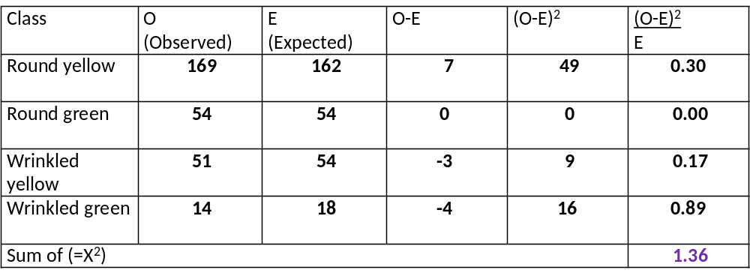

- Work of Degrees of freedom (df) 3

- Find calculate value: 1.36

- Find P value: between 0.50 and 0.75

- Compare values and draw conclusion. What would we write?

The probability that the difference between the observed and expected values is due to chance is more than 5%
The differences between the observed and expected values is not significant so is due to chance
We accept the null hypothesis. There will be no significant difference between the observed and expected phenotypes of different types of seeds

Practice Question:
Curled wings and spineless bristles are both autosomal recessive characteristics in the fruit fly. Pure-breeding fruit flies with straight wings and normal bristles were crossed with pure-breeding flies with curled wings and spineless bristles. The F1 all had straight wings and normal bristles. Virgin female flies from the F1 were then test-crossed (back-crossed) with males showing both recessive characteristics, giving the following results: -
Straight wings, normal bristles 186
Straight wings, spineless bristles 18
Curled wings, normal bristles 16
Curled wings, spineless bristles 180

The ratio of phenotypes expected in a dihybrid test-cross such as this is 1:1:1:1

Use the chi-squared test and the provided table of probabilities to find the probability of results of the test-cross departing significantly by chance from the expected ratio. Show your working.

Class | O  (Observed) | E  (Expected) | O-E | (O-E)² | (O-E)²  E
Straight wings, normal bristles | 186 | 100 | 86 | 7396 | 73.96
Straight wings, spineless bristles | 18 | 100 | -82 | 6724 | 67.24
Curled wings, normal bristles | 16 | 100 | -84 | 7056 | 70.56
Curled wings, spineless bristles | 180 | 100 | 80 | 6400 | 64.00
Sum of (=X²) |  |  |  |  | 275.76

Explain the discrepancy between the E and O results of the cross.
The probability that the difference between the observed and expected values is due to chance is less than 5%
The differences between the observed and expected values is significant so is not due to chance
We reject the null hypothesis.
Another factor must be affecting the results for example the genes may be linked on the same chromosome.

Outcome:
- Define what is meant by the term population
- Describe and explain the mathematical equations used to express allele and genotype frequencies.
- Explain what the Hardy Weinberg principle predicts
- Explain the conditions under which Hardy Weinberg principle applies
- Apply knowledge of Hardy Weinberg to the context of a question to calculate the frequency of an allele or genotype.
Populations (population genetics)

Definitions:
Populations: A group of organisms of the same species that lives in a habitat and can interbreed

Gene pool: All the alleles of all the genes of a population

Allele frequency: The number of times an allele occurs in a gene pool

The Hardy-Weinberg Principle
Definition:
Hardy-Weinberg: Mathematical model, which predicts that allele frequencies will not change from generation to generation

What assumptions do we make when using Hardy-Weinberg?
- Population is very large.
- Mating within the population is random.
- There is no selective advantage for any genotype.
- There is no mutation.
- The population is isolated ie no migration.
In practice, all of these are unlikely to be met.

Allele: p + q = 1
Genotype: p² + 2pq + q² = 1
Allele: p+q=1
- p = frequency of dominant allele
- q =frequency of recessive allele
- Each allele frequency is always between 0 and 1
(0 = no-one has the alleles; 1 = it is the only allele in the population)
Genotype: p² + 2pq + q² = 1

- Sufferers = _q²
- Carriers = 2pq
- Non-sufferes are = _p²
- Four combinations: pp + pq + qp + qq = 1.0
Example:
In a population of 2000, 1 person is a cystic fibrosis sufferer. Work out how many carriers of cystic fibrosis there are in the country.
- Write out both equations.
Allele: p + q = 1
Genotype: p² + 2pq + q² = 1

- Identify which equation you need to use.
Read the information in the questions carefully, look at the graph axis.
If questions use the word allele use equation p + q = 1
If questions use the words phenotype or genotype use equation p² + 2pq + q² = 1
- Work out q²
q² = 1 in 2000; 1/2000 = 0.0005
- Work out q
q = √q² = 0.022
- Work out p
So p = 1 – 0.022 = 0.978
- Complete calculation and check answers.
2pq = 2 x 0.978 x 0.022, 2pq = 0.0430
That means 4.30 in 100 people are carriers. So in a population of 2000 there are:
2000 x 4.30/100 = 86 carriers
Practice question:
PKU is a genetic disease. Homozygous recessives suffer the disease. 1 in 15,000 people are born with PKU. Use the Hardy – Weinberg equation to calculate the frequency of the PKU allele in the population.
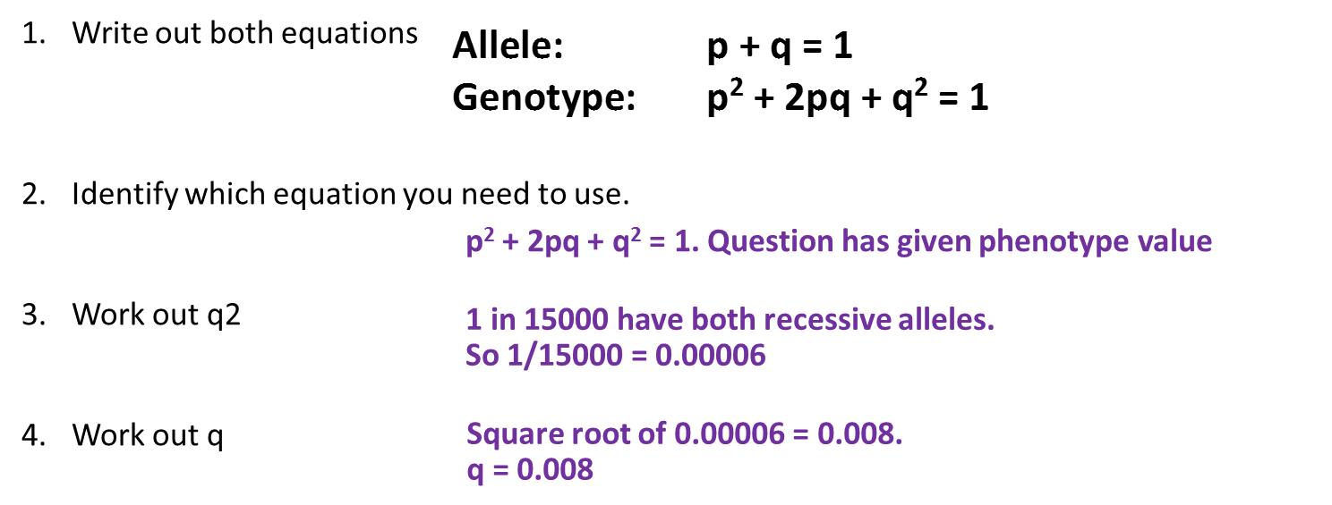
Exam Question:
Q1. Warfarin is a substance which inhibits blood clotting. Rats which eat warfarin are killed due to internal bleeding. Some rats are resistant to warfarin as they have the allele W^{R}. Rats have three possible genotypes:

W^{R}W^{R} resistant to warfarin
W^{R}W^{S} resistant to warfarin
W^{S}W^{S} susceptible (not resistant) to warfarin.

In addition, rats with the genotype W^{R}W^{R} require very large amounts of vitamin K in their diets. If they do not receive this they will die within a few days due to internal bleeding.

(a) How can resistance suddenly appear in an isolated population of rats which has never before been exposed to warfarin?

Mutation / (spontaneous) change in a gene / change in DNA

(b) A population of 240 rats was reared in a laboratory. They were all fed on a diet containing an adequate amount of vitamin K. In this population, 8 rats had the genotype W^{S}W^{S}, 176 had the genotype W^{R}W^{S} and 56 had the genotype W^{R}W^{R}.

(i) Use these figures to calculate the actual frequency of the allele W^{R} in this population. Show your working.

Answer __ Correct answer: 0 / 6;;_(2)

(ii) The diet of the rats was then changed to include only a small amount of vitamin K. The rats were also given warfarin. How many rats out of the population of 240 would be likely to die within a few days?

64_(1)

(c) In a population of wild rats, 51% were resistant to warfarin.

(i) Use the Hardy-Weinberg equation to estimate the percentage of rats in this population which would be heterozygous for warfarin resistance. Show your working.

Correct answer = 42%;;; (only if q² = 0.49) 3 marks
OR 0.42;; 2 marks
OR p + q = 1 / p² + 2pq + q² = 1 / p = 1– 0.7 / q² = 0.49 / q = 0.7;

Answer = 2pq / use of appropriate numbers; 2 marks

Q2. (a) What does the Hardy–Weinberg principle predict?

The frequency / proportion of alleles (of a particular gene);

Will stay constant from one generation to the next / over
generations / no genetic change over time;

Providing no mutation / no selection / population large / population
genetically isolated / mating at random / no migration;

The table shows the frequencies of some alleles in the population of cats in three cities.

City | Frequency of allele
City | White | Non-agouti | Blotched | Long-haired
Athens | 0.001 | 0.72 | 0.25 | 0.50
Paris | 0.011 | 0.71 | 0.78 | 0.24
London | 0.004 | 0.76 | 0.81 | 0.33

(b) White cats are deaf. Would the Hardy–Weinberg principle hold true for white cats? Explain your answer.

White / deaf cats unlikely to survive / selected against;

Will not pass on allele (for deafness / white fur) (to next
generation) / will reduce frequency of allele;

(c) What is the evidence from the table that non-agouti and blotched are alleles of different genes?

In Paris / London frequencies (of these alleles) add up to more than 1;

Can be shown by correct figures to be more than 1
e.g. 0.71 + 0.78 = 1.49
Accept: more than 100%

(d) Hair length in cats is determined by a single gene with two alleles. The allele for long hair (h) is recessive. The allele for short hair (H) is dominant. Use the information in the table and the Hardy–Weinberg equation to estimate the percentage of cats in London that are heterozygous for hair length. Show your working.

Two marks for correct answer of 44(.22);;

One mark for incorrect answer in which p / frequency of H
determined as 0.67 and q / frequency of h as 0.33

OR

Answer given as 0.44(22);

