3.6.3 Skeletal muscles are stimulated to contract by nerves and act as effectors.
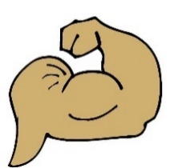NAME: ___________TEACHER BOOKLET_______________
Reflection on Learning outcomes | or | Target
Describe the three types of muscle in the body
Explain the role of skeletal muscle, linked to the role of tendons and joints
Explain why muscles which move bones that form part of a joint, work as antagonistic pairs.
Describe some common antagonistic pairs in the body.
Explain what a neuromuscular junction is and describe and explain the detailed structure of a neuromuscular junction.
Explain how action potentials are transmitted across a neuromuscular junction by release of acetylcholine and compare this to synaptic transmission
Explain how muscle fibres stimulated to contract by one motor neurone act as one motor unit.
Describe the microscopic and gross structure of skeletal muscles.
Explain what is meant by a myofibril and a sarcomere.
Explain the arrangements of actin and myosin in a myofibril linked to isotropic bands and anisotropic bands and the thickness of each type of protein filament.
Interpret diagrams to illustrate the positions of the A and I bands and H zones and Z lines.
Recall how the release of acetylcholine across a neuromuscular junction trigger the release of calcium ions.
Explain the importance of the release of calcium ions in causing a conformational change in tropomyosin
Explain the roles of key molecules myosin, actin, calcium and ATP in causing myofibril contraction in regards to the sliding filament theory
Explain the role of phosphocreatine in some muscle fibres.
Describe the locations of slow and fast skeletal muscle fibres.
Explain differences in the structure and properties of slow and fast skeletal muscle fibres.

Outcome
• Describe the three types of muscle in the body

Structure and Function of the three muscle types

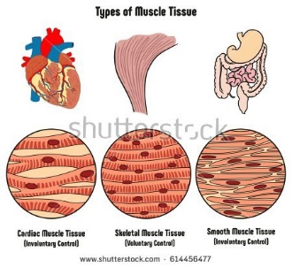
There are three types of muscle
- Skeletal
- Smooth
- Cardiac

Task: Place the correct label under each diagram:


The table below describes the features and properties of each of the muscle tissue types.

 | Skeletal | Smooth | Cardiac
Cells | Long multinucleate fibres | Short and spindle-shaped; one nucleus per cell. | Branched with intercalated discs joining cells at their ends; one nucleus per cell.
Appearance | Striped / striated | Unstriped / unstriated | Striped / striated
Controlled by | Voluntary NS | Involuntary NS | Myogenic;  Involuntary NS - controls RATE of contraction
Distribution | Attached to the skeleton | In tubular organs such as blood vessels, intestines, airways and reproductive system | Heart
Function | Movement and maintenance of posture | Peristalsis, uterine contraction, control diameter of blood vessels/airways, reflexes e.g. pupil size | Contracts to pump blood around heart
Under a microscope | 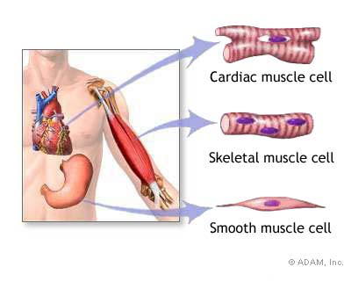
Outcomes:
- Explain the role of skeletal muscle, linked to the role of tendons and joints
- Explain why muscles which move bones that form part of a joint, work as antagonistic pairs
- Describe some common antagonistic pairs in the body.

Antagonistic muscle action
Skeletal muscles are attached to bone by tendons.
Pairs of muscles contract and relax to move bones at the joint.
Bones of the skeleton are incompressible (rigid) so they act as levers, giving the muscles something to pull against.
Definition:
Antagonistic muscle pairs: Muscles that work together in opposition to move bones at joints.

e.g. as one contracts, the other relaxes. This pulls a bone which is part of a joint.
Q: What is the advantage of skeletal muscles being arranged in pairs?
- Muscles can only pull on bones when they contract (shorten).
- Muscles cannot push (lengthen or expand) on bones.
Tasks:
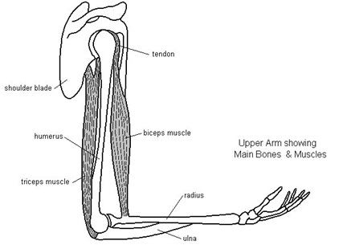
      - Put the following labels on the diagram of the elbow joint:

biceps muscle, triceps muscle, tendon, shoulder blade, radius, ulna, humerus

      - Use different colours for the biceps and triceps.

      - Fill in the gaps below using these words:

relaxes, radius, triceps, contracts, extends, flexes,, biceps

Example of an antagonistic muscle pairs:
- Bicep contracts and the tricep relaxes
- This pulls the radius and bends (flexes) the arm at the elbow.
- Tricep contracts and bicep relaxes
- This pulls the ulna and straightens (extends) the arm at the elbow.

Recap questions:
- What are the three types of muscle in the body and what are their roles?
Smooth muscle – Vasoconstriction in blood vessels, cardiac muscle to pump blood around the heart/body, skeletal muscle for movement and maintaining posture.
- Muscles can pull as they contract, but they cannot push. What would happen to a bone if muscles did not work in antagonistic pairs?
Bone would not be moved as no opposite force
- Evaluate this statement: “In an antagonistic pair of muscles, one muscle contracts whilst the other expands”.
Yes- Muscles do work in antagonistic pairs
No- Muscles cannot expand but can be lengthened by antagonistic movement.
- What other antagonistic pairs are there in the body?
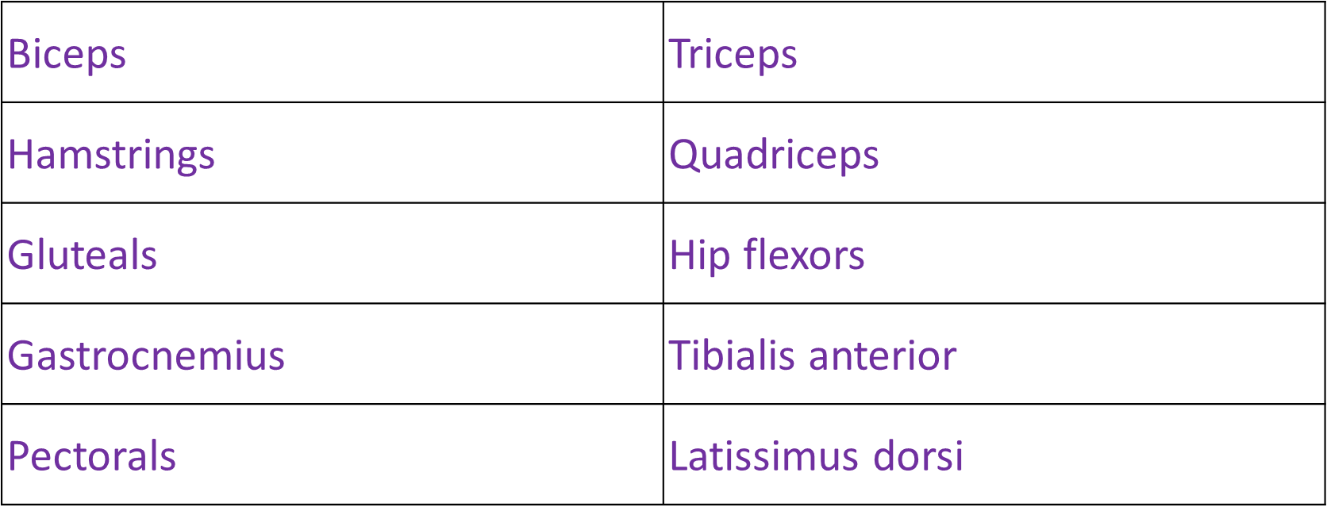
Outcomes:
- Explain what a neuromuscular junction is and describe and explain the detailed structure of a neuromuscular junction.
- Explain transmission across a neuromuscular junction by release of acetylcholine and compare this to synaptic transmission.
- Explain how muscle fibres stimulated to contract by one motor neurone act as a motor unit.

The Neuromuscular Junction
The nervous system controls muscle action as motor neurones are connected to muscle cells. Impulses stimulate contraction.

Definition:
The neuromuscular junction is a synapse between a motor neurone and a skeletal muscle fibre (muscle cell).

Task: Use page 369 in Toole and Toole to answer the following questions:
What would happen if there was only 1 NMJ, and what do many NMJs ensure?
One NMJ: Takes time for a wave of contraction to travel across the muscle, Not all fibres would contract at the same time , Movement slow
Many NMJ’s: Contraction of muscle is rapid and powerful

What is a motor unit?
All the muscle fibres which are supplied by a single motor neurone act together as a single functional unit.
Why are they important – how does this link into the force the muscle exerts?
- Slight force is required - only a few motor units are stimulated
- Large force required - many motor units are stimulated.
Complete the diagram of the neuromuscular junction, using your previous knowledge of synapses
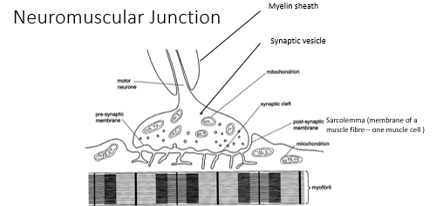
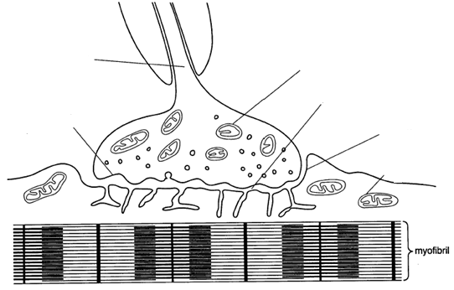

The neuromuscular junction endplate is wavy and has a larger SA than a synapse

Sequence of events at a Neuromuscular Junction
Task: Fill in the gaps below using these words
- Depolarisation of membrane causes Ca ²⁺ channel to open;
- Ca ²⁺ enter by (facilitated) diffusion;
- Causes vesicles to fuse with presynaptic membrane;
- Releasing acetylcholine into synaptic cleft;
- Acetylcholine diffuses across cleft;
- Binds to receptors on the membrane of muscle fibre/sarcolemma ;
- Causes sodium ion channels to open;
- Sodium ions diffuse in causes depolarisation of membrane of muscle fibre/scarclemma and muscle contracts;
- The Ach is hydrolysed by acetylcholinesterase to prevent muscle being overstimulated.
- The choline and ethanoic acid diffuse back into the presynaptic neurone where they are recombined to synthesise Ach using ATP produced by mitochondria.
Compare & contrast synapses and neuromuscular junctions:
Task: In the space below draw a table to compare and contrast synapses and neuromuscular junctions. 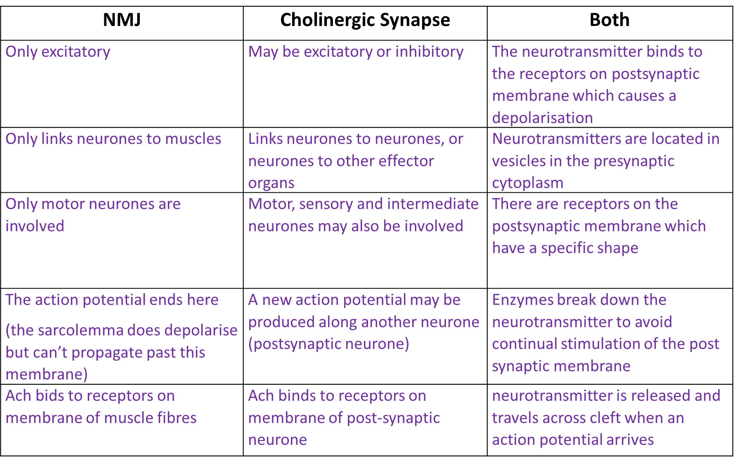
Exam Questions:
Q1. Figure 1 shows the structure of a neuromuscular junction. The vesicles contain acetylcholine.
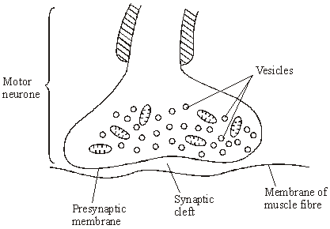
Figure 1
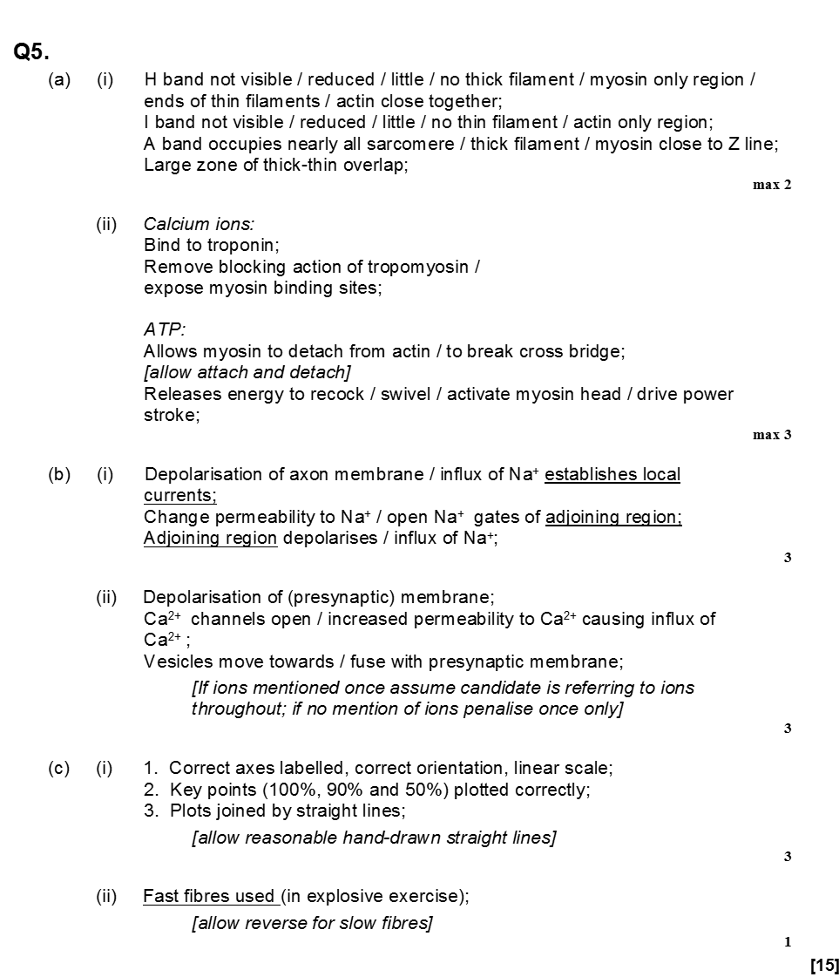
(i) An action potential is generated at the cell body of the motor neurone.
Explain how this action potential passes along the motor neurone to the neuromuscular junction.

(ii) When the action potential arrives at the neuromuscular junction, it results in the secretion of acetylcholine into the synaptic cleft. Explain how.

Q2. Explain why mitochondria are essential for the transmission of impulses across a cholinergic synapse/NMJ cleft. (4)
- Mitochondria produce ATP by aerobic respiration
- Required for sodium – potassium ion pump/maintain conc. grad
- Used in Ach formation
- Used in vesicle formation/ movement
- Used in fusion of vesicles with membrane/exocytosis
- Calcium ions actively transported
Gross structure of skeletal muscles
Outcomes:
- Describe the microscopic and gross structure of skeletal muscles.
- Explain what is meant by a myofibril and a sarcomere.
- Explain the arrangements of actin and myosin in a myofibril linked to isotropic bands and anisotropic bands and the thickness of each type of protein filament.
- Interpret diagrams to illustrate the positions of the A and I bands and H zones and Z lines.

Task: Use text book page 367 and label the diagram below with the following words:

Tendon, whole skeletal muscle, striations, nucleus, muscle fibre, myofibril, bundle of muscle fibres, single muscle fibre, actin, myosin, sarcomere.

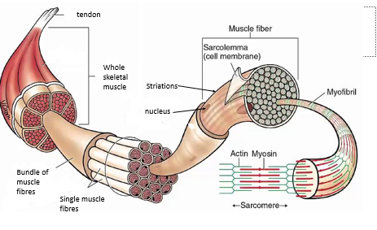

Tasks:
1. Fill in the gaps using the words in the box:
- Individual muscles contain hundreds of MUSCLE FIBRES
- Each muscle fibre is one large cell
- Each cell has many nuclei
- And contain many mitochondria, glycogen granules, and specialised smooth ER called sarcoplasmic reticulum
- The cell membrane is called the sarcolemma.
- The cytoplasm is called the sarcoplasm
- In each fibre there are many MYOFIBRILS
- These contain the contractile units called SARCOMERES
- In each myofibril there are protein FILAMENTS made of actin & myosin

2.Put the following in the correct order from smallest to largest: Myofibril, Sarcomere, Whole muscle Muscle fibre
whole muscle muscle fibre myofibril sarcomere

Microscopic structure of skeletal muscle

Myofibrils are made of two types of protein filaments.
Thin filaments are made up of three proteins:
- Actin - there are two strands of actin coiled around each other like a string of beads
- Tropomyosin - a long thin, molecule, which lies in a groove between the two chains of actin molecules

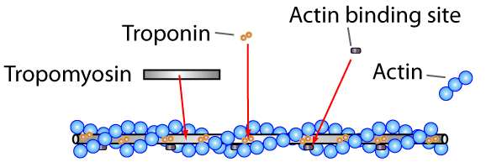

Thick filaments are made up of myosin protein:
- The filament is made from many myosin molecules lying side by side.
- Each myosin molecule has two heads which point out to form cross bridges.
- The tails of the myosin meet in the middle at the M line.

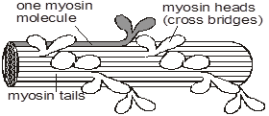

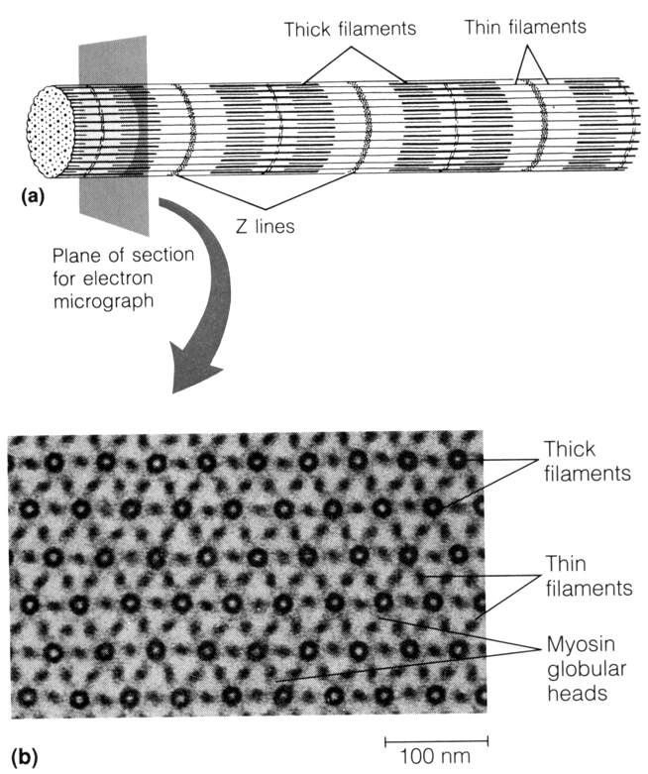
The thin and the thick filaments give the myofibril a striped appearance with dark and light bands. These bands are caused by the presence or absence of actin and myosin filaments.

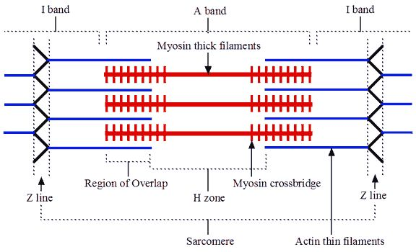
The arrangement of thick and thin filaments in muscle myofibril
Tasks:
M line
- Colour in the thick myosin filaments and the thin actin filaments on the diagram above.
- Add the M line
- Using the diagram above, put the following labels on the diagram of the myofibril below and then describe what each label represents.
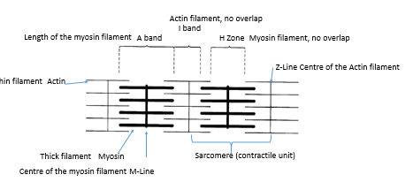
Z line (x3), M line (x2), Sarcomere (x2), A band, I band, H zone

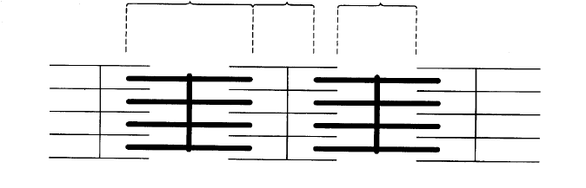

- Describe the composition of the two types of bands:
- Light bands / I, or isotropic, bands are produced by –
Only thin filaments (Actin) no overlap of Myosin (thick) and Actin (thin).

- Dark bands / A, or anisotropic, bands are produced by -
Overlap between Myosin (thick) and Actin (thin) filaments.
Excluding H zone which isn’t as dark as only myosin is present

- Consolidate your knowledge by filling in the blanks below:
Using these words: Dark A, Actin, Myosin, Z, Light I, Sarcomere, H, A, Do not.

- The thick myosin filaments produce the dark A band
- The thin actin filaments extend in each direction from the Z line
- Where the thin do not overlap the thick filaments, the light I band is created
- The H zone is that portion of the A band where the thick and thin filaments do not overlap
- The entire array of thick and thin filaments between the Z lines, is called a sarcomere
- The sarcomere is the CONTRACTILE UNIT of the muscle fibre

- Fully label the diagram below:

Exam tip: You must also be able to recognise the bands and zones on an electron micrograph of a myofibril

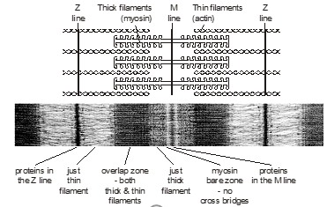
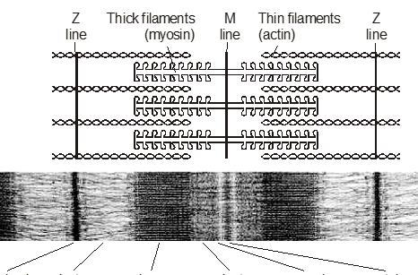

- Fill in the diagrams below to show the protein filaments present in the cross sections of different parts of a sarcomere. The H zone has been done for you. Justify your answer.
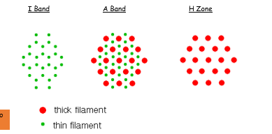
A band

Muscle contraction
Outcomes:
- Recall how the release of acetylcholine across neuromuscular junctions, triggers the release of calcium ions.
- Explain the importance of the release of calcium ions in causing a conformational change in tropomyosin
- Explain the roles of key molecules myosin, actin, calcium and ATP in causing myofibril contraction in regards to the sliding filament theory
Muscles contraction can be explained by the sliding filament theory. The actin and myosin filaments slide over one another to shorten the sarcomere and make the myofibrils in the muscle fibre (one muscle cell) contract. The filaments themselves DO NOT change length/contract.

Role of actin and myosin filaments in muscle contraction
Actin filaments:
- There are myosin binding sites on the actin filaments.
- In the relaxed muscle, these binding sites on actin are blocked by tropomyosin.
Myosin filaments:
- Myosin heads are hinged and can bend backwards and forwards.
- Myosin heads can bind to myosin binding site on actin and pull the actin filament past the myosin filament using energy from ATP.
- Myosin heads can detach from actin and re-sets, moving further along the actin filament using energy from ATP.

Events of muscle contraction - The sliding filament theory
- Action potential from motor neurone depolarises the sarcolemma
- Depolarisation travels deep into the muscle fibre through T-tubules
- Calcium ion channels on sarcoplasmic reticulum open
- Calcium ions (Ca²⁺) diffuse into the myofibril from sarcoplasmic reticulum
- Ca²⁺ bind to tropomyosin on actin filament causing it to change shape and move away
- Exposes the myosin binding site on the actin
- Myosin heads attach to binding site on actin forming a cross-bridge
- Hydrolysis of ATP on the myosin head causes myosin head to bend
- Pulling actin filament past the myosin filament
- Attachment of a new ATP molecule to each myosin head causes myosin head to detach from the binding site on actin and reset
- Moving further along the actin filament to form new cross-bridges

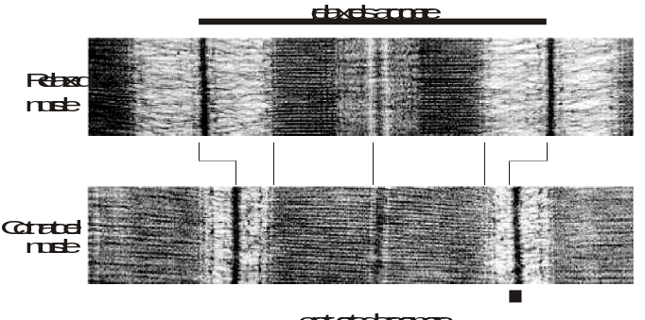
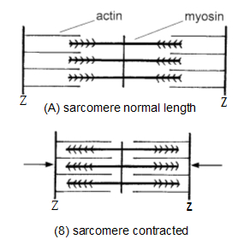
This mechanism causes the sarcomere to shorten in length, therefore causing the myofibril to shorten and the muscle fibre to contract. This is shown in the diagram and electron micrograph below:
Contracted sarcomere
Relaxed sarcomere
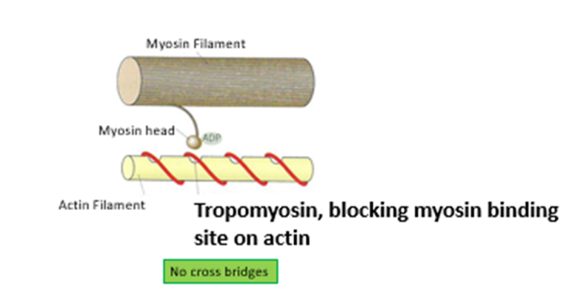
Task: Consolidate your understanding on the sliding filament theory by adding annotations to the diagram below:
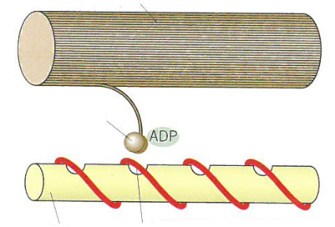
1

2
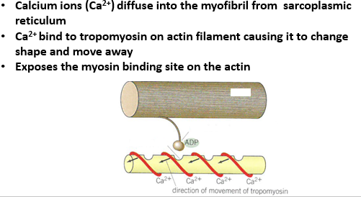
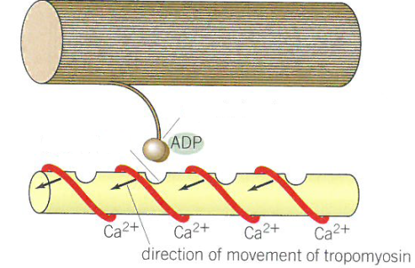

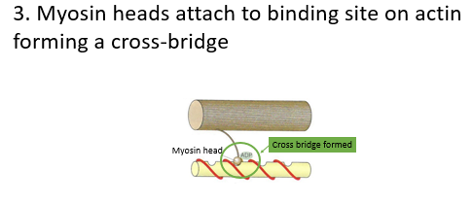
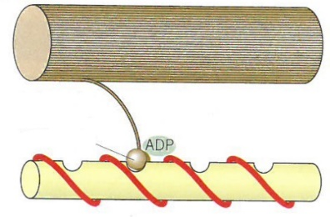
3

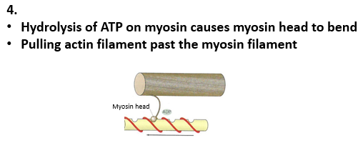
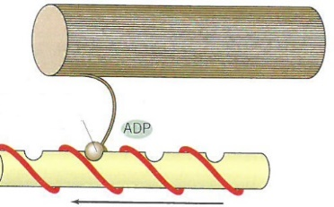
4

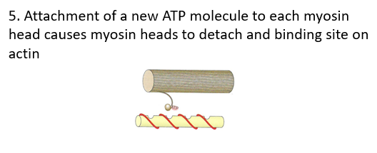
5
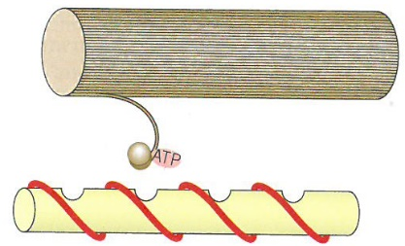

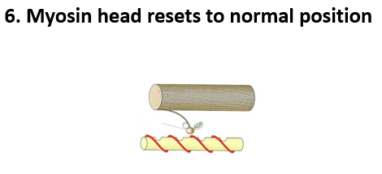
6
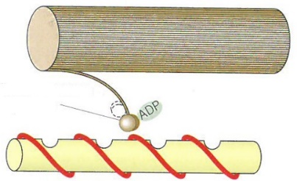

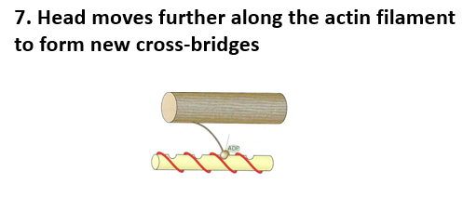
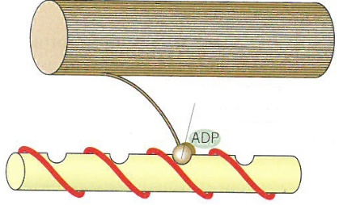
7

What happens to the bands/zones when the sarcomere contracts?
Task: Fill in the gaps below using the terms:
Stays the same length, becomes narrower, shorter, remain the same length, overlap, closer together
In a contracted sarcomere:
- The light I band becomes narrower
- The dark A band stays the same length
- The H zone becomes narrower
- The Z lines move closer together - there is more overlap of thick and thin filaments
- Therefore, length of the sarcomere is shorter
- The filaments remain the same length

How does a muscle relax?
- Ca²⁺ actively transported back into sarcoplasmic reticulum
- Using energy from hydrolysis of ATP
- Tropomyosin can now block myosin binding site on actin filaments again
- Myosin heads now unable to bind to actin filaments and contraction stops
- Muscle relaxes
- Force from the antagonistic muscle can pull the actin filaments out from between myosin filaments.
- Sarcomere lengthens, causing the myofibril to lengthen, causing the muscle fibre (one cell) to lengthen.

Exam Questions

Q3.
(a) Describe the roles of calcium ions and ATP in the contraction of a myofibril.
1. Calcium ions diffuse into myofibrils from (sarcoplasmic) reticulum;
2. (Calcium ions) cause movement of tropomyosin (on actin);
3. (This movement causes) exposure of the binding sites on the actin;
4. Myosin heads attach to binding sites on actin;
5. Hydrolysis of ATP (on myosin heads) causes myosin heads to bend;
6. (Bending) pulling actin molecules;
7. Attachment of a new ATP molecule to each myosin head causes myosin heads to detach (from actin sites).

(b) ATP is an energy source used in many cell processes. Give two ways in which ATP is a suitable energy source for cells to use.
1. Releases relatively small amount of energy / little energy lost as heat;
Key concept is that little danger of thermal death of cells
2. Releases energy instantaneously;
Key concept is that energy is readily available
3. Phosphorylates other compounds, making them more reactive;
4. Can be rapidly re-synthesised;
5. Is not lost from / does not leave cells
Q4.
(a) A sarcomere is made up of different molecules.
Complete the table by naming the molecule that carries out the function described.
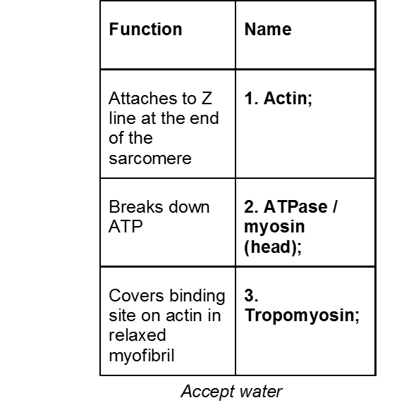

(3)
(b) The diagram shows the arrangement of actin and myosin in a sarcomere.
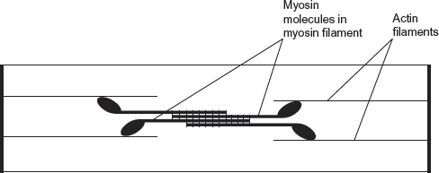
One form of muscle disease is caused by a mutated allele of a gene. This leads to production of myosin molecules that are unable to bind to other myosin molecules.
If myosin molecules are unable to bind to other myosin molecules, this prevents muscle contraction.
Use the diagram and your knowledge of how muscles contract to suggest why.
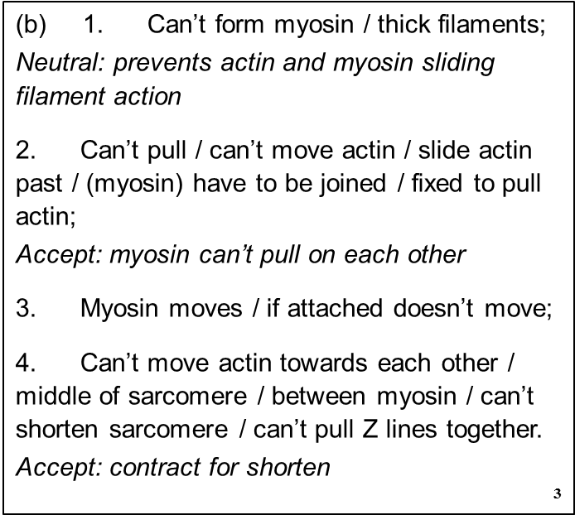

(3)

Q5. (a) Figure 1 shows part of a myofibril from skeletal muscle.
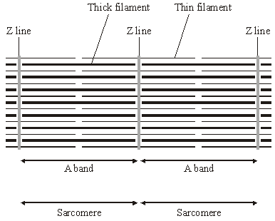
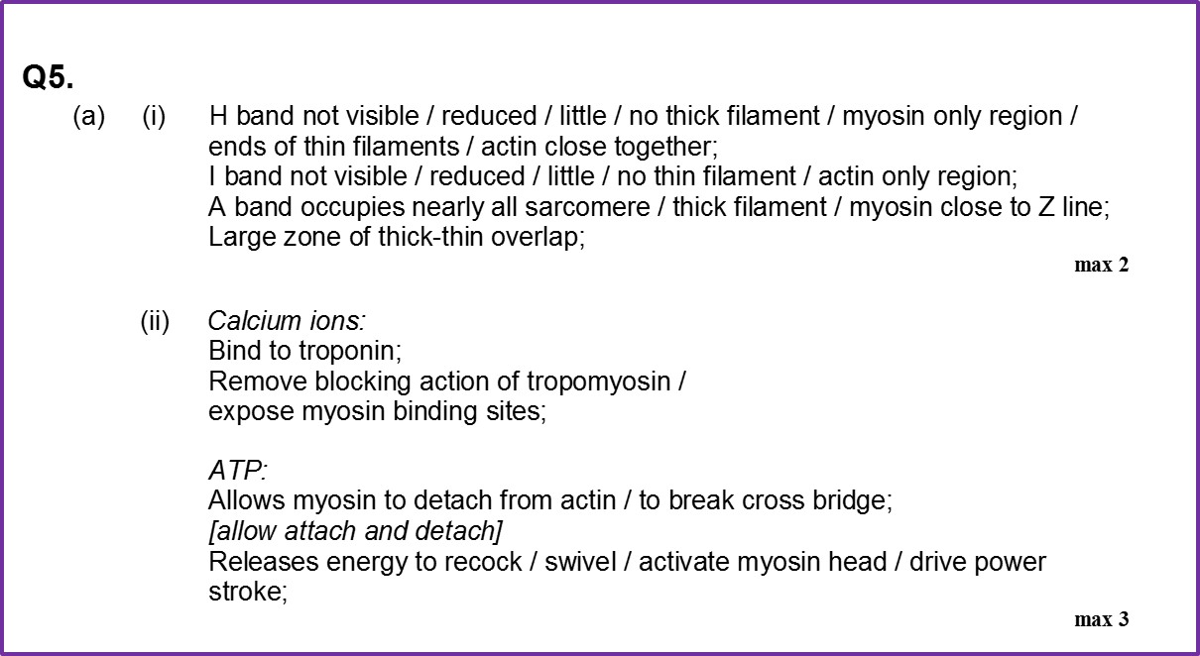
(i) Describe two features, visible in the diagram, which show that the myofibril is contracted.
1.
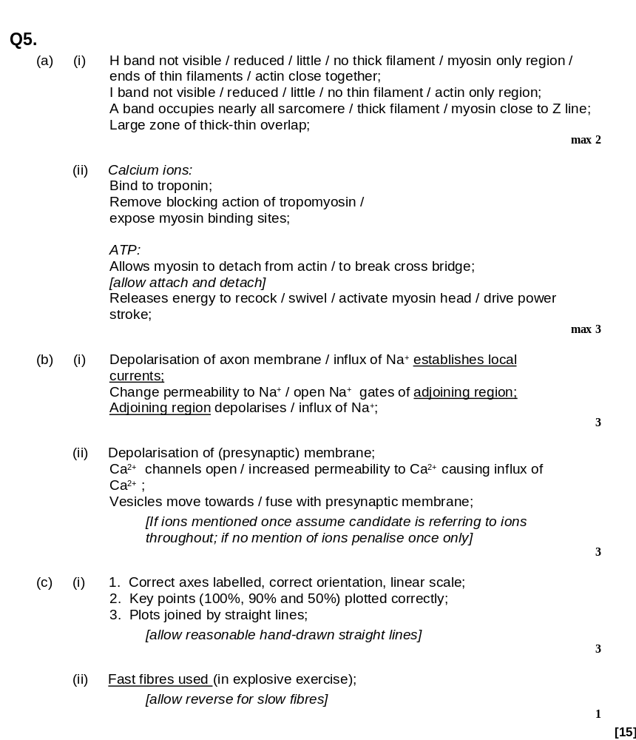
(ii) Explain the role of calcium ions and ATP in bringing about contraction of a muscle fibre.

Outcomes:
• Describe the locations of slow and fast skeletal muscle fibres
• Explain differences in the structure of slow and fast skeletal muscle fibres
• Explain differences in the properties of slow and fast skeletal muscle fibres.
• Explain the role of phosphocreatine in some muscle fibres.

Types of Muscle Fibres
There are 2 types of muscle fibres (one muscle cell):
- Slow muscle fibres (Slow-twitch)
- Fats muscle fibres (Fast-twitch)
Slow-twitch | Fast-twitch
Contract slower (110ms) | Contract more rapidly (50ms)
Contractions less powerful | Contractions more powerful
Adapted for aerobic respiration by avoiding build-up of lactic acid (fatigue resistant) | Easily fatigued due to lactic acid build up
Adapted to work over a longer period e.g. maintaining posture | Adapted to a short period of intense exercise e.g. sprinting, eye movement
Most common in calf muscle | More common in biceps
Rich supply of blood vessels to deliver high conc of O2 & glucose for aerobic respiration (lower conc of anaerobic enzymes) | High concentration of enzymes for anaerobic respiration to provide ATP rapidly (lower number of capillaries)
Large store of myoglobin to store O₂ (makes them red in colour) | Small store of myoglobin (makes them pale in colour)
Numerous mitochondria – produce ATP | Store of phosphocreatine to rapidly generate ATP from ADP in anaerobic conditions (low mitochondria count)
Task: Complete the table below on the properties of the 2 types of muscle using page 369 in Toole and Toole.

- Suggest why there is a high concentration of glycogen required in fast muscle fibres?
To provode glucose for anaerobic repiration

- Suggest why is a rich supply of blood vessels required in slow muscle fibres?
To supply high concs of O2
To give a shorter diffusion pathway for O2
To provide a good glucose supply as there is little stored glycogen present.
Therefore give a high rate of aerobic respiration
And prevent build up of lactic acid
Maintenance of the ATP Supply
ATP needs to be regenerated for continued muscle contraction. In very active muscles the demand for ATP and oxygen (O₂) is higher than the rate blood can supply O₂. Therefore, there are different ways of supplying ATP.
The energy is needed for:
- Movement of myosin heads (bending, detaching and resetting)
- Reabsorption of calcium ions into sarcoplasmic reticulum by active transport
Task: Match the three mechanisms below to their description;
Aerobic respiration, Anaerobic respiration, Phosphocreatine (cannot enter muscle)
Mechanism | Description
Anaerobic respiration | ATP is provided by glycolysis. Very quick supply, but produces lactic acid (toxic).
Phosphocreatine | Regenerates ATP. Phosphate group from phosphocreatine combines with ADP to form ATP.
Aerobic respiration | Respiration of pyruvate in mitochondria. Dependent on oxygen supply and respiratory substrate availability

Phosphocreatine, also known as creatine phosphate (CP or PCr), is a phosphorylated creatine molecule that is stored in skeletal muscle cells and brain cells. It can be used to regenerate ATP very rapidly but runs out after a few seconds, so is used only during short intense exercise.
ADP + PCr (phosphocreatine) ATP + Cr (creatine)
Phosphocreatine generates ATP quickly by adding a phosphate to a molecule of ADP released by the contracting muscle.

Exam Questions
Q6. Scientists investigated the effect of regular exercise on skeletal muscle fibres in mice. The scientists compared the muscle fibres of mice after six weeks of regular exercise (trained mice) with those of mice that had not exercised (control mice). The scientists stained the muscle fibres from both sets of mice to show succinic acid dehydrogenase activity. The darker the stain the greater the succinic acid dehydrogenase activity.
The diagram below shows a typical set of results they obtained.
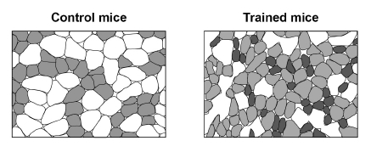
(a) Succinic acid dehydrogenase is an enzyme used in the Krebs cycle.
Suggest one reason for the difference in the staining between the muscle fibres of the control mice and the trained mice.
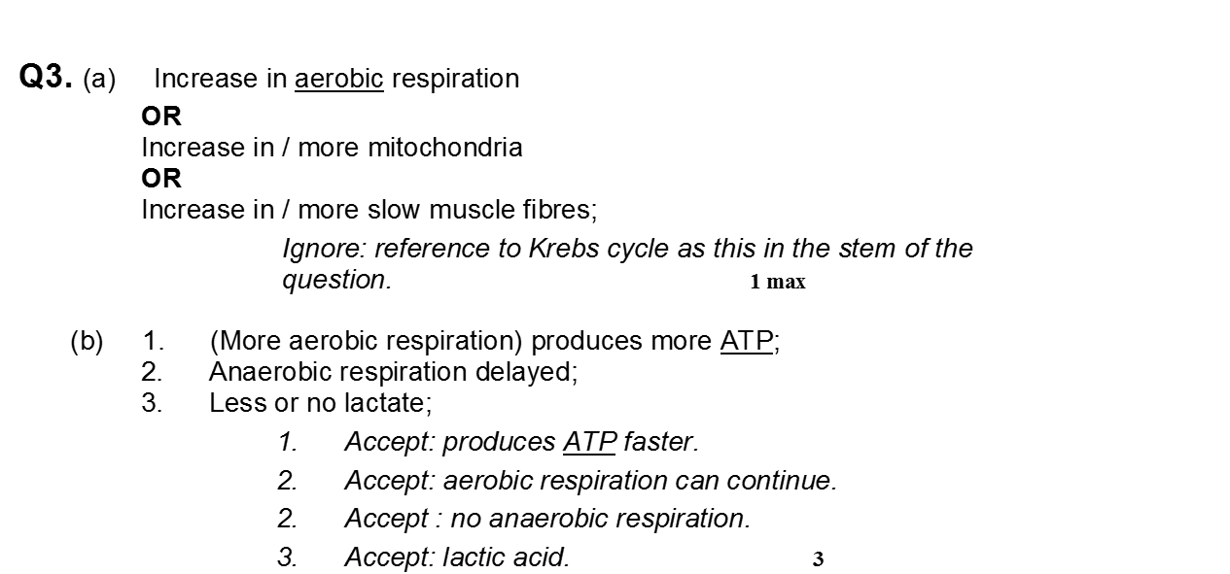
___________________________________________________________________
___________________________________________________________________
(1)
(b) The scientists then compared the length of time that the control mice and the trained mice could carry out prolonged exercise. The trained mice were able to exercise for a longer time period than control mice.
Explain why.

(c) The scientists determined the mean diameter of muscle fibres in trained mice using an optical microscope to examine sections of muscle tissue. The circular area (πr²) of one field of view was 1.25 mm². The diameter of this area was equal to the diameter of 15 muscle fibres.
Using this information, calculate the mean diameter in μm (micrometres) of muscle fibres in this section of tissue.
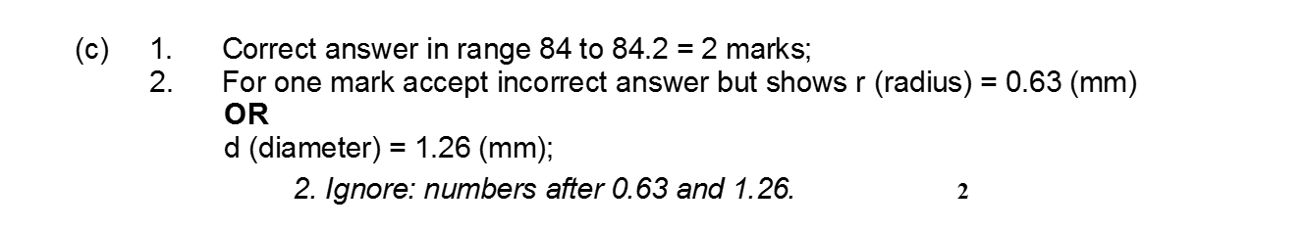
Answer ____________________ μm
(2)
(d) The scientists also compared the diameter of samples of muscle fibres taken from young mice and adult mice.
Some of their results are shown in the graph.
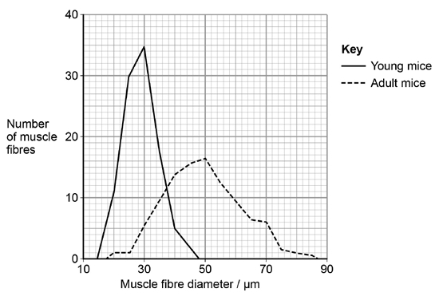
Describe two differences between these samples of muscle fibres.
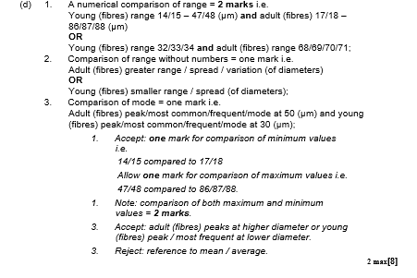
1.

(2) (Total 8 marks)

Q7. Researchers investigated whether the blood supply to slow and fast muscle fibres in a muscle changes with age. They used diaphragms taken from hamsters (Mesocricetus auratus). The diaphragm is in constant use for breathing. They took diaphragms from groups of young, adult and old hamsters.
They removed the diaphragm from each animal and took a sample of muscle tissue.They examined it under an optical (light) microscope. For each sample they selected several fields of view at random. In each field of view, they then counted the number of capillaries associated with each type of muscle fibre.
This allowed the researchers to calculate the mean number of capillaries for each type of muscle fibre, for each age group.
The table below shows the researchers’ results which include standard deviation (SD).

Hamster  age group | Number of  hamsters in  group | Mean number of capillaries associated  with each type of muscle fibre
Hamster  age group | Number of  hamsters in  group | Slow fibres  (± SD) | Fast fibres  (± SD)
Young | 9 | 3.4  (±0.8) | 4.0  (±0.8)
Adult | 10 | 4.7  (±0.2) | 6.3  (±0.4)
Old | 8 | 4.6  (±0.9) | 6.8  (±0.6)
(a) Give four precautions that the researchers took to make their calculations of mean number of capillaries per fibre reliable.
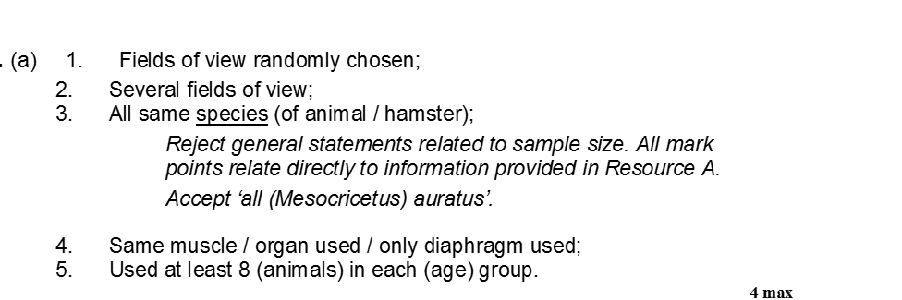

(b) The researchers examined the muscle of an animal in the old age group. They found one field of view containing only slow muscle fibres. They counted 69 capillaries in this field of view.
(i) Use a calculation to estimate how many slow muscle fibres were visible in this field of view. Show your working.
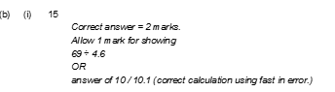

Number of slow muscle fibres = ____________________
(2)
(ii) The actual number of slow muscle fibres in the field of view was not the same as the number you calculated in question (i).
Give one reason why.
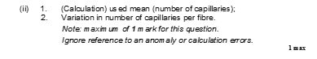
(c) A student read the report of the researchers’ investigation. She thought that the investigation was unethical but that a conclusion could still be made.
(i) Suggest why she thought the investigation was unethical.
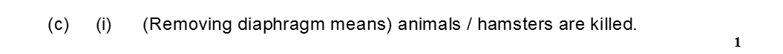
______________________________________________________________
(1)
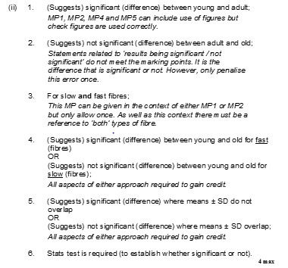
(ii) She concluded that age had a significant effect on the mean number of capillaries per fibre.
(3)

Q8. Between the ages of 20 and 50, 10% of total muscle mass is lost. Between the ages of 50 and 80, a further 40% of the original total muscle mass is lost. Most of the muscle lost consists of fast fibres.
(i) Plot a graph on the grid below to show the percentage of muscle mass remaining between the ages of 20 and 80. Assume that the rate of muscle loss in each age range is constant.
 (3)
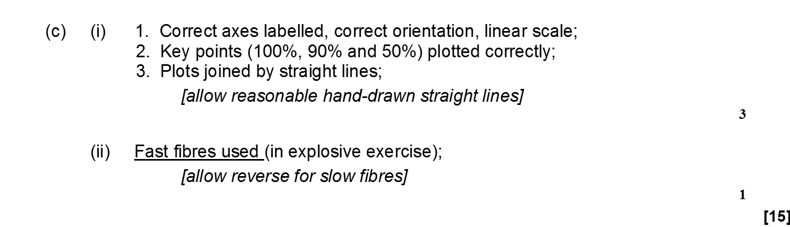
(ii) Explain why explosive exercises, such as sprinting and weightlifting, will be more affected by this muscle loss than aerobic exercises, such as jogging.

