3.6.2: Nervous coordination
Name: ___TEACHER_____________________________
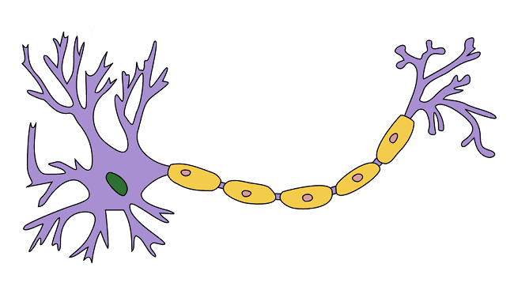
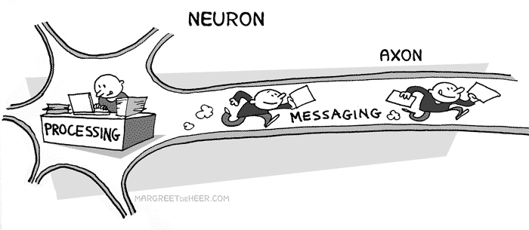

Reflection on Learning objectives | or | Target
Describe and explain the structure of a myelinated motor neurone and nodes of Ranvier

Explain what is meant by a resting potential and describe the events in generating a resting potential

Explain what is meant by an action potential and describe the events in generating an action potential

Apply knowledge to explain oscilloscope traces
Explain what is meant by the all or nothing principle.

Explain what is meant by and importance of the refractory period and why action potentials are prevented.

Explain how action potentials pass along unmyelinated neurones
Explain how action potentials pass along myelinated neurones by saltatory conduction, and why this is faster than conductance along unmyelinated neurones.

Explain the factors which affect the speed of nerve impulse conductance.

Explain the functions of synapses
Describe and explain the detailed structure of a synapse including the sequence of events

Explain how synaptic transmission allows for unidirectionality, temporal and spatial summation, and inhibition by inhibitory synapses. Analyse information provided to predict and explain the effects of specific drugs on a synapse.

Comparison table
Hormonal system | Nervous system
Communication using chemicals (hormones) | Communication using nerve impulses
Transmissions in the blood | Transmissions by neurones
Transmission is relatively slow | Transmissions is very rapid
Hormones travel to all areas of the body but only target cells respond | Nerve impulses travel to specific part of the body
Response is wide spread | Response is localised
Response is slow | Response is rapid
Response is long-lasting | Response is short-lived
Effect may be permanent and irreversible | Effect usually temporary and reversible.

Outcome:
- Describe and explain the structure of a myelinated motor neurone and nodes of Ranvier

Neurone Structure:
Neurones are specialised cells that allow communication between different parts of the body as nervous impulses

Definition:
EXCITABLE: Can detect and respond to stimuli
CONDUCTIVE: Can transmit impulses or action potentials
There are 3 types of neurone.
SENSORY: Impulse from receptor to CNS
Exam Note: A nerve is made up of a collection of neurones joined together with connective tissue.
You do not need to be able to label a neurone in your exam

INTERMEDIATE: Impulse between neurones
MOTOR: Impulse from CNS to effector.
Labels for diagrams (some words will be used more than once)
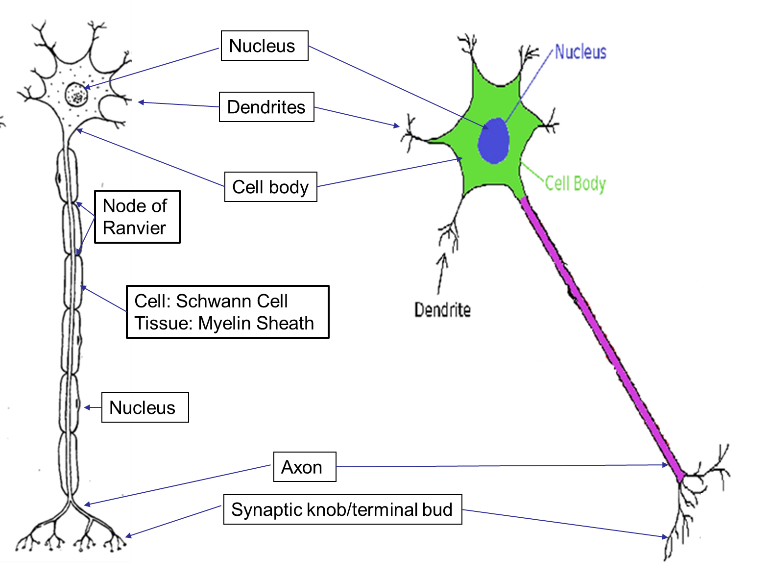

Describe the difference between a myelinated and unmyelinated neurone.
- Myelinated has Schwann cells/myelin sheath wrapped around the axon, the non-myelinated doesn’t.
- Myelinated has Nodes of Ranvier, non-myelinated doesn’t

Myelin Sheath Structure:
Schwann cells:  - Surrounds the axon  - Form the myelin sheath | Myelin Sheath:  - Forms covering of axon  - Rich in lipid known as myelin.

Outcome:
- Explain what is meant by a resting potential and explain the events in generating a resting potential

Neurones rapidly transmit electrical impulses.
Definition:
Electrical impulses: A brief change in the distribution of electrical charges across the axon membrane of neurones.
The change in charge is caused by the movement of Na⁺ and K⁺ ions across the axon membrane.
To establish the correct concentration of these ions the neurone produces a RESTING POTENTIAL.
Resting Potential
Definition:
The difference in electrical charge maintained across the membrane of an axon of a neurone when not stimulated.

Producing a Resting Potential: http://sites.sinauer.com/neuroscience5e/animations02.01.html
- Sodium-potassium pump actively pumps 3x Na⁺ ions out of the cell
- 2x K⁺ ion into the cell at the same time requires ATP.
- Some K⁺ diffuses back out of neurone through open K⁺ channels. The membrane is more permeable to K⁺/less permeable to Na⁺ ions.
- More + ions are outside the cell then inside the cell.
- This sets up an electrochemical gradient.
- The potential difference outside the cell compared to inside the cell is -65mV
- The membrane is polarised

Revision poster: Add information to the diagram below.

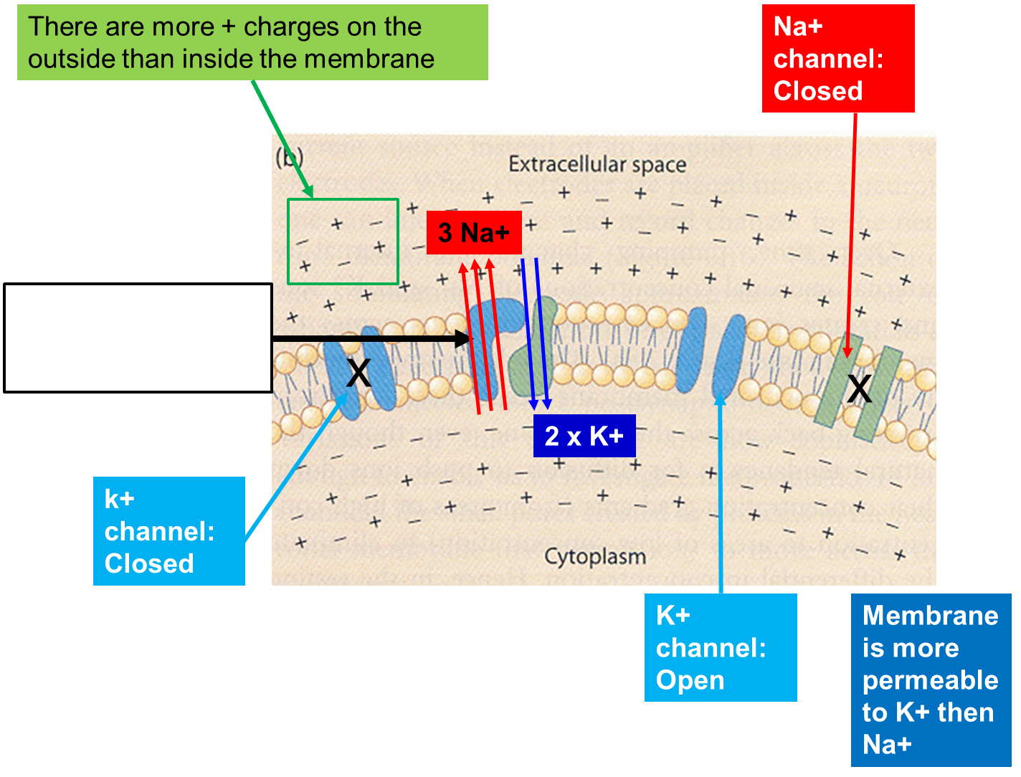

Exam Questions

Q1. The resting potential of a neurone is maintained by the unequal distribution of ions inside and outside the plasma membrane. The diagram shows the plasma membrane of a neurone and the three different proteins that are involved in maintaining the resting potential.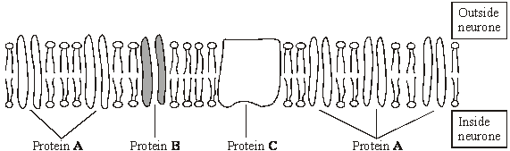

(a) Protein C requires ATP to function. Describe the role of protein C.
Transports Na⁺ and K⁺ ;
By active transport / pump / against concentration gradient;
Restores ion balance after an action potential;
[reject K⁺ out and Na⁺ in

(b) (i) Proteins A and B differ from each other. Explain why different proteins are required for the diffusion of different ions through the membrane.
each protein has a specific tertiary structure / shape;
because the ions have different sizes / shape / charge;
[reject receptors binding]

(ii) The plasma membrane of the neurone is more permeable to potassium ions than to sodium ions. Give the evidence from the diagram that supports this observation.
fewer protein B molecules, which transport sodium ions / more protein A molecules, which transport potassium ions
Q2. (a) Describe how the resting potential is established in an axon by the movement of ions across the membrane.

active transport / pump of Na⁺ out of axon;
diffusion of K⁺ out of axon / little diffusion of Na⁺ into the axon;

2

(b) Sodium and potassium ions can only cross the axon membrane through proteins. Explain why.
can not pass through phospholipid bilayer;
because water soluble / not lipid soluble / charged / hydrophilic / hydrated;

Outcome:
- Explain what is meant by an action potential and describe the events in generating an action potential.
- Apply knowledge to explain oscilloscope traces

Action potential:
Definitions:
Action Potential: A brief reversal of the resting potential across the axon membrane.
Threshold potential: Minimum intensity that a stimulus must reach in order to trigger an action potential in a neurone
http://highered.mcgraw-hill.com/sites/0072495855/student_view0/chapter14/animation__the_nerve_impulse.html
Task: Describe the membrane images to explain what happens during an action potential
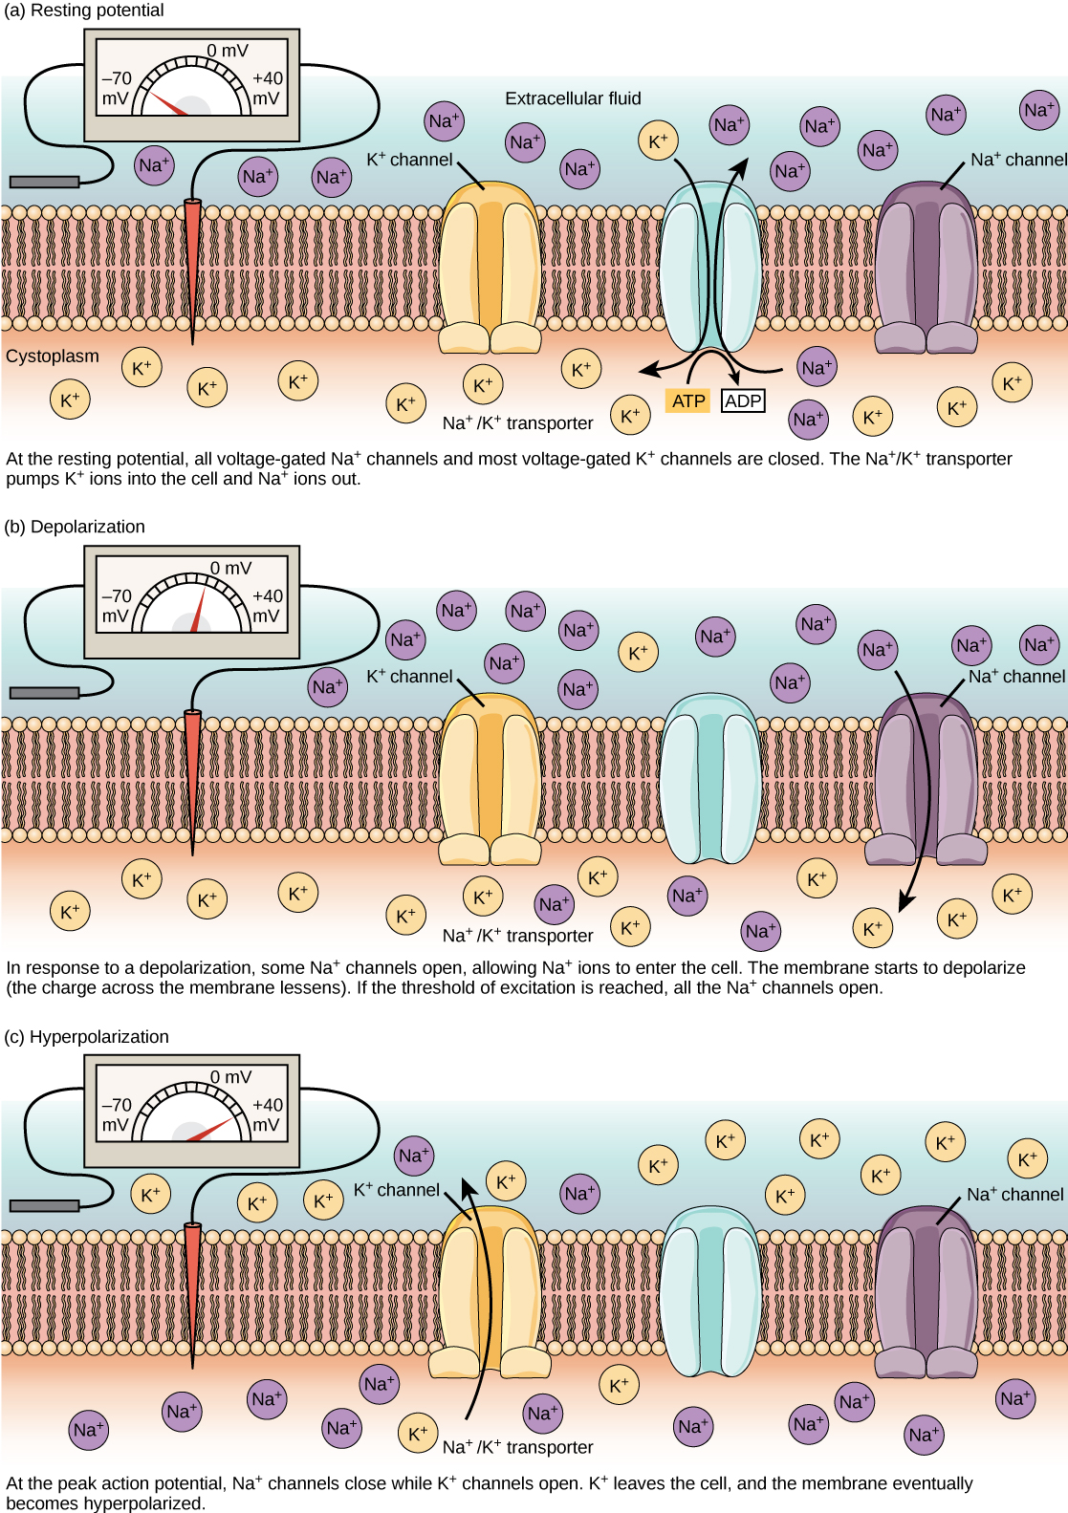 | Resting potential:  - Polarised, - 65mV  - Na⁺ / K⁺ actively transported 3 Na+ out, 2 K+ in to cell  - Few K⁺ channels open, few K+ diffuse out cell  - Na⁺ gated channels closed  Depolarisation: Stimulus causes some Na+ channels open, some Na+ diffuses into the cell.  The membrane depolarises and the inside becomes less negative compared with the outside and reaches a threshold value of -50mV.  If threshold is reached:  More Na+ channels open and many Na+ flood in.  The inside of the cell becomes positive compared with the outside of the cell  Repolarisation: The potential difference across the membrane reaches +40mV .  The Na+ channels close, the k+ channels open.  The membrane becomes repolarised and negative inside compared with outside  More K+ channels open causing more K+ to diffuse out of the cell  Hyperpolarisation: The membrane is hyperpolarised. The potential difference becomes more negative than -65mV due to the flood of K+ out of the cell.  The K+ channel closes and the Na+/K+ pumps restore the resting potential of -65mV This re establishes the ion concentration across the membrane. Also known as refractory period

Outcome:
- Explain what is meant by the all or nothing principle.
How does the brain interpret the size of the stimulus?
Definition:
All or nothing response: If threshold is reached an action potential will fire with the same change in voltage, no matter how big the stimulus is.
- The higher the frequency of the action potentials in a given time period the stronger the stimulus

- By having different neurones with different threshold potentials allows the brain to interpret the number and type of neurone that are transmitting an AP to determine the size of the stimulus.
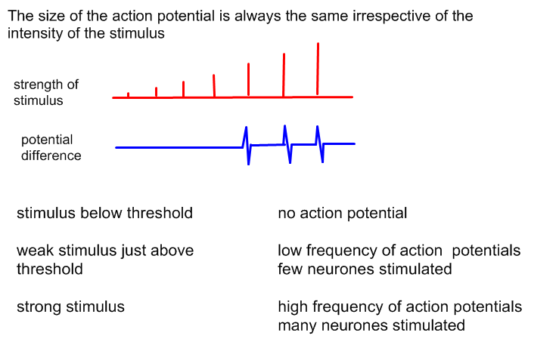

_______________________________________________________________________________________________
_______________________________________________________________________________________________
_______________________________________________________________________________________________
_______________________________________________________________________________________________
_______________________________________________________________________________________________
_______________________________________________________________________________________________
_______________________________________________________________________________________________
_______________________________________________________________________________________________
_______________________________________________________________________________________________
_______________________________________________________________________________________________
_______________________________________________________________________________________________
_______________________________________________________________________________________________
Outcome:
- Explain what is meant by and importance of the refractory period and why action potentials are prevented.
The refractory period:
State | Explain
Ensures action potential only go in one direction. | - AP pass from active to resting region  - AP cannot be produced in refractory period  - Prevents AP from spreading in both directions along axon
Produces discrete impulses. | - New AP cannot be formed immediately behind first AP  - Allows AP to be separated  - Helps show strength/frequency of stimulus
Limits the number of action potentials. | - AP’s are discrete  - Limits the strength of the stimulus that can be detected  - Body/brain not overloaded with stimulus

Task: Complete a revision poster for how an action potential moves along a neurone. Add arrows to the diagram showing the direction in which the ions move.

Include the following terms
Na+ K+ Polarised Depolarised Repolarised Hyperpolarised Sodium/Potassium pump
Active transport Diffusion Threshold potential Resting potential Action potential
All or nothing Frequency Strength of stimulus

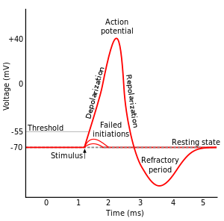

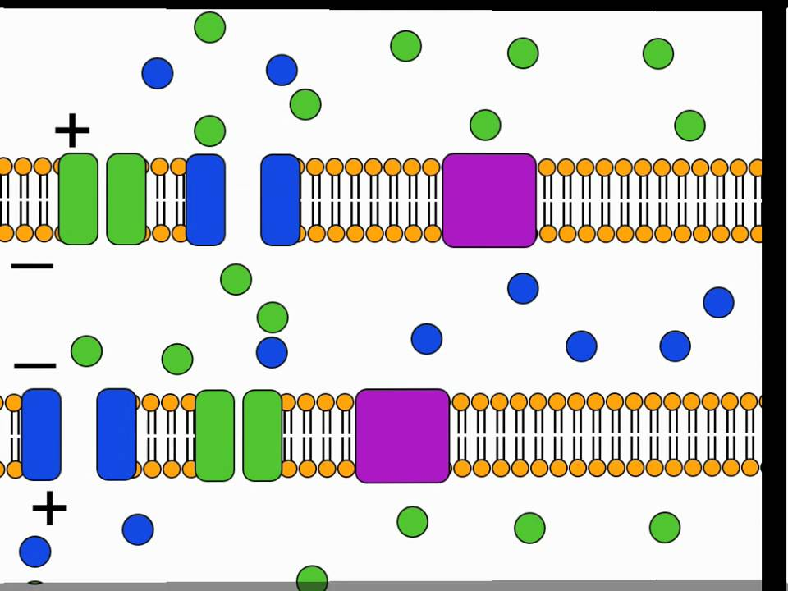

Exam questions:
Q3. The diagram shows the change in the charge across the surface membrane of a non-myelinated axon when an action potential is produced.
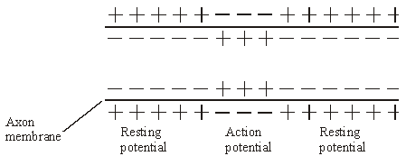
(a) Describe how the change shown in the diagram occurs when an action potential is produced.
Sodium gates or channels open / increase in permeability of axon membrane to sodium ion;
Sodium ions enter axon
Q4. During an action potential, the permeability of the cell-surface membrane of an axon changes. The graph shows changes in permeability of the membrane to sodium ions (Na⁺) and to potassium ions (K⁺) during a single action potential.
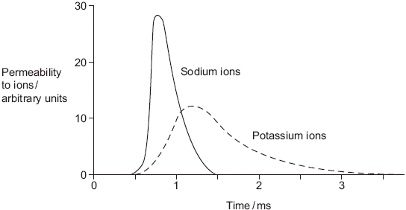
(a) Explain the shape of the curve for sodium ions between 0.5 ms and 0.7ms.
(Ion) channel proteins open, sodium in;
Changes membrane potential / makes inside of axon less negative / positive / depolarisation / reaches threshold;
More channels open / positive feedback;
Accept other phrases for ion channel proteins providing that it is clear that it is something through which ions pass. Reject carrier.
First marking point relates to opening. Third point must relate to more (channels) opening.

(b) During an action potential, the membrane potential rises to +40 mV and then falls. Use information from the graph to explain the fall in membrane potential.
Potassium channels open;
Potassium out;
Sodium channels close;
Do not penalise candidate who refers to sodium or potassium. Ions are mentioned in question.
Reject pump

(c) After exercise, some ATP is used to re-establish the resting potential in axons. Explain how the resting potential is re-established.
Pump / active transport / transport against concentration gradient;
Of sodium from axon / sodium out / of potassium in;
Do not penalise candidate who refers to sodium or potassium. Ions are mentioned in question

Outcome:
- Explain how action potentials pass along unmyelinated neurones
- Explain how action potentials pass along myelinated neurones by saltatory conduction, and why this is faster than conductance along unmyelinated neurones.
- Explain the factors which affect the speed of nerve impulse conductance.
http://www.youtube.com/watch?v=7EyhsOewnH4&NR=1
Non-myelinated transmission of an action potential
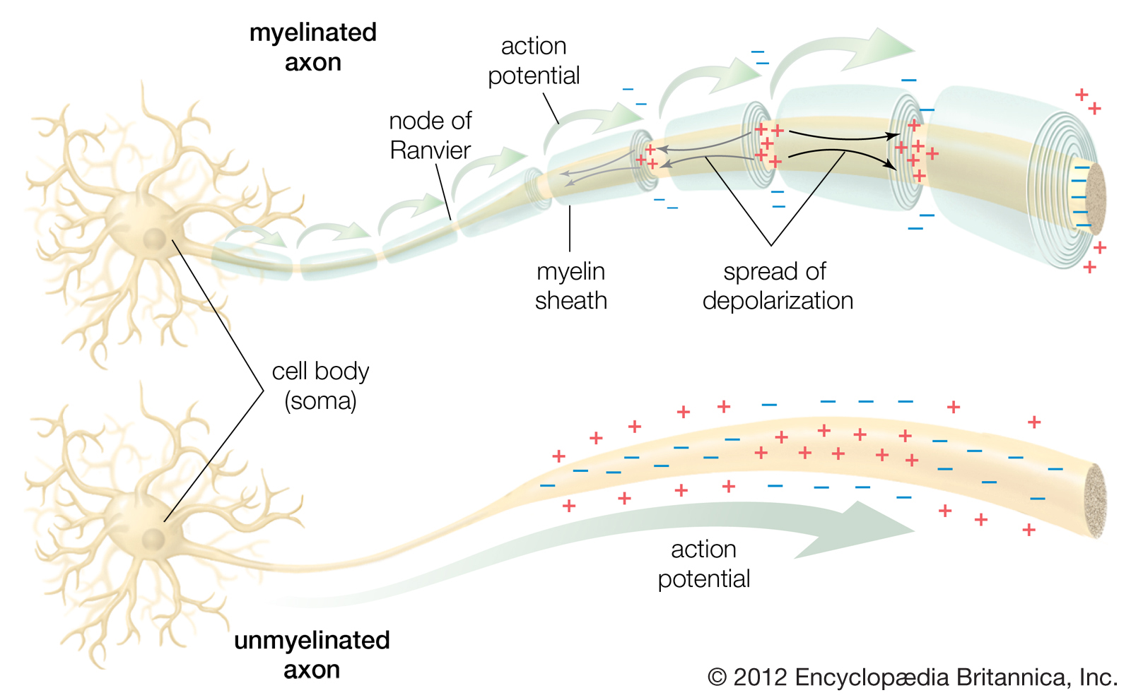
- During an action potential gated Na⁺ channels are open
- There is a high conc of Na+ in the depolarised region of the axon and low conc of Na⁺ in the resting regions to either side.
- This sets up conc gradients.
- Na⁺ diffuses sideways from a high to low conc.
- Diffusion of Na⁺ depolarises the next region causing Na+ channels to open (when it reaches -50mV- threshold potential).
- This causes the generation of a new AP in this region. The action potential is therefore a travelling wave of depolarisation.
Task: Can you draw this process out in the space below. Drawing helps you remember the information as you are changing the format of the information which is more challenging.
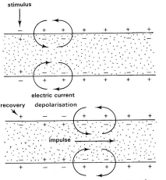
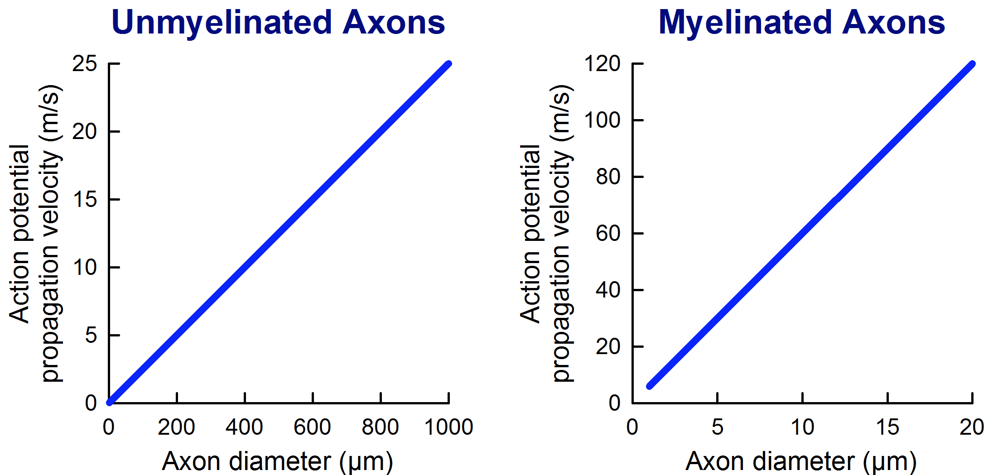
We have learnt the difference between myelination and non-myelination. Look at the 2 graphs carefully, what conclusions can be drawn from these graphs about the effect of myelination on speed of AP transmissions?
Axon | Myelinated | Unmyelinated
Diameter | Smaller | Larger
Velocity | Greater | Smaller
 | Increasing diameter will increase velocity,  directly proportional | Increasing diameter will increase velocity  , directly proportional

Myelinated transmission of an action potential

Note: The word salutatory comes from the Latin word saltare meaning “to jump”
Task: Fill in the gaps below using the appropriate word (some words may be used more than once)
Cannot | Nodes | Insulates
50x | Electrically | Along
Jump | Saltatory | Elongated
Increases | Ranvier | Conduction
- Myelin electrically insulates axons which increases the speed of transmission of conducion
- Sodium ions and potassium ions cannot flow through the myelin sheath. Ion exchange can only occur across the axon membrane at the Nodes of Ranvier.
- Action potentials appear to jump from one node to the next which is called saltatory conduction
- This can increase the speed of transmission by up to 50x
- Local currents are elongate and Na⁺ diffuse along the inside of the neurone from one Node of Ranvier to the next.

Factors that affect the speed at which can AP travels.
- Temperature
- Diameter
- Presence of myelin sheath
Factor | Describe | Explain
1.Temperature  - Lower temperature  - Higher temperature | Slower rate of diffusion of ions  Faster rate of diffusion of ions | Slower rate of conduction  Ions less kinetic energy  Slower response  Faster rate of conduction  Ions have more kinectic energy  Faster response
2.Diameter  - Smaller Diameter  - Larger diameter | Larger Diameter  Quicker diffusion of ions | More resistance to flow of ions in cytoplasm  Faster response  Less resistance to flow of ions in cytoplasm  Quicker response.
3.Presence of myelin sheath  - Myelinated neuron  - Nonmyelinated neuron | Quicker diffusion of ions  Faster diffusion of ions | Steeper conc gradient  Depolarisation only at Nodes of Ranvier  Quicker response  Shallower conc gradient  Depolarisation along length of axon  Slower response

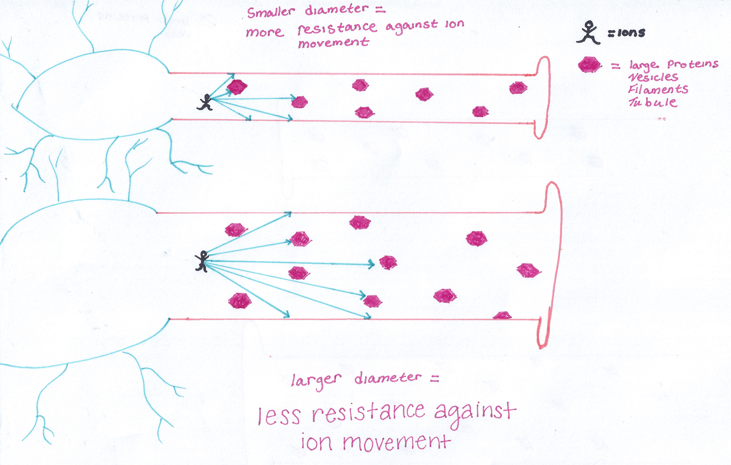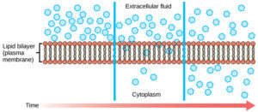

Exam questions:

Q5.(a) A myelinated axon conducts impulses faster than a non-myelinated axon.
Explain this difference.
1. (In myelinated) action potential / depolarisation only at node(s);
2. (In myelinated, nerve impulse) jumps from node to node / saltatory;
3. (In myelinated) action potential / impulse does not travel along whole length;
The question is about speed of transmission, not repolarisation or related matters
Accept converse for non-myelinated

Doctors investigated the relationship between myelin in brain tissue and different types of dementia. All types of dementia involve loss of mental ability. The doctors measured the mean amount of myelin in samples of brain tissue from. The doctors’ results are shown in the figure. The vertical bars show standard errors.
• a control group of 12 people without dementia
• 20 people with vascular dementia (VaD)
• 19 people with Alzheimer's dementia (AD)
• 31 people with Lewy body dementia (LD).
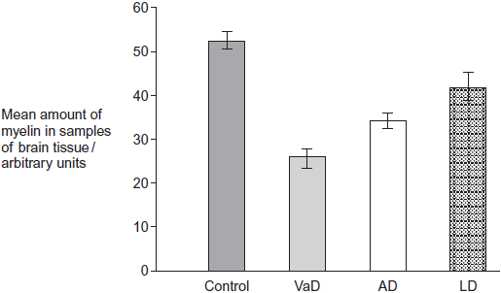
(b) The doctors used a statistical test to compare the results for AD and LD.
They obtained a value for P of 0.047.What does this result show about the difference between the means for AD and LD? Use the words probability and chance in your answer.
1. Probability of obtaining this difference by chance;
Reject ‘results’ once only
This statement often split round 2.
2. Is less than 5% / less than 0.05 / less than one in twenty;
Accept is 4.7% / 0.047 but reject less than 4.7% / 0.047
Accept correct greater than 95% / greater than 0.95 arguments
3. Difference is significant;
Reject ‘results’ once only
(c) A student who read this investigation concluded that there was a relationship between the amount of myelin in a person’s brain and whether or not they had dementia. Do these data support this conclusion? Give reasons for your answer.
1. (All) dementia results lower (than control group) / non-dementia result higher;
2. Error bars do not overlap so differences are (possibly) significant;
Neutral results
Accept not due to chance / statistically significant
In this context, accept references to standard deviation
3. Dementia may be due to other factors / not only due to a lack of myelin;
Accept suitable named factor e.g. genetic
4. (Because) big / significant differences in myelin in different dementia;
Not just ‘different’
5. Only small sample sizes / only one study / more data required;
Outcome:
- Describe and explain the detailed structure of a synapse including the sequence of events
- Explain the functions of synapses
Synapse structure
A synapse is the junction between 2 neurones. There is a very narrow gap of about 20nm between neurones called the synaptic cleft .
An action potential (electrical) cannot cross the synaptic cleft so chemicals called neurotransmitters are used. Neurones are transducer, the synapse is where the transduction occurs.
Synapses that use acetylcholine are called cholinergic synapses
Labels for the diagram
Axon | Neurotransmitter receptor | Na+ channel
Dendrite | Vesicle | Synaptic cleft
Neurotransmitter | Pre-synaptic membrane | Post-synaptic membrane
Mitochondria
. 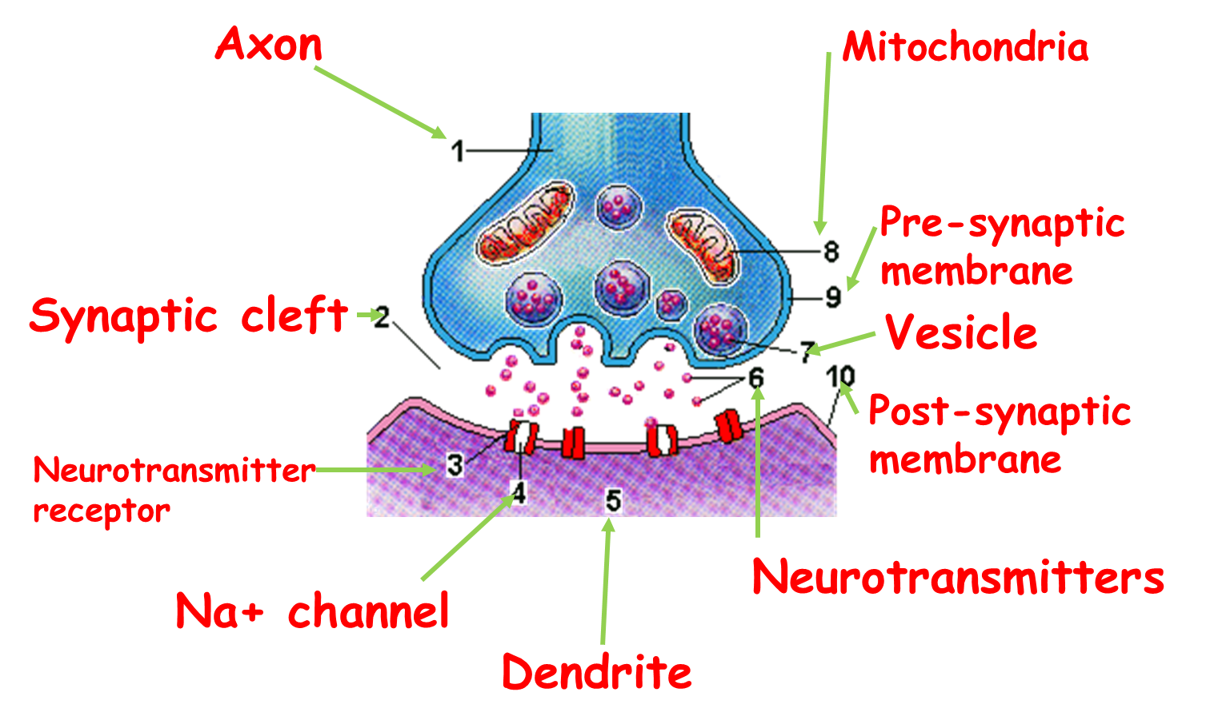
Neurotransmitters are made by the pre-synaptic neurone and are stored in synaptic vesicles at the end of the axon in the synaptic knob. The membrane of the post-synaptic neurone has membrane receptors which have specific binding sites for neurotransmitters.

Sequence of events at a synapse
- AP arrives at synaptic knob causing depolarisation of membrane
- Ca²⁺ channels open and Ca²⁺ enter the axon by facilitated diffusion
- Causes vesicles containing neurotransmitter to move and fuse
- With presynaptic membrane
- Neurotransmitter released into the synaptic cleft and diffuses across cleft
- Neurotransmitter binds with specific receptors on the post-synaptic membrane
- Na⁺ channel open and Na+ floods in
- Post-synaptic membrane is depolarised.
- Acetylcholinesterase (enzyme in cleft) hydrolyses acetylcholine into acetyl and choline
- Product diffuse back to pre-synaptic membrane to be resynthesized.
Quick fire questions:
- The neurotransmitter acetylcholine diffuses very quickly across the cleft. State 2 adaptions of a cleft that increases the rate of diffusion (Year 1)
Large conc released from pre-synaptic membrane/ synaptic cleft very short diffusion distance/ NT broken down at the post-synaptic membrane.
- Nicotine is able to bind to acetylcholine receptors, explain what this shows about acetylcholine and nicotine? (Year 1)
Similar shaped molecules able to bind to the same receptors.
- If nicotine does bind to the receptor the hormone stays bound. Suggest why the nicotine stays bound to the receptor?
Nicotine similar shape but not the same so enzyme cannot break the nicotine down.
- Describe the effect on the post-synaptic neurone if the nicotine stays bound to the receptor.
Nicotine not broken down so stays bound to the receptor on the Na+ channel, channel stays opens/ membrane is continually stimulated/ membrane is constantly depolarised.

Outcome:
- Explain how synaptic transmission allows for unidirectionality, temporal and spatial summation, and inhibition by inhibitory synapses. Analyse information provided to predict and explain the effects of specific drugs on a synapse.
Features of synapses:
Textbook page 362-363 will also help you.
Words for gap fill:
Pre | Pre | Receptor | Low | Threshold
High | Many | Post | Post | Vesicles
Threshold | Vesicles | Threshold
- State: Impulses are only transmitted in 1 direction.
Explain: NT only produced in the pre-synaptic membrane in VESICLES
AP causes movement of VESICLES
NT binds to RECEPTORS only found on POST-synaptic membrane

- State: Synaptic transmission of an impulse can use temporal summation.
Explain: 1 POST-synaptic neurone stimulated to release NT
LOW frequency of impulses doesn’t exceed THRESHOLD potential, no AP
HIGH frequency of impulses does exceed THRESHOLD potential, AP fired

- State: Synaptic transmission of an impulse can use spatial summation.
Explain: MANY pre-synaptic neurones connected to 1 POST-synaptic neurone
If both pre-synaptic neurones release NT and THRESHOLD potential is reached AP fired

- State: Synapses can be inhibitory.
Explain: Less likely for AP to be fired in post-synaptic neurone

Describe how synapses can be inhibitory:
Pre-synaptic neurone releases NT which binds to Cl⁻ channels on the post synaptic membrane
NT also binds to K⁺ channels
Cl⁻ channels open, Cl⁻ diffuse into the post-synaptic neurone
K⁺ diffuses out of the post-synaptic neurone into the cleft
The movement of ions cause hyperpolarisation of post-synaptic membrane
MORE Na+ channels must be opened to allow MORE Na+ to diffuse in
To reach threshold
- Unidirectional 2. Temporal summation

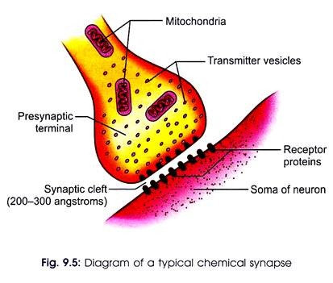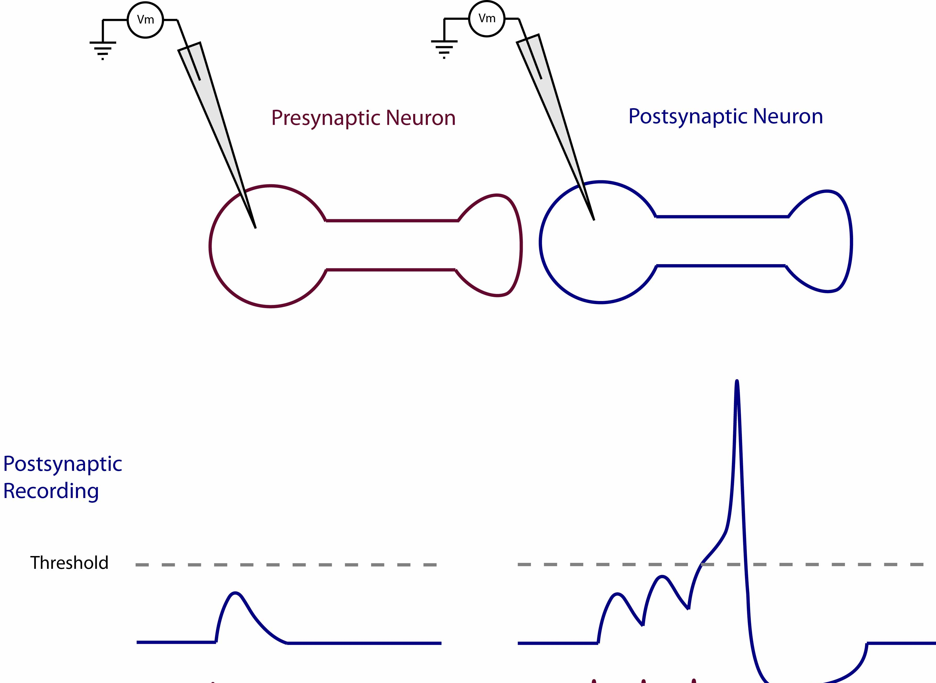

3.Spatial summation 4. Inhibitory (include description)
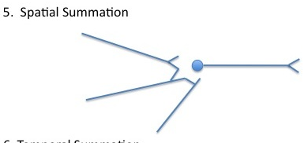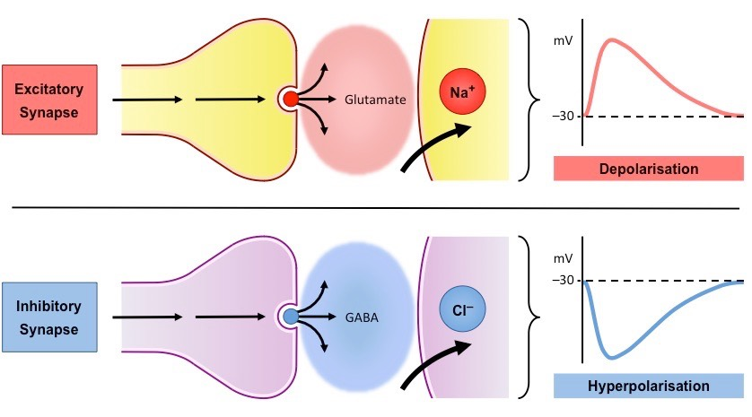

Exam questions:
Q5. (i) Describe the sequence of events which allows information to pass from one neurone to the next neurone across a cholinergic synapse.
1. (impulse causes) calcium ions / Ca⁺⁺ to enter axon;
2. vesicles move to / fuse with (presynaptic) membrane;
3. acetylcholine (released);
4. (acetylcholine) diffuses across synaptic cleft / synapse;
5. binds with receptors on (postsynaptic) membrane; (reject active sites, disqualify point)
6. sodium ions / Na⁺ enter (postsynaptic) neurone;
7. depolarisation of (postsynaptic) membrane;
8. if above threshold nerve impulse / action potential produced
Q6. Secretion of neurotransmitters into a synaptic cleft may produce an action potential in a postsynaptic neurone.
- Explain how the release of acetylcholine at an excitatory synapse reduces the membrane potential of the postsynaptic membrane.

Binds to receptor / proteins; and opens Na⁺ channels;
Na⁺ enter and make membrane potential less negative / depolarised

- Explain what causes transmission at a synapse to occur in only one direction.

(Vesicles containing) neurotransmitter only in presynaptic membrane /neurone;
Receptor / proteins only in postsynaptic membrane / neurone;

(iii) GABA is a neurotransmitter which inhibits the production of action potentials.
The diagram and the graph show how the release of GABA from a presynaptic membrane affects the membrane potential of a postsynaptic membrane.
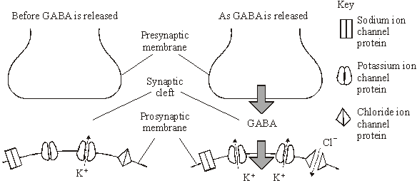
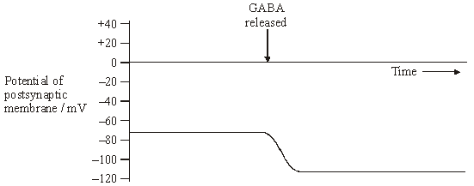
When the postsynaptic membrane is stimulated by acetylcholine, an action potential is less likely if GABA is released at the same time. Explain why.
GABA opens K⁺ and Cl– channels so K⁺ passes out and Cl– passes in;
Membrane potential more negative / hyperpolarised;
Requires increased stimulation / must open more Na⁺ channels / allow more Na⁺ to enter;
To reach threshold;

Q7. Acetylcholine is a neurotransmitter which binds to postsynaptic membranes and stimulates the production of nerve impulses. GABA is another neurotransmitter. It is produced by certain neurones in the brain and spinal cord. GABA binds to postsynaptic membranes and inhibits the production of nerve impulses. The diagram shows a synapse involving three neurones.

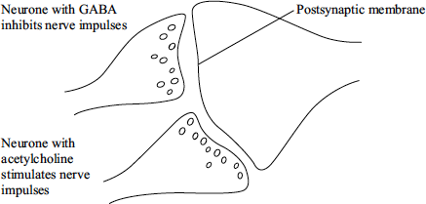
(a) Describe the sequence of events leading to the release of acetylcholine and its binding to the postsynaptic membrane.
Action potential arrives / depolarisation occurs;
Calcium ions enter synaptic knob;
Vesicles fuse with membrane;
Acetylcholine diffuses (across synaptic cleft);
Binds to receptors;

(b) The binding of GABA to receptors on postsynaptic membranes causes negatively charged chloride ions to enter postsynaptic neurones. Explain how this will inhibit transmission of nerve impulses by postsynaptic neurones.

Inside becomes more negatively charged / hyperpolarised;
stimulation does not reach threshold level / action potential not produced;
Depolarisation does not occur / reduces effect of sodium ions entering;

Outcome:
- Use the information provided to predict and explain the effects of specific drugs on a synapse.
Effect of drugs on synapses
There are many different neurotransmitters responsible for the exchange of information across a synapse. There are many different types of receptor on the post synaptic membrane. Each receptor is complementary to 1 type of neurotransmitter. Some NT and receptors are excitatory (new AP produced in next neurone). Some NT and receptors are inhibitory (less likely for a new AP in the next neurone). Many medicinal and recreational drugs affect how synapses work, affecting the brains perception of stimuli.
Some examples of effects:
State: Create more AP’s
Explain: Some drugs create more AP’s which stimulate release of more NT or inhibits enzymes which break down the NT.
The body's response to impulse is enhanced
State: Create fewer AP’s
Explain: Some drugs inhibit the release of NT/blocks receptors on the post synaptic membrane.
The body's response to impulse is reduced

Serotonin: regulates sleep and emotions. Prozac is an antidepressant that works in the same synapses as serotonin
Endorphins: Used to block pain pathways. Morphine and codeine bind to specific receptors in the brain where endorphins normally work; mimic endorphins.

Exam questions:
Q8. The black mamba is a poisonous snake. Its poison contains a toxin. The table shows the base sequence of mRNA that codes for the first two amino acids of this toxin.

 | Base sequence of anticodon on tRNA | U | G | C | ;
 | Base sequence of mRNA | A | C | G | A | U | G
 | Base sequence of DNA | T | G | C | T | A | C

Complete the table to show
(a) (i) the base sequence of the anticodon on the first tRNA molecule that would bind to this mRNA sequence.
(1)
(ii) the base sequence of the DNA from which this mRNA was transcribed.
(1)
(b) A mutation in the base sequence of the DNA that codes for the toxin would change the base sequence of the mRNA. Explain how a change in the base sequence of the mRNA could lead to a change in the tertiary structure of the toxin.

(c) Different primary structure / amino acid sequence / amino acid coded for;

Reject: different amino acids produced / formed

Neutral: refs. to bonds

1

(c) The black mamba’s toxin kills prey by preventing their breathing. It does this by inhibiting the enzyme acetylcholinesterase at neuromuscular junctions. Explain how this prevents breathing.

1. Acetylcholine not broken down / stays bound to receptor;

2. Na⁺ ions (continue to) enter / (continued) depolarisation / Na⁺ channels (kept) open / action potentials / impulses fired (continuously);

3. (Intercostal) muscles stay contracted / cannot relax;

‘Muscles contract’ is not enough

Accept: diaphragm stays contracted / cannot relax

3

Q9. (a) Describe how calcium ions are involved in synaptic transmission.

(Nerve impulse causes) Ca²⁺ to enter presynaptic neurone/membrane;

(Ca²⁺ entry) causes fusion of vesicles with presynaptic membrane /
causes exocytosis / release of transmitter;

2

1

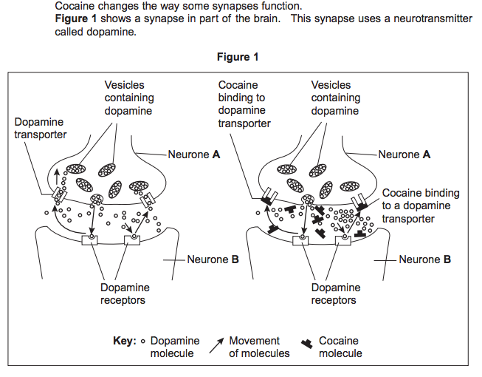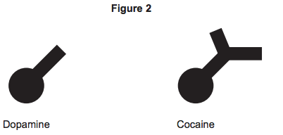

(b) This synapse only transmits information from neurone A to neurone B and not from B to A. Give one reason why.

Vesicles / neurotransmitter / dopamine (only) in / from A;

OR

Receptors (only) on B;

(i) Explain why cocaine is able to bind to the dopamine transporter, as shown in Figure 1.

Dopamine and cocaine have similar shapes (in part);

Cocaine can fit transporter;

Reject ref. to ‘active site’

(ii) Dopamine is released at synapses in parts of the brain where pleasure is perceived. Using information from Figures 1 and 2, explain how the use of cocaine can result in feelings of pleasure.

Cocaine blocks transport of dopamine out of gap / into A;

Dopamine concentration rises / is maintained / remains;

Ignore ref. to ‘active site’

Continues to stimulate/bind to receptors;

Causes continued firing of impulses (in B);

