3.5.4: Nutrient Cycles

Name __________________________________

Reflection on Learning outcomes | or | Target
Describe the stages of the phosphorus cycle, and the ions at each stage
Explain the role of saprobionts and mycorrhizae in the phosphorus cycle
Interpret information/data about the phosphorus cycle and apply knowledge.
Describe the stages of the nitrogen cycle, and the ions/molecules at each stage
Explain the processes of saprobiotic nutrition, ammonification, nitrification, nitrogen fixation and denitrification within the nitrogen cycle
Explain the role of saprobionts and mycorrhizae in the nitrogen cycle
Interpret information/data about the nitrogen cycle and apply knowledge.
Explain why farmers utilise natural and artificial fertilisers
Explain how eutrophication is caused, and what the impact is on the ecosystem in which it happens
Interpret information/data about eutrophication and apply knowledge

Glossary of terms
Use this page to add the definitions to the key terms found in this booklet. Some key terms have been given some you will need to add yourselves as we work through the booklet.
Producer
Molecule
Biomass
Ion
Consumer
Inorganic
Saprobiont
Mycorrhizae
Natural Selection
Reproductive Isolation
Gene Pool
Allopatric speciation
Sympatric Speciation
Genetic drift
DNA Hybridisation

NUTRIENT CYCLES
Learn the common features of all nutrient cycles
Common features of all nutrient cycles:
- 1. Nutrient taken up by PRODUCER. Absorption
- 2. PRODUCER uses nutrients forming into complex molecules
- 3. PRODUCER is eaten, nutrients passed into CONSUMER
- 4. CONSUMER is eaten by CONSUMER passing on nutrients
- 5. PRODUCER and CONSUMER die
- 6. SAPROBIONTIC microorganisms breakdown nutrients to be RECYCLED.
Add the descriptions above to the diagram on the next page


Answer these quick fire questions
- Why is it important that producers take up nutrients before consumers eat the producers?
Producers take up inorganic ions/molecules and convert these into organic molecules. Consumers cannot convert inorganic ions to organic molecules so instead need to digest organic molecules from other organisms.

- Plants are producers. What is the inorganic molecule that plants take up for the process of photosynthesis? What is the organic molecule that plants make from photosynthesis?
? Inorganic molecule: Carbon dioxide, organic molecule: Glucose
- To digest the producers consumers need enzymes. Explain the importance of enzymes in digestion.
Enzymes are Biological catalyst which speed up the rate of reaction (in this case digestion) by lowering the activation energy but are not used up/altered by the reaction.
- What is the importance of saprobiontic micro-organisms in the cycle?
Turn the organic molecules back into inorganic ions/molecules so return the nutrient back to the cycle.
- Why must nutrient cycles be a cycle?
Otherwise the nutrient would run out or be trapped inside the cycle so the cycle would stop.

Watch the video showing an overview of the two cycles we are going to be looking at in this topic.
http://www.bing.com/videos/search?q=phosphorus+cycle&adlt=strict&view=detail&mid=51A84770C013EE31C0C151A84770C013EE31C0C1&FORM=VRDGAR
Exam questions practice.
Use the information on the previous pages and APPLY your knowledge to the question below.
EQ1.
(a)
Precaution | Reason
standardise source of leaves, e.g. same age / tree | same chemical composition;
standardise discs, e.g. same size | same S.A. for decomposition;
standardise treatment of discs, e.g. bury to same depth | same decomposers / named abiotic factor;
standardise soil conditions, e.g. water content / pH | affects enzyme / bacterial decomposition;

(1 mark for each precaution)
(1 mark for each reason)
One precaution only from each area
3 max

(b) sharp decrease, levelling off / gradual decrease, decrease;
increased decomposition due to increased temperature / warmer months;
enzyme action increases due to increased temperature;
rapid decrease due to removal of sugars / starch;
cellulose takes longer to be digested;
3 max

(c) secrete enzymes / cellulase / carbohydrase;
extracellular digestion;
absorption of soluble / digested products / sugars;
3

Outcome:
- Describe the stages of the phosphorus cycle, and the ions at each stage.
- Explain the role of saprobionts and mycorrhizae in the phosphorus cycle.
- Interpret information/data about the phosphorus cycle and apply knowledge.

PHOSPHORUS CYCLE
Starter
Think back to the video about the two nutrient cycles then answer the questions below.
- Why are sedimentary rocks so important in the phosphorus cycle?
_____________________________________________________
- Why is the majority of phosphates trapped inside rocks?
_____________________________________________________
- How do plants get the phosphates?
_____________________________________________________
- How many years can phosphates be trapped in a biological cycle for?
_____________________________________________________
- What are the main components of fertilisers?
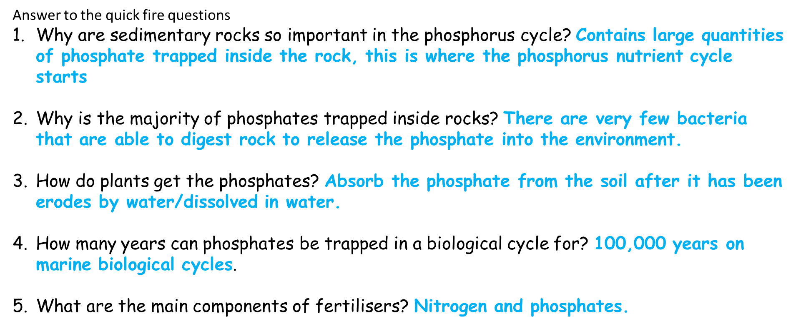
_____________________________________________________

Note: When we are referring to the element itself we refer to it as phosphorus, when we are talking about the form of phosphorus that is used in the cycle we refer to it as phosphate. Phosphorus is very reactive so is rarely in its element form, it is usually reacted with O so we refer to it as phosphate.

Activity: Read through the terms/description on the next page and fully annotate the diagram on the next page.
Term | Description
- Erosion/use of fertilisers | - Phosphorus found as phosphate ions in sedimentary rocks  - Erosion causes release of phosphate ions  - Dissolve in water
- Absorption | - Dissolved phosphates uptaken by roots of PRODUCER  - Dissolved phosphates uptaken by MYCORRHIZAE  - Converted to biomass
- Feeding and digestion | - PRODUCER eaten by CONSUMER passing on phosphate ions
- Excretion and decomposition | - Excess ions excreted in waste or death of PRODUCER/CONSUMER  - Fixed into bones/shells.  - Fungi/Bacteria breakdown biomass release phosphate ions
- Deposition | - Phosphate ions dissolved in water forming sedimentary rocks.

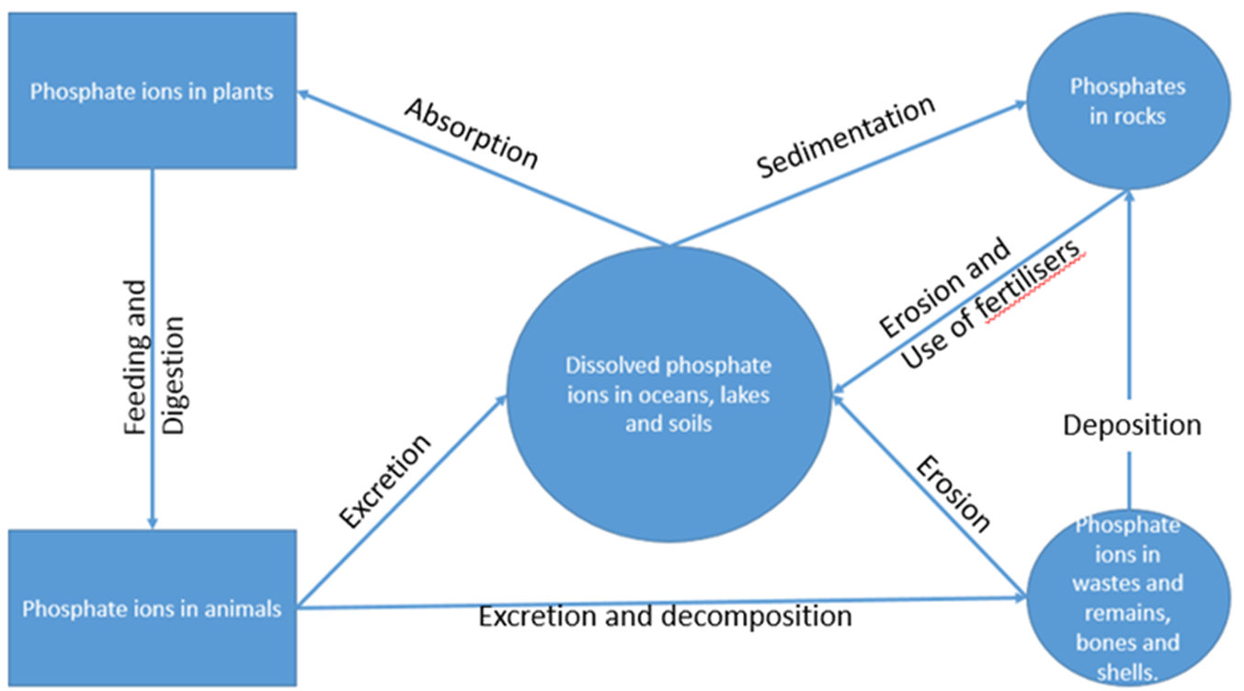

Create your own flow diagram showing the process of the Phosphorous cycle
There are many organisms that play a key role in nutrient cycles two common organisms are;
Definitions
Mycorrhizael Fungi: Mycorrhizae is the symbiotic relationship between plant and fungi
Saprobionts: Organisms that digest their food externally and then absorb the products.

How are Saprobionts and Mycorrizhae involved in the Phosporous Cycle?
Saprobionts
Release hydrolytic enzymes that break down dead organic matter to release phosphate from phosphate containing sources such as DNA and RNA back into the soil.
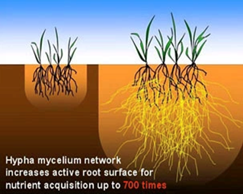
Mycorrhizae:
- Association between fungal filaments and the roots of plants.
- Fungi are extensions of the root system.
- Fungi increase absorption of water and minerals.
- Fungi act like a sponge around root system.
- Fungi and roots have a mutualiastic relationship.
Quick fire questions:
- The mycorrhizae is a mutualistic relationship. What is meant by a mutualistic relationship?
________________________________________________________
- Suggest the advantage of this relationship for the fungi.
_______________________________________________________
- Suggest the advantage of this relationship for the plant?
________________________________________________________
- Suggest why the fungi are wrapped around the roots like a sponge.
________________________________________________________
- Suggest how the structure of the fungi could increase uptake by 700x
________________________________________________________
- Suggest how the fungi are able to survive under ground with little to no light.
Answer to the quick fire questions on page 5
- Both organisms benefit from the relationship.
2. Fungi obtain organic compounds from plant eg sugars and amino-acids.

3. Plants obtain water and increased inorganic ions uptake eg phosphate ions
4. Reduced diffusion distance for ions into root cells.
5. Increased surface area, long and thin.
6. Obtain nutrients required from the plant through mutualistic relationship.

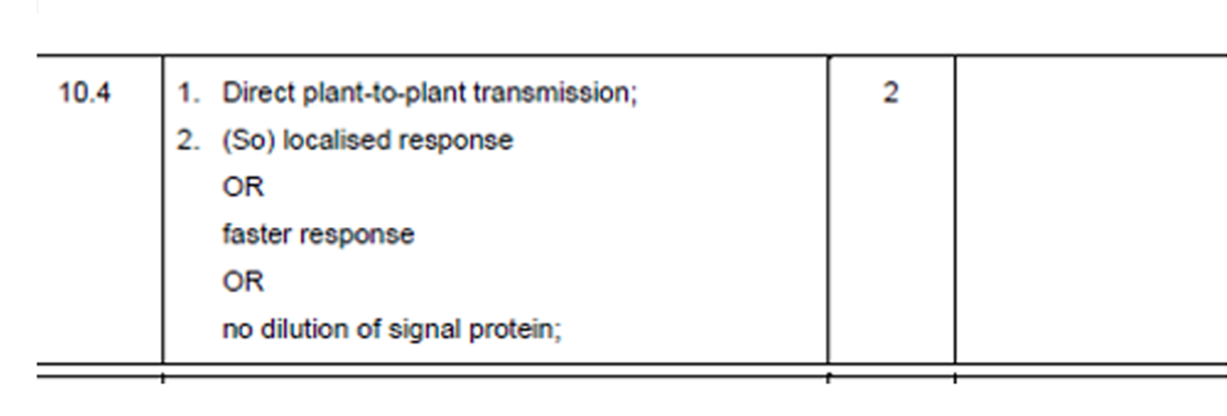
Exam question: Suggest and explain the advantage to tomato plants of transmitting signal protein through mycorrhizal networks, rather than releasing them into the air (2marks)
________________________________________________________________________________________________________________________________________________________________________________________________________________________________________________________________________________________________________________________________________________________________________________

Outcome:
- Describe the stages of the nitrogen cycle, and the ions/molecules at each stage
- Explain the processes of saprobiotic nutrition, ammonifcation, nitrification, nitrogen fixation and denitrfication within the nitrogen cycle
- Explain the role of saprobionts in the nitrogen cycle.
- Interpret information/data about the nitrogen cycle and apply knowledge.

NITROGEN CYCLE
Watch the video on the Nitrogen cycle and copy the diagram into the space below. https://youtu.be/LS4rAyvmZ3U
Exam note: The names of individual species of bacteria are NOT required

Activity: Now use what you have just learnt to Fill in the diagram below using pages 307-309 in the Toole and Toole textbook.
Words to use:
Decomposition & Ammonification Free-living soil bacteria Rhizobium in root nodules Haber process Denitrification Organic Nitrogen in animals Feeding Transport from root nodules Uptake by roots Nitrification Nitrifying bacteria Nitrites in soil (NO₂₋₎ Nitrification Denitrification Denitrifying bacteria Nitrogen Fixation.

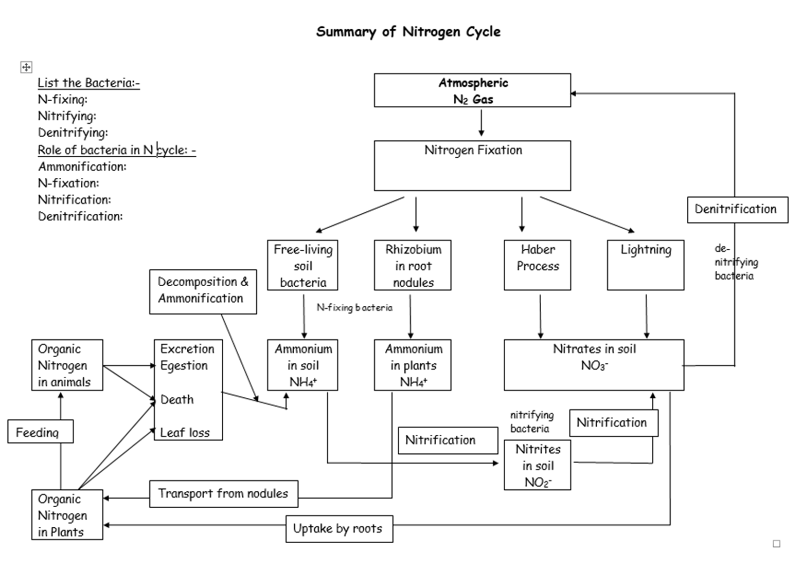

You need to know about each step of the Nitrogen cycle, it is important that you know the name of the group of bacteria involved. Do not confuse the bacteria with each other you will lose marks.

Stages of the Nitrogen Cycle
You could be asked to describe each of these stages
Fill in the blanks using the words below:
Anaerobic, Living, Aerobic, Nitrogen gas, Urea, Lightning, Nitrates, Protein, Living, Rhizobium, Nitrites, Nucleic-acids, Nitrates, Oxidation, Haber, nodules, waste, Aerobic, Dead, Ammonia

- Ammonification (3 marks)
  - Produce ammonium ions from organic nitrogen containing compounds released into soil.
  - Includes: Urea, proteins,nucleic acids and Vitamins
  - Saprobiotic fungi and bacteria- feed on Waste/Dead.
Exam Tip: You must give a named example of a Nitrogen containing Organic compound such as protein or DNA

- Nitrification (3 marks)
  - Free-living bacteria: Ammonium ions Nitrites Nitrates
  - Oxidation reaction
  - Aerobic conditions.

- Nitrogen fixation (4 marks)
  - Lightning.
  - Haber process
  - Free-living bacteria: Nitrogen ammonia
  - Mutualistic bacteria: Live in nodules of Legumous plants called Rhizobium which live in Aerobic conditions.

- Denitrification (3 marks)
  - Bacteria in anaerobic conditions.
  - Nitrates Nitrogen gas
  - Waterlogged soil

Quick Questions
Identify the process
- Lightening converting nitrogen gas into nitrates in the soil. ___________________
- Ammonium ions in the soil being converted into nitrites in the soil by soil bacteria.______________
- Worms digesting nitrates into nitrogen gas in the soil. ___________________
- The Haber process. _____________________
- Cows urinating in a field. _____________________
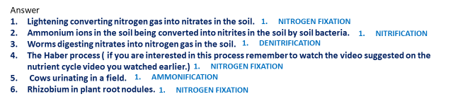
- Rhizobium in plant root nodules. _______________________

How are Saprobionts involved in the Nitrogen Cycle
Saprobiotic Microorganisms:
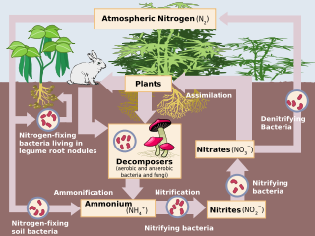
Saprobionts – organisms that feed externally on dead or decaying organic material.
Saprobiotic – process by which saprobionts feed.
- When producers/consumers die their complex molecules are digested
- Digestion carried out by saprobiotic bacteria/fungi (decomposers).
- Cause release of nutrients back into the soil in original simple form e.g. ammonium ions
- Ensure nutrients are released for reuse

Mark scheme perfect answer:
How can dead plant/animal material affect soil content/abiotic factors? You have been given the key terms, can you link them together to produce a 4 mark exam answer?
Terms: Saprobiotic bacteria/fungi aerobic respiration Oxygen Proteins amino-acids ammonium nitrifying bacteria nitrates

Write the mark scheme perfect answer below
- ___ Saprobiotic bacteria/fungi use oxygen to carry out aerobic respiration.
- Proteins are hydrolysed into amino acids.
- Amino acids are converted into ammonium ions (ammonification).
- Nitrifying bacteria converted ammonium ions into nitrates.
- Nitrates are available to plants for uptake into roots.
______________________________________________________________________________________________
Answer these questions to consolidate your knowledge
- What is the form of N in the air? _________________
- What is N fixation ______________________________________________________
- Describe the conditions for N fixing bacteria _______________________________________
- Leghaemoglobin is found in legumous plants surrounding the N fixing bacteria. Suggest the function of the leghaemoglobin. ________________________________________
- Give 2 other methods used to fix N
- What happens when plants and animals die? ______________________
- What happens to the ammonia from urea _______________________________
- Ammonia in the soil is converted to nitrites, which are then converted to nitrates in the soil.
- Write the chemical structure for the 3 nitrogen containing molecules ____ ______ ______
- Give the name for the type of bacteria required for this process _____________________
- Describe the conditions these bacteria require ______________________
- Describe the conditions for the denitrifying bacteria _________________________________


Exam Questions
Q1. In autumn when there is no crop, farm land may be used to grow mustard. The mustard absorbs nitrates which otherwise can leach out of the soil at this time of the year. The mustard is ploughed back into the soil just before sowing of the main crop in the spring.
(a) Nitrogen compounds in the mustard plants are made available for the main crop after ploughing in spring. Describe the role of microorganisms in this process.
......................................................................................................................
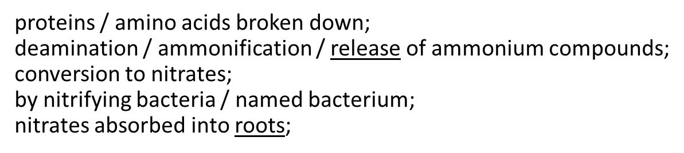
.... ..................................................................................................................

......................................................................................................................
......................................................................................................................
................................................................................................................ (5)
(c) Plants absorb a number of other nutrients from the soil including phosphates. Describe why phosphates are needed by a growing plant.
......................................................................................................................
production of phospholipids;
in cell membranes;
synthesis of ATP;
production of DNA;
production of RNA;
production of NADP;
.............. ........................................................................................................
......................................................................................................................
................................................................................................................. (4)
Q2. (a) Farmers who grow wheat sometimes leave a field fallow for a year by not growing a crop in it. The concentration of nitrate ions in the soil decreases when a field is left fallow.
(i) When grass is grown in the field, fewer nitrate ions are lost than when the field is left with bare soil. Explain why.
(i) presence of grass causes less nutrients / minerals / nitrates / ammonium ions to be leached;
(do not allow references to less nitrogen)
.........................................................................................................(1)
(ii) A crop of leguminous plants such as clover may be grown in the field and then ploughed in. Explain why less fertiliser would be needed for the wheat crop in the following year.
(ii) clover contains nitrogen-fixing bacteria; (do not allow references to nitrifying bacteria) decomposition (of ploughed clover) introduces nitrates / ammonium ions into soil;

(b) The table gives information about the yield and profitability of a wheat crop grown using different amounts of fertiliser.

Nitrogen  fertiliser  applied /  kg ha^{–1} | Grain  yield /  tonnes ha^{–1} | Grain  protein / % | Value  added by  using fertiliser /  £ha^{–1} | Cost of  using  fertiliser /  £ha^{–1} | Benefit : cost ratio
0 | 2.4 | 11.7 | – | – | –
25 | 2.5 | 12.5 | 19 | 11 | 1.7 : 1.0
50 | 2.5 | 12.9 | 25 | 22 | 1.1 : 1.0
75 | 2.5 | 13.3 | 31 | 33 | 0.9 : 1.0
100 | 2.5 | 13.5 | 37
(i) Describe the effects of increasing fertiliser application on the yield and protein content of the grain produced.
(i) minimal effect / no significant effect on yield / small increase up to 25 kg ha^{–1};
increase in protein content of grain with all fertiliser applications;

(2)
(ii) Use the data in the table to estimate the benefit: cost ratio for a fertiliser application of 100 kg ha^{–1}. Write your answer in the table.
(ii) (37 ÷ 44 =) 0.84 : 1.0 (allow 0.8 : 1);

(1)

Outcome:
- Explain why farmers utilise natural and artificial fertilisers
- Explain how eutrophication is caused, and what the impact is on the ecosystem in which it happens
- Interpret information/data about eutrophication and apply knowledge

FERTILISERS AND EUTROPHICATION
Fertilisers can be used to provide plants with minerals, particularly nitrates, to support their growth
In agriculture systems, the harvesting of crops prevents the reintroduction of minerals to the soil so we need to replenish those lost minerals and nutrients using fertilisers.

There are;
Natural fertilisers which consist of dead and decaying remains of plants, animals and their waste

Artificial fertilisers which are mined from rocks before being converted into different forms with their composition tailored for specific crops.

Read page 311 and 312 in your textbook to complete the questions below.
- Explain why fertilisers are needed in an agricultural ecosystem.
Crops are grown repeatedly and intensively on the same area of land. Mineral ions are taken up by the crops, which are transported and consumed away from the land. The mineral ions they contain are not returned to the same area of land and so the levels in the soil are reduced, which can limit the rate of photosynthesis. Fertilisers need to be applied to replace them if photosynthesis f productivity is to be maintained.
- Using Figure 1, determine what concentration of fertiliser you would advise a farmer to apply to a field of wheat.
100 kg ha 1 - although 150 kg ha- 1 gives a slightly better yield, this is marginal and the cost of using 50% more fertiliser makes it uneconomical.

- Suggest a reason why, after a certain point, the addition of more fertiliser no longer improves the productivity of a crop.
Some other factor is limiting photosynthesis, e.g. light. C0₂ and only the addition of this factor will increase photosynthesis and hence productivity.

- Distinguish between natural and artificial fertilisers.
Natural fertilisers are organic and come from living organisms in the form of dead remains, urine or faeces (manure). Artificial fertilisers are inorganic and are mined from rocks and deposits.

How fertilisers increase productivity
- Nitrogen is need to make proteins and DNA.
- Where there are more nitrates available, plants are likely to develop earlier, grow quicker and taller and cover a greater area with their leaves.
- This therefore increases the rate of photosynthesis and also increases productivity.
- Artificial fertilisers have been very beneficial in providing cheaper food.

Now Complete the questions on page 312.
- State which forms of nitrogen used in the investigation are natural fertilisers. ________________________________________________________________________________
- Suggest why the investigation included a plot to which no nitrogen-containing fertiliser was added. ________________________________________________________________________________
- Suggest how the addition of nitrogen-containing fertiliser, in whatever form, increased productivity. _________________________________________________________________________________________________
- The mass of each fertiliser used was different in each case. Suggest why this was necessary. _________________________________________________________________________________________________
- It is sometimes claimed that nitrogen-containing fertilisers in the form of ammonium salts increase productivity of crops better than other forms of nitrogen-containing fertilisers. State, with your reasons, whether or not you think the results of this experiment support this view. __________________________________________________________________________________________________________________________________________________________________________________________________
- The increase in productivity when manure was applied was lower than for other forms of nitrogen-containing fertiliser. This is because the manure has to break down before its nitrogen is released and this process takes a few months. Suggest how a farmer who spreads manure on his/her crops, might use this information in order to improve productivity. _________________________________________________________________________________________________
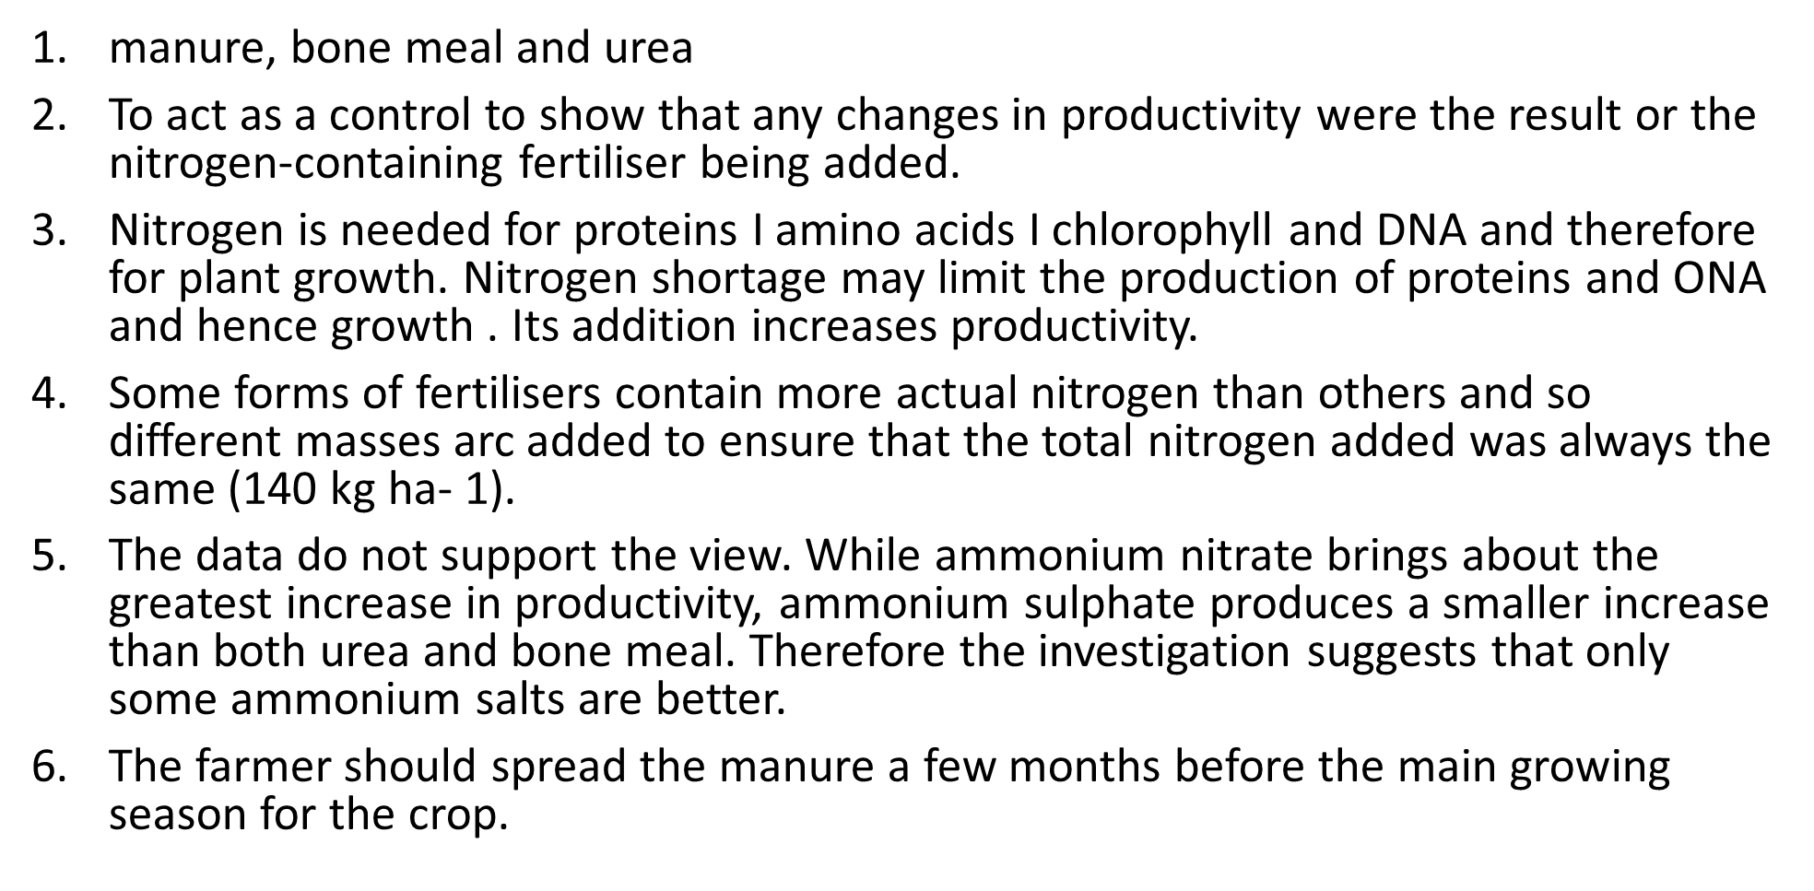

Environmental consequences of using fertilisers
The effects of nitrogen fertilisers

Nitrogen containing fertilisers can have detrimental effects such as:
Reduced species diversity – nitrogen favours the growth of rapidly growing species such as grasses, nettles and weeds. Some species grow quickly and out compete the others.
Leaching – leads to pollution of watercourses
Eutrophication – caused by leaching of fertilisers into watercourses

Leaching
- Rain water can dissolve soluble nitrates and carry them deeper into the soil beyond the reach of plant roots.
- The nitrates may travel to water courses and into water that is used for human consumption.
- High levels of nitrates in water can cause inefficient transport of oxygen to the brain.
Eutrophication
Eutrophication consists of the following sequence of events:
- In most lakes, there are very few nitrates and so this is limiting factor on plant/algae growth
- Nitrate/ Nutrient levels increase due to leaching, there is no longer a limiting factor, and so plants/algae both grow exponentially
- Algae grow and cover the upper layers of the water. This is called “algae bloom”.
- The algae on the top of the water, absorbs sunlight, preventing it from reaching the bottom of the lake.
- Light becomes a limiting factor for plants/algae at the bottom of the lake and so they die
- Saprophytic algae can now grow exponentially feeding on the decaying plant matter. More aerobic saprophytic bacteria, more oxygen used up in respiration and more nitrates produced from decaying organisms.
- Oxygen is a limiting factor for aerobic organisms such as fish and so they eventually die.
- Without any aerobically respiring organisms, anaerobically respiring organisms no longer have to compete and so they begin increase in number. Anaerobic organisms further breakdown other dead material thus producing more nitrates as well as some toxic wastes such as, hydrogen sulphide which makes the water putrid
Use the box to draw and annotate a diagram describing the stages of eutrophication.

Exam Questions:
Q1. Answers should be written in continuous prose, where appropriate.
A large lake is surrounded by fields. These fields are separated from each other by hedges. One hundred years ago the lake was a habitat for many plants, invertebrates and fish. Today the lake has no fish and few plants or invertebrates. Explain how increased use of inorganic fertilisers on the fields may have led to these changes.
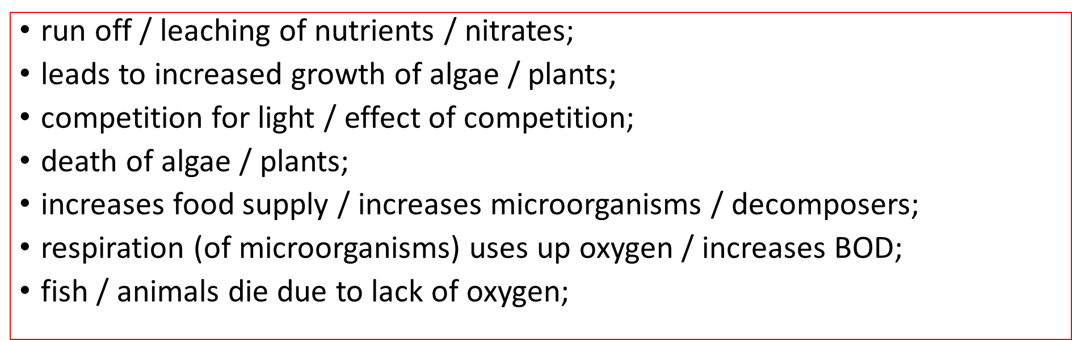
................................................................................................................................
................................................................................................................................
................................................................................................................................
................................................................................................................................
.............................................................................................................................(5)
Q2. Purification ponds can be used in warm climates to break down sewage. The ponds are about 1m deep and contain bacteria and green algae. The diagram summarises the processes involved in the breakdown of sewage in a purification pond.
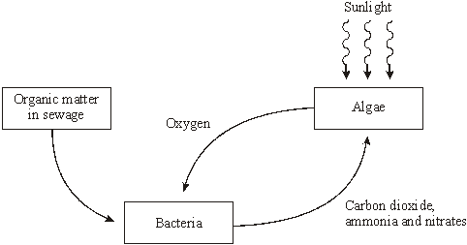

- Explain the advantage of having both algae and bacteria in a purification pond.
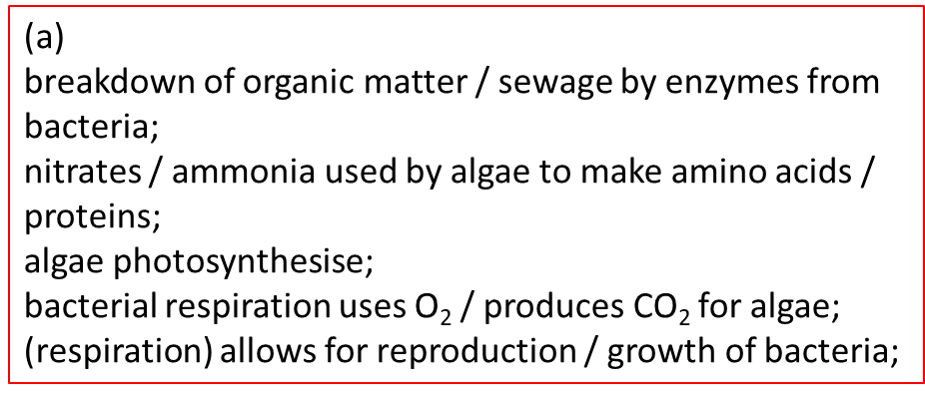

......................................................................................................................
......................................................................................................................
......................................................................................................................
................................................................................................................. (4)
(b) Purification ponds only work efficiently when they are shallow and warm. Explain why.
(b)
sufficient light penetration for photosynthesis (of algae);
warm leads to faster enzyme activity;
faster bacterial respiration / decomposition;
faster photosynthesis;
increased growth / reproduction of bacteria / algae;

................................................................................................................. (4)
Read through pages 313-314 of the Toole & Toole text book Then complete the poster below. The skill you are practising is to condense information into concise, precise information. MAX 50 WORDS PER B0X
Eutrophication (You could draw a flow diagram)
Leaching
Reduced species Diversity
Effects of nitrogen-containing fertilisers

