Photosynthesis
GCSE and Yr 1 Bridging Work

- GCSE photosynthesis. Can you balance the equation below:

CO₂ + O₂ ^{light energy}₋₋ C₆H₁₂O₆ + O₂

- GCSE photosynthesis True or false: Plants respire constantly. ______________________________________
- GCSE photosynthesis. Justify your answer to the question above. ___________________________________
________________________________________________________________________________________
- Leaf structure. Label the image of a leaf
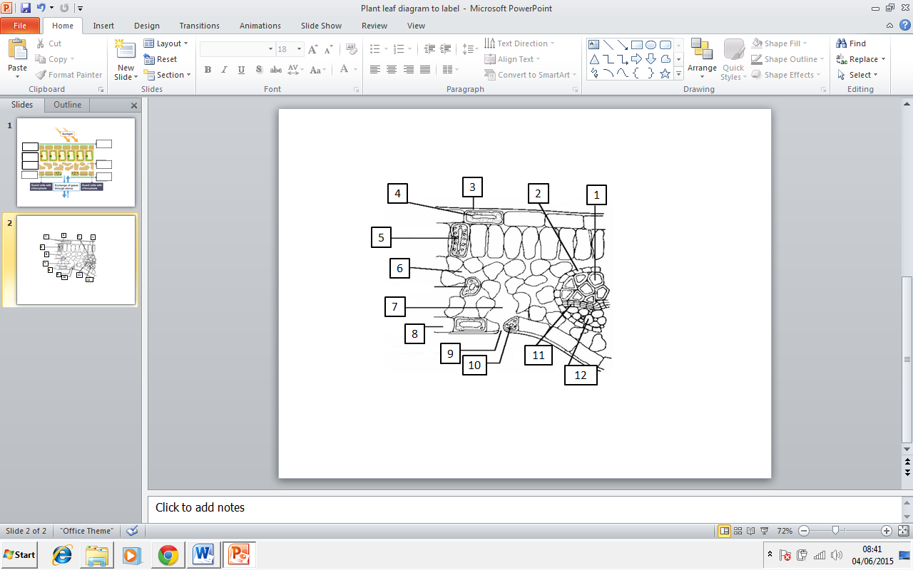

Outcome:
- Describe the structure of chloroplasts, explain where the light independent reaction occurs, explain where the light dependent reaction occurs.

- Chloroplast structure and function. Label the structure for image 1 and 2. Describe the function of each label.

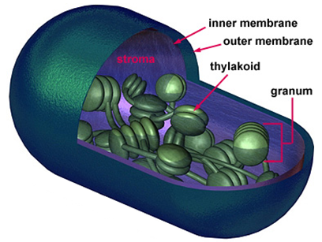

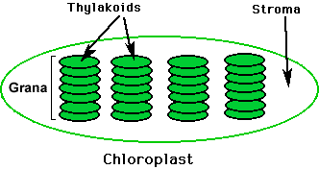

Image 2

Image 1

- Chloroplast structure and function. Use the words provided to fill in the gaps below.
Envelope | Chloroplast | DNA | Stroma | Starch
Ribosomes | Light independent | Light dependent | Membrane | Lipid
 | Thylakoid |  | Grana

The organelles that carry out photosynthesis are called___________________ They are surrounded by a double ___________________ called the ___________________. Chloroplasts contain both ___________________ and ___________________ that allows them to make their own proteins. Inside the chloroplast is a fluid called the ___________________ that carries out the ___________________ reaction. It also contains___________________ grains and _________________ droplets. Within the stroma are disc-like structures called ___________________ that are stacked together in groups of up to 100 to form structures called ___________________. This is where the___________________ reaction of photosynthesis takes place.

- Chloroplast structure and function. Name the cell shown and state where they are found. Why do the chloroplasts move around the cell?
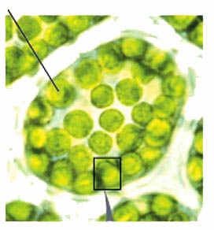
____________________________________________________
____________________________________________________
____________________________________________________

- Chloroplast structure and function. Name the type of microscope used to produce these images, explain your answer.
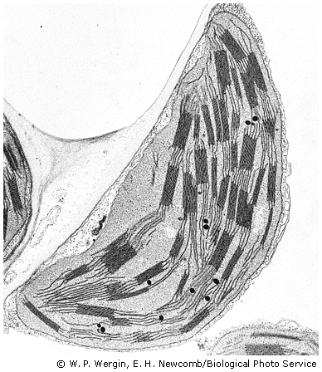
________________________________________________________________________________________________________________________________________________________________________________
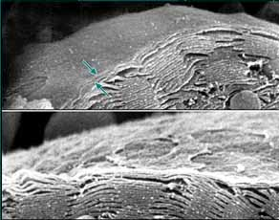

- Chloroplast structure and function.
- Chloroplast contain starch grains. State the monomer(s) within starch, describe how you would test for the presence of starch.
_______________________________________________________________________________________________________________________________________________________________________________________________________________________________________________________________
- Suggest why chloroplast use starch grains as an effective storage molecule.
__________________________________________________________________________________________________________________________________________________________________________
- Chloroplasts contain oil droplets. State the monomer(s) within the oil droplets, describe how you would test for the presence of oil.
- _______________________________________________________________________________________________________________________________________________________________________________________________________________________________________________________________
- Chloroplasts contain enzymes, describe how you would test for the presence of enzymes.
__________________________________________________________________________________________________________________________________________________________________________

- Chloroplast structure and function The grana contain an enzyme known as ATP synthase. Suggest the function of ATP synthase.
________________________________________________________________________________________________________________________________________________________________________________
- ATP structure and function. In the process of photosynthesis the plant produces ATP. Draw and label the structure of an ATP molecule (You should have at least 4 labels)

- ATP structure and function . List 3 reasons why ATP is a good energy storage molecule.
________________________________________________________________________________________________________________________________________________________________________________
__________________________________________________________________________________________________________________________________________________________________________

