Photosynthesis homework 2:Light independent stage, limiting factors
Q4.Scientists investigated the effect of the water potential of soil water on plant growth. They investigated the effect of this water potential on several plant processes.
The figure below shows their results in the form they were presented. The bars show whether or not each process was occurring. The plants stopped growing when the water potential of the soil water was below –0.7 mPa. All of the changes in the plants were related to the ability of the roots to take up water from the soil.
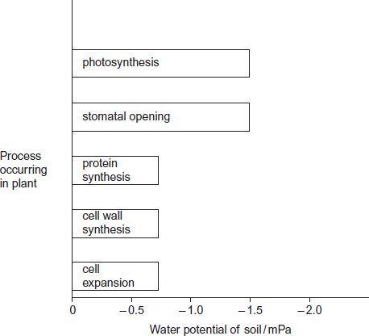
(a) Describe the results in the figure.
___________________________________________________________________
___________________________________________________________________
___________________________________________________________________
___________________________________________________________________(2)
(b) Explain the relationship between stomatal opening and photosynthesis.
___________________________________________________________________
___________________________________________________________________
___________________________________________________________________(2)
(c) Although photosynthesis is still occurring, plants stop growing when the soil water potential falls below –0.7 mPa. Use information from the figure above to suggest two reasons why.
___________________________________________________________________
___________________________________________________________________
___________________________________________________________________ (3)

Q5.During photosynthesis, carbon dioxide reacts with ribulose bisphosphate (RuBP) to form two molecules of glycerate 3-phosphate (GP). This reaction is catalysed by the enzyme Rubisco. Rubisco can also catalyse a reaction between RuBP and oxygen to form one molecule of GP and one molecule of phosphoglycolate. Both the reactions catalysed by Rubisco are shown in Figure 1.
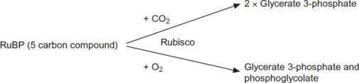
(a) (i) Where exactly in a cell is the enzyme Rubisco found?
______________________________________________________________(1)
(ii) Use the information provided to give the number of carbon atoms in one molecule of phosphoglycolate.
 (1)
(b) Scientists investigated the effect of different concentrations of oxygen on the rate of absorption of carbon dioxide by leaves of soya bean plants. Their results are shown in Figure 2.
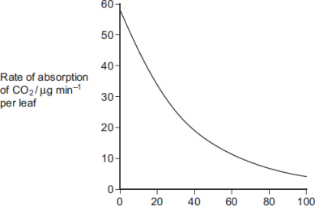
Concentration of oxygen / %
Use Figure 1 to explain the results obtained in Figure 2.
___________________________________________________________________
___________________________________________________________________
___________________________________________________________________
___________________________________________________________________(2)

(c) Use the information provided and your knowledge of the light-independent reaction to explain why the yield from soya bean plants is decreased at higher concentrations of oxygen. Phosphoglycolate is not used in the light-independent reaction.
___________________________________________________________________
___________________________________________________________________
___________________________________________________________________
___________________________________________________________________(3)
Q6.The diagram shows the energy flow through a freshwater ecosystem.
All units are kJ m^{–2}year^{–1}.
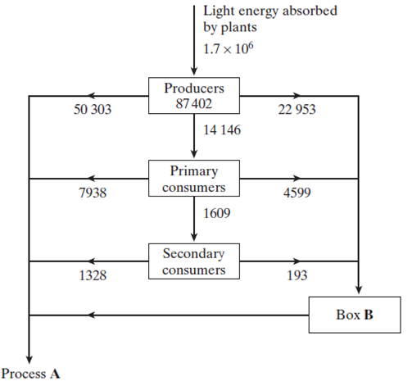
(a) Name
(i) process A;
______________________________________________________________(1)
(ii) the group of organisms represented by box B.
______________________________________________________________(1)
(b) Calculate the percentage efficiency with which light energy is transferred to energy in producers. Show your working.

Answer ____________________(2)
(c) Describe the effect of light energy in the light-dependent reaction of photosynthesis.
___________________________________________________________________
___________________________________________________________________
___________________________________________________________________ (2)
(d) If a plant is kept in the dark it is still able to produce carbohydrates, as long as it is provided with two products of the light-dependent reaction of photosynthesis. Give the name of these products and explain their function in the light-independent reaction of photosynthesis.
Name _____________________________________________________________
Function ___________________________________________________________
___________________________________________________________________
Name _____________________________________________________________
Function ___________________________________________________________
___________________________________________________________________(4)
Q7.An investigation was carried out into the effect of carbon dioxide concentration and light intensity on the rate of photosynthesis in a species of plant.
(a) The temperature was kept constant during this investigation. Explain why.
___________________________________________________________________
___________________________________________________________________(2)
(b) The table shows the effect of increasing carbon dioxide concentration on the rate of photosynthesis in maize.

Carbon dioxide  concentration / arbitrary units | Rate of photosynthesis / arbitrary  units
30 | 10
60 | 20
100 | 30
150 | 40
230 | 50
300 | 60
400 | 60

Describe and explain the effect of increasing carbon dioxide concentration on the rate of photosynthesis.
___________________________________________________________________
___________________________________________________________________
___________________________________________________________________
___________________________________________________________________ (3)
Q8. Comprehension Practice
Resource A – D relate to a single investigation.
Scientists investigated the effect of supplying extra carbon dioxide on the yield of tomatoes growing in a glasshouse. They compared the mean yield of tomatoes from 1995 to 1997 when no extra carbon dioxide was supplied with the mean yield of tomatoes from 1998 to 2000 when extra carbon dioxide was supplied.
Resource A Tomato plants were grown in two glasshouses, each with an area of 2000 m². Figure 1 shows the mean number of hours of sunshine per month during fruit production.

 | 1995 - 1997  (no extra carbon dioxide) | 1998 - 2000  (extra carbon dioxide)
Mean number of hours of  sunshine per month | 148.91 | 147.00
• The scientists used heating to maintain the tempera ture inside the glasshouses above 18 °C. They opened the windows to keep the tempera ture below 30 °C.
• From 1998 to 2000 they maintained the carbon dioxide concentration between 0.06 % and 0.08 % when the windows were closed and between 0.04 % and 0.05 % when the windows were open.
• The carbon dioxide concentration in the air outside the glasshouse was 0.04 %.
Resource B Figure 2 shows the mean difference between the yield of tomatoes with extra carbon dioxide and the yield with no extra carbon dioxide for each week during the harvesting period.
If the yield is greater when extra carbon dioxide is supplied, the difference in yield is shown as an increase. If the yield is lower when extra carbon dioxide is supplied, the difference is shown as a decrease.
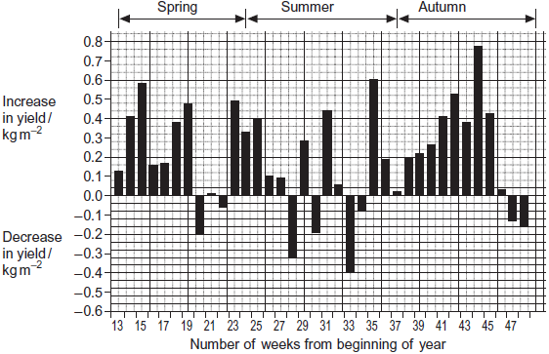
Resource C Figure 3 shows the relationship between the time when the tomatoes were harvested and the yield.

Number of weeks from  beginning of year | Mean yield per week with  extra carbon dioxide / kg m^{–2} | Mean yield per week without  extra carbon dioxide / kg m^{–2}
13 – 19 | 1.25 | 0.83
20 – 25 | 1.62 | 1.47
26 – 48 | 1.23 | 1.06
The commercial price for tomatoes varies with the time of year. The highest price is paid for tomatoes between weeks 13 and 19. The lowest price is paid between weeks 26 and 48.
Resource D Whiteflies are an important insect pest of tomatoes. The adults can fly from plant to plant. Their young do not have wings. The adults and young feed on the plant sap and introduce viruses into the tomato plants. Feeding and the introduction of viruses both reduce the yield of tomatoes. The scientists controlled the number of whitefly in the glasshouses by releasing parasitic wasps. The wasps lay their eggs in the young of the whitefly. The wasp eggs hatch and feed on the young whitefly, killing them.
(a) (i) An increase in carbon dioxide concentration affected the yield of tomatoes in week 35. Use Figure 2 to describe how.
______________________________________________________________
______________________________________________________________(1)
(ii) There was a decrease in yield when extra carbon dioxide was supplied during some weeks of the year. Use information from Resource A to suggest why.
______________________________________________________________ (1)

(b) Using Figure 3, calculate the percentage increase in yield when extra carbon dioxide was added for weeks 13 to 19. Show your working.

Percentage increase ____________________(2)
(c) Additional information is required for tomato growers to decide whether it is economically profitable to add extra carbon dioxide to produce very early tomatoes.
Give two pieces of information that the growers would require.
1. _________________________________________________________________
___________________________________________________________________
2. _________________________________________________________________
___________________________________________________________________(2)
(d) Adding extra carbon dioxide during the summer (weeks 24 – 36) is unlikely to be profitable. Use data from the resource sheet explain why.
___________________________________________________________________
___________________________________________________________________
___________________________________________________________________
___________________________________________________________________(2)
(e) The control experiment in this investigation was when data were collected with no extra carbon dioxide added. Some scientists said this control experiment was not satisfactory. Explain how you could improve the control experiment.
___________________________________________________________________
___________________________________________________________________
___________________________________________________________________
___________________________________________________________________(2)

