3.6.1: Survival and response
Name __Teacher______________________________
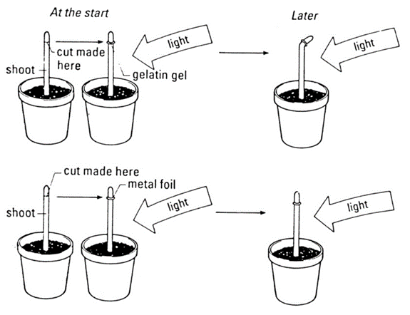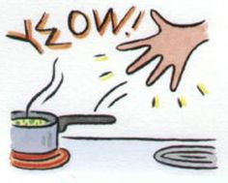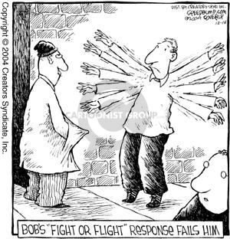
Reflection on Learning outcomes | or | Target
Explain what is meant by taxes, kineses, how they differ and how taxes & kineses aid survival.
Explain what is meant by phototropism and gravitropism, and by positive and negative tropisms and how this is caused by IAA.
Describe where IAA is produced and the effect different concentrations have on root/shoot growth.
Apply knowledge of kineses and IAA to draw and explain conclusions with appropriate stat tests.
Explain the role of reflexes and why they are important.
Explain the role of sensory, intermediate and motor neurones in a reflex arc and explain the sequence of events which bring about a reflex action.
Explain the features of sensory reception which are common to all receptors.
Explain what is meant by the sympathetic and parasympathetic nervous system.
Describe the structure of a Pacinian corpuscle and explain the stimulus which Pacinian corpuscles respond to produces a generator potential in a response to a specific stimulus.
Identify the pigments in rod and cone cells.
Explain how rod and cone cells’ visual acuity, sensitivity to light and sensitivity to colour are accounted for by the presence of rhodopsin/iodopsin and connections to the optic nerve.
Describe, and locate on a diagram, the structures, which are responsible for events during the cardiac cycle and explain the events which take place during the cardiac cycle to stimulate and transmit a wave of electrical activity to make the heartbeat.
Explain the roles of the SAN, AVN and bundle of His.
Explain the location of, and the role played by chemoreceptors and pressure receptors involved in detecting changes which lead to changes in heart rate.
Explain the role of the autonomic nervous system (sympathetic and parasympathetic) in controlling heart rate.
Explain the role of the medulla oblongata.
Outcome:
- Explain what is meant by taxes, kineses, how they differ and how taxes & kineses aid survival.
- Explain what is meant by phototropism and gravitropism, and by positive and negative tropisms and how this is caused by IAA
Glossary of term
Term | Definition
Stimulus | Detectable change in internal/external environment that causes a change to the organism
Receptor | Cell that detects a stimulus. Receptors are specific to 1 type of stimulus
Coordinator | Formulates a suitable response to a stimulus
Effector | Organ that produces a response
Taxis | A directional response  Towards the stimulus is known as positive taxis  Away from the stimulus is known as negative taxis
Kinesis | A non-directional response  Causes organisms to change the speed of their movement  In favourable conditions movement is slow with many turns  In unfavourable conditions movement is fast with few turns
Tropism  (Geo, photo) | The growth of a plant in response to a directional stimulus  Towards the stimulus is known as positive tropism  Away from the stimulus is known as negative tropism
Taxis and kinesis
In your exam you are given “novel” or “unknown” examples of behaviour in different organisms, you need to be able to identify the type of behaviour shown and then justify (provide evidence for) your answer from the information the question has given you. Do these images/descriptions show Kinesis or taxis? Can you work out if this is + or -?
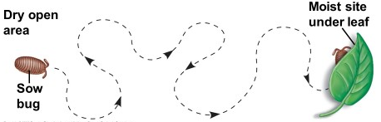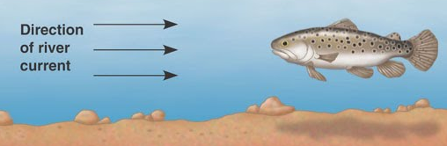
Image 1: Kinesis
Justification: Non-directional, turns
Image 2: Taxis
Justification: Directional, into river current, positive
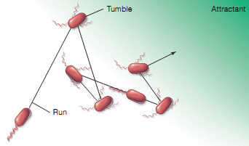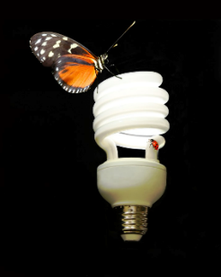
Image 3: Kinesis
Justification: turns
Image 4: Taxis
Justification: positive phototaxis towards the light source
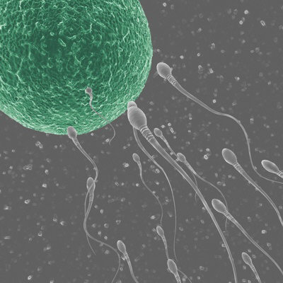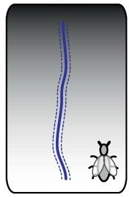
Description 1: Some species of bacteria move away from the waste they produce.
Description 1:Taxis
Justification: In question- Directional

Description 2: Earthworms burrow down into soil
Description 2:Taxis
Justification: In question- Directional

Image 5: Taxis
Justification: positive chemotaxis towards the chemical released by the egg
Image 6: Taxis
Justification: positive phototaxis towards the light source
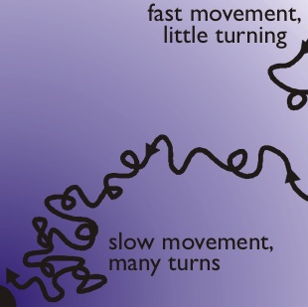
Image 7: Kinesis
Justification: speed of movement and the turns

Description 3: Flatworms make many random turns when a chemical gradient is detected.
Description 3:Kinesis
Justification: In question

Description 4: Maggots are larvae of flies move away from bright light
Description 4:Taxis
Justification: In question- Directional

Description 5: 20 flatworms were placed in a dish of water; after an hour the flatworms were evenly spread around the dish. A light proof cover was placed over half the dish, one hour later all the flatworms were slowly moving in the dark side of the dish.
Description 5: Kinesis
Justification: In question- Implies speed

T/F quiz.
If statement is false then you need to correct it.
1. Taxis and kinesis are directional responses. F- Kinesis isn’t directional
2. Tropism can occur in plants and animals. F- Plants only
3. Movement towards a stimulus is known as “positive”. T
4. Stimulus is a detectable change in internal environment. F- Can be external too
5. Stimuli are detected by receptors. T
6. An effector is an organ that bring about a response to a stimulus. T
7. Woodlice move slower in moist conditions, this is known as a positive kinesis. F- Kinesis can’t be + as its non-directional
8. Plant shoots show negative phototropism. F- + phototropism
9. Roots show geotropism. T
10. Receptors can be stimulated by hormones. T

Outcome:
- Describe where IAA is produced and the effect different concentrations have on root/shoot growth.

Kinesis, taxis and tropisms are responses to internal or external stimulus. You need to be able to describe the response and also be able to describe and explain how this how this response is brought about by a stimulus.

Tropism
In plants the response is a tropism, this tropism is caused by a chemical called IAA. You need to be able to describe and apply your knowledge of how IAA causes tropism.

Phototropism | Gravitropism/Geotropism
- Cell at shoot tip produce IAA  - IAA diffuses down all regions of shoot  - Direction of light affects diffusion of IAA. IAA diffuses away from light  - IAA concentration build up on shaded side of shoot. IAA causes cell elongation.  - Shaded side of shoot elongated faster than non-shaded side. Shoot tip bends towards light. | - Cell at root tip produced IAA  - IAA diffuses down all regions of root.  - Gravity causes movement of IAA from upper to lower side of root cells.  - IAA concentration build up on lower side of root. IAA inhibit cell elongation.  - Lower side of root elongates slower than upper side of root. Root tip bends downwards deeper into soil.

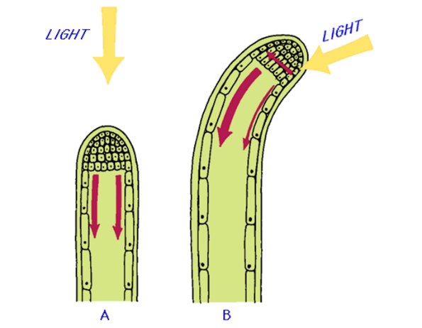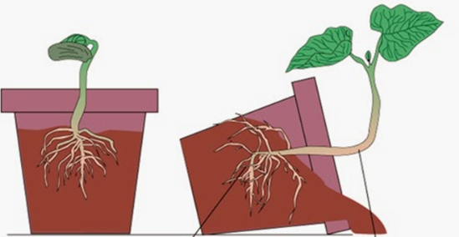
Outcome:
- Apply knowledge of kineses and IAA to draw and explain conclusions with appropriate stat tests.
Exam Questions: Tropism application questions
Q1. Scientists investigated the response of lateral roots to gravity. Lateral roots grow from the side of main roots. The diagrams show four stages, A to D, in the growth of a lateral root and typical cells from the tip of the lateral root in each stage. All of the cells are drawn with the bottom of the cell towards the bottom of the page.
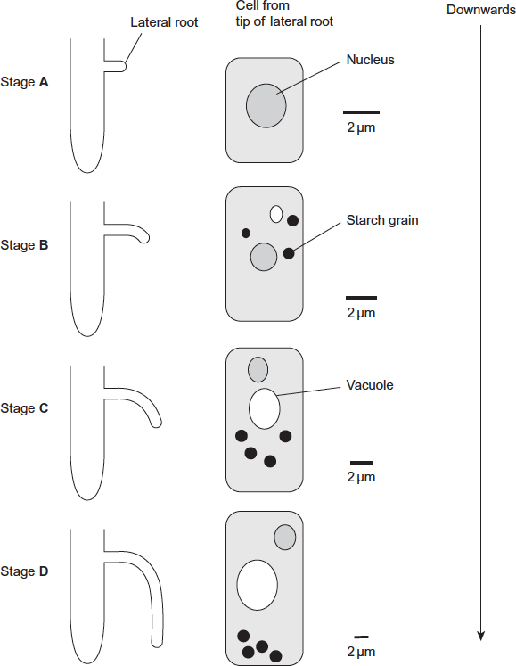
Describe three changes in the root tip cells
between stages A and D.
- Three changes described;;;
Neutral nucleus shrinks, since it doesn’t. Eg

- Formation / growth of vacuole;

- Formation of starch grains / amyloplasts; Accept starch grains get bigger

- Movement of grains / amyloplasts towards bottom of cell; Note − list rule applies

- Cells get longer / wider / larger;

3 max

(b) The scientists’ hypothesis was that there was a relationship between the starch grains in the root tip cells and the bending and direction of growth of lateral roots. Does the information in the diagram support this hypothesis? Give reasons for your answer.

(b) 1. Grows sideways before starch grains form;
2. Bending starts when / as grains form;
3. More bending as grains increase in number; Ignore starch grain growth references
4. More elongation (of cells) / growth (of roots) downwards as starch grains increase / move;
5. Bending starts before grains move down;
6. Could be related to vacuole; Ignore references to nucleus

(c) The diagram shows the distribution of indoleacetic acid (IAA) in the lateral root at Stage B. Explain how this distribution of IAA causes the root to bend.
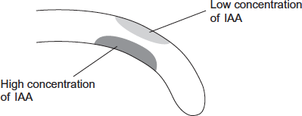
(c) 1. (IAA) at bottom of root / where IAA concentration high inhibits expansion / elongation (of cells);
2 and 3 need reference to expansion / elongation, not just growth
2. (IAA) at top of root / where IAA concentration low leads to expansion / elongation (of cells); Accept less inhibition
Q2. IAA is a specific growth factor.
(a) Name the process by which IAA moves from the growing regions of a plant shoot to other tissues.
Diffusion

(b) When a young shoot is illuminated from one side, IAA stimulates growth on the shaded side. Explain why growth on the shaded side helps to maintain the leaves in a favourable environment.

(b) 1. Causes plant to bend / grow towards light / positive phototropism;

2. (Light) required for photosynthesis;

NAA is a similar substance to IAA. It is used to control the growth of cultivated plants. Plant physiologists investigated the effect of temperature on the uptake of NAA by leaves. They sprayed a solution containing NAA on the upper and lower surfaces of a leaf. The graph shows their results.
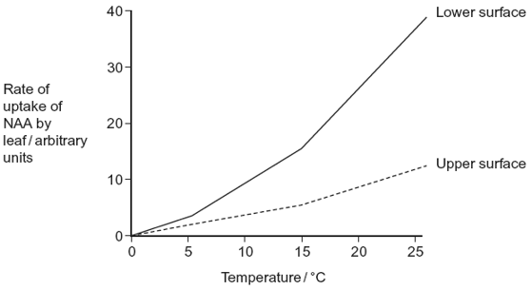
(c) Explain the effect of temperature on the rate at which NAA is taken up by the lower surface of the leaf.

1. More kinetic energy / faster movement of molecules;

2. More diffusion;

Ignore references to opening stomata.

(d) There are differences in the properties of the cuticle on the upper and lower surfaces of leaves.
(i) Suggest how these differences in the cuticle might explain the differences in rates of uptake of NAA by the two surfaces.

1. Thick cuticle on upper surface / thin cuticle on lower surface / few stomata on upper surface / no stomata on upper surface;

2. More diffusion / shorter diffusion pathway (on lower surface);

1. Ignore cuticle only on upper surface. Ignore references to more or less waxy.
(ii) In this investigation, the physiologists investigated the leaves of pear trees. Explain why the results might be different for other species.

Different species have different (qualified) properties;

Eg cuticle thickness

Leaf size

Number of stomata

Exam Questions: Taxis and Kinesis application questions

Q1. A biologist investigated the behaviour of a species of worm that lives in soil. He cultured three samples of worms in three separate trays of soil for many days.
Each culture:

• contained a food supply

• was kept at a different temperature.
The temperatures of the cultures were 17 °C, 20 °C and 23 °C. The biologist then removed food from the trays for several hours. Then he transferred each sample of worms onto a glass surface where there was no food. Each surface had a temperature gradient across it. After 1 hour, the biologist recorded the position of each worm.

The figure below shows his results. On each diagram, 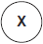 marks where he released the worms onto the glass surface.

Temperature gradient
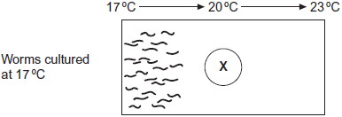

Temperature gradient
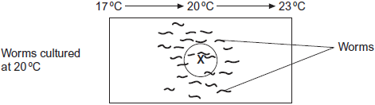

Temperature gradient
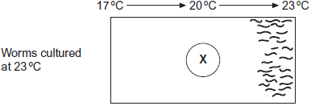
(a) The biologist concluded that the worms’ behaviour demonstrated taxis.
How do these results support this conclusion?

(a) 1. (Taxis is) movement towards / away from a stimulus / a directional response / movement (to a stimulus);

2. (Move towards) temperature they were used to / cultured in;

Movement towards temperature they were used to = 2 marks
(b) Using the information provided, suggest an explanation for the worms’ behaviour on the glass surfaces in the absence of food.

(b) 1. Hungry, so seeking food / in absence of food respond to temperature;

Ignore references to temperature and enzymes

Must be stated not inferred from other statements

2. Move towards temperature they were used to / cultured in;

3. Associate (this temperature) with food;

Accept they think food is here

Stated not inferred

4. (Then) stay in this temperature;

3 max
(c) In each experiment, the biologist exposed the surfaces to light that was dim and even, so he could see where the worms went. Apart from seeing where the worms went, suggest two reasons why it was important that the light was dim and even.

(c) 1. (Dim) worms live in soil / dark / affected by bright light / dim light is like normal environment / what they are used to;

2. (Even) because worms might move towards / away from bright light / to avoid creating light gradient / prevent worms showing phototaxis / all parts of surface exposed to same light;

Accept to avoid kinesis due to light

3. (Dim light) ensures heat from light not a variable / heat from lamp could kill / dry out worms;

Not just to control variables / factors

2 max

Outcome:
- Explain the role of reflexes and why they are important.
- Explain the role of sensory, intermediate and motor neurones in a reflex arc and explain the sequence of events which bring about a reflex action.
- Explain what is meant by the sympathetic and parasympathetic nervous system.

Kinesis, taxis and tropisms are responses to internal or external stimulus. You need to be able to describe the response and also be able to describe and explain how this how this response is brought about by a stimulus. You also need to be able to describe and explain how more complicated organisms have more complicated response systems.
In organisms the responses are brought about by the nervous and hormonal system. You need to understand the gross structure of the nervous system.
Structure of the nervous system
You do not need to learn these definitions but you do need to understand them as they will be used in the exam question. Put the correct term in the box using the words provided below:
Sensory neuron | Central nervous system | Motor Neuron
Peripheral nervous system | Somatic nervous system | Autonomic nervous system
Sympathetic nervous system | Reflex arc | Parasympathetic nervous system

Term | Definition
Motor neuron | A neurone that transmits an action potential from the central nervous system to an effector
Somatic NS | Carries nerve impulses to body muscles which are under conscious control.
Central NS | Spinal cord and brain.
Sensory Neuron | A neurone that transmits an action potential from a sensory receptor to the central nervous system
Reflex arc | Pathway of neurones involved in an involuntary response to sensory stimulus.
Peripheral NS | Neurones radiating out from the spinal cord to the rest of the body
Autonomic NS | Carries nerve impulses to glands, smooth or cardiac muscles which are not under conscious control, involuntary. Sympathetic and parasympathetic nervous system form part of this.
Sympathetic NS | Increases heart rate by sending more impulses to excite the SAN
Parasympathetic NS | Decreases heart rate by sending more impulses to inhibit the SAN

Add information to the diagrams below using the definitions in the table.
Make sentences of no more than 20 words explaining how the following terms link together.

- Sensory neuron, motor neuron and central nervous system
- Sensory neuron, motor neuron and peripheral nervous system
- Central nervous system, peripheral nervous system, somatic and autonomic nervous system.
- Motor neuron, peripheral nervous system, somatic and autonomic nervous system
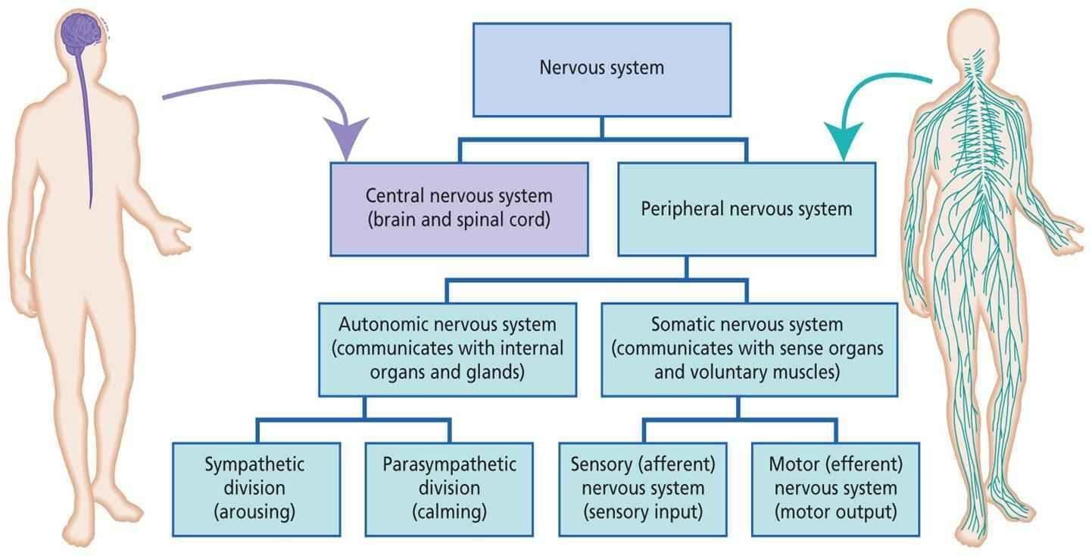
Image of the nervous system: Image of reflex arc:
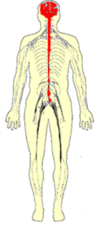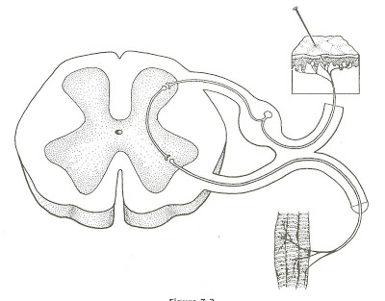
Neurone images:
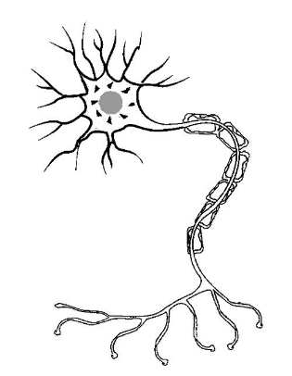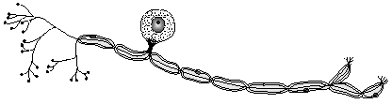

Space to write sentences:
Peripheral nervous system contains motor neurones which send impulses to the autonomic and somatic systems causing response.
Peripheral nervous system contains somatic and autonomic system which transmit/receives impulses from central nervous system
Sensory neurones carry impulses from receptor to central nervous system, motor neurones transmit impulses from central nervous system to effector.
Peripheral nervous system is made up of the motor and sensory neurones

Reflex arc
Features/importance of a reflex arc:
- Rapid
- Protect body tissues
- Doesn’t need to be learnt/involuntary
- Help escape predators/find food sources
- Enables homeostasis

Add the following labels to the diagram of a reflex arc. Highlight which labels are in the central nervous system and which are in the peripheral nervous system
Stimulus/receptor | Sensory neuron | Effector
Motor neuron | Inter/relay neuron | Spinal cord

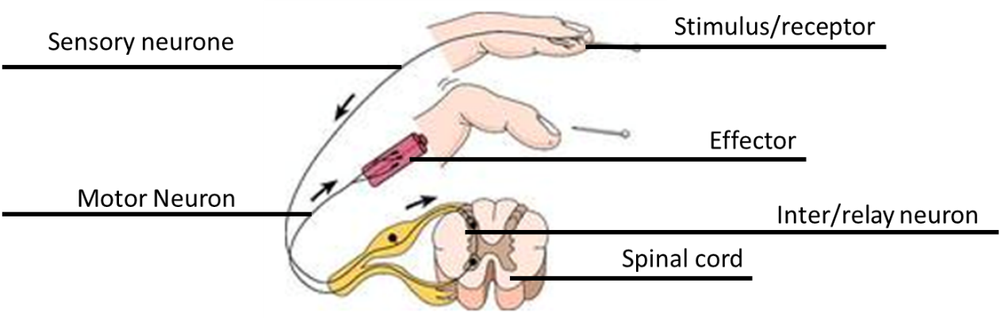
__________________________________________________________
Exam question
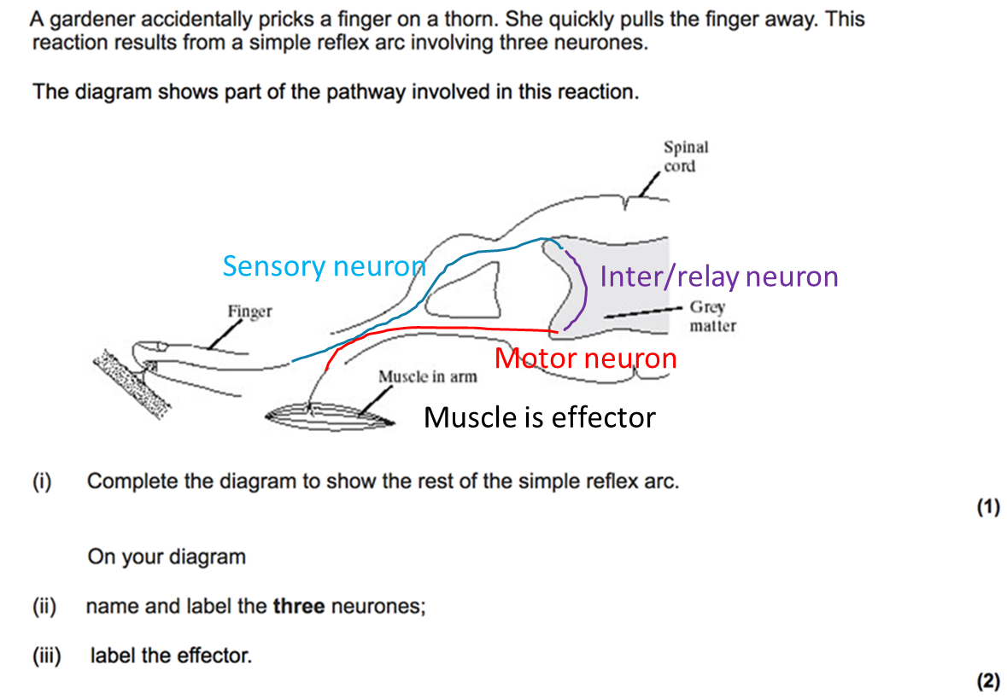
Outcome:
- Explain the features of sensory reception which are common to all receptors.

Receptors:
At the beginning of all responses is a receptor. Your body has lots of different types of receptors.
Common features shared by all receptors:
- Specific to a single type of stimulus
- Produces a generator potential by acting as a transducer.
Recap: Definitions from Nervous communication booklet
Definition:
Transducer: Converts between different forms of energy

Generator potential: Depolarisation of the membrane of a receptor cell as a result of stimulus till threshold is reached

Receptor: Pacinian corpuscle
Outcome:
- Describe the structure of a Pacinian corpuscle and explain the stimulus which Pacinian corpuscles respond to produces a generator potential in a response to a specific stimulus.
The image below is a hand drawing of what the Pacinian corpuscle looks like. Read page 337-338 in the textbook and add the following labels.
Layers of connective tissue/lamella Capsule Blood capillaries
Neurone ending (sensory) Stretch-mediated Na+ channels Dendron/neurone
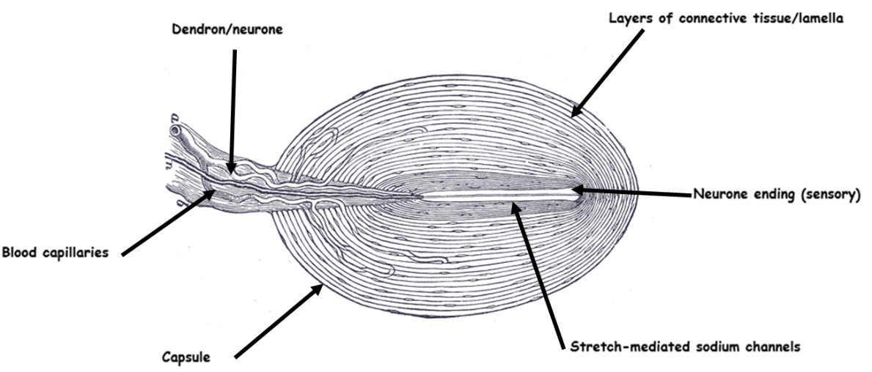
Description
At rest stretch mediated Na+ channels in the Pacinian Corpuscle are closed.
Pressure applied to corpuscle.
Lamella become DEFORMED.
Membrane around neurone stretches.
Causes the stretch-mediated Na+ channels to open.
Na+ diffuses into neurone down concentration gradient.
Produces generator potential. If generator potential is sufficient an action potential passes along the sensory neurone. Greater pressure opens more Na+ channels
Not all images in the exam will be the same. You will need to be able to identify the corpuscle from any image. You have 2 additional images below.
Describe 2 features that would identify these are the Pacinian corpuscle.
Transverse section.
Lamella around central Dendrite
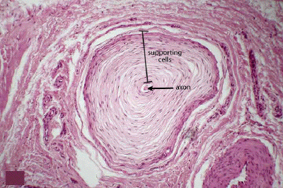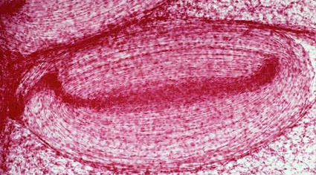
Longitudinal section.
Oval shaped with layered lamella

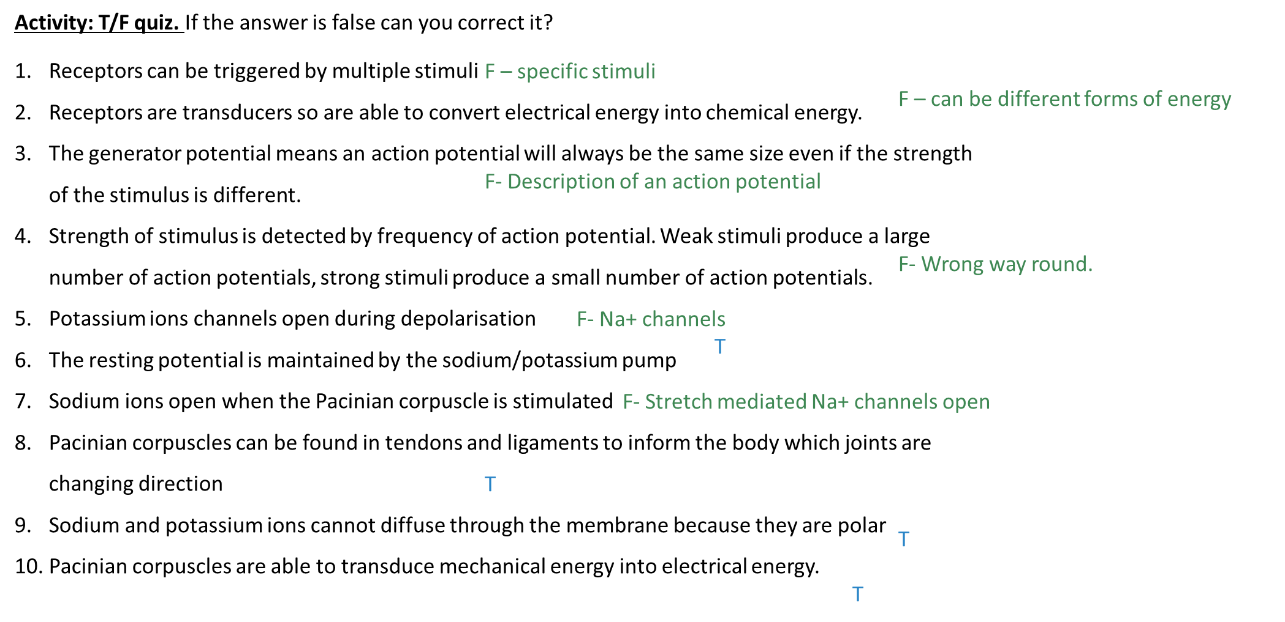

Exam question:

A biologist investigated the stimulation of a Pacinian corpuscle in the skin of a fingertip.
She used microelectrodes to measure the maximum membrane potential of a Pacinian corpuscle and its sensory neurone when different pressures were applied to the fingertip. The figure below shows the Pacinian corpuscle, its sensory neurone and the position of the microelectrodes.

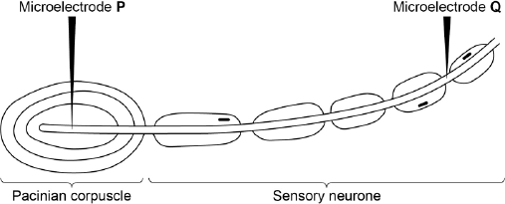

Pressure applied to the  fingertip | Membrane potential at P /  millivolts | Membrane potential at Q /  millivolts
None | –70 | –70
Light | –50 | –70
Medium | +30 | +40
Heavy | +40 | +40
(a) Explain how the resting potential of –70 mV is maintained in the sensory neurone when no pressure is applied.

(a) 1. Membrane more permeable to potassium ions and less permeable to sodium ions;

2. Sodium ions actively transported / pumped out and potassium ions in.

2

(b) Explain how applying pressure to the Pacinian corpuscle produces the changes in membrane potential recorded by microelectrode P.

(b) 1. (Pressure causes) membrane / lamellae to become deformed / stretched;

2. Sodium ion channels in membrane open and sodium ions move in;

3. Greater pressure more channels open / sodium ions enter.

3

(c) The membrane potential at Q was the same whether medium or heavy pressure was applied to the finger tip. Explain why.

(c) 1. Threshold has been reached;

2. (Threshold or above) causes maximal response / all or nothing principle.

2

Receptor: Photoreceptors (Rods and cones in the eyes)
Outcome:
- Identify the pigments in rod and cone cells.
- Explain how rod and cone cells’ visual acuity, sensitivity to light and sensitivity to colour are accounted for by the presence of rhodopsin/iodopsin and connections to the optic nerve.
Two types of photoreceptor:
Type 1: Rods Function: low light intensities Pigment: Rhodpsin
Type 2: Cones Function: Colour vision Pigment: Iodopsin
Definition:
Visual acuity: The ability of the brain to distinguish between two separate sources of light.
Poor visual acuity: The brain is not able to distinguish between 2 separate sources of light that are close together so are seen as one source of light (Rods).
Good visual acuity: The brain is able to distinguish between 2 separate sources of light that are close together so are seen as two separate sources of light (Cones).
Majority of the exam questions are based on these definitions.
Eye structure.
You DO NOT need to be able to label the structure of the eye, this is to help you understand the exam questions. Use the comprehension task on the PowerPoint and the labels provided to add details to the diagram below.
Retina | Lens | Fovea | Cornea
Pupil | Blind spot | Iris | Ciliary muscles
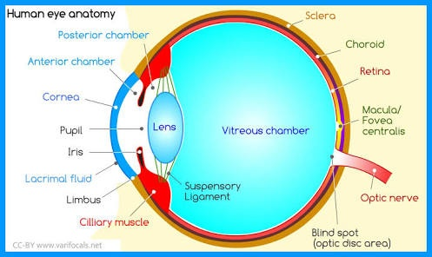

Use the comprehension and your labelled diagram to answer the question below. These are no exam questions.
- Describe the appearance of the pupil and lens when you are driving at night. Explain your answer.
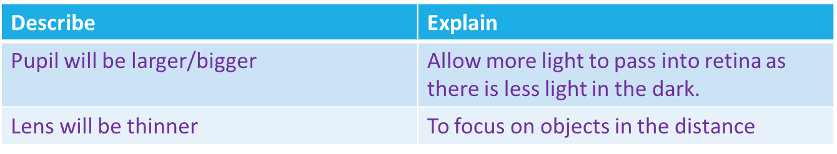
- The aqueous humor is a transparent jelly like substance. Suggest why.
Transparent to let maximum light through to the Retina
Jelly to maintain pressure/eye shape/eye structure/protect retina against mechanical damage
- Cones are clustered in the Fovea and are used to detect colour vision. Suggest why the cones are located directly behind the lens.
Colour vision is mostly used in the day
More light in the day to pupil will be smaller
Light more focused
Fovea is directly where the light is focused on the Retina.
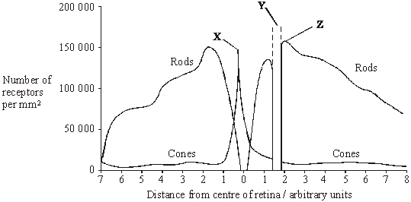
- Name X and Y from the graph.
X = Fovea Y= Blind spot/optic nerve
Retina Structure :
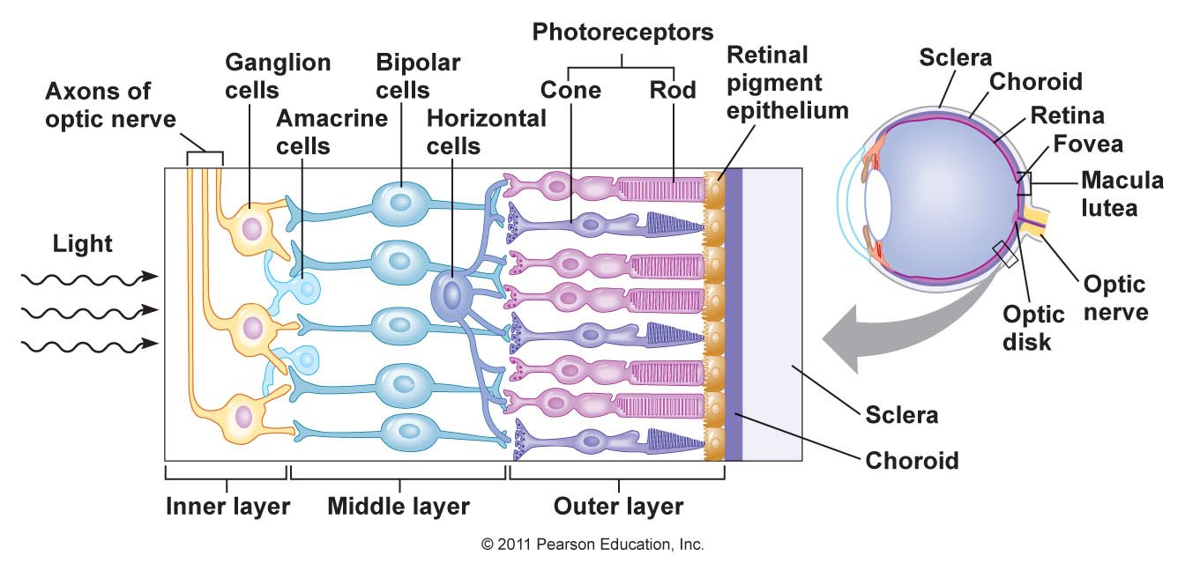
Use the words in the image to fill in the gaps below.
Light hits the Retina and passes through the _________ ______________ through the _____________ cells and hits the _________ and ___________ photoreceptors.
Photoreceptors:
Definition:
Retinal convergence: A number of rod cells are attached to 1 bipolar cell so it is more likely an action potential will be created.
Bleaching: When light convert all pigment inside Rod/Cone cell so cell is no longer sensitive to light so cannot produce an action potential. If no light pigment is reformed and Rod/Cone is sensitive again.
Use the slide on the PowerPoint to fill in the contrast table below. You must learn this table.
Pigment | Rhodopsin (Rod) | Iodopsin (Cone)
Types | 1 | 3: Red, blue, Green
Biological molecule | Protein | Protein
Sensitivity | Light intensity.  Very sensitive to light. | Colour.  Each pigment sensitive to different wavelength of light
Reaction | Rhodopsin + Light Opsin + Retinal | Iodopsin + Light Opsin + Retinal
Bipolar cell | Many rods to 1 bipolar cell | 1 cone to 1 bipolar cell
Visual Acuity | Low  Many rods synapse to 1 bipolar cell.  Many rods need to be stimulated to cause action potential in 1 bipolar cell.  Unable to distinguish separate points of light | High  1 cone synapses to 1 bipolar cell  1 cone needs to be stimulated to cause action potential in 1 bipolar cell  Able to distinguish separate points of light.
Location | Concentrated at periphery, fewer at Fovea, more. | Concentrated at Fovea, fewer at periphery of retina, less
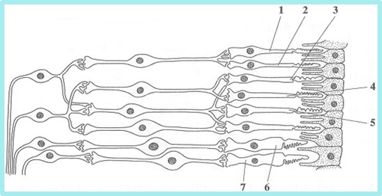
Light only needs to hit 6/7 to stimulate a bipolar cell. High visual acuity.
Light would need to hit 3,4,5 to stimulate 1 bipolar cell. Low visual acuity

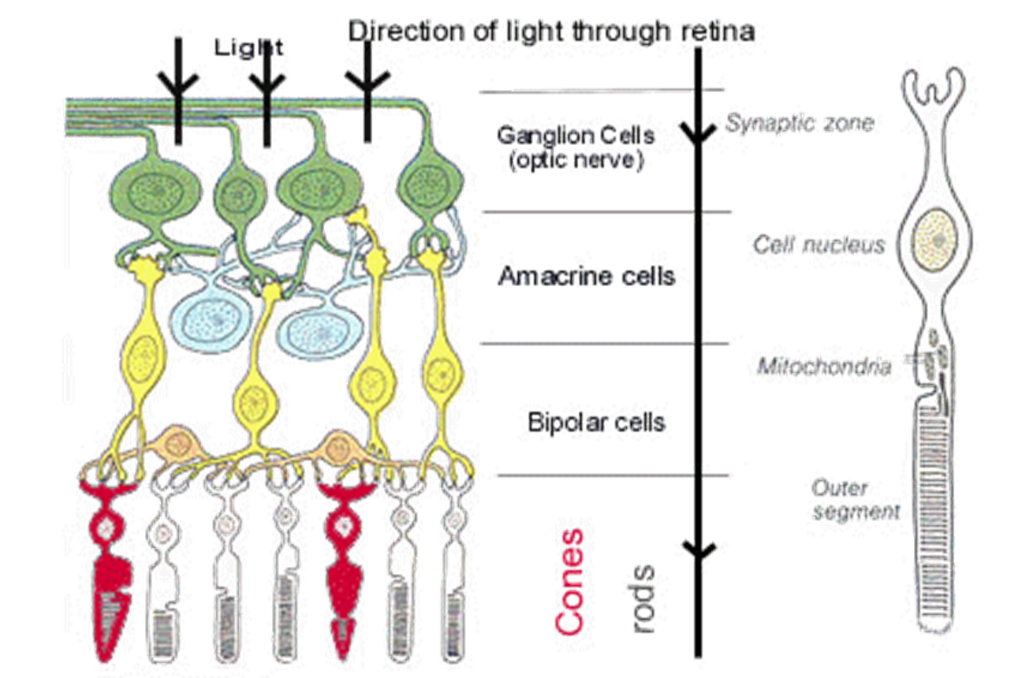

Exam Questions:

Q1. The diagram shows part of the retina in a human eye.

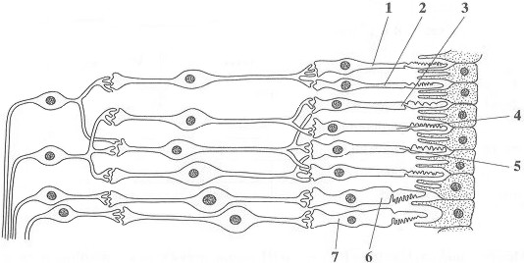
(a) Explain each of the following observations.
(i) When light falls on cells 1 and 2, only one spot of light is seen. But, when light falls on cells 2 and 3, two spots of light are seen.

1 and 2 share neurone but 2 and 3 have separate neurones (to brain);

(ii) When one unit of light energy falls on cell 3, no light is seen. But, when one unit of light energy falls on cell 3, one unit falls on cell 4 and one unit falls on cell 5, light is seen.

1 unit is sub-threshold / 3 units are above threshold / give sufficient depolarisation;
(1 unit) No impulses / no action potential / in (sensory) neurone /
does not stimulate (sensory) neurone / 3 units → impulses;
(Spatial) summation / sufficient neurotransmitter released / from
3 receptors / insufficient N-T from one;
Reject ‘temporal’
(b) Cells of the same type as cells 6 and 7 are found in large numbers at the fovea. This results in colour vision with high visual acuity.Explain what causes vision using the fovea.
(i) to be in colour;

(Three) different types of (cone) cells / types 6 and 7 sensitive to different wavelengths / different frequencies / different colours

(ii) to have high visual acuity.

Impulses along separate neurone from each receptor cell / each receptor cell connects to separate neurone;

Q2. After moving from bright light into darkness, it takes several minutes for the rod cells to recover their sensitivity. Researchers measured the ability of the rod cells to detect small spots of light of different colours and intensity after a person moved into darkness. The results are shown in Figure 1. Figure 2 shows the amount of light of different wavelengths that rhodopsin absorbs.

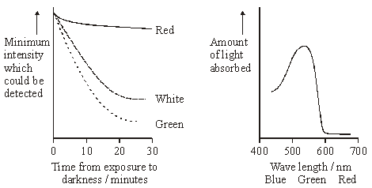

Figure 1 Figure 2
(i) Explain why it takes time for the rod cells to recover their sensitivity to light after moving into darkness.

Rhodopsin bleached / broken down by light;
Time for resynthesis;

(ii) Use information in Figures 1 and 2 to explain the differences in sensitivity of rod cells to red and green light.

Rhodopsin / pigment absorbs green light more readily than red / is more sensitive to green light;
(after resynthesis) less (intense) green light needed to break down rhodopsin (than red);

(iii) Suggest an explanation for the difference in sensitivity of rod cells to the white and green spots after 30 minutes.

White has (high proportion of) wavelengths to which rhodopsin not sensitive;

Outcome:
- Describe, and locate on a diagram, the structures, which are responsible for events during the cardiac cycle and explain the events which take place during the cardiac cycle to stimulate and transmit a wave of electrical activity to make the heartbeat.
- Explain the roles of the SAN, AVN and bundle of His.

Definitions:
Sino-atrial Node (SAN): Wall of right atrium produces initial wave of excitation to begin cardiac cycle. Pace-maker of the heart.
Atrio-ventricular Node (AVN): Detects wave of excitation, delays excitation, passes excitation down the septum to the purkyne fibres.
Bundles of His: Fibres connect to the AVN, located in the septum, carry wave of excitation to apex of heart.
Myogenic: Wave of excitation initiated within muscle cell itself.

Stage name | Electrical control of cardiac cycle | Cardiac cycle (MPVD)
Atrial Systole | - SAN sends wave of excitation across both atria causing muscle to contract  - Non-conductive tissue stops excitation passing into ventricles  - Wave of excitation picked up by AVN and delays excitation to allow atria to fully empty
Ventricular Systole | - AVN sends wave down Purkyne fibres to apex of the heart  - Wave of excitation is released by both side of the ventricles from the apex upwards causing ventricles to contract
Diastole | - Wave of excitation dissipates into the chest cavity, muscle relaxes
Year 1 maths recap:
Cardiac output = Stroke volume X heart rate.
- Rearrange the equation to work out the stroke volume.
Cardiac output/ heart rate = stroke volume
- If the stroke vol = 61cm³ and the heart rate = 79 beats per minute, what is the cardiac output?
61 x 79 = 4819cm3/min
- If the heart rate = 75bpm and cardiac output is 5175cm³ per min what is the stroke volume?
5175/75=69cm3
- If stroke volume is 0.071L and cardiac output is 5538cm³ per min, what is the heart rate?
5538/71=78bpm
- If the heart rate is 74bpm and cardiac output is 5402cm³ per min what is the stroke volume in L?
5402/74 = 73cm3 /1000=0.073l

Exam Questions:

Q1. The diagram shows the pathways in the heart for the conduction of electrical impulses during the cardiac cycle.

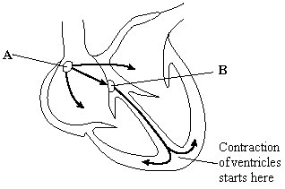

(a) The table shows the blood pressure in the left atrium, the left ventricle and the aorta at different times during part of a cardiac cycle.

 | Blood pressure / kPa
Time / s | Left atrium | Left ventricle | Aorta
0.0 | 0.5 | 0.4 | 10.6
0.1 | 1.2 | 0.7 | 10.6
0.2 | 0.3 | 6.7 | 10.6
0.3 | 0.4 | 17.3 | 16.0
0.4 | 0.8 | 8.0 | 12.0

(i) At which time is blood flowing into the aorta?

(i) 0.3 s

(ii) Between which times are the atrioventricular valves closed?

0.2 - 0.4 s

(b) The maximum pressure in the left ventricle is higher than the maximum pressure in the right ventricle. What causes this difference in pressure?

thicker / more muscle in the left ventricle

Q2. (a) Describe how a heartbeat is initiated and coordinated.

1. SAN sends wave of electrical activity / impulses (across atria) causing atrial contraction;

Accept excitation

2. Non-conducting tissue prevents immediate contraction of ventricles / prevents impulses reaching the ventricles;

3. AVN delays (impulse) whilst blood leaves atria / ventricles fill;

4. (AVN) sends wave of electrical activity / impulses down Bundle of His;

4. Allow Purkyne fibres / tissue

5. Causing ventricles to contract from base up;

(b) Explain how the heart muscle and the heart valves maintain a one-way flow of blood from the left atrium to the aorta.

1. Atrium has higher pressure than ventricle (due to filling / contraction) causing atrioventricular valves to open;

Start anywhere in sequence, but events must be in the correct order.

1. Accept bicuspid, reject tricuspid

2. Ventricle has higher pressure than atrium (due to filling / contraction) causing atrioventricular valves to close;

3. Ventricle has higher pressure than aorta causing semilunar valve to open;

Points 1, 2 and 3 must be comparative: eg higher 3. Allow aortic valve

4. Higher pressure in aorta than ventricle (as heart relaxes) causing semilunar valve to close;

4. Allow aortic valve

5. (Muscle / atrial / ventricular) contraction causes increase in pressure;

Outcome:
- Explain the location of, and the role played by chemoreceptors and pressure receptors involved in detecting changes which lead to changes in heart rate.
- Explain the role of the autonomic nervous system (sympathetic and parasympathetic) in controlling heart rate.
- Explain the role of the medulla oblongata.
Use page 342-343 in the textbook to complete the diagram using the labels below:

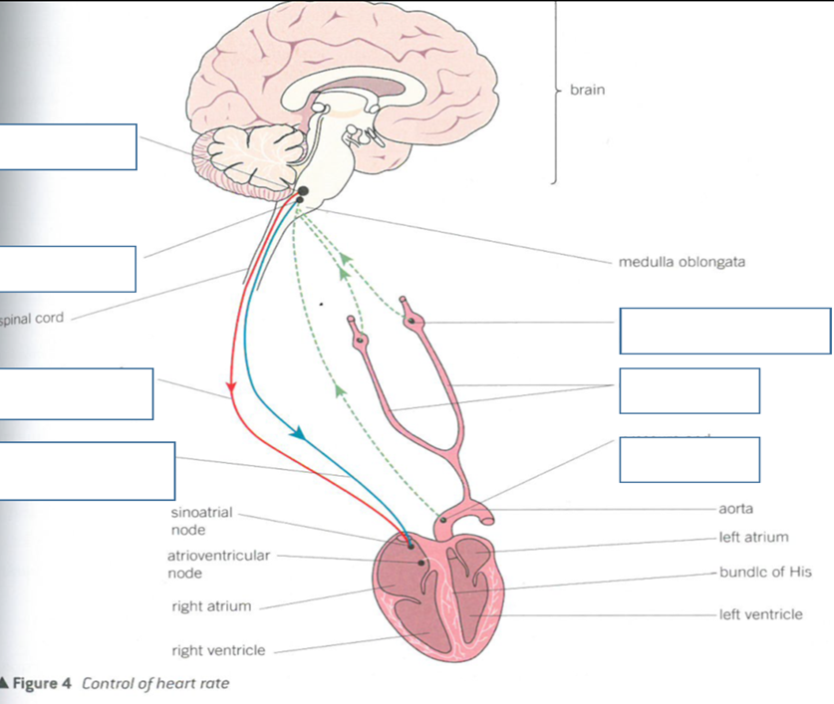
Factor | Receptor and location | Effect on heart rate
Rise in blood pressure | Pressure/Baro receptors in Aorta | - Increased impulses from baroreceptor to Medulla Oblongata  - Increased impulses via parasympethic NS to SAN  - Parasympathetic is inhibitory so reduces impulses from SAN  - Less impulses arrive to AVN  - Heart rate reduces
Rise in Carbon dioxide concentration/ increase in acidity of the blood | Chemoreceptors in Aorta | - Increased impulses from Chemoreceptor to Medulla Oblongata  - Increased Impulses via sympathetic NS to SAN  - Sympathetic is excitatory so increases impulses from SAN  - More impulses arrive to AVN  - Heart rate increases.
Effect of starting to exercise on cardiac cycle (incl the autonomic NS)

Year 1 cardiac cycle
Electrical control of cardiac cycle.

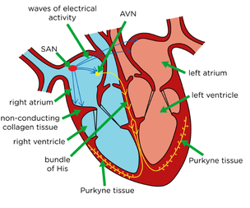
Effect of recovering from strenuous exercise on cardiac cycle (incl the autonomic NS)

Exam Questions:
Q1. (a) Exercise causes an increase in heart rate. Describe the role of receptors and of the nervous system in this process.

1. Chemoreceptors detect rise in CO₂ / H₊ / acidity / carbonic acid / fall in pH

OR Baro / pressure receptors detect rise in blood pressure;

2. Send impulses to cardiac centre / medulla;

3. More impulses to SAN;

4. By sympathetic (nervous system for chemoreceptors / CO₂)

OR

By parasympathetic (nervous system for baro / pressure receptors / blood pressure);

1. Ignore: location of receptors.

1. Ignore: chemoreceptors detect oxygen.

2 and 3. Accept: action potentials.

2. Reject: ‘messages’, ‘signals’, ‘an impulse’ or an ‘action potential’.

3. Ignore: messages’, ‘signals’, ‘an impulse’ or an ‘action potential’ as emphasis here is on increase in frequency.

(b) AMP-activated protein kinase (AMPK) is an enzyme that regulates a number of cellular processes. Exercise leads to activation of AMPK. The diagram shows one effect of activation of AMPK during exercise.

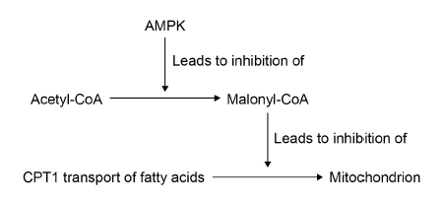
CPT1 is a channel protein that transports fatty acids into mitochondria. Using the diagram above, explain the benefit of activation of AMPK during exercise.

1. Less / no malonyl-CoA;

2. (More) fatty acids transported / moved into mitochondria;

3. Respiration / oxidation of fatty acids provides ATP;

1. ‘Inhibition of malonyl-CoA’ on its own is not enough but accept production of malonyl-CoA is inhibited.

2. Accept: ‘transport of fatty acids into mitochondria is not inhibited’.

2. Ignore: method of entry.

3. Accept: for respiration any stage of aerobic respiration e.g. Krebs (cycle), link (reaction) etc.

3. Reject: production of energy, but accept production of energy in the form of ATP.

3. Accept: acetyl CoA can enter Krebs cycle / mitochondria to provide ATP.
Q2. (a) Explain how a rise in blood pressure results in a decrease in the rate of heartbeat.

1. pressure receptors / baroreceptors / stretch receptors in aorta / carotid arteries / carotid sinus; (reject carotid body)
2. send impulses to cardiovascular centre / medulla / cardio-inhibitory centre;
(reject signals / messages / electronic)
3. impulses via parasympathetic nerves / vagus; (accept inhibitory nerve)
4. to SAN;
5. release of ACh / inhibits SAN / decreases impulses from SAN;
6. decreases impulses to AVN / decreased stimulation of AVN / decreases impulses from AVN;

(any reference to signals / messages / electronic disqualifies points 3 and 5 only)

(b) Some drugs inhibit the transmission of nerve impulses to the heart. Explain how these drugs reduce high blood pressure.

(b) 1. inhibit impulses in sympathetic nerves / from cardio-acceleratory centre;
2. SAN not stimulated / noradrenaline not released so heart rate lowers / does not increase;
(accept inhibits / blocks synapses);

