3.5.2 Respiration

Name __________________________________
Reflection on outcomes | or | Target
Know where the different stages of aerobic respiration occur.
Explain the roles of coenzymes and reduced NAD in respiration.
Explain the significance of the oxidation reactions involved in glycolysis, the link reaction and the Krebs cycle.
Describe the process of electron transfer associated with oxidative phosphorylation.
Explain chemiosmosis and the role of ATP synthase in producing ATP.
Describe the process of anaerobic respiration in animals and some microorganisms.
Explain the advantage of producing ethanol or lactate using reduced NAD.
Compare and contrast aerobic and anaerobic respiration.
Investigation into the effect of a named variable on the rate of respiration of cultures of single-celled organisms.
Interpret information/data about aerobic and anaerobic respiration and apply knowledge.
Describe how other substrates such as lipids and amino acids can be broken down into products which enter the Krebs cycle.

Outcome:
- Explain the roles of coenzymes and reduced NAD in respiration.
- Explain the significance of the oxidation reactions involved in glycolysis, the link reaction and the Krebs cycle.
Important molecules and definitions:
ATP Recap

- Draw and label the structure (components 1 mark)
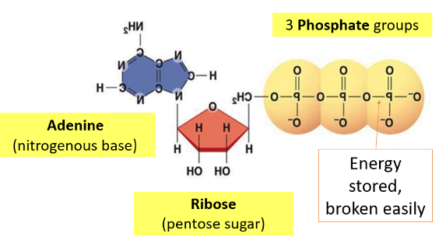

- Describe the equation for hydrolysis (correct 1 marks, reverse and enzymes 1 mark)

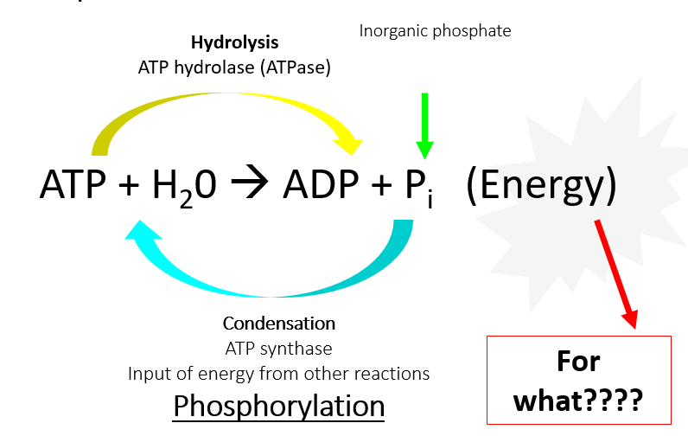

- List the used of ATP (3 examples 1 mark)

- Active transport
- Muscle contraction
- Synthesis of protein and DNA (anabolic reactions)
- Cell division
- Secretory activities (endo- and exocytosis)
- Activation of other molecules (phosphorylation of glucose)

- Explain why is it suitable as energy source (2 examples 1 mark)
- Immediate source of energy but cannot be stored so regularly re-synthesised
- Broken down in one step reaction so energy released quickly
- Releases small suitable amounts of energy that can be managed
- Can be re-synthesized (made again)
- Soluble – so transported around the cell
- Can not leave the cell
- Activates other molecules making them more reactive
- Describe the 3 ways to synthesis ATP (1 mark for each)
- Substrate-level phosphorylation
Phosphate transferred from other molecules
- Oxidative phosphorylation
The energy of oxidation reactions is linked to phosphorylation
- Photophosphorylation
The energy of light/photons linked to phosphorylation

NAD – nicotinamide adenine dinucleotide
- This is a co-enzyme!
- It is not an enzyme / protein itself.
- It binds (temporarily) to dehydrogenase enzymes and acts as a carrier for hydrogen.
NAD⁺
Reduced NAD
(NADH⁺ + H⁺ - has gained electrons and hydrogen)
Normal

Reduction and oxidation
Definition:
Reduction is: gaining electrons/hydrogen

Oxidation is: losing electrons or hydrogen

Respiration equation
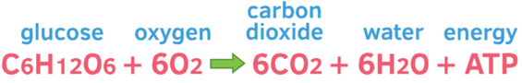
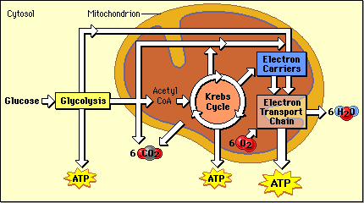

Stage 1: Glycolysis
Location: cytoplasm/cytosol
Requires oxygen: No
Draw out the process of glycolysis in the space below.

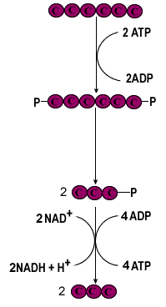
Glucose (6C)
Phosphorylation and ATP hydrolysis.

Hexose Bisphosphate (6C)
Lysis

2 x triose phosphate (3C)

Oxidation of triose phosphate.
Formation of reduced NAD.
ATP synthesis.

2 x pyruvate(3C)

The process of glycolysis, per 1 mole of glucose, how many…
- Net moles of ATP are produced? 2
- Moles of NAD are reduced? 2
- Moles of pyruvate are produced? 2
- Moles of oxygen are required? 0
- Moles of carbon dioxide are produced? 0
- Moles of water are produced? 0

Explain why there is only a NET gain of 2 ATP
4 ATP are produced but 2 are reduced to activate the glucose at the beginning of glycolysis

___________________________________________________________________________________
Exam questions:

The figure below represents the first stage of respiration.
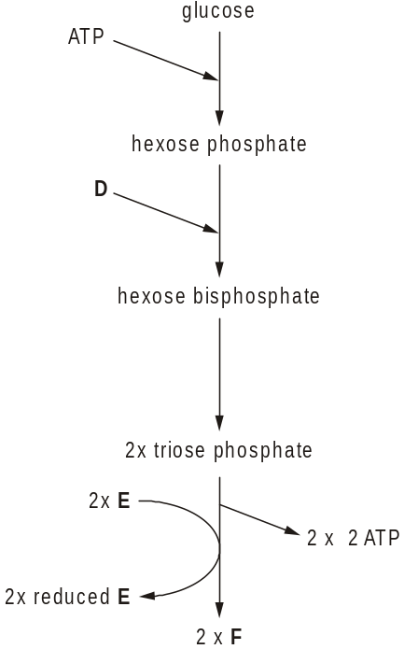

(a) Name the stage represented by the figure above.
Glycolysis
[1]

(b) State precisely where in the cell this stage takes place. Cytosol
[1]
(c) Identify the compounds D, E and F.

D – ATP
E – NAD
F - Pyruvate
[3]

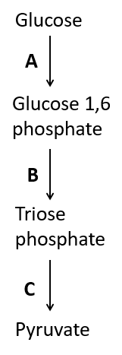

The following figure is an outline of the glycolytic pathway.

With reference to the figure, state the letter, A, B or C, in the glycolytic pathway where the following processes occur.
- phosphorylation using ATP A
- dehydrogenation C
- formation of ATP C
- splitting of a hexose B

[Total 4 marks]

Outcome:
- Know where the different stages of aerobic respiration occur.
- Explain the significance of the oxidation reactions involved in glycolysis, the link reaction and the Krebs cycle
Mitochondria structure recap
On the electro microgram can you label the following structures.
Outer membrane Inner membrane/Cristae Matrix DNA Lipid droplets
Rough Endoplasmic reticulum

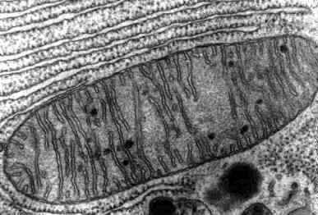

Next to each of the structures below give the function:
- Double membrane
- Outer membrane - permeable to nutrient molecules, ions, ADP and ATP due to presence of porins
- Inner membrane/Cristae- site of electron transport chain and permeable only to CO₂, O₂ and H₂O. Folds on inner surface which increase S.A for ATP production.
- Matrix – mixture of enzymes for ATP production, mitochondrial ribosomes, tRNA and DNA.

Year 1 Mitochondria exam questions

Q1. The diagram shows a eukaryotic cell.

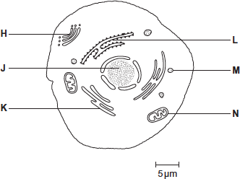

(a) Complete the table by giving the letter labelling the organelle that matches the function.

Function of organelle | Letter
Protein synthesis | L
Modifies protein (for example, adds carbohydrate to protein) | H
Aerobic respiration | N

(3)

(b) Use the scale bar in the diagram above to calculate the magnification of the drawing.
Show your working.

1800−2200;

1.8, 2.0 or 2.2 in working or answer = 1 mark.

Ignore units in answer.

1 mark for an incorrect answer in which student clearly divides measured length by actual length (of scale).

Accept I / A or I / O for 1 mark but ignore triangle.

Accept approx 60mm divided by 30μm for 1 mark

Answer = ____________________ (2)

Q2. (a) The diagram shows two organelles found in a eukaryotic cell.

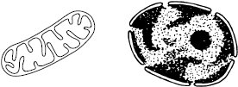

A B

(i) Name the organelles.

A A mitochondrion and B nucleus;
(need both for one mark)____________________________________________________________

B ____________________________________________________________(1)

(ii) Explain how the inner membrane is adapted to its function in organelle A.

increased surface area;
for respiration / enzymes;______________________________________________________________

______________________________________________________________

______________________________________________________________

______________________________________________________________(2)

Q3. The drawing shows part of a human cell.

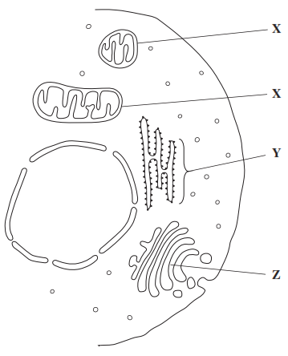

(a) Name organelles

X X = mitochondria;
Y = (rough) endoplasmic reticulum;

Accept ribosomes/ER/RER for Y

Reject smooth endoplasmic reticulum for Y

_________________________________________________________________

Y ________________________________________________________________(2)

(b) (i) The organelles labelled X all have very similar shapes in this cell.
Explain why they appear to have different shapes in this drawing.

(Sections cut at) different angles/in different planes;

Ignore name given to organelle

______________________________________________________________

______________________________________________________________

(Extra space) ___________________________________________________

_____________________________________________________________(1)

Stage 2: Link reaction

Location: Mitochondria (matrix)

Oxygen needed: No but needed for pyruvate to enter mitochondria.

How does pyruvate enter the mitochondria? Active transport

Draw out the process of the Link reaction in the space below.

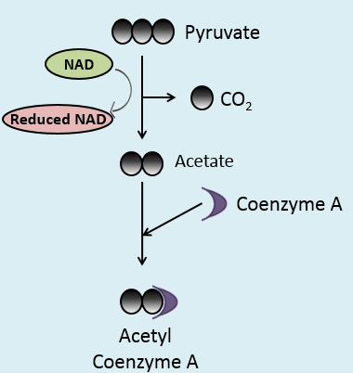

In the process of the link reaction, per 1 mole of glucose, how many…
- Net moles of ATP are produced? 0
- Moles of NAD are reduced? 2 (because 2 pyruvates from glycolysis)
- Moles of Acetyl Coenzyme A are produced? 2
- Moles of oxygen are required? 0
- Moles of carbon dioxide are produced? 2
- Moles of water are produced? 0

Stage 3: Krebs cycle

Location: Mitochondria (matrix)

Oxygen needed: No but needed for pyruvate to enter mitochondria.

Draw out the process of the Kreb cycle in the space below.

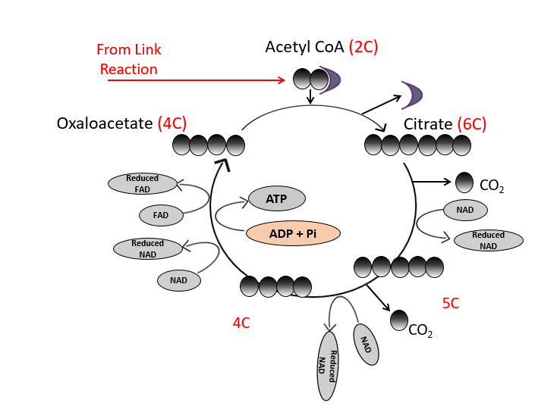

In the process of the Krebs cycle, per 1 mole of glucose, how many…
- Net moles of ATP are produced? 2
- Moles of NAD and FAD are reduced? 6 NAD and 2 FAD
- Moles of oxygen are required? 0
- Moles of carbon dioxide are produced? 4
- Moles of water are produced? 0

Exam questions:

(a) Describe how acetylcoenzyme A is formed in the link reaction.

1. Oxidation of / hydrogen removed from pyruvate and carbon dioxide released;

2. Addition of coenzyme A.

Accept: NAD reduced for oxidation

(2)

(b) In the Krebs cycle, acetylcoenzyme A combines with four-carbon oxaloacetate to form six-carbon citrate. This reaction is catalysed by the enzyme citrate synthase.

(i) Oxaloacetate is the first substrate to bind with the enzyme citrate synthase. This induces a change in the enzyme, which enables the acetylcoenzyme A to bind.

Explain how oxaloacetate enables the acetylcoenzyme A to then bind to the enzyme.

1. Change (in shape) of active site / active site moulds around the substrate;

Reject: reference to inhibitor

Accept: change in tertiary structure affecting active site

2. (Substrate / active site) now complementary.

Neutral: references to two active sites

(2)

(ii) Another substance in the Krebs cycle is called succinyl coenzyme A. This substance has a very similar shape to acetylcoenzyme A.

Suggest how production of succinyl coenzyme A could control the rate of the reaction catalysed by citrate synthase.

1. Is a competitive inhibitor / attaches to active site;

Neutral: reference to inhibitor forming an enzyme-substrate complex

2. Reduces / prevents enzyme-substrate / E-S complex forming.

Accept: Reduces / prevents acetylcoenzyme A binding to enzyme / citrate synthase

(2)

Outcome:

- Describe the process of electron transfer associated with oxidative phosphorylation.
- Explain chemiosmosis and the role of ATP synthase in producing ATP.

Stage 4: Oxidative phosphorylation

Location: Across inner membrane and Inter-membrane space of mitochondria

Oxygen needed: Yes

Draw out the process of Oxidative phosphorylation in the space below.

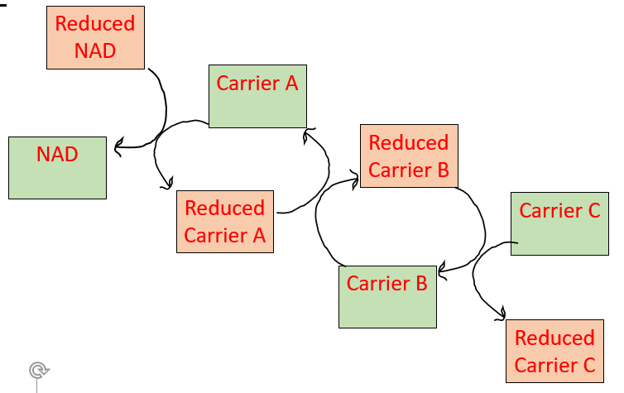

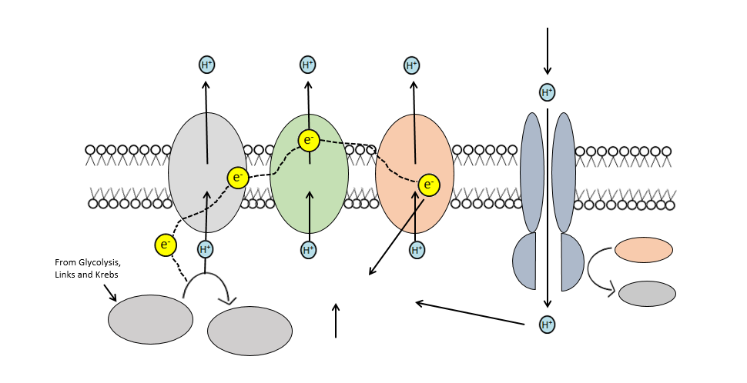
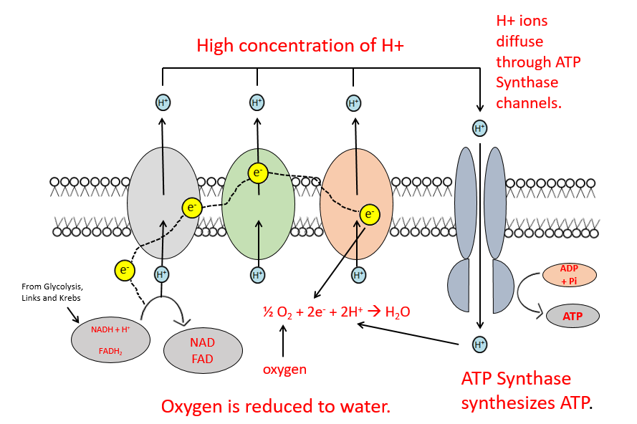

Chemiosmosis

- Energy is released as electrons pass along the ETC in the cristae.
- Energy used to PUMP protons from the NAD/FAD from the matrix into the intermembranal space.
- Proton gradient established.
- Protons flood from intermembranal space to matrix down concentration gradient,
- Cause ATP synthase to smash ADP + Pi forming ATP.

In the process of oxidative phosphorylation, per 1 mole of glucose, how many…
- Net moles of ATP are produced? 34
- Moles of NAD are reduced? 0
- Moles of oxygen are required? 6
- Moles of carbon dioxide are produced? 0
- Moles of water are produced? 6

Describe how ATP is made in mitochondria.

1. Substrate level phosphorylation / ATP produced in Krebs cycle;

2. Krebs cycle / link reaction produces reduced coenzyme / reduced NAD / reduced FAD;

3. Electrons released from reduced / coenzymes / NAD / FAD;

4. (Electrons) pass along carriers / through electron transport chain / through series of redox reactions;

5. Energy released as electron move between carriers in electron transport;

6. Protons move into intermembrane space;

7. Protons move down concentration gradient through ATP synthase;

8. ADP / ADP + Pi;

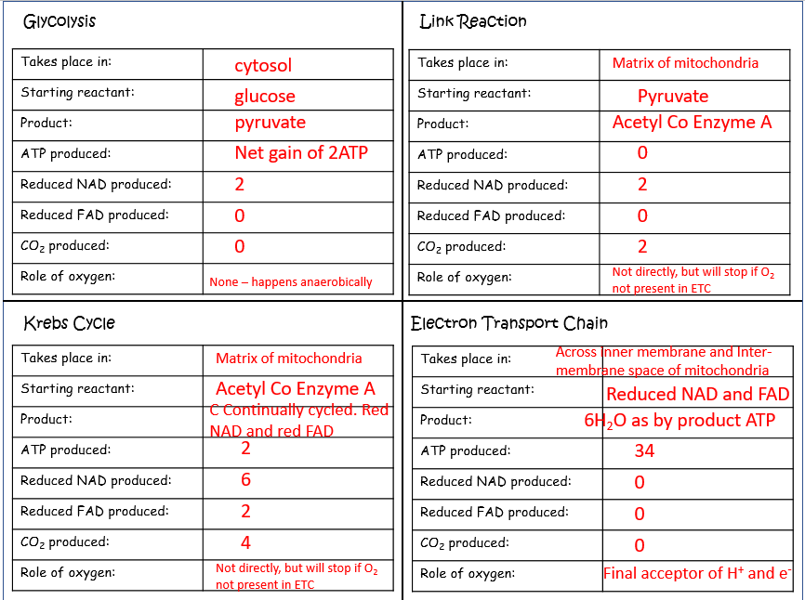

Exam questions:

Q1. (a) An investigation was carried out into the production of ATP by mitochondria. ADP, phosphate, excess substrate and oxygen were added to a suspension of isolated mitochondria.

(i) Suggest the substrate used for this investigation.

pyruvate / succinate / any suitable Krebs cycle substrate

(1)

(ii) Explain why the concentration of oxygen and amount of ADP fell during the investigation.

ADP and phosphate forms ATP;
oxygen used to form water / as the terminal acceptor;

(2)

(iii) A further investigation was carried out into the effect of three inhibitors, A, B and C, on the electron transport chain in these mitochondria. In each of three experiments, a different inhibitor was added. The table shows the state of the electron carriers, W–Z, after the addition of inhibitor.

Inhibitor added | Electron carrier
Inhibitor added | W | X | Y | Z
A | oxidised | reduced | reduced | oxidised
B | oxidised | oxidised | reduced | oxidised
C | reduced | reduced | reduced | oxidised

Give the order of the electron carriers in this electron transport chain. Explain your answer.

Order Y X W Z

Explanation

order of carriers linked to sequence of reduction / reduced
carriers cannot pass on electrons when inhibited;

(2)

Q2. Researchers investigated the effect of cyanide on oxygen uptake by mitochondria. They prepared a suspension of mitochondria from animal cells and a suspension of mitochondria from plant cells. They placed the suspensions in separate flasks containing isotonic solution, started the timer and began recording the concentration of oxygen in each flask.

• After 5 minutes, they added a respiratory substrate and ADP to each flask.

• After 13 minutes, they added cyanide solution to each flask.

The graph below shows their results. From P to R the curves for animal and plant mitochondria overlap.

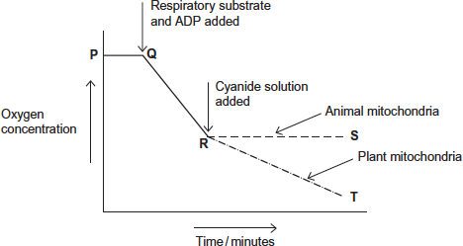

(a) Explain the line between P and Q.

1. No aerobic respiration / electron transfer / oxidative phosphorylation;

Reject reference to anaerobic respiration.

2. (Because) no (respiratory) substrate / nothing to respire;

Reject idea of ‘little’ or ‘less’ − this would result in a change in oxygen concentration.

Accept the idea of no residual respiratory substrate in the mitochondria.

___________________________________________________________________

___________________________________________________________________

___________________________________________________________________

___________________________________________________________________(2)

(b) (i) Explain the line between Q and R.

(Oxygen concentration falls because)

1. Aerobic respiration (uses oxygen);

Accept ‘oxidative phosphorylation / electron transfer takes place’.

2. Oxygen is terminal / electron acceptor;

3. (oxygen combines with) protons / H⁺ and electrons / e⁻ to form water / H₂O;

All aspects are required to gain mark.

______________________________________________________________

______________________________________________________________

______________________________________________________________

______________________________________________________________(2)

(ii) The respiratory substrate and ADP added after 5 minutes (Q) were part of a buffered isotonic solution.What other substance would the buffer or solution have to contain?

Phosphate (ions) / inorganic phosphate / P_{I};

Reject ‘phosphorus’ or ‘P’.

Accept ‘PO₄’.

______________________________________________________________

______________________________________________________________(1)

(c) Describe and explain the difference between line R to S (animal mitochondria) and line R to T (plant mitochondria).

) 1. Oxygen concentration continues to fall in plants but stays constant
in animals;

For ‘plants’ accept ‘line R to T’, for ‘animals’ accept ‘line R to S’.

MP1 and MP2. Accept answers in terms of ‘use’ of oxygen rather than change in concentration.

2. (Oxygen concentration) falls more slowly in plants than before
cyanide added;

3. (Because aerobic) respiration continues in plant (mitochondria);

Accept (because aerobic) respiration stops in animal (mitochondria).

4. (Because) electron transfer / oxidative phosphorylation continues in plant (mitochondria);

Accept (because) electron transfer stops in animal (mitochondria).

Accept for one additional mark

(up to 4 max) use of Resource A i.e: idea that plant cytochrome oxidase is (more) resistant to cyanide

OR

idea that animal cytochrome oxidase not resistant to cyanide.

___________________________________________________________________

___________________________________________________________________

___________________________________________________________________

___________________________________________________________________

___________________________________________________________________

___________________________________________________________________

___________________________________________________________________

__________________________________________________________________(4)

Q3. (a) Describe how ATP is made in mitochondria.

Substrate level phosphorylation / ATP produced in Krebs cycle;

Accept alternatives for reduced NAD

2. Krebs cycle / link reaction produces reduced coenzyme / reduced NAD / reduced FAD;

2. Accept description of either Krebs cycle or link reaction

3. Electrons released from reduced / coenzymes / NAD / FAD;

4. (Electrons) pass along carriers / through electron transport chain / through series of redox reactions;

5. Energy released;

5. Allow this mark in context of electron transport or chemiosmosis

6. ADP / ADP + Pi;

6. Accept H⁺ or hydrogen ions and cristae

7. Protons move into intermembrane space;

7. Allow description of movement through membrane

8. ATP synthase;

8. Accept ATPase. Reject stalked particles

___________________________________________________________________

___________________________________________________________________

___________________________________________________________________

___________________________________________________________________

___________________________________________________________________

___________________________________________________________________

___________________________________________________________________

___________________________________________________________________

___________________________________________________________________

___________________________________________________________________

___________________________________________________________________

___________________________________________________________________(6)

Outcome:
- Describe the process of anaerobic respiration in animals and some microorganisms.
- Explain the advantage of producing ethanol or lactate using reduced NAD.
- Compare and contrast aerobic and anaerobic respiration.

Anaerobic respiration

Anaerobic condition in animals
Glycolysis is the only way to generate ATP for energy.
Reduced NAD can’t lose its e⁻ and H⁺ as the ETC stops without O₂ as the final accepter.
Reduced NAD can’t receive any more e⁻ and H⁺
We need to recycle the reduced NAD to continue to do glycolysis and release ATP.

In the space below draw out the process of glycolysis (AO1)

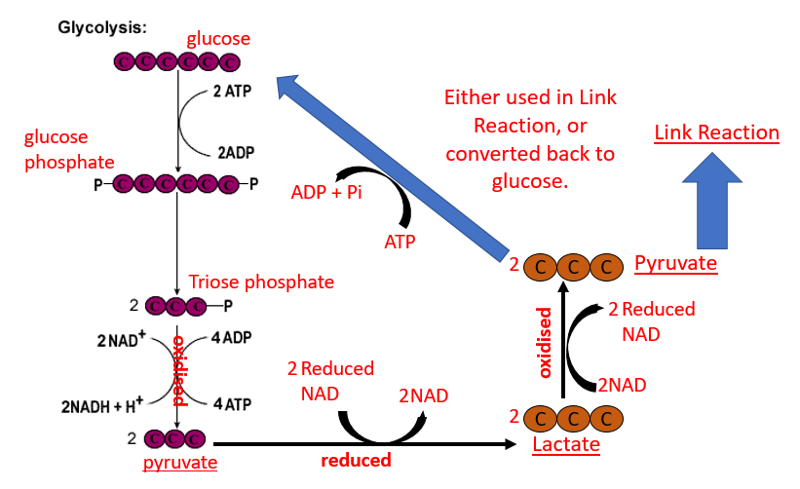

Lactate fermentation – mammalian muscle cells
- Pyruvate is converted into lactate.
- Pyruvate accepts hydrogen from reduced NAD.
- NAD can now be reused in glycolysis.

Anaerobic conditions in some microorganisms
In the space below draw out the process of glycolysis (AO1)

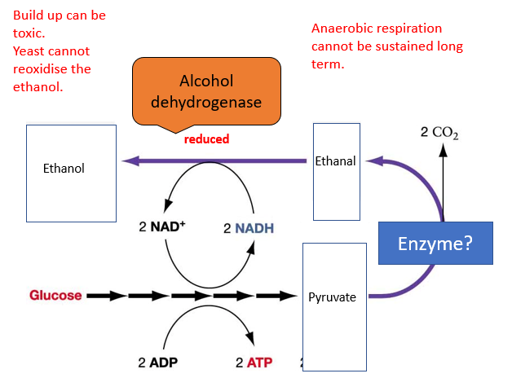

Ethanol (alcohol) fermentation - fungi such as yeast.
- Pyruvate is decarboxylated to form ethanal. CO₂ is removed.
- Ethanal accepts hydrogen from reduced NAD and is reduced to ethanol.
- NAD can now be reused in glycolysis.

Explain the issues with cells using anaerobic respiration.

Build up lactate / ethanol in cells can become toxic.
Enough oxygen is needed in animals to re-oxidise the lactate back to pyruvate.
Yeast cannot re-oxidise ethanol.
Only a small amount of ATP is yielded from glycolysis.
Anaerobic respiration cannot be sustained for long periods.

Anaerobic respiration summary

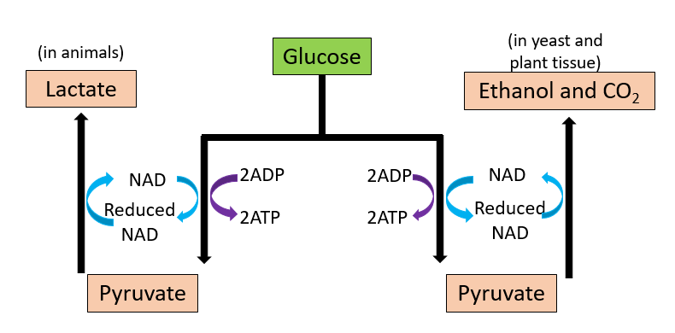

Compare and Contrast aerobic and anaerobic respiration.
Exam tip: Contrast questions should always be in table,
 | Aerobic | Anaerobic
Requires glucose | Yes | Yes
Number of ATP produced | 38 | 2
Products at end | 6CO₂ 6H₂O | Either Lactate (mamalls) or  Ethanol (yeast andt plants) and CO₂
Occurs in eukaryotic cells | Yes | Yes
Occurs in prokaryotic cells | Yes | Yes
Occurs in cytoplasm | Yes | Yes
Occurs in mitochondria | Yes | No
Oxygen needed | Yes | No.

___________________________________________________________________________________
Exam Questions:
Q1. Some plant seeds can respire aerobically and anaerobically. A summary of the process of anaerobic respiration is shown below.
(a) (i) Where in a cell does stage 1 occur?
Cytoplasm/cytosol
(1)
(ii) Explain how stage 2 enables stage 1 to continue.

1. Regenerates/produces NAD / oxidises reduced NAD;

2. NAD reduced in stage 1/glycolysis / NAD accepts hydrogen in stage 1/glycolysis;

Note: penalise use of NADP for first marking point obtained.

Do not accept NAD accepts only protons but allow accepts protons and electrons.

(2)
(b) The Respiratory Quotient (RQ) can provide information on the type of respiration taking place in an organism. The following equation is used to calculate the RQ.
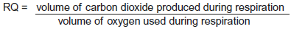
(i) What would be the RQ for aerobic respiration of glucose?
 1/one/1.0;
(1)
(ii) A student calculated that the RQ of germinating seeds was 1.8.
Use the information provided to explain this result.

1. Aerobic and anaerobic respiration occurring;

Accept: some/mainly anaerobic respiration occurring.

2. More carbon dioxide produced than oxygen uptake;

(2)

(c) Aerobic respiration produces more ATP per molecule of glucose than anaerobic respiration.
Explain why.

1. Oxygen is final/terminal (electron) acceptor / oxygen combines with electrons and protons;

2. (Aerobic respiration) oxidative phosphorylation / electron transfer chain;

3. Anaerobic (respiration) only glycolysis occurs / no Krebs / no link reaction;

Ignore: number of ATP produced.

3. Accept: without oxygen.

3. Ignore: converse

(2)
Q3. Intensive rearing of livestock produces large quantities of waste. Some farmers use an anaerobic digester to get rid of the waste. In an anaerobic digester, microorganisms break down the large, organic molecules in the waste. This produces methane, which is a useful fuel. It also produces organic substances that can be used as a natural fertiliser. The diagram shows an anaerobic digester.
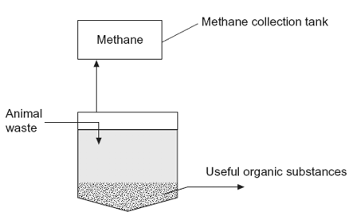
(a) (i) Suggest two advantages of processing waste in anaerobic digesters rather than in open ponds.

1. Gases / correct named gas not released;

2. Conditions (in digester) can be controlled;

3. Products / named product can be collected;

4. Open ponds associated with health risk / environmental damage / eutrophication;

Correct named gases include: methane, carbon dioxide, hydrogen sulphide, nitrogen oxides

1. Allow substance = product

4. Accept ‘pond’ in any context

(2)

(ii) The anaerobic digester has a cooling system, which is not shown in the diagram. Without this cooling system the digester would soon stop working. Explain why.

1. Respiration causes temperature increase / release of heat;

2. Enzymes would be denatured / microorganisms killed

(2)
(b) (i) The over-application of fertiliser increases the rate of leaching. Explain the consequences of leaching of fertiliser into ponds and lakes.

1. Increase algae / algal bloom causes light to be blocked out;

2. Plants can’t photosynthesise / plants and / or algae die;

3. Bacteria / saprobionts / EW feed off / breakdown dead organisms using up oxygen / bacteria respire / BOD rises (3)
(ii) Give one advantage of using natural fertiliser produced in the digester rather than an artificial fertiliser.

1. Acts as soil conditioner / improves drainage / aerates soil / increases organic content of soil;

2. Contains other elements / named element / wider range of elements;

3. Production of artificial fertiliser energy-consuming;

4. Less leaching / slow release (of nutrient);

Unspecified answers relate to natural fertiliser. Ignore references to cost / eutrophication

2. i.e. elements other than nitrogen, phosphorus and potassium
(1)
Respirometer experiment

Outcome:
- Investigation into the effect of a named variable on the rate of respiration of cultures of single-celled organisms.
- Interpret information/data about aerobic and anaerobic respiration and apply knowledge.
- Describe how other substrates such as lipids and amino acids can be broken down into products which enter the Krebs cycle.

Watch this video: https://www.youtube.com/watch?v=r9o_VdToClE and answer the questions below.
- Name the gas measured to calculate the rate of respiration?
_________________________________________________________________________________

- Name the stage of aerobic respiration requires this gas?
_________________________________________________________________________________

- Name the chemical in the cotton ball. Describe the importance of this chemical
_________________________________________________________________________________
_________________________________________________________________________________

- If the chemical wasn’t present describe the effect on the volume/pressure in the glass tube. Explain your answer.
_________________________________________________________________________________
_________________________________________________________________________________

- Explain the role of the glass beads
_________________________________________________________________________________
_________________________________________________________________________________

- Explain why the bubble (meniscus) moves towards the peas.
_________________________________________________________________________________
_________________________________________________________________________________

- Application of knowledge: Suggest how you would use this apparatus to prove the peas had a higher rate of aerobic respiration than the dried peas.
_________________________________________________________________________________
_________________________________________________________________________________

.
- Application of knowledge: Suggest why this experiment can only measure the rate of aerobic respiration.
_________________________________________________________________________________
_________________________________________________________________________________

Add notes to the diagram below to describe and explain how a respirometer is set up and used. Highlight the mark scheme perfect answers.

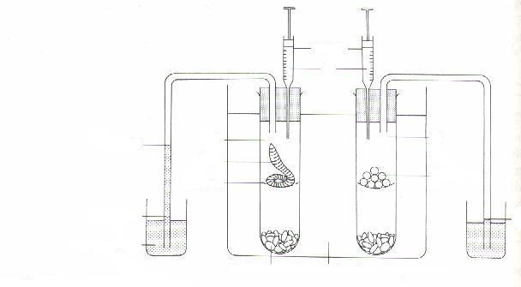
Key points
- Potassium hydroxide absorbs the CO₂ and the O₂ is used up/consumed
- Volume of air in the respiration chamber decreases- Reduced volume of air = reduced pressure
- Higher pressure in the tube than in the chamber so air is drawn in- manometer fluid moves towards the tube/organism
- The rate the fluid moves can be measured
- Any pressure changes in the compensation tube will be due to atmospheric pressure changes
- Distance fluid moved in this tube can be taken away from distance in other tube for actual respiration rate
- The volume of gas can be calculated using the formula: (πr²I)/t.
- So we need to know the diameter of the tube, how far the bubble has moved and in how long. (often then divided by mass so the answer is per gram.
Instead of moving towards the organisms, why might the meniscus move away from the organisms?
________________________________________________________________________________
________________________________________________________________________________
Identify factors that would need to be controlled in the respirometer.
________________________________________________________________________________
________________________________________________________________________________
Exam questions:
Q1.The figure below shows the apparatus used for measuring the rate of oxygen consumption in aerobic respiration by seeds.
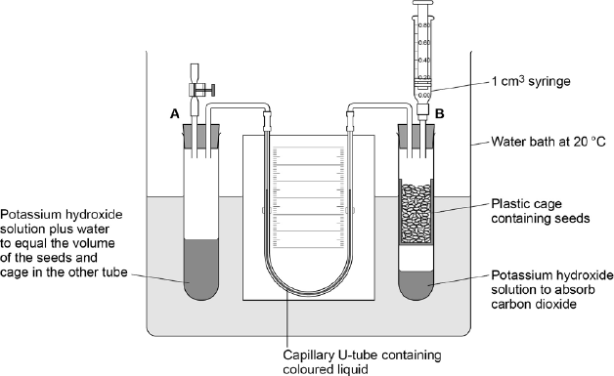
(a) For the first 10 minutes, the tap attached to tube A was left open and the syringe from tube B was removed.
Suggest three reasons why the apparatus was left for 10 minutes.
1. _________________________________________________________________
___________________________________________________________________
2. _________________________________________________________________
___________________________________________________________________
3. _________________________________________________________________
___________________________________________________________________(3)
(b) Suggest and explain why the chosen temperature was 20 °C for this experiment.
___________________________________________________________________
___________________________________________________________________
___________________________________________________________________
___________________________________________________________________(2)
After 10 minutes, the tap attached to tube A was closed and the syringe was attached to tube B. Every minute, the syringe plunger was moved until the levels in the U-tube were the same. The reading on the syringe volume scale was then recorded. The results are shown in the table below.

Time / minutes | Reading on syringe  volume scale / cm³
0 | 0.84
1 | 0.81
2 | 0.79
3 | 0.76
4 | 0.73
5 | 0.70
6 | 0.68
7 | 0.66
8 | 0.63
9 | 0.62
10 | 0.58
(c) During the experiment, the coloured liquid in the tubing moved towards tube B.
Explain what caused this.
___________________________________________________________________
___________________________________________________________________
___________________________________________________________________
___________________________________________________________________
___________________________________________________________________
___________________________________________________________________(3)
(d) The mass of the seeds was 1.6 g. Use the information in the table above to calculate the rate of oxygen consumption in cm³ g^{–1} hour^{–1} by the seeds. Show your working.

Rate = ____________________ cm³ g^{–1} hour^{–1} (2)
Q2.A student investigated the rate of gas exchange in aerobically respiring seeds using the apparatus shown in the diagram. She carried out two experiments.
• In Experiment 1, she put potassium hydroxide solution in the beaker. Potassium hydroxide solution absorbs carbon dioxide.
• In Experiment 2, she put water in the beaker.
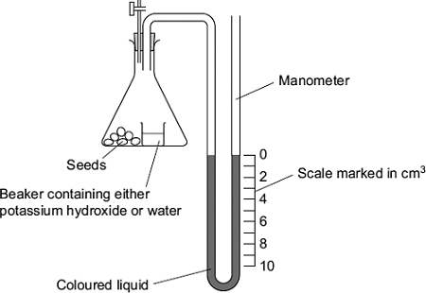
(a) Both experiments were carried out at the same temperature. Explain why.
___________________________________________________________________
___________________________________________________________________
___________________________________________________________________ (2)
(b) (i) The level of coloured liquid in the right-hand side of the manometer tube went down during Experiment 1. Explain why.
______________________________________________________________
______________________________________________________________
______________________________________________________________
______________________________________________________________ (3)
The results from both experiments are shown in the table.

Experiment | Solution in beaker | Fall in volume of coloured liquid in  right-hand side of manometer / cm³
1 | Potassium hydroxide | 5
2 | Water | 1
(ii) Use these results to calculate the volume of carbon dioxide produced during Experiment 1.
Answer = ____________________ cm³ (1)
(c) The student repeated Experiment 1 using seeds which were respiring anaerobically.
What would happen to the level of coloured liquid in the right-hand side of the manometer tube? Explain your answer.
___________________________________________________________________
___________________________________________________________________
___________________________________________________________________
___________________________________________________________________(2)
Q3. A student investigated the rate of anaerobic respiration in yeast. She put 5 g of yeast into a glucose solution and placed this mixture in the apparatus shown in the figure below.
She then recorded the total volume of gas collected every 10 minutes for 1 hour.
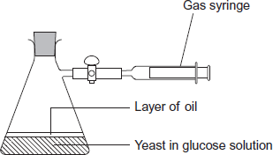
(a) Explain why a layer of oil is required in this investigation.
___________________________________________________________________
___________________________________________________________________(1)
(b) The student’s results are shown in the following table.

Time / minutes | Total volume of gas  collected / cm³
10 | 0.3
20 | 0.9
30 | 1.9
40 | 3.1
50 | 5.0
60 | 5.2
(i) Calculate the rate of gas production in cm³ g^{–1} min^{–1} during the first 40 minutes of this investigation. Show your working.

Answer = ____________________ cm³ g^{–1} min^{–1}(2)
(ii) Suggest why the rate of gas production decreased between 50 and 60 minutes.
______________________________________________________________
______________________________________________________________(1)
(iii) Yeast can also respire aerobically. The student repeated the investigation with a fresh sample of yeast in glucose solution, but without the oil. All other conditions remained the same.
Explain what would happen to the volume of gas in the syringe if the yeast were only respiring aerobically.
______________________________________________________________
______________________________________________________________
______________________________________________________________ (2)
(c) Respiration produces more ATP per molecule of glucose in the presence of oxygen than it does when oxygen is absent. Explain why.
___________________________________________________________________
___________________________________________________________________
___________________________________________________________________ (2)
Q4.The diagram shows apparatus used to measure the oxygen uptake of snails that live on the seashore. The apparatus was kept at a constant temperature.
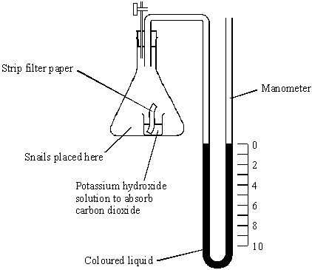
(a) (i) Explain the purpose of the strip of filter paper in the potassium hydroxide solution.
______________________________________________________________
_____________________________________________________________(1)
(ii) The level of liquid in the right-hand side of the manometer went down during the experiment. Explain why.
______________________________________________________________
______________________________________________________________
______________________________________________________________
______________________________________________________________(2)
(iii) What measurements are needed to calculate the rate of oxygen uptake by the snails in mm³ g^{–1} h^{–1}?
______________________________________________________________
______________________________________________________________
______________________________________________________________(3)
(b) Two experiments were carried out using the apparatus shown in the diagram.
1 The oxygen uptake of batches of 10 seashore snails kept in moist air was measured at temperatures between 5 °C and 35 °C.
2 Experiment 1 was repeated but with batches of 10 seashore snails covered by aerated seawater.
The experiments were repeated several times and means and standard deviations calculated. The results are shown in the table. The values given are means plus or minus one standard deviation.

Temperature / °C | Oxygen uptake of  snails kept in moist  air / mm³ g^{–1} h^{–1} | Oxygen uptake of  snails kept in  seawater / mm³ g^{–1} h^{–1}
5 | 35 ± 2 | 28 ± 8
10 | 34 ± 6 | 32 ± 3
15 | 36 ± 3 | 35 ± 3
20 | 86 ± 8 | 52 ± 10
25 | 141 ± 13 | 96 ± 15
30 | 132 ± 14 | 108 ± 9
35 | 120 ± 16 | 79 ± 21
(i) Describe one similarity and one difference between the pattern of mean oxygen uptake of the snails kept in moist air and those covered by seawater.
______________________________________________________________
______________________________________________________________
______________________________________________________________
______________________________________________________________(2)
(ii) Explain why valid conclusions cannot be drawn about the trends in oxygen uptake at temperatures of 25 °C and above.
______________________________________________________________
______________________________________________________________
______________________________________________________________
______________________________________________________________(2)

Respiratory substrates

Respirometer can be used to identify the substrate being respired:
- Glucose
- Lipids
- Proteins
Write out the equation for respiration:

Write out the table showing the respiratory quotient for these substrates:

1.Describe why the value for
- Glucose is 1
_________________________________________________________________________________

- Fatty acids/lipids is 0.7
_________________________________________________________________________________

- Proteins is 0.9
_________________________________________________________________________________

2.Suggest the value for anaerobic respiration, explain your answer
_______________________________________________________________________________________
_______________________________________________________________________________________

