Inheritance booklet revision questions part 2 NAME:

Q1. In a species of snail, shell colour is controlled by a gene with three alleles. The shell may be brown, pink or yellow. The allele for brown, C^{B}, is dominant to the other two alleles. The allele for pink, C^{P}, is dominant to the allele for yellow, C^{Y}.
(a) Explain what is meant by a dominant allele.
........................................................................................................................
........................................................................................................................
........................................................................................................................
(1)

(b) Give all the genotypes which would result in a brown-shelled snail.
........................................................................................................................
(1)

(c) A cross between two pink-shelled snails produced only pink-shelled and yellow-shelled snails. Use a genetic diagram to explain why.

(3)
(Total 5 marks)

Q3.When most people fold their arms, they either always have their left arm on top, L, or always have their right arm on top, R. A geneticist investigated this characteristic on five small islands, A, B, C, D and E.
Her results are shown in Figure 1.
Figure 1
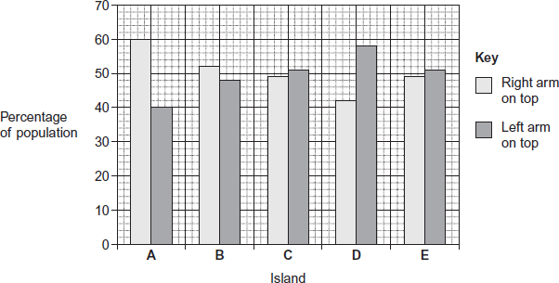
On one of the islands she recorded the arm-folding characteristics of parents and their children.
These results are shown in Figure 2.
Figure 2

 | Arm-folding of parents | Arm-folding of the children / %
 | Arm-folding of parents | Right arm on top, R | Left arm on top, L
 | R and R | 41 | 59
 | R and L | 45 | 55
 | L and L | 44 | 56

The geneticist concluded that arm-folding is not determined by a single gene with a dominant allele and a recessive allele.
(a) The geneticist investigated arm-folding on five small islands.
(i) Use information from Figure 1 to describe the results she obtained.
...............................................................................................................
...............................................................................................................
...............................................................................................................
...............................................................................................................
...............................................................................................................
(2)
(ii) Suggest advantages of using island populations in this investigation.
...............................................................................................................
...............................................................................................................
...............................................................................................................
...............................................................................................................
...............................................................................................................
(2)
(b) The geneticist concluded that arm-folding is not determined by a single gene with a dominant allele and a recessive allele.
Use information from Figure 2 to explain why she reached this conclusion.
........................................................................................................................
........................................................................................................................
........................................................................................................................
........................................................................................................................
........................................................................................................................
........................................................................................................................
(Extra space) ..................................................................................................
........................................................................................................................
........................................................................................................................
(3)
(c) In another study, the geneticist investigated arm-folding in genetically identical twins.
Data from this study supported her conclusion from the island study.
Suggest the evidence she found that supported her conclusion.
........................................................................................................................
........................................................................................................................
........................................................................................................................
(1)
(Total 8 marks)

Q5.Read the following passage carefully.

 | A large and growing number of disorders are now known to be due to types of mitochondrial disease (MD). MD often affects skeletal muscles, causing muscle weakness.
 | We get our mitochondria from our mothers, via the fertilised egg cell. Fathers do not pass on mitochondria via their sperm. Some mitochondrial diseases are caused by mutations of mitochondrial genes inside the mitochondria.  Most mitochondrial diseases are caused by mutations of genes in the cell nucleus that are involved in the functioning of mitochondria. These mutations of nuclear DNA produce recessive alleles. | 5
 | One form of mitochondrial disease is caused by a mutation of a mitochondrial gene that codes for a tRNA. The mutation involves substitution of guanine for adenine in the DNA base sequence. This changes the anticodon on the tRNA.  This results in the formation of a non-functional protein in the mitochondrion. | 10
 | There are a number of ways to try to diagnose whether someone has a mitochondrial disease. One test involves measuring the concentration of lactate in a person’s blood after exercise. In someone with MD, the concentration is usually much higher than normal. If the lactate test suggests MD, a small amount of DNA can be extracted from mitochondria and DNA sequencing used to try to find a mutation. | 15

Use information in the passage and your own knowledge to answer the following questions.
(a) Mitochondrial disease (MD) often causes muscle weakness (lines 1–3). Use your knowledge of respiration and muscle contraction to suggest explanations for this effect of MD.
........................................................................................................................
........................................................................................................................
........................................................................................................................
........................................................................................................................
........................................................................................................................
........................................................................................................................
(Extra space) ................................................................................................
........................................................................................................................
........................................................................................................................
(3)

Two couples, couple A and couple B, had one or more children affected by a mitochondrial disease. The type of mitochondrial disease was different for each couple.
None of the parents showed signs or symptoms of MD.
• Couple A had four children who were all affected by an MD.
• Couple B had four children and only one was affected by an MD.
(b) Use the information in lines 5–9 and your knowledge of inheritance to suggest why:
• all of couple A’s children had an MD
• only one of couple B’s children had an MD.
Couple A ........................................................................................................
........................................................................................................................
........................................................................................................................
........................................................................................................................
Couple B ........................................................................................................
........................................................................................................................
........................................................................................................................
........................................................................................................................
(Extra space) ................................................................................................
........................................................................................................................
........................................................................................................................
........................................................................................................................
(4)
(c) Suggest how the change in the anticodon of a tRNA leads to MD (lines 10–13).
........................................................................................................................
........................................................................................................................
........................................................................................................................
........................................................................................................................
........................................................................................................................
........................................................................................................................
(Extra space) ................................................................................................
........................................................................................................................
........................................................................................................................
(3)
(d) If someone has MD, the concentration of lactate in their blood after exercise is usually much higher than normal (lines 15–17). Suggest why.
........................................................................................................................
........................................................................................................................
........................................................................................................................
........................................................................................................................
........................................................................................................................
........................................................................................................................
(Extra space) ................................................................................................
........................................................................................................................
........................................................................................................................
(3)

(e) A small amount of DNA can be extracted from mitochondria and DNA sequencing used to try to find a mutation (lines 18–19).
From this sample:
• how would enough DNA be obtained for sequencing?
• how would sequencing allow the identification of a mutation?
........................................................................................................................
........................................................................................................................
........................................................................................................................
........................................................................................................................
(2)
(Total 15 marks)

﻿
Q7. The histogram shows the variation in height of 17-year-old male students from one college.
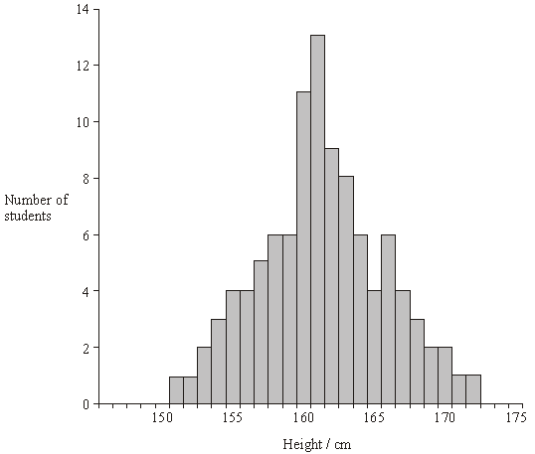
(a) What does the histogram indicate about the inheritance of this feature? Explain your answer.
......................................................................................................................
......................................................................................................................
......................................................................................................................
......................................................................................................................
(2)

(b) The standard error of the mean was calculated. What information would this give about the mean height of 17-year-old males?
......................................................................................................................
......................................................................................................................
......................................................................................................................
......................................................................................................................
(2)
(Total 4 marks)
Q9. Ions of metals such as zinc often pollute rivers. The effect of zinc ions on gas exchange and respiration in fish was investigated. Fish were kept in tanks of water in a laboratory.
The fish in one group (X) had a solution of a zinc compound injected directly into their blood and were then put in a tank of zinc-free water. A second group (Y) was not injected but had the solution of the zinc compound added to the water in the tank.
The partial pressure of oxygen in the blood of both groups of fish was then monitored. The results are shown in the graph.
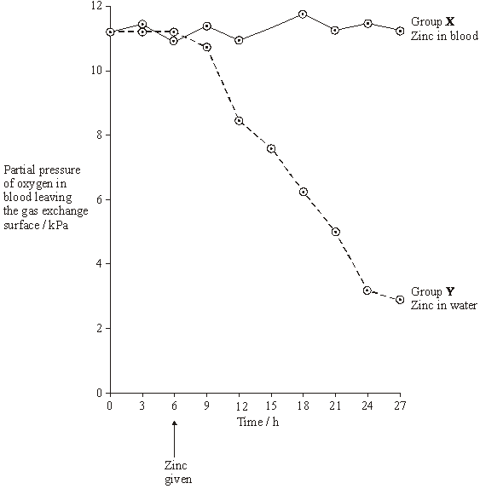
(a) During this investigation, the water temperature in the tanks was kept constant. Explain why changes in the water temperature might lead to the results of the investigation being unreliable.
......................................................................................................................
......................................................................................................................
(1)

(b) The results from the two groups were compared using a statistical test.
(i) Suggest a null hypothesis that could be tested.
.............................................................................................................
(1)

(ii) Explain why it is important to use a statistical test in analysing the results of this investigation.
.............................................................................................................
.............................................................................................................
.............................................................................................................
.............................................................................................................
(2)

(c) Two suggestions were made to explain the results shown in the graph.
A Zinc ions reduce the rate at which oxygen is taken up from the water and passes into the blood.
B Zinc ions reduce the ability of haemoglobin to transport oxygen.
Which of these suggestions is the more likely? Explain the evidence from the graph that supports your answer.
......................................................................................................................
......................................................................................................................
......................................................................................................................
......................................................................................................................
(2)

(d) During the investigation, the pH of the blood was also monitored. It decreased in group Y. Suggest an explanation for this decrease in pH.
......................................................................................................................
......................................................................................................................
......................................................................................................................
......................................................................................................................
......................................................................................................................
......................................................................................................................
(3)

(e) Leaves were collected from sycamore trees growing in a polluted wood and the concentration of some metal ions in samples of these leaves was measured. Woodlice were then fed with the leaves. After 20 weeks, the concentration of the ions in the bodies of the woodlice was measured. Some of the results are shown in the table.

 | Concentration of ions / µg g^{–1}
 | Copper | Cadmium | Zinc | Lead
Leaves | 52 | 26 | 1430 | 908
Woodlice | 1130 | 525 | 1370 | 132

(i) Which of the elements shown in the table is concentrated most by the woodlice? Use suitable calculations to support your answer.

(2)
(ii) Suggest what happens to most of the lead ions in the leaves eaten by the woodlice.
.............................................................................................................
.............................................................................................................
(1)
(iii) Explain the difference in the copper ion concentration between the leaves and the woodlice.
.............................................................................................................
.............................................................................................................
.............................................................................................................
.............................................................................................................
(2)
(f) Yorkshire fog is a species of grass. Two varieties of Yorkshire fog were studied. One variety was tolerant to arsenic, while the other variety was not. In a series of investigations, it was found that
• Arsenic-tolerant plants grow in soil which contains a high concentration of arsenic.
• Arsenic-tolerant plants growing in soil containing high concentrations of arsenic and phosphorus-containing compounds have very low concentrations of arsenic in their cells. They also have low concentrations of phosphates in their cells. Arsenic and phosphorus are chemically similar.
• Plants that are not tolerant to arsenic grow poorly on soil which has a high concentration of both arsenic and phosphorus-containing compounds.
• Tolerance to arsenic in Yorkshire fog is caused by a single gene with the allele, a, for tolerance recessive to the allele, A, for non-tolerance.
(i) What caused the allele for tolerance to first arise?
.............................................................................................................
.............................................................................................................
(1)
(ii) Give two functions of phosphates in plant cells.
1 ..........................................................................................................
.............................................................................................................
2 ..........................................................................................................
.............................................................................................................
(2)

(iii) Arsenic-tolerant Yorkshire fog plants are very rare in areas with low concentrations of arsenic in the soil, even where the soil has a high concentration of phosphate. Explain why they are unable to compete in these conditions with plants that are not tolerant to arsenic.
.............................................................................................................
.............................................................................................................
.............................................................................................................
.............................................................................................................
.............................................................................................................
.............................................................................................................
(3)
(Total 20 marks)

Q11. Figure 1 and Figure 2 show the chromosomes from a single cell at different stages of meiosis.
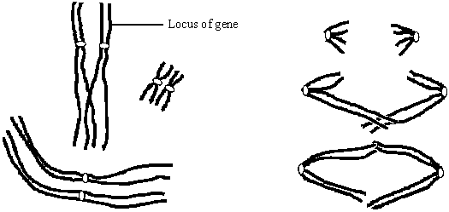
Figure 1 Figure 2
(a) What is the diploid number of chromosomes in the organism from which this cell was taken?
......................................................................................................................
(1)

(b) Describe what is happening to the chromosomes at the stage shown in
(i) Figure 1;
.............................................................................................................
.............................................................................................................
.............................................................................................................
.............................................................................................................
(2)

(ii) Figure 2.
.............................................................................................................
.............................................................................................................
.............................................................................................................
.............................................................................................................
(2)

(c) (i) The genotype of this organism is Bb. The locus of this pair of alleles is shown in Figure 1.
Label two chromosomes on Figure 2 to show the location of the B allele and the location of the b allele.
(1)

(ii) How many genetically different gametes can be produced by meiosis from a cell with the genotype, Bb Cc Dd? Assume these genes are located on different pairs of homologous chromosomes. Show your working.

.............................................................................................................
(2)
(Total 8 marks)
Q13.The fruit fly is a useful organism for studying genetic crosses. Female fruit flies are approximately 2.5 mm long. Males are smaller and possess a distinct black patch on their bodies. Females lay up to 400 eggs which develop into adults in 7 to 14 days. Fruit flies will survive and breed in small flasks containing a simple nutrient medium consisting mainly of sugars.
(a) Use this information to explain two reasons why the fruit fly is a useful organism for studying genetic crosses.
1......................................................................................................................
........................................................................................................................
2......................................................................................................................
........................................................................................................................
(2)

(b) Male fruit flies have the sex chromosomes XY and the females have XX. In the fruit fly, a gene for eye colour is carried on the X chromosome. The allele for red eyes, R, is dominant to the allele for white eyes, r. The genetic diagram shows a cross between two fruit flies.
(i) Complete the genetic diagram for this cross.

 | Phenotypes of parents | red-eyed female |  | white-eyed male
 | Genotype of parents | .................................. | × | ..................................
 | Gametes | ..............and................ |  | ..............and................
 | Phenotypes of offspring | red-eyed females | and | red-eyed males
 | Genotype of offspring | .................................. |  | ..................................

(3)

(ii) The number of red-eyed females and red-eyed males in the offspring was counted. The observed ratio of red-eyed females to red-eyed males was similar to, but not the same as, the expected ratio. Suggest one reason why observed ratios are often not the same as expected ratios.
...............................................................................................................
...............................................................................................................
...............................................................................................................
(1)

(c) Male fruit flies are more likely than female fruit flies to show a phenotype produced by a recessive allele carried on the X chromosome. Explain why.
........................................................................................................................
........................................................................................................................
........................................................................................................................
........................................................................................................................
........................................................................................................................
(2)
(Total 8 marks)

Q15. Duchenne muscular dystrophy is a sex-linked inherited condition which causes degeneration of muscle tissue. It is caused by a recessive allele. The diagram shows the inheritance of muscular dystrophy in one family.
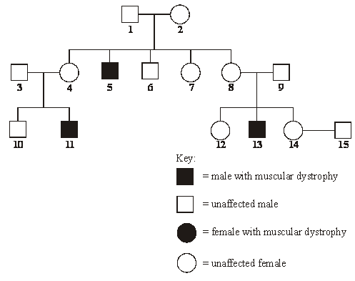
(a) Give evidence from the diagram which suggests that muscular dystrophy is
(i) sex-linked; ...........................................................................................
.............................................................................................................
(1)
(ii) caused by a recessive allele. ...............................................................
.............................................................................................................
(1)
(b) Using the following symbols,
X^{D} = an X chromosome carrying the normal allele
X^{d} = an X chromosome carrying the allele for muscular dystrophy
Y = a Y chromosome
give all the possible genotypes of each of the following persons.
5 ..................................................................................................................
6 ..................................................................................................................
7 ..................................................................................................................
8 ..................................................................................................................
(2)
(c) A blood test shows that person 14 is a carrier of muscular dystrophy. Person 15 has recently married person 14 but as yet they have had no children. What is the probability that their first child will be a male who develops muscular dystrophy?
......................................................................................................................
(1)
(Total 5 marks)
Q17. A sex-linked gene controls fur colour in cats. Ginger-coloured fur is controlled by the allele G, and black-coloured fur is controlled by the allele g. Some female cats have ginger and black patches of fur. They are described as tortoiseshell. Male cats cannot be tortoiseshell.
(a) What is meant by a sex-linked gene?
......................................................................................................................
......................................................................................................................
(1)
(b) A male cat with the genotype X^{g} Y mates with a tortoiseshell female.
(i) Give the phenotype of the male.
.............................................................................................................
(1)
(ii) Give the genotype of the tortoiseshell female.
.............................................................................................................
(1)
(iii) Complete the genetic diagram to show the genotypes and the ratio of phenotypes expected in the offspring of this cross.
Parents Male Tortoiseshell female
Parental genotypes X^{g} Y ........................

Parental gametes

Offspring genotypes

Offspring phenotypes
Ratio

(3)
(c) The effect of the G and g alleles is modified by another gene. This gene is not sex-linked and it has two alleles. The allele d changes the ginger colour to cream and the black colour to grey. The dominant allele D does not modify the effect of G or g.
A cream-coloured male cat mated with a black female whose genotype was X^{g}X^{g} Dd. Male kittens of two different colours were produced. Complete the genetic diagram.
Parental Cream-coloured Black
phenotypes male female

Parental ..................... X^{g}X^{g} Dd
genotypes

Parental
gametes

Male kitten
genotypes

Male kitten
colours

(3)
(Total 9 marks)

Q19. Human ABO blood groups are determined by the presence or absence of two antigens (A and B) on the plasma membrane of the red blood cells. The inheritance of these blood groups is controlled by three alleles:
I ^{A} – determines the production of antigen A
I ^{B} – determines the production of antigen B
I º – determines the production of no antigen
Alleles I ^{A} and I ^{B} are codominant. Allele I º is recessive to both.
The pedigree shows the pattern of inheritance of these blood groups in a family over three generations.
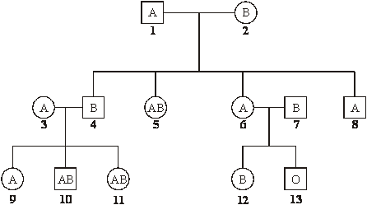
(a) (i) How many antigen-determining alleles will be present in a white blood cell? Give a reason for your answer.
.............................................................................................................
.............................................................................................................
(1)
(ii) Which antigen or antigens will be present on the plasma membranes of red blood cells of individual 5?
.............................................................................................................
(1)
(b) If individuals 6 and 7 were to have another child, what is the probability that this child would be male and blood group A? Explain your answer.
......................................................................................................................
......................................................................................................................
......................................................................................................................
......................................................................................................................
......................................................................................................................(3)
(Total 5 marks)
Q21. In a breed of cattle the H allele for the hornless condition is dominant to the h allele for the horned condition. In the same breed of cattle the two alleles C^{R} (red) and C^{W} (white) control coat colour. When red cattle were crossed with white cattle all the offspring were roan. Roan cattle have a mixture of red and white hairs.
(a) Explain what is meant by a dominant allele.
......................................................................................................................
......................................................................................................................
(1)
(b) Name the relationship between the two alleles that control coat colour.
......................................................................................................................
(1)
(c) Horned, roan cattle were crossed with white cattle heterozygous for the hornless condition. Compete the genetic diagram to show the ratio of offspring phenotypes you would expect.
Parental phenotypes Horned, roan × hornless, white

Parental genotypes

Gametes

Offspring genotypes

Offspring phenotypes

Ratio of offspring
phenotypes
(4)
(d) The semen of prize dairy bulls may be collected for in vitro fertilisation. The sperms in the semen can be separated so that all the calves produced are of the same sex. The two kinds of sperms differ by about 3% in DNA content.
(i) Explain what causes the sperms of one kind to have 3% more DNA than sperms of the other kind.
.............................................................................................................
.............................................................................................................
.............................................................................................................
.............................................................................................................
(2)

(ii) Suggest one reason why farmers would want the calves to be all of the same sex.
.............................................................................................................
.............................................................................................................
(1)
(Total 9 marks)
Q23. Other than resistance, give two disadvantages of using pesticides.
1 .............................................................................................................................
................................................................................................................................
2 .............................................................................................................................
................................................................................................................................
(Total 2 marks)
Q25. Coat colour in Labrador dogs is controlled by two different genes. Each gene has a dominant and a recessive allele. The two genes are inherited independently but the effects of the alleles interact to produce three different coat colours. The table gives four genotypes and the phenotypes they produce.

Genotype | Phenotype
BbEe | black
bbEe | chocolate
Bbee | yellow
bbee | yellow

(a) What colour coat would you expect each of the following genotypes to give?
(i) BBEe …………………………
(ii) bbEE …………………………
(2)

(b) A BbEe male was crossed with a bbee female. Complete the genetic diagram to show the ratio of offspring you would expect.
Parental phenotypes Black male × Yellow female

Parental genotypes BbEe bbee

Gametes

Offspring genotypes

Offspring phenotypes
Ratio of offspring
phenotypes
(3)
(c) The yellow coat colour of Labrador dogs is due to the presence of the pigment phaeomelanin in the hairs. The black and chocolate coat colours are due to different amounts of another pigment, eumelanin, deposited in these hairs. The more eumelanin there is, the darker the hair. The diagram shows the action of genes E and B in producing the different coat colours.
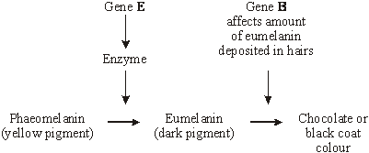
Use this information to explain how
(i) the genotype bbee produces a yellow coat colour;
.............................................................................................................
.............................................................................................................
.............................................................................................................
.............................................................................................................
(2)
(ii) the genotype BbEe produces a black coat colour.
.............................................................................................................
.............................................................................................................
.............................................................................................................
.............................................................................................................
(2)
(Total 9 marks)
Q27. The production of pigment in rabbit fur is controlled by two genes.
One gene controls whether any pigment is made. This gene has three alleles. Allele A codes for the production of one form of the enzyme tyrosinase, which converts tyrosine into a black pigment. Allele A^{h} codes for the production of a second form of the enzyme, which becomes inactive at temperatures close to a rabbit’s core body temperature, so only the face, ears, legs and tail are pigmented. A third allele, a, fails to code for a functional tyrosinase.
The other gene controls the density of pigment in the fur. This gene has two alleles. Allele B is dominant and results in the production of large amounts of pigment, making the fur black.
Allele b results in less pigment, so the fur appears brown.
(a) How do multiple alleles of a gene arise?
......................................................................................................................
......................................................................................................................
......................................................................................................................
......................................................................................................................
(2)
(b) The table shows some genotypes and phenotypes.

Genotype | Phenotype
A–B– | all fur black
aaB– | all fur white (albino)
a^{h}abb | white body fur with brown face, ears, legs and tail (Himalayan)

(i) What do the dashes represent in the genotype of the black rabbit?
.............................................................................................................
.............................................................................................................
(1)

(ii) Give all the possible genotypes for a Himalayan rabbit with black face, ears, legs and tail.
.............................................................................................................
.............................................................................................................
(2)

(iii) Suggest an explanation for the pigment being present only in the tail, ears, face and legs of a Himalayan rabbit.
.............................................................................................................
.............................................................................................................
.............................................................................................................
.............................................................................................................
(2)

(c) Using the information given, explain why the phenotypes of rabbits with AABB and Aa^{h}BB genotypes are the same.
......................................................................................................................
......................................................................................................................
......................................................................................................................
......................................................................................................................
(2)
(Total 9 marks)
Q29. Cyanide is a poisonous substance. Cyanogenic clover plants produce cyanide when their tissues are damaged. The ability to produce cyanide is controlled by genes at loci on two different chromosomes. The dominant allele, A, of one gene controls the production of an enzyme which converts a precursor to linamarin. The dominant allele, L, of the second gene controls the production of an enzyme which converts linamarin to cyanide. This is summarised in the diagram.
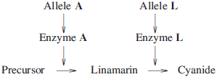

(a) Acyanogenic clover plants cannot produce cyanide. Explain why a plant with the genotype aaLl cannot produce cyanide.
........................................................................................................................
........................................................................................................................
(1)
(b) A clover plant has the genotype AaLl.
(i) Give the genotypes of the male gametes which this plant can produce.
...............................................................................................................
(1)
(ii) Explain how meiosis results in this plant producing gametes with these genotypes.
...............................................................................................................
...............................................................................................................
...............................................................................................................
...............................................................................................................
(2)
(c) Two plants, heterozygous for both of these pairs of alleles, were crossed. What proportion of the plants produced from this cross would you expect to be acyanogenic but able to produce linamarin? Use a genetic diagram to explain your answer.

(3)

In an investigation, cyanogenic and acyanogenic plants were grown together in pots. Slugs were placed in each pot and records were kept of the number of leaves damaged by the feeding of the slugs over a period of 7 days. The results are shown in Table 1.
Table 1

 |  | Undamaged | Damaged
 | Cyanogenic plants | 160 | 120
 | Acyanogenic plants | 88 | 192

(d) A x² test was carried out on the results.
(i) Suggest the null hypothesis that was tested.
...............................................................................................................
...............................................................................................................
(1)
(ii) x² was calculated. When this value was looked up in a table, it was found to correspond to a probability of less than 0.05. What conclusion can you draw from this?
...............................................................................................................
...............................................................................................................
...............................................................................................................
...............................................................................................................
...............................................................................................................
...............................................................................................................
(3)

A second investigation was carried out in a field of grass which had been undisturbed for many years. Table 2 shows the population density of slugs and the numbers of cyanogenic and acyanogenic clover plants at various places in the field.
Table 2

 | Population density of slugs | Number of acyanogenic clover plants per m² | Number of cyanogenic clover plants per m²
 | Very low | 26 | 10
 | Low | 17 | 26
 | High | 0 | 10
 | Very high | 0 | 5

(e) Explain the proportions of the two types of clover plant in different parts of the field.
........................................................................................................................
........................................................................................................................
........................................................................................................................
........................................................................................................................
........................................................................................................................
........................................................................................................................
........................................................................................................................
........................................................................................................................
(Extra space)..................................................................................................
........................................................................................................................
(4)
(Total 15 marks)

Q31.Chickens have a structure called a comb on their heads. The drawings show two types of comb.
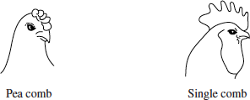
The shape of the comb is controlled by two alleles of one gene. The allele for pea comb, A, is dominant to the allele for single comb, a.
The colour of chicken eggs is controlled by two alleles of a different gene. The allele for blue eggs, B, is dominant to the allele for white eggs, b.
The genes for comb shape and egg colour are situated on the same chromosome.
A farmer crossed a male chicken with the genotype AaBb with a female chicken that had a single comb and produced white eggs.
(a) What was the genotype of the female parent?
........................................................................................................................
(1)

The diagram shows how the alleles of the genes were arranged on the chromosomes of the male parent.
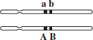
(b) Which two genotypes will be most frequent in the offspring?
........................................................................................................................
(1)

(c) The farmer could identify which of the female offspring from this cross would eventually produce blue eggs. Explain how.
........................................................................................................................
........................................................................................................................
........................................................................................................................
........................................................................................................................
(Extra space)...................................................................................................
........................................................................................................................
(2)

(d) Genes A and B are close together on the chromosome. This is important when trying to identify which of the female offspring would produce blue eggs. Explain why.
........................................................................................................................
........................................................................................................................
........................................................................................................................
........................................................................................................................
(Extra space)...................................................................................................
........................................................................................................................
(2)

(e) Suggest two environmental factors which are likely to affect egg production.
1 .....................................................................................................................
2 .....................................................................................................................
(2)

In chickens it is the males which are XX and the females which are XY.
(f) A gene on the X chromosome controls the rate of feather production. The allele for slow feather production, F, is dominant to the allele for rapid feather production, f.
A farmer made a cross between two chickens with known genotypes. He chose these chickens so that he could tell the sex of the offspring soon after they hatched by looking at their feathers.
Which of the crosses shown in the table did he make? Explain your answer.

 | Cross | Genotype of  male parent | Genotype of  female parent
 | A | X^{F} X^{F} | X^{f}Y
 | B | X^{F} X^{f} | X^{f}Y
 | C | X^{f} X^{f} | X^{F}Y
 | D | X^{F} X^{f} | X^{F}Y

Answer ..........................................................................................................
Explanation ....................................................................................................
........................................................................................................................
........................................................................................................................
........................................................................................................................
(Extra space)...................................................................................................
........................................................................................................................
(3)

(g) Female chickens are more likely than male chickens to show recessive sex-linked characteristics. Explain why.
........................................................................................................................
........................................................................................................................
........................................................................................................................
........................................................................................................................
........................................................................................................................
........................................................................................................................
(Extra space)...................................................................................................
........................................................................................................................
(3)
(Total 14 marks)

Q33..The diagram shows the inheritance of coat colour in pigs through three generations.
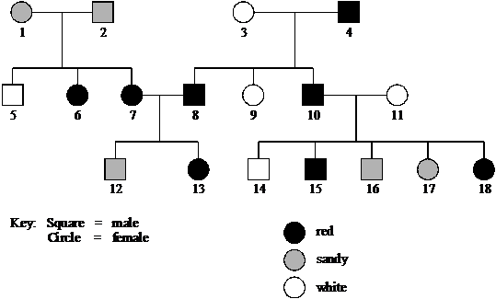
(a) Explain one piece of evidence from the diagram which shows that coat colour is not controlled by one gene with two codominant alleles.
........................................................................................................................
........................................................................................................................
........................................................................................................................
........................................................................................................................
........................................................................................................................
........................................................................................................................
........................................................................................................................
(3)
Two hypotheses were put forward to explain the results, each based on the action of two pairs of alleles.
 |  | Hypothesis 1 | Hypothesis 2
 | Phenotype | Genotype | Genotype
 | Red | A_B_ | A_B_ or A_bb
 | Sandy | A_bb or aaB | aaB_
 | White | aabb | aabb

( _ represents either a dominant or a recessive allele of the gene)
(b) Assuming that Hypothesis 1 is correct, give one possible genotype for each of the following individuals in the diagram.
11 .....................................................
10 .....................................................
2 .......................................................
(2)
(c) Explain one piece of evidence from the diagram which shows that Hypothesis 2 should be rejected.
........................................................................................................................
........................................................................................................................
........................................................................................................................
........................................................................................................................
(2)
(d) Individual 18 was crossed with a pig of genotype Aabb.
Use Hypothesis 1 to predict the genotypes and the ratio of phenotypes expected in the
offspring of this cross.

 |  | Individual 18 | Other parent
 | Parental  genotypes | ................................. | Aabb
Parental
gametes
Offspring
genotypes
Offspring
phenotypes
Expected ratio
of offspring
phenotypes

(4)
(Total 11 marks)

Q35. Hair type in dachshund dogs is controlled by two genes which are on different chromosomes.
Dogs with the H allele have wiry hair and dogs with the genotype hh have non-wiry hair.
The length of wiry hair is always the same. Dogs with non-wiry hair have either long or short hair. The length of non-wiry hair is controlled by another gene. Dogs with the D allele have short hair and those with the genotype dd have long hair.
(a) Give all the possible genotypes for dachshunds with non-wiry, short hair.
........................................................................................................................
(1)

(b) What type of interaction is occurring between the two genes? Explain your answer.
........................................................................................................................
........................................................................................................................
........................................................................................................................
........................................................................................................................
(2)

(c) A wiry-haired male with the genotype HhDd was mated with a non-wiry, long-haired female with the genotype hhdd. Complete the genetic diagram to show the ratio of offspring phenotypes expected in this cross.
Parental phenotypes Wiry-haired male Non-wiry, long-haired female
Parental genotypes HhDd hhdd
Gametes
Offspring genotypes
Offspring phenotypes
Ratio of offspring
phenotypes
(3)
(Total 6 marks)

Q37.
a) Explain one way in which the behaviour of chromosomes during meiosis produces genetic variation in gametes.
........................................................................................................................
........................................................................................................................
........................................................................................................................
........................................................................................................................
(2)

(b) In mosquitoes, the sex of an individual is determined by one gene. Males have the genotype Mm and females mm.
Another gene is carried on the same chromosome. Normal males and females are homozygous dd for this gene. Abnormal males have a dominant D allele.
The possible genotypes are shown below. The vertical lines represent homologous chromosomes.
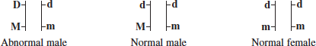
During meiosis, allele D causes the homologous chromosome carrying the m allele to disintegrate. Cells lacking this chromosome do not develop further.
Complete the genetic diagram to show how allele D is transmitted from an abnormal male to his offspring.

 | Parental phenotypes | Abnormal male | Normal female
 | Parental genotypes | 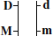 | 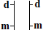
 | Gametes | ....................... | .......................
 | Offspring genotype(s) | ............................................................
 | Offspring phenotype(s) | ............................................................

(3)
(Total 5 marks)

M1. (a) Is always expressed / shown (in the phenotype);
Reject ‘is always present’ without further qualification
1

(b) C^{B}C^{B}, C^{B}C^{P} and C^{B}C^{Y};
All three are required for the mark
Or
C^{B}C^{B}, C^{P}C^{B} and C^{Y}C^{B};
Accept C^{B}C^{B}, C^{B}C^{P}, C^{B}C^{Y},
C^{Y}C^{B} and C^{P}C^{B}
Accept BB, BP and BY or
BB, BP, BY, YB and PB
1

(c) 1. Two genotypes (as parents) shown as C^{P} C^{Y}
Award one mark maximum for candidates who have misread the question and complete a correct genetic cross between a pink snail, C^{P}C^{Y} and a yellow snail, C^{Y}C^{Y} to give pink and yellow offspring
Or
Two sets of gametes shown as C^{P} and C^{Y};
2. Genotypes of offspring shown as C^{P} C^{Y}, C^{P} C^{P} and C^{Y} C^{Y};
3. Above genotypes of offspring correctly linked to phenotypes i.e. pink and yellow;
Accept ratio (or equivalent) of 3 pink: 1 yellow for mark point 3
3

(d) 1. Correct answer of 42% = 3 marks
Answer of 0.42 = 2 marks
Award one mark maximum for answer of
49.9 / 49.98 / 50% or 0.49 / 0.5
2. q² = 0.49 / 49% OR q = 0.7 / 70%
Award one mark maximum for answer of 40.8 / 41% or 0.41
3. Shows understanding that 2pq = heterozygotes / carriers / shows answer is derived from 2pq;
Accept: b² = 0.49 / 49% or b = 0.7 / 70% for mark point 2
3
[8]

M3.(a) (i) 1. No overall pattern / pattern (of right or left most
common) is not the same for all islands;
Allow expression in other ways e.g. three islands show left on top is more common
2. For (B) C and E there is little difference;
3. Large differences on A and D and opposite ways (to each other);
Need both aspects but allow other expressions of ‘opposite ways’
2 max

(ii) 1. Can record all individuals on (small) islands;
2. (So) no / less sampling error;
3. (Maybe) different rates of mutation / different selection pressures / different environmental conditions;
4. Inbreeding / breeding with close relatives (more likely);
5. (Little) gene flow / (more chance of) genetic drift;
Accept reference to either of these ideas for this point
2 max

(b) 1. If R is recessive, R × R parents cannot produce L offspring;
Accept use of genetic diagrams to illustrate points 1 and 2
2. If L is recessive, L × L parents cannot produce R offspring;
Accept right arm on top as R etc.
3. R × R and L × L parents produce both types of offspring;
Need reference to two parent crosses for this mark
3

(c) Both L and R in a set of twins / (some) twins show different arm-folding;
1
[8]

M5.(a) 1. Reduction in ATP production by aerobic respiration;
2. Less force generated because fewer actin and myosin interactions in muscle;
3. Fatigue caused by lactate from anaerobic respiration;
3

(b) Couple A,
1. Mutation in mitochondrial DNA / DNA of mitochondrion affected;
2. All children got affected mitochondria from mother;
3. (Probably mutation) during formation of mother’s ovary / eggs;
Couple B,
4. Mutation in nuclear gene / DNA in nucleus affected;
5. Parents heterozygous;
6. Expect 1 in 4 homozygous affected;
4 max

(c) 1. Change to tRNA leads to wrong amino acid being incorporated into protein;
2. Tertiary structure (of protein) changed;
3. Protein required for oxidative phosphorylation / the Krebs cycle, so less / no ATP made;
3

(d) 1. Mitochondria / aerobic respiration not producing much / any ATP;
2. (With MD) increased use of ATP supplied by increase in anaerobic respiration;
3. More lactate produced and leaves muscle by (facilitated) diffusion;
3

(e) 1. Enough DNA using PCR;
2. Compare DNA sequence with ‘normal’ DNA;
2
[15]

M7. (a) polygenic inheritance / several genes;
many categories / continuous range / single or multiple allele inheritance
would produce discrete categories / eq.;
2
(b) (SE gives idea of) variability of mean;
time / population mean would lie within these limits in 68% / 70% /
2 / 3 of samples;
2
[4]
M9. (a) (variation in) temperature will affect the solubility of oxygen / rate of respiration / use of oxygen by cells / diffusion / gas exchange;
to gain credit point made must concern oxygen
1

(b) (i) there is no difference between the partial pressure of oxygen in the two groups / the partial pressure of oxygen is the same in each group;
1
(ii) results may have been due to chance and statistical test allows us to determine the probability of this / of the difference between results
being significant;
enables acceptance or rejection of null hypothesis;
The key points here are chance and probability used in the correct context.
2

(c) A;
because partial pressure of oxygen only reduced when zinc in water / in Y / because when injected zinc / in X has no effect on partial pressure of oxygen in blood;
2

(d) less oxygen transport to cells / in fish / in blood;
anaerobic respiration;
lactic acid produced / less carbon dioxide removed (from gills);
more H⁺;
3 max

(e) (i) copper;
calculation based on comparing concentration in woodlice with that in leaves;
accept any suitable method here, giving marks for the method and explanation. For example, calculating ratio of concentration in woodlice to concentration in leaves.
2

(ii) not absorbed from gut / passes out in faeces / egested / urine / excreted;
1
(iii) woodlice eat large amount of leaves;
copper stored / accumulates in body;
2

(f) (i) mutation;
1
(ii) (as a component of) nucleic acids / DNA / RNA / nucleotides;
phospholipids;
ATP / ADP;
2 max
(iii) arsenic-tolerant plants would not be able to take up phosphates / take up a little phosphate;
since likely to involve same mechanism / same carrier / protein;
(process of ) growth would be poorer than non-tolerant plants;
3
[20]

M11. (a) 6;
1
(i) chromosomes are arranged in (homologous) pairs / bivalents;
crossing over / chiasma present / exchange of genetic information;
bivalents arranged independently;
2 max

(ii) separation / spliting / pulling apart of homologous chromosomes /
pairs of chromosomes;
(must give indication that one chromosome moves to each side)
(must be in the context of meiosis – not chromatid movements and not chromosomes separate)
pulled at centromere / by spindle / fibres;
2

(c) (i) the short arm of both chromosomes labelled on the middle
homologous pair;
(B and b must be labelled on separate chromosomes)
1
(ii) 8 = 2 marks;
working showing genotypes with 1 allele from each pair
(for example, B C D) = 1 mark
2
[8]

M13.(a) 1. Large number of eggs / offspring / flies (therefore) improves reliability / can use statistical tests / are representative / large sample (size) / reduces sampling error;
Each mark point requires a feature linked in mark scheme (by therefore) to an explanation
Do not accept a large number of eggs produces a large number of flies unless the term sample is used
Ignore references to accuracy or precision
2. Small size / (breed) in small flasks / simple nutrient medium (therefore) reduces costs / easily kept / stored;
Accept small size so can be kept in small flasks
3. Size / markings / phenotypes (therefore) males / females easy to identify;
Answers must relate to size, markings or use the term phenotype
4. Short generation time / 7 - 14 days / develop quickly / reproduce quickly (therefore) results obtained quickly / saves times / many generations;
2 max

(b) (i) 1. X^{R}X^{R} and X^{r}Y;
All marking points are completely independent. Allow crosses from the following parents for a possible three marks:
X^{R}X^{R} and X^{r}-
X^{R}X^{R} and X^{r}Y;
RR and rY / rY⁻
RR and r− or RR and r
2. X^{R} and X^{R} plus X ^{r} and Y;
3. X^{R}X^{r} and X^{R}Y;
OR
1. X^{R}X^{r} and X^{r}Y;
OR
X^{R}X^{r} and X^{r}−
X^{R}X^{r} and X^{r}Y;
2. X^{R} and X^{r} plus X^{r} and Y;
Rr and rY / rY⁻
Rr and r⁻ or Rr and r
Accept different symbols e.g. W and w
2. Accept gametes in a punnet square
3. X^{R}X^{r} and X^{R}Y;
3

(ii) Fertilisation is random / fusion of gametes is random / small / not large population / sample / selection advantage / disadvantage / lethal alleles;
Mutation = neutral
Random mating = neutral
Accept fertilisation / fusion of gametes is due to chance
1

(c) 1. Males have one allele;
Answers should be in context of alleles rather than chromosomes
2. Females need two recessive alleles / must be homozygous recessive / could have dominant and recessive alleles / could be heterozygous / carriers;
2
[8]

M15. (a) (i) Only seen in males / not in females;
1
(ii) Unaffected parents / mother → child with M.D. /
(1 ×)2 → 5 / (3 ×) 4 → 11 / 8 (× 9) → 13;
1

(b) 5 = X^{d}Y
6 = X^{D}Y
7 = X^{D}X^{d} AND X^{D}X^{D}
8 = X^{D}X^{d};;
All 4 correct = 2 marks
2 or 3 correct = 1 mark
max 2
(c) ¼ / 0.25 / 25% / 1:3 / 1 in 4; (NOT ‘1:4’)
1
[5]

M17. (a) gene located on X / Y / one sex chromosome;
(allow gene on X or Y chromosome, not X and Y)
1

(b) (i) black;
1
(ii) X^{G}X^{g};
(lose this mark if the wrong genotype is given for the female in (iii))
(must show X chromosomes to gain the mark)
1
correct parent gametes
(X^{g} and Y from male, X^{G} and X^{g} from female);
correct offspring genotypes (X^{g}X^{g}, X^{G}X^{g}, X^{G}Y, X^{g}Y);
correct link of offspring genotypes with phenotypes;
X^{g}X^{g} black female
X^{G}X^{g} tortoiseshell female
X^{G}Y ginger male X^{g}Y black male
(correct gametes, offspring genotypes and link with phenotypes based on incorrect parent genotype = 3 marks)
3

(c) X^{G}Y dd; correct male kitten genotypes (X^{g}Y Dd and X^{g}Y dd);
correct link of kitten genotypes with phenotypes;
(ignore female kittens)
X^{g}Y Dd black
X^{g}Y dd grey
(correct kitten genotypes and phenotypes based on incorrect parent genotype = 2 marks)
3
[9]

M19. (a) (i) Two, as white blood cells are diploid cells / alleles are present on each chromosome of an homologous pair / one maternal and one paternal;
1
(ii) A and B
(reject I^{A} and I^{B})
1

(b) 1 in 8 / 1 / 8 / 12.5% / 1:7 / 0.125;
(Reject 1:8) parents I^{A}I^{O} and I^{B}I^{O} ;
give 1:3 / ¼ / 1 in 4 / 25% probability of blood group A and half will be male;
(accept 2nd and 3rd points from a suitable genetic diagram)
3
[5]
M21. (a) is always expressed(in the phenotype) / produces (functional) proteins;
1
(b) codominance;
1

(c) Parental geneotypes - hhC^{R}C^{w}, HhC^{w}C^{w};
Gametes- 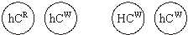
Offspring geneotypes - HhC^{R}C^{w}, hhC^{R}C^{w}, HhC^{w}C^{w}, hhC^{w}C^{w};
Offspring pheneotypes - hornless horned hornless horned
roan roan white white
Ratio of offspring - 1 1 1 1;
4

(d) (i) sperm(with more DNA) have X chromosome;
X is larger / has more genes than Y;
2
(ii) female for milk / males for meat / male or female for breeding;
1
[9]

M23. bioaccumulation / biomagnification;
higher dose to have the same effect / develop tolerance;
kill natural enemies / predators of pest;
kill (beneficial) organisms (not a predator) / named;
hazard to user / enters water / food chain;
residue left on crop;
[2]

M25. (a) (i) black;
1
(ii) chocolate;
1

(b) BE, Be, bE, be and be;
BbEe, Bbee, bbee, bbEe;
1 black: 2 yellow: 1 chocolate;
3

(c) (i) no enzyme coded for when no dominant / E allele;
phaeomelanin not converted – (remains yellow);
2
(ii) E allele results in enzyme producing eumelanin;
B allele - more eumelanin deposited in hairs;
2
[9]
M27. (a) mutations;
which are different / at different positions in the gene;
2
(b) (i) either dominant or recessive allele;
1
(ii) a^{h}a^{h} BB, a^{h}aBB, a^{h}a^{h} Bb, a^{h}aBb;;
(allow 1 mark for 2 or 3 correct answers)
2
(iii) temperature lower at extremities;
enzyme active / not denatured;
2

(c) if allele A is present (normal) tyrosinase / enzyme is produced, so it does
not matter what other allele is present / explanation of why heterozygote is
same phenotype as double dominant in terms of enzyme produced;
phenotype / rabbit is black as both have alleles A and B;
2
[9]

M29.(a) Cannot make (active) enzyme A (which converts precursor to linamarin) / cannot make linamarin;
1

(b) (i) AL + Al + aL + al ;
1

(ii) Meiosis separates alleles / homologous chromosomes / pairs of chromosomes;
Independent assortment / means either of A / a can go with either of L / l;
Accept “random segregation” but cancel if reference to crossing-over
2

(c) From parental genotypes: AaLl × AaLl (no mark)
Note: If wrong parental genotypes / wrong gametes: ALLOW correct derivation of offspring genotypes = 1 max
Correct derivation of offspring genotypes; max 2 marks if error in Punnett square

 |  | AL | Al | aL | al
 | AL | AALL | AALl | AaLL | AaLl
 | Al | AALl | AAll | AaLl | Aall
 | aL | AaLL | AaLl | aaLL | aaLl
 | al | AaLl | Aall | aaLl | aall

Correct identification of offspring genotypes with at least one A and two l alleles (= grey cells in above table);
Correct proportion: 3 / 16 / 3:13 / 18.75% ;
3

(d) (i) There was no (significant) difference in damage between cyanogenic and acyanogenic / being cyanogenic has no effect;
1

(ii) The difference (from expected / from chance variation) is significant / difference / results not just due to chance;
Reject null hypothesis;
Being cyanogenic does help protect from slug damage;
3

(e) High slug population:
1. Find only cyanogenic plants / only cyanogenic plants survive;
2. (Cyanide release) limits / stops feeding by slugs / slugs killed;
Accept: converse argument re. acyanogenic plants
Low slug population:
3. Find both types of plant;
4. Less selection pressure on plants from slugs / no selective advantage / no selection / described;
4
[15]
M31.
a) aabb;
1

(b) AaBb and aabb;
1

(c) Pea comb offspring will produce blue eggs;
Alleles A and B are inherited together / are on the same chromosome;
2

(d) Reference to crossing over;
Reduce chance of genes being separated (by crossing over);
If crossing over occurred some gametes will contain alleles A and b;
2 max

(e) Two suitable environmental factors;
e.g.
Diet / named component of diet;
Temperature;
Light intensity / duration;
Disease;
2 max

(f) Cross C / X^{f} X^{f} and X^{F}Y;
1

(Only) cross where all males are one phenotype and all females are a different phenotype;
Cross showing all males are slow feather production, all females fast feather production;
2

(g) Two alleles for each gene present in male / chromosomes are homologous in male;
Female has one allele for each gene;
Recessive alleles always expressed in female;
Males need two recessive alleles for allele to be expressed / in males recessive alleles can be masked by dominant allele
3 max
[14]
M33.
(a) sandy stated as heterozygous / suitable allusion to alleles;
suitable cross chosen; (as in table)
N.B. second two points linked, not stand-alone
explained why could not be codominance;
N.B. Second two points linked, not stand alone

 | Suitable cross | Reason why not codominance
 | 3 and 4 | Offspring should all be sandy
 | 10 and 11 | Offspring should all be sandy
 | 7 and 8 | Offspring should all be red

BUT if candidate assumes sandy is homozygous, mark accordingly
e.g. "look at cross 1 and 2; all their offspring would be sandy;"
and not that, if red or white then identified as heterozygote,
then full 3 marks are still possible.
3

(b) 11 aabb,
10 = AaBb, (N.B. only possibility, not A-B-)
2 = A_bb or aa B- (or one possible genotype);
if all 3 correct - 2 marks / if 2 correct - 1 mark; one or fewer - 0 marks
2

(c) 1 mark for each element of clear explanation i.e.
- choice of a suitable piece of evidence;
- explaining why Hypothesis 2 could not account for the observed result;
(only cross really possible is 1 and 2) i.e. if sandy was aaB_, individuals 1 and 2 would both have been aaB; so their offspring could only be either white or sandy (as no A alleles present);
2

(d) (Mark line by line, not to 'first error': do not allow for consequential errors)
Individual 18 Other parent
Parental
genotypes AaBb; No mark for this
(AaBb)
Parental gametes AB Ab aB ab and Ab ab;
Offspring
genotypes

 | AABb | Aabb | AaBb | Aabb
 | AaBb | Aabb | aaBb | aabb
 | (Punnett not necessary

Offspring
phenotypes red sandy white
Expected ratio 3 4 1;
4
[11]
M35.
(a) hhDD, hhDd;
(both correct 1 mark)
1

(b) Epistasis;
One gene controlling / inhibiting the expression of another;
2

(c) Gametes correct HD, Hd, hD, hd, hd
(correct for both parents);
Genotypes HhDd, Hhdd, hhDd, hhdd ;
Phenotypes wiry wiry non-wiry, short non-wiry, long
Ratio 2 1 1 ;
3
[6]

M37.(a) Two linked points:
Crossing over / exchange of material (between chromatids);
Different combinations of alleles / linkage groups changed / broken;
OR
Independent assortment / alignment of (homologous) chromosomes;
Different combinations of (maternal and paternal) chromosomes / alleles;
2 max

 | (b) | Gamete genotype |  | 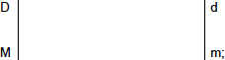
 | (b) | Offspring genotype |  | 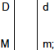
 | (b) | Offspring  phenotypes | Abnormal males / (all) (no females);

3
[5]

