3.2.2 All cells arise from other cells

Name __________________________________

Reflection on learning outcomes | or | Target
Explain what binary fission is and the organisms which carry out binary fission.
Describe the process of binary fission.
Explain why viruses are not classified as being living organisms.
Describe the sequence of events by which viruses replicate
Explain why viruses are so difficult to treat and develop medicines against.
Explain the different outcome of mitosis and meiosis.
Recognise where meiosis and mitosis occurs when given information about an unfamiliar life cycle.
Explain what the cell cycle is and why it does not occur in some cells from multicellular organisms.
Describe the stages of the cell cycle.
Recognise the stages of the cell cycle: interphase, prophase, metaphase, anaphase and telophase (including cytokinesis).
Explain the appearance of cells in each stage of mitosis.
Explain the events involved in the formation of tumours and cancers and why this is damaging to the body.
Identify the processes within the cell cycle which are disrupted and which lead to cancer.
State that cancer treatments often work to inhibit stages of the cell cycle.
Interpret data relating to cancer treatments and their effects on the rate of cell division
Explain how meiosis results in variation.
Complete diagrams showing the chromosome content of cells after the first and second meiotic division, when given the chromosome content of the parent cell.
Explain how random fertilisation of haploid gametes further increases genetic variation within a species.
Explain what a non-disjunction event is and how it occurs.
Compare and contrast gene and chromosomal mutations.

Outcome:
- Explain what binary fission is and the organisms which carry out binary fission.
- Describe the process of binary fission.
- Explain the appearance of cells in each stage of mitosis.

Binary fission (definition, organisms and process)

Binary fission occurs in what type of cell?

_______________________________________________

Where is genetic information contained in this type of cell? (hint: there is two)

_____________________________________________________

Out of the two places you mentioned above, which one can be in variable amounts?

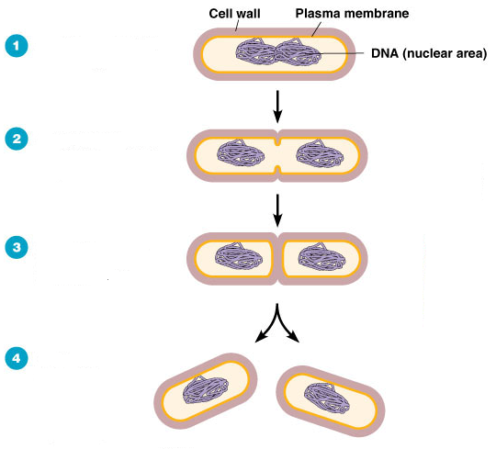
Questions:
1.A bacterial cell undergoes binary fission every twenty minutes. Starting with a single bacterium how may bacteria will be formed at the end of 3 hours?

Answer:________________

2. A bacterial cell undergoes binary fission every twenty minutes. Starting with a single bacterium how may bacteria will be formed at the end of 7 hours?
Give your answer in standard form.
Answer:___________________

1. Bacteria replicate by binary fission;

2. Replication of (circular) DNA;

3. Division of cytoplasm to produce 2 daughter cells;

4. Each with single copy of (circular) DNA;

Viruses are classed as been non-living so do not undergo cell division.
You can be asked to describe the sequence of events by which viruses replicate.
So you will need to make sure you recap this from the immunity topic.

Why are viruses difficult to treat and develop medicines against?

_______________________________________________________________________________________________________________________________________________________________________________________________________________________________________________________________________________________________________________________________________________________________________________________________________________________________

___________________________________________________________________________________
Exam questions:
Q1.
(a) Bacteria are often used in industry as a source of enzymes. One reason is because bacteria divide rapidly, producing a large number of them in a short time.
Describe how bacteria divide.
___________________________________________________________________
___________________________________________________________________
___________________________________________________________________
___________________________________________________________________
(2)
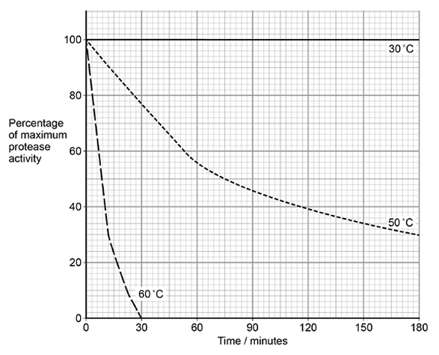
(b) Washing powders often contain enzymes from bacteria. These enzymes include proteases that hydrolyse proteins in clothing stains.
The graph shows the effect of temperature on a protease that could be used in washing powder.

Explain the shape of the curves at 50 °C and 60 °C.
___________________________________________________________________
___________________________________________________________________
___________________________________________________________________
___________________________________________________________________
___________________________________________________________________
___________________________________________________________________
___________________________________________________________________
___________________________________________________________________
(4)

(c) Some proteases are secreted as extracellular enzymes by bacteria.
Suggest one advantage to a bacterium of secreting an extracellular protease in its natural environment.
Explain your answer.
___________________________________________________________________
___________________________________________________________________
___________________________________________________________________
___________________________________________________________________
___________________________________________________________________
(2)
(d) Mammals have some cells that produce extracellular proteases. They also have cells with membrane-bound dipeptidases.
Describe the action of these membrane-bound dipeptidases and explain their importance.
___________________________________________________________________
___________________________________________________________________
___________________________________________________________________
___________________________________________________________________
___________________________________________________________________
(2)
(Total 10 marks)

Mitosis

Mitosis definition:

______________________________________________________________________________________________________________________________________________________________________

Where does mitosis occur?

______________________________________________________________________________________________________________________________________________________________________

Stage of mitosis | Description
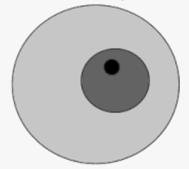
I______________
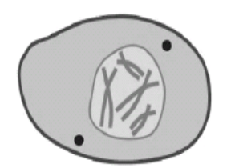
P______________
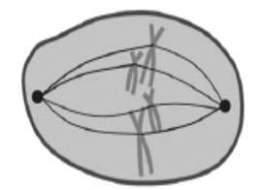
M______________
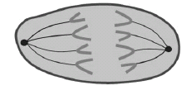
A______________
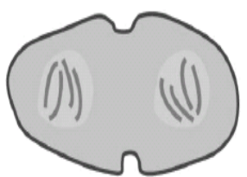
T______________

When doing a root tip squash you always:

Use only the first 5 mm from the tip of an onion root because this is where dividing cells are found / mitosis occurs.

Press down firmly on the cover slip to create thin layer of cells so light passes through (making nuclei visible).

Exam tips

In mitosis examiners like to give you pictures of lots of cells under the microscope. You could be asked the following:
- How many cells are in a certain phase (as a number/percentage), calculate time spent in a certain phase or comparing to another result.
- Applying your knowledge to how certain chemicals can interfere with mitosis.
- Asking practical application from completing the root tip squash practical.

Exam questions:

Q1.
The photograph shows cells from an onion root tip. The root tip has been squashed and stained to show the stages of mitosis.
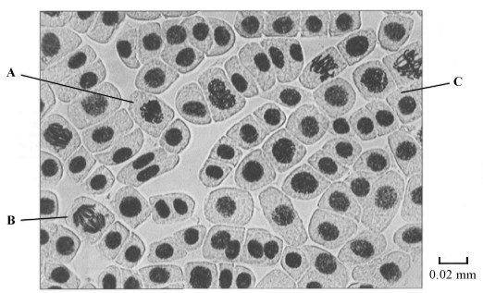
(a) (i) At what stage of mitosis is cell A?
______________________________________________________________
(1)
(ii) What is the evidence that cell B is in anaphase?
______________________________________________________________
______________________________________________________________
(1)
(iii) Cell C is in interphase. Give two processes which occur during interphase that enable cell division to occur.
1. ____________________________________________________________
______________________________________________________________
2. ____________________________________________________________
______________________________________________________________
(2)

(b) Explain how you would calculate the magnification of the photograph.
___________________________________________________________________
___________________________________________________________________
(1)

(c) The number of cells at each stage of mitosis was counted. The results are shown in the table.

Stage of mitosis | Number of cells
Interphase | 123
Prophase | 32
Metaphase | 12
Anaphase | 6
Telophase | 27
One complete cell cycle takes 24 hours. The number of cells at each stage is proportional to the time spent at that stage. Calculate the length of time spent in metaphase. Show your working.

Answer ____________________ hours
(2)
(Total 7 marks)
Q2.
The diagram shows two chromosomes in a cell undergoing mitosis.
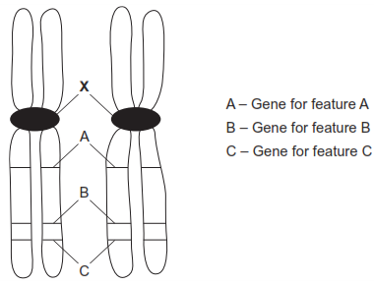
(a) Name X.
___________________________________________________________________
(1)
(b) These are homologous chromosomes. Give two pieces of evidence from the diagram that support this.
1. _________________________________________________________________
___________________________________________________________________
2. _________________________________________________________________
___________________________________________________________________
(2)
(c) What will happen to these chromosomes in anaphase?
___________________________________________________________________
___________________________________________________________________
___________________________________________________________________
___________________________________________________________________
(2)
(Total 5 marks)
Q3.
(a) The following statements describe stages of mitosis.
A chromosomes align at the centre of the cell attached to spindle fibres
B chromatids are in groups at the poles
C chromosomes become visible
D chromatids move towards the poles
Complete the table by entering the appropriate letter.

Stage of mitosis | Letter of description of the stage
Prophase
Metaphase
Anaphase
Telophase
(3)
(b) The graph shows changes in the mass of DNA in a cell during one cell cycle.
Five stages have been identified on the graph.
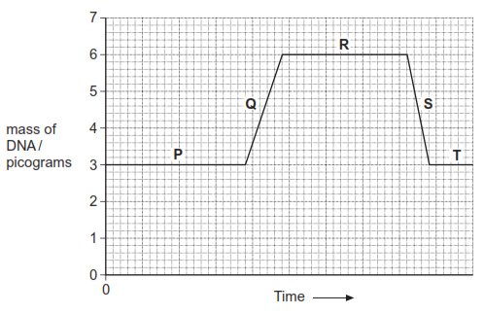
(i) Which letter represents the stage when DNA is replicating? 
(1)
(ii) Explain the change in the DNA content during stage S.
______________________________________________________________
______________________________________________________________
(1)
(Total 5 marks)
Q4.
(a) The diagram shows a chromosome at the start of mitosis.

Describe and explain the appearance of the chromosome.
___________________________________________________________________
___________________________________________________________________
___________________________________________________________________
___________________________________________________________________
(2)
(b) The photographs show two stages in mitosis.
Stage A Stage B
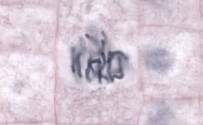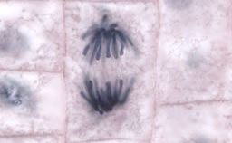
Name stages A and B. Describe what is happening to the chromosomes in each stage.
(i) Stage A
______________________________________________________________
______________________________________________________________
______________________________________________________________
(2)
(ii) Stage B
______________________________________________________________
______________________________________________________________
______________________________________________________________
(2)
(Total 6 marks)

Meiosis

Outcome:
- Explain the outcome of meiosis.
- Complete diagrams showing the chromosome content of cells after the first and second meiotic division, when given the chromosome content of the parent cell.
- Recognise where meiosis and mitosis occurs when given information about an unfamiliar life cycle

Starter activity Match up exercise.
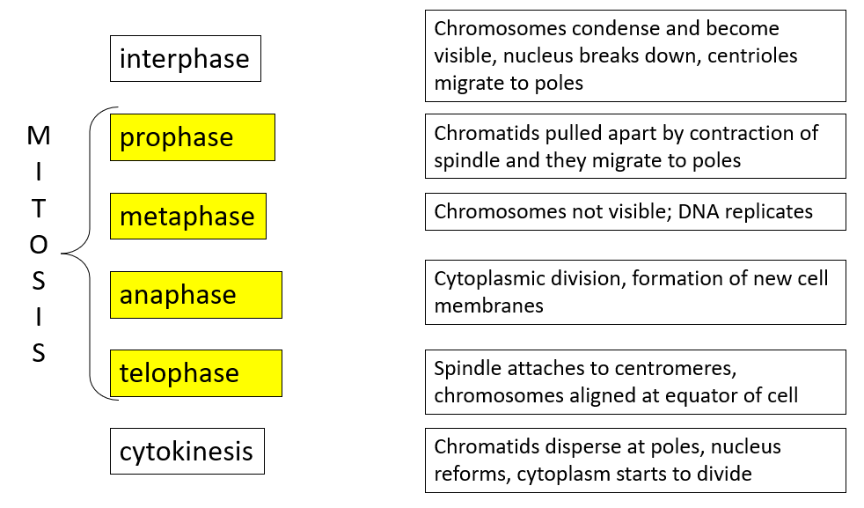

Meiosis definition:

________________________________________________________________________________________________________________________________________________________________

Where does meiosis occur?

________________________________________________________________________________________________________________________________________________________________

Image | Stage and description
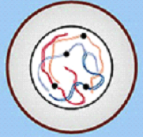 | I______________
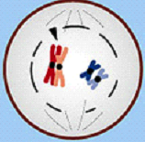 | P______________
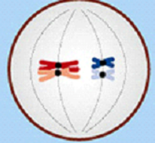 | M______________
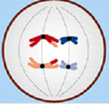 | A______________
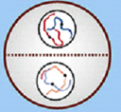 | T______________
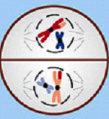 | P______________
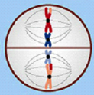 | M______________
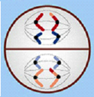 | A______________
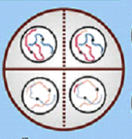 | T______________
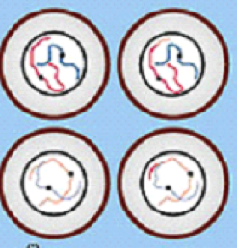 | C______________

What is the difference between meiosis I and meiosis II?
_________________________________________________________________________________________________________________________________________________________________________________________________________________________________________________________

Outcome:
- Explain how meiosis results in variation.
- Explain how random fertilisation of haploid gametes further increases genetic variation within a species.
- Explain what a non-disjunction event is and how it occurs.
- Compare and contrast gene and chromosomal mutations.

How does meiosis result in variation?

_________________________________ and ______________________________________________

What is crossing over?

_________________________________________________________________________________________________________________________________________________________________________________________________________________________________________________________

What is independent assortment?
_________________________________________________________________________________________________________________________________________________________________________________________________________________________________________________________

How does meiosis result in variation?

Homologous chromosomes pair up

Independent segregation

Maternal and paternal chromosomes are re-shuffled in any combination;

Crossing over leads to exchange of parts of (non-sister) chromatids / alleles between homologous chromosomes;

(Both) create new combinations of alleles;

How does meiosis result in variation?

Homologous chromosomes pair up

Independent segregation

Maternal and paternal chromosomes are re-shuffled in any combination;
Crossing over leads to exchange of parts of (non-sister) chromatids / alleles between homologous

Non- disjunction event

Sometimes individual homologous pairs of chromosomes fail to sperate during meiosis. This is known as non-disjunction and usually results in the gamete having either one more or fewer chromosomes. When fertilised with a gamete with a normal complete chromosome number this will make the offspring have more or fewer chromosomes than normal. This will be the same in all their body cells. An example of non-disjunction is down syndrome.

A non-disjunction event is an example of a ‘chromosome mutation’. A chromosome mutation changes the structure or number of whole chromosomes. This is different to a gene mutation which is a change in the base sequence of a gene.

Extension task: Read through the information on ‘hybridisation and polyploidy’ in the Toole and Toole textbook on pages 221-223 and complete the questions. You can check your answers when you’re done on 622.

___________________________________________________________________________________
Exam Questions:

Q1.
The diagram represents a cell from a fruit fly in which the diploid number is eight.
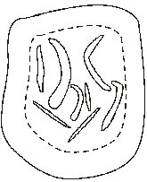
(a) Draw a diagram to show
(i) this cell during anaphase of mitosis;

(2)
(ii) the chromosomes in a gamete produced from this cell by meiosis.

(2)

(b) Explain why meiosis is important in sexual reproduction, apart from producing gametes that are genetically different.
___________________________________________________________________
___________________________________________________________________
___________________________________________________________________
___________________________________________________________________
(2)
(Total 6 marks)
Q2.
(a) Give one process which occurs in the nucleus of a cell during interphase which is necessary before cell division can take place.
___________________________________________________________________
(1)
(b) The diagram shows the chromosomes from a cell with a diploid chromosome number of six.
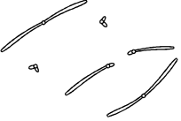
Draw a diagram to show the chromosomes from one of the resulting cells if
(i) the cell divides by mitosis;

(2)
(ii) the cell divides by meiosis.

(2)
(c) Explain one advantage of cells lining the human gut dividing very frequently.
___________________________________________________________________
___________________________________________________________________
(1)
(Total 6 marks)
Q3.
(a) Figure 1 shows one pair of homologous chromosomes.
Figure 1
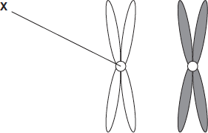
(i) Name X.
______________________________________________________________
(1)
(ii) Describe the role of X in mitosis.
______________________________________________________________
______________________________________________________________
______________________________________________________________
______________________________________________________________
(2)

(iii) Homologous chromosomes carry the same genes but they are not genetically identical. Explain why.
______________________________________________________________
______________________________________________________________
______________________________________________________________
(1)
(b) Figure 2 shows three pairs of homologous chromosomes in a cell at the end of cell division.
Figure 2

(i) The appearance of each chromosome in Figure 2 is different from those shown in Figure 1. Explain why.
______________________________________________________________
______________________________________________________________
______________________________________________________________
(1)
(ii) Complete the diagram to show the chromosomes in one cell that could be produced from the cell in Figure 2 as a result of meiosis.

(2)

(iii) Other than independent segregation, give one way in which meiosis allows the production of genetically different cells.
______________________________________________________________
______________________________________________________________
(1)
(Total 8 marks).

Outcome:
- Explain what the cell cycle is and why it does not occur in some cells from multicellular organisms.
- Describe the stages of the cell cycle.
- Recognise the stages of the cell cycle: interphase, prophase, metaphase, anaphase and telophase (including cytokinesis).

What is the cell cycle?
______________________________________________________________________________________________________________________________________________________________________________

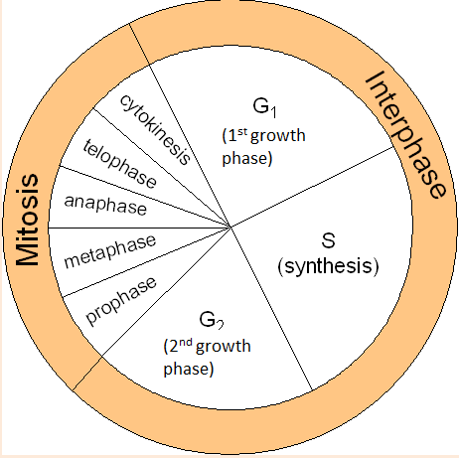
Interphase occupies most of the cell cycle.
- G1 phase: synthesis of proteins
- S phase: DNA is replicated.
- G2 phase: organelles grow and divide, ATP stores increased.
Nuclear division
- Mitosis (PMAT)
Cell division
- Cytokinesis

Where are the 3 main checkpoints in the cell cycle?
- ____________________________________
- ____________________________________
- ____________________________________
The number of cells at each stage of mitosis was counted. The results are shown in the table.
One complete cell cycle takes 24 hours. The number of cells at each stage is proportional to the time spent at that stage. Calculate the length of time spent in metaphase. Show your working.
What equation would you use to calculate this?

Stage of mitosis | Number of cells
Interphase | 123
Prophase | 32
Metaphase | 12
Anaphase | 6
Telophase | 27

Answer ........................................................... Hours (2)

Outcome:
- Explain the events involved in the formation of tumours and cancers and why this is damaging to the body.
- Identify the processes within the cell cycle which are disrupted and which lead to cancer.
- State that cancer treatments often work to inhibit stages of the cell cycle.
- Interpret data relating to cancer treatments and their effects on the rate of cell division
What is cancer?
______________________________________________________________________________________________________________________________________________________________________________
How is cancer often treated?
______________________________________________________________________________________________________________________________________________________________________________
What are the problems with using these drugs?
______________________________________________________________________________________________________________________________________________________________________________

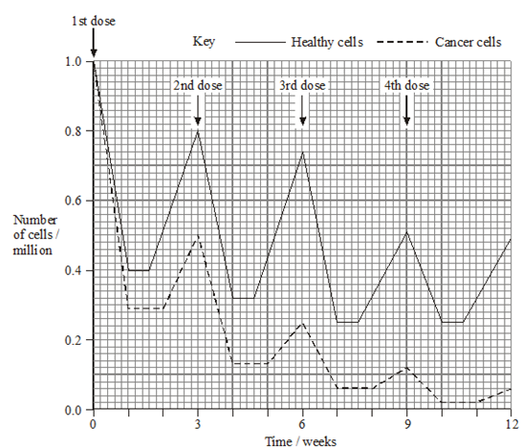

This is a typical exam question in which you are expected to interpret data relating to cancer treatments and how they effect cell division.

It would be possible to kill more cancer cells by administering the drug more frequently or giving a larger dose. Suggest why
The drug was not given more frequently
______________________________________________________________________________________________________________________________________________________________________________
The dose of the drug was not increased
______________________________________________________________________________________________________________________________________________________________________________
_____________________________________________________________________________________
Exam Questions:
Q1.
Yeast is a single-celled eukaryotic organism. When yeast cells are grown, each cell forms a bud. This bud grows into a new cell. This allows yeast to multiply because the parent cell is still alive and the new cell has been formed.
Scientists grew yeast cells in a culture. They counted the number of cells present and measured the total concentration of DNA in the culture over a period of 6 hours. Their results are shown in the graph.
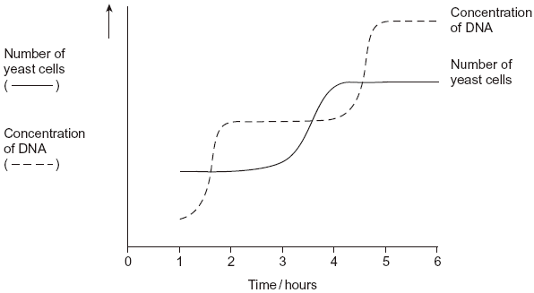
(a) Use your knowledge of the cell cycle to explain the shape of the curve for the number of yeast cells
(i) between 1 and 2 hours
______________________________________________________________
______________________________________________________________
(1)
(ii) between 3 and 4 hours.
______________________________________________________________
______________________________________________________________
(1)
(b) Use the curve for the concentration of DNA to find the length of a cell cycle in these yeast cells. Explain how you arrived at your answer.
Length of cell cycle ___________________________________________________
Explanation _________________________________________________________
___________________________________________________________________
___________________________________________________________________
___________________________________________________________________
(3)
(Total 5 marks)

Q2.
The diagram shows a cell cycle.
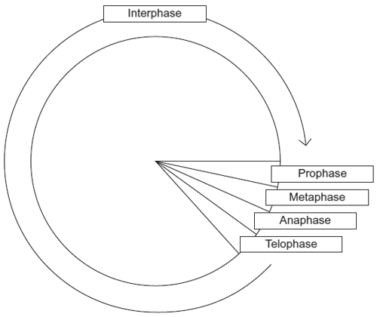
(a) In prophase of mitosis, the chromosomes become visible. Describe what happens in
(i) metaphase
______________________________________________________________
______________________________________________________________
______________________________________________________________
______________________________________________________________
______________________________________________________________
(2)
(ii) anaphase.
______________________________________________________________
______________________________________________________________
______________________________________________________________
______________________________________________________________
______________________________________________________________
(2)
(b) (i) Cells lining the human intestine complete the cell cycle in a short time. Explain the advantage of these cells completing the cell cycle in a short time.
______________________________________________________________
______________________________________________________________
______________________________________________________________
(1)
(ii) The time required for a cell to complete the cell cycle was 4 hours 18 minutes.
Calculate the time required in minutes for this cell to multiply to produce eight cells.
Show your working.

Answer ____________________
(2)
(c) Mikanolide is a drug that inhibits the enzyme DNA polymerase. Explain why this drug may be effective against some types of cancer.
___________________________________________________________________
___________________________________________________________________
___________________________________________________________________
___________________________________________________________________
___________________________________________________________________
(2)
(Total 9 marks)

Q3.
The diagram shows a cell cycle.
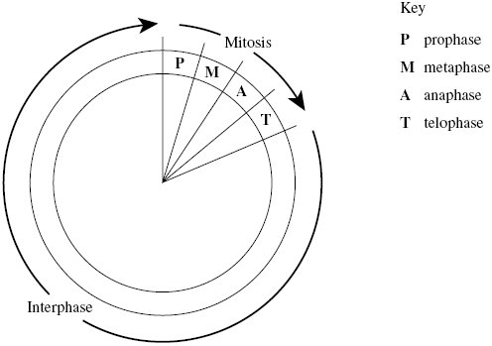
(a) The table shows the number of chromosomes and the mass of DNA in different nuclei.
All the nuclei come from the same animal. Complete this table.

Nucleus | Number of chromosomes | Mass of DNA / arbitrary units
At prophase of mitosis | 26 | 60
At telophase of mitosis
From a sperm cell
(4)
(b) If the DNA of the cell is damaged, a protein called p53 stops the cell cycle.
Mutation in the gene for p53 could cause cancer to develop. Explain how.
___________________________________________________________________
___________________________________________________________________
___________________________________________________________________
___________________________________________________________________
___________________________________________________________________
___________________________________________________________________
(3)
(c) Drugs are used to treat cancer. At what phase in the cell cycle would each of the following drugs act?
(i) A drug that prevents DNA replication
______________________________________________________________
(1)
(ii) A drug that prevents spindle fibres shortening
______________________________________________________________
(1)
(Total 9 marks)
Q4.
(a) Boxes A to E show some of the events of the cell cycle.

A
Chromatids seperate

B Nuclear envelopes disappears

C
Cytoplasm divides

D Chromosomes condense and become visible

E Chromosomes on the equator of the spindle
(i) List these events in the correct order, starting with D.
D
_______ _______ _______ _______ _______ _______
(1)
(ii) Name the stage described in box E.
______________________________________________________________
(1)
(b) Name the phase during which DNA replication occurs.
___________________________________________________________________
(1)
(c) Bone marrow cells divide rapidly. As a result of a mutation during DNA replication, a bone marrow cell may become a cancer cell and start to divide in an uncontrolled way. A chemotherapy drug that kills cells when they are dividing was given to a cancer patient. It was given once every three weeks, starting at time 0. The graph shows the changes in the number of healthy bone marrow cells and cancer cells during twelve weeks of treatment.
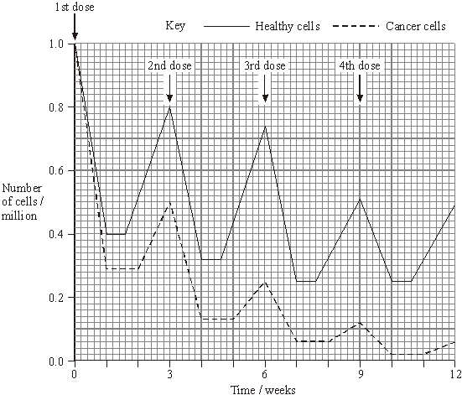
(i) Using the graph calculate the number of cancer cells present at week 12 as a percentage of the original number of cancer cells. Show your working.

Answer ____________________%
(2)

(ii) Suggest one reason for the lower number of cancer cells compared to healthy cells at the end of the first week.
______________________________________________________________
(1)
(iii) Describe two differences in the effect of the drug on the cancer cells, compared with healthy cells in the following weeks.
1. ____________________________________________________________
______________________________________________________________
2. ____________________________________________________________
______________________________________________________________
(2)
(Total 8 marks)

