3.2.2 All cells arise from other cells

Name __________________________________

Reflection on learning outcomes | or | Target
Explain what binary fission is and the organisms which carry out binary fission.
Describe the process of binary fission.
Explain why viruses are not classified as being living organisms.
Describe the sequence of events by which viruses replicate
Explain why viruses are so difficult to treat and develop medicines against.
Explain the different outcome of mitosis and meiosis.
Recognise where meiosis and mitosis occurs when given information about an unfamiliar life cycle.
Explain what the cell cycle is and why it does not occur in some cells from multicellular organisms.
Describe the stages of the cell cycle.
Recognise the stages of the cell cycle: interphase, prophase, metaphase, anaphase and telophase (including cytokinesis).
Explain the appearance of cells in each stage of mitosis.
Explain the events involved in the formation of tumours and cancers and why this is damaging to the body.
Identify the processes within the cell cycle which are disrupted and which lead to cancer.
State that cancer treatments often work to inhibit stages of the cell cycle.
Interpret data relating to cancer treatments and their effects on the rate of cell division
Explain how meiosis results in variation.
Complete diagrams showing the chromosome content of cells after the first and second meiotic division, when given the chromosome content of the parent cell.
Explain how random fertilisation of haploid gametes further increases genetic variation within a species.
Explain what a non-disjunction event is and how it occurs.
Compare and contrast gene and chromosomal mutations.

Outcome:
- Explain what binary fission is and the organisms which carry out binary fission.
- Describe the process of binary fission.
- Explain the appearance of cells in each stage of mitosis.

Binary fission (definition, organisms and process)

Binary fission occurs in what type of cell? Prokaryotic cells

Where is genetic information contained in this type of cell? (hint: there is two)

Circular DNA and plasmids

Out of the two places you mentioned above, which one can be in variable amounts?

Plasmids

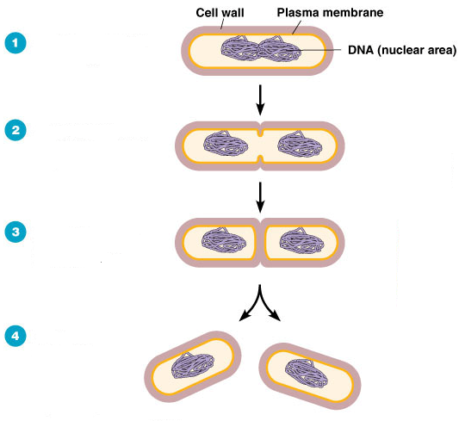
Questions:
1.A bacterial cell undergoes binary fission every twenty minutes. Starting with a single bacterium how may bacteria will be formed at the end of 3 hours?

Answer: 512 cells

2. A bacterial cell undergoes binary fission every twenty minutes. Starting with a single bacterium how may bacteria will be formed at the end of 7 hours?
Give your answer in standard form.
Answer: 2.1 x 10⁶ bacteria

1. Bacteria replicate by binary fission;

2. Replication of (circular) DNA;

3. Division of cytoplasm to produce 2 daughter cells;

4. Each with single copy of (circular) DNA;

Viruses are classed as been non-living so do not undergo cell division.
You can be asked to describe the sequence of events by which viruses replicate.
So you will need to make sure you recap this from the immunity topic.

Why are viruses difficult to treat and develop medicines against?

Viruses don’t have structures like a cell wall so drugs used to treat bacterial infections cannot be used on viral infections.
Viruses enter your body cells and the majority of drugs cannot enter your cells.

___________________________________________________________________________________
Exam questions:
Q1.
(a) Bacteria are often used in industry as a source of enzymes. One reason is because bacteria divide rapidly, producing a large number of them in a short time.
Describe how bacteria divide.
(a)
1. Binary fission;
2. Replication of (circular) DNA;
3. Division of cytoplasm to produce 2 daughter cells;
4. Each with single copy of (circular) DNA;
1. Ignore reference to ‘chromosome’
2. Ignore ‘copy’.
4. Ignore references to number of plasmids.

(2)
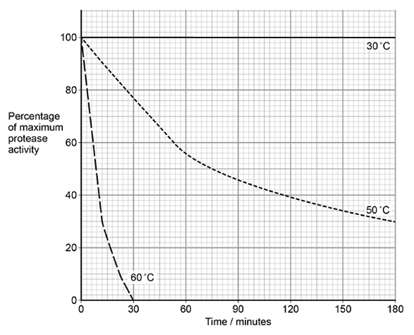
(b) Washing powders often contain enzymes from bacteria. These enzymes include proteases that hydrolyse proteins in clothing stains.
The graph shows the effect of temperature on a protease that could be used in washing powder.

Explain the shape of the curves at 50 °C and 60 °C.
(b)
1. Both denatured (by high temperature);
2. Denaturation faster at 60 °C due to more (kinetic) energy;
3. Breaks hydrogen / ionic bonds (between amino acids / R groups);
4. Change in shape of the active site / active site no longer complementary so fewer enzyme-substrate complexes formed / substrate does not fit;
3. Ignore references to disulphide bonds
3. Accept (at 60 °C) Change in shape of the active site / active site no longer complementary so no enzyme-substrate complexes formed / substrate does not fit;

(4)

(c) Some proteases are secreted as extracellular enzymes by bacteria.
Suggest one advantage to a bacterium of secreting an extracellular protease in its natural environment.
Explain your answer.

(c)
1. To digest protein;
2. (So) they can absorb amino acids for growth / reproduction / protein synthesis / synthesis of named cell component;
OR
(So) they can destroy a toxic substance / protein;
1. For ‘digest’ accept ‘break down’ here.
2. Accept ‘(so) they can destroy antibodies / antibiotics / viral antigens / bacterial antigens’

(2)
(d) Mammals have some cells that produce extracellular proteases. They also have cells with membrane-bound dipeptidases.
Describe the action of these membrane-bound dipeptidases and explain their importance.

(d)
1. Hydrolyse (peptide bonds) to release amino acids;
2. Amino acids can cross (cell) membrane;
OR
Dipeptides cannot cross (cell) membrane;
OR
Maintain concentration gradient of amino acids for absorption;
OR
Ensure (nearly) maximum yield from protein breakdown;
2. Ignore references to crossing gut membranes.
2. Accept ‘there are carrier proteins for amino acids’
2. Accept ‘no carrier proteins for dipeptides’

(2)
(Total 10 marks)

Mitosis

Mitosis definition:

Production of two daughter cells that have the same number of chromosomes as the parent cell and each other.

Where does mitosis occur?

Body cells

How chromosomes replicate during Interphase
Below is a diagram of a pair of homologous chromosomes before DNA replication has occurred. Complete the diagram by drawing a pair of homologous chromosomes after DNA replication has occurred an labelling them.

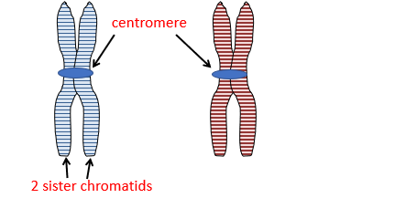



Homologous chromosome definition:

______________________________________________________________________________________________________________________________________________________________________

Stage of mitosis | Description
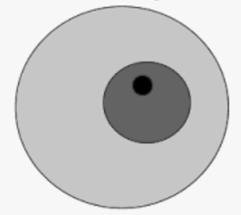  Interphase | - Chromosomes are dispersed (so not visible)  - Each chromosome replicates.  - Chromosomes made of 2 sister chromatids, joined at centromere.
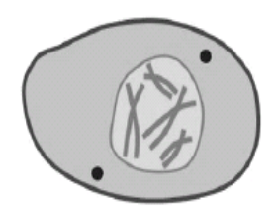  Prophase | - Chromosomes shorten and thicken to become visible.  - Nuclear envelope breaks down.  - Centrioles move to the poles of the cell and start forming spindle fibres.
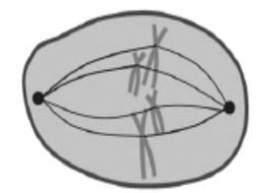  Metaphase | - Spindle fibres attach to centromeres and line up the chromosomes at the equator of cell
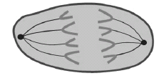  Anaphase | - Spindles contract  - ‘sister’ chromatids separate and are pulled to opposite sides of the cell
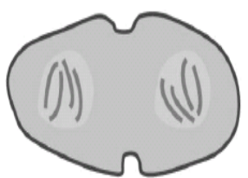  Telophase | - Spindle breaks down.  - Nuclear envelope reforms.  - Chromosomes disperse.  - Cytokinesis begins.

___________________________________________________________________________________
Exam questions:

Exam tips
In mitosis examiners like to give you pictures of lots of cells under the microscope. You could be asked the following:
- How many cells are in a certain phase (as a number/percentage), calculate time spent in a certain phase or comparing to another result.
- Applying your knowledge to how certain chemicals can interfere with mitosis.
- Asking practical application from completing the root tip squash practical.

Q1.
The photograph shows cells from an onion root tip. The root tip has been squashed and stained to show the stages of mitosis.
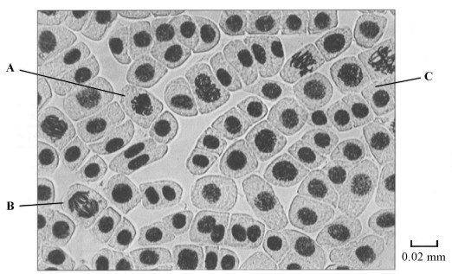
(a) (i) At what stage of mitosis is cell A?
Prophase;
(1)
(ii) What is the evidence that cell B is in anaphase?
Chromosomes / chromatids moved apart;
(1)
(iii) Cell C is in interphase. Give two processes which occur during interphase that enable cell division to occur.

A wide range of processes occurs during interphase. This list is by no means exhaustive, but we would expect to see answer such as:
Increase in volume of cell / volume of cytoplasm / increase in mass / cell bigger; increase in number of organelles;
synthesis of protein / named protein;
DNA replication / increase / chromosomes copied;
ATP synthesis / respiration;
(2)
(b) Explain how you would calculate the magnification of the photograph.

Divide real length of bar (in mm) / 10 by 0.02;
(1)
(c) The number of cells at each stage of mitosis was counted. The results are shown in the table.

Stage of mitosis | Number of cells
Interphase | 123
Prophase | 32
Metaphase | 12
Anaphase | 6
Telophase | 27
One complete cell cycle takes 24 hours. The number of cells at each stage is proportional to the time spent at that stage. Calculate the length of time spent in metaphase. Show your working.

12 / 200 × 24 / single error in otherwise correct method;
1.44 hours (1 hour 26 min);

Answer ____________________ hours
(2)
(Total 7 marks)

Q2.
The diagram shows two chromosomes in a cell undergoing mitosis.
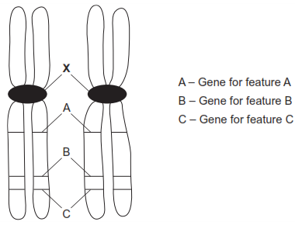
(a) Name X.
Centromere;

(1)
(b) These are homologous chromosomes. Give two pieces of evidence from the diagram that support this.
Same size;
Same shape;
Same genes;
In same sequence/locus/loci;

(2)
(c) What will happen to these chromosomes in anaphase?
Chromatids separate;
(Chromatids) pulled to opposite ends of cell;
By spindle fibres;
Become part of new nuclei;

(2)
(Total 5 marks)

Q3.
(a) The diagram shows a chromosome at the start of mitosis.
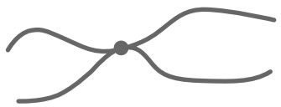
Describe and explain the appearance of the chromosome.
DNA replicated/two DNA strands/molecules;
Coiled/condensed/wound up (to make visible);
Giving/made of (two) chromatids;
Attached at centromere; Accept linear so eukaryote; with histone; Accept have become shorter and fatter
(2)
(b) The photographs show two stages in mitosis.
Stage A Stage B
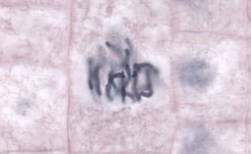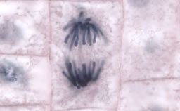
Name stages A and B. Describe what is happening to the chromosomes in each stage.
(i) Stage A
Stage A, anaphase/prophase;
Chromatids/chromosomes moving to poles/chromosomes condensed/
coiled/wound up;
Points not linked but need correct description with stage in this case. Accept prophase because the image could be interpreted as such

(2)
(ii) Stage B
Stage B, metaphase;
Chromosomes on equator/attaching to spindle;
Points not linked
Accept equator of cell
Reject centre of cell
Accept chromatids for chromosomes
(2)
(Total 6 marks)

Outcome:
- Explain the outcome of meiosis.
- Complete diagrams showing the chromosome content of cells after the first and second meiotic division, when given the chromosome content of the parent cell.
- Recognise where meiosis and mitosis occurs when given information about an unfamiliar life cycle

Meiosis definition:

Production of four daughter cells that have half the number of chromosomes as the parent cell.

Where does meiosis occur?
Sex cells (gametes)

Image | Stage and description
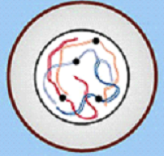 | Interphase  Chromosomes replicate (DNA synthesis)
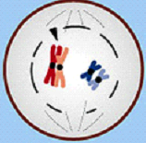 | Prophase I  - Chromosomes condense becoming visible  - Nuclear membrane breaks down  - Spindle starts to form
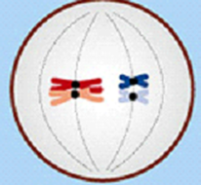 | Metaphase I  - Spindle attaches to centromeres.  - Bivalents lined up along the equator in homologous pairs
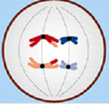 | Anaphase I  - Bivalents pulled apart by spindle and homologous chromosomes pulled to poles  - Maternal and Paternal chromosomes separated randomly.
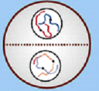 | Telophase I  - Chromosomes reach poles
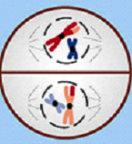 | Prophase II  - Spindles form around both sets of chromsomes  - (nuclear membrane breaks down if it had reformed)
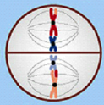 | Metaphase II  - Spindle fibres line chromosomes up along equator
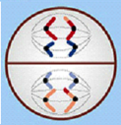 | Anaphase II  - Spindle fibres contract  - Centromeres divide & chromatids separate and are pulled to the poles
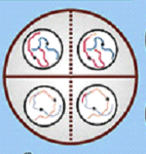 | Telophase II  - Chromosomes reach poles & disperse  - Spindle breaks down  - Nuclear membranes reforms  - Cytokinesis begins
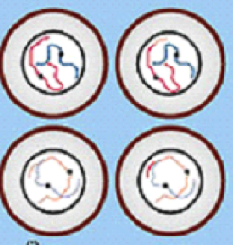 | Cytokinesis  - Cytoplasm divides (cytokinesis)  - Membranes form around new cells  - 4 haploid cells produced

What is the difference between meiosis I and meiosis II?
In Meiosis I homologous pairs of chromosomes are separated where as in Meiosis II pairs of chromatids are separated.

 | Meiosis | Mitosis
1 | Reduces the chromosome number | Maintains the same chromosome number as in the parent nucleus
2 | Crossing over | No crossing over
3 | Two divisions | One division
4 | Genetically different | Genetically identical

The diagram shows the life cycle of an organism. The numbers show how many chromosomes are present in one cell at each stage of the life cycle.
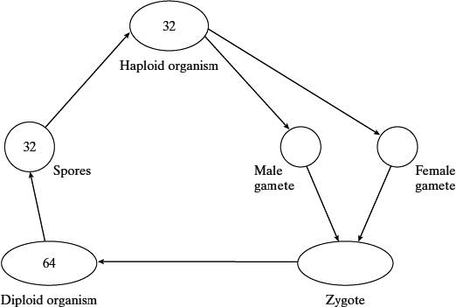
(i) Name the type of cell division that must be involved in producing the spores.
Meiosis (1)
(ii) How many chromosomes are there in a male gamete from this organism?
32 (1)

Outcome:
- Explain how meiosis results in variation.
- Explain how random fertilisation of haploid gametes further increases genetic variation within a species.
- Explain what a non-disjunction event is and how it occurs.
- Compare and contrast gene and chromosomal mutations.

How does meiosis result in variation?

Crossing over in prophase I and Independent segregation in anaphase I

What is crossing over?
- During meiosis 1, the chromatids of each pair of homologous chromosomes become twisted around each other.
- During this twisting tension are created and parts of the chromosome break off.
- These broken portions join with the chromatids of its homologous partner.
- It is the equivalent portions of the chromosomes that are exchanged.
- New genetic combinations of alleles are produced.

Draw a diagram below to show crossing over:
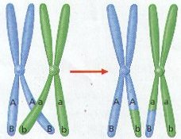

What is independent assortment?
How different combinations of homologous chromosomes can be separated during anaphase I leading to genetically unique gametes.

Draw a diagram below to show independent assortment:

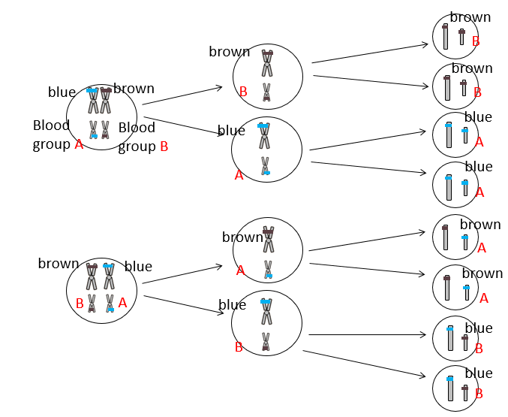

How does meiosis result in variation?

Homologous chromosomes pair up

Independent segregation

Maternal and paternal chromosomes are re-shuffled in any combination;

Crossing over leads to exchange of parts of (non-sister) chromatids / alleles between homologous chromosomes;

(Both) create new combinations of alleles;

Why meiosis is important in sexual reproduction
Produces haploid cells so fertilisation maintains the chromosome number in next generation.

Non- disjunction event

Sometimes individual homologous pairs of chromosomes fail to sperate during meiosis. This is known as non-disjunction and usually results in the gamete having either one more or fewer chromosomes. When fertilised with a gamete with a normal complete chromosome number this will make the offspring have more or fewer chromosomes than normal. This will be the same in all their body cells. An example of non-disjunction is down syndrome.

A non-disjunction event is an example of a ‘chromosome mutation’. A chromosome mutation changes the structure or number of whole chromosomes. This is different to a gene mutation which is a change in the base sequence of a gene.

Extension task: Read through the information on ‘hybridisation and polyploidy’ in the Toole and Toole textbook on pages 221-223 and complete the questions. You can check your answers when you’re done on 622.
___________________________________________________________________________________
Exam Questions:

Q1.
The diagram represents a cell from a fruit fly in which the diploid number is eight.
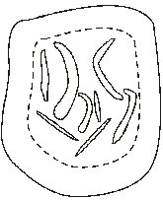
(a) Draw a diagram to show
(i) this cell during anaphase of mitosis;
8 ‘chromatids’ each side;
spindle drawn;

(2)
(ii) the chromosomes in a gamete produced from this cell by meiosis.
4 chromosomes;
1 from each homologous pair;

(2)
(b) Explain why meiosis is important in sexual reproduction, apart from producing gametes that are genetically different.
produces haploid cells / chromosome number halved;
fertilisation maintains the diploid / chromosome number (in next generation);

(2)
(Total 6 marks)
Q2.
(a) Give one process which occurs in the nucleus of a cell during interphase which is necessary before cell division can take place.
replication / duplication / doubling of chromosomes /
replication of DNA / transcription of DNA;

(1)
(b) The diagram shows the chromosomes from a cell with a diploid chromosome number of six.
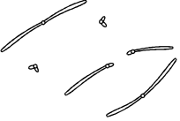
Draw a diagram to show the chromosomes from one of the resulting cells if
(i) the cell divides by mitosis;
cell to show correct number of chromosomes;
correct shape and position of centromere;
Further explained on teaching ppt

(2)
(ii) the cell divides by meiosis.
as (i) except everything halved – Ignore crossing over;
(if mitosis and meiosis reversed, allow 1 if otherwise correct)
Further explained on teaching ppt

(2)
(c) Explain one advantage of cells lining the human gut dividing very frequently.
to replace cells;

(1)
(Total 6 marks)

Q3.
(a) Figure 1 shows one pair of homologous chromosomes.
Figure 1
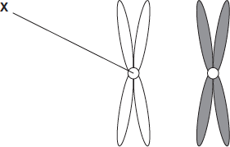
(i) Name X.
Centromere;
Accept: if phonetically correct
Reject: centriole

(1)
(ii) Describe the role of X in mitosis.
1. Holds chromatids together;
2. Attaches (chromatids) to spindle;
3. (Allows) chromatids to be separated / move to (opposite) poles / (centromere) divides / splits at metaphase / anaphase;
3. Q Neutral: chromosomes or chromatids split / halved / divided
3. Reject: reference to homologous chromosomes being separated
Accept ‘chromosomes’ instead of ‘chromatids’
Ignore incorrect names for X

(2)
(iii) Homologous chromosomes carry the same genes but they are not genetically identical. Explain why.
(Homologous chromosomes) carry different alleles;
Accept alternative descriptions for ‘alleles’ eg different forms of a gene / different base sequences
Neutral: reference to maternal and paternal chromosomes

(1)
(b) Figure 2 shows three pairs of homologous chromosomes in a cell at the end of cell division.
Figure 2
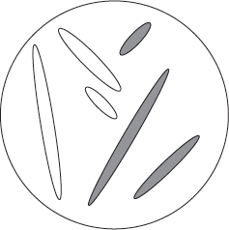
(i) The appearance of each chromosome in Figure 2 is different from those shown in Figure 1. Explain why.
(In Figure 2)
1. Chromatids have separated (during anaphase);
1. Q Neutral: split / halved / divided
1. Reject: reference to homologous chromosomes
being separated
or
2. Chromatids have not replicated;
1. & 2. Accept ‘chromosomes’ instead of ‘chromatids’
or
3. Chromosomes formed from only one chromatid;
Accept converse arguments for Figure 1
Ignore references to the cell not dividing as in the question stem
Ignore: named phases

(1)
(ii) Complete the diagram to show the chromosomes in one cell that could be produced from the cell in Figure 2 as a result of meiosis.
1. Three chromosomes;
Ignore shading
2. One from each homologous pair;
Only one mark for three chromosomes shown as pairs of chromatids

(2)
(iii) Other than independent segregation, give one way in which meiosis allows the production of genetically different cells.
Crossing over / alleles exchanged between chromosomes or chromatids / chiasmata formation / genetic recombination;
Accept: description of crossing over eg sections of chromatids break and rejoin
Neutral: random fertilisation
Reject: reference to sister chromatids
Q Neutral: genes exchanged
Neutral: mutation

(1)
(Total 8 marks)

Outcome:
- Explain what the cell cycle is and why it does not occur in some cells from multicellular organisms.
- Describe the stages of the cell cycle.
- Recognise the stages of the cell cycle: interphase, prophase, metaphase, anaphase and telophase (including cytokinesis).

What is the cell cycle?
- The cell cycle is an ordered set of events, leading to cell growth and division.

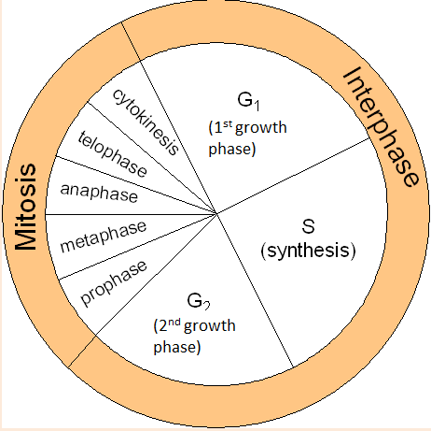
Interphase occupies most of the cell cycle.
- G1 phase: synthesis of proteins
- S phase: DNA is replicated.
- G2 phase: organelles grow and divide, ATP stores increased.
Nuclear division
- Mitosis (PMAT)
Cell division
- Cytokinesis
Where are the 3 main checkpoints in the cell cycle?
- G1/S Can DNA replication begin
- G2/M Has DNA replication been completed correctly?
- Spindle checkpoint

The number of cells at each stage of mitosis was counted. The results are shown in the table.
One complete cell cycle takes 24 hours. The number of cells at each stage is proportional to the time spent at that stage. Calculate the length of time spent in metaphase. Show your working.
What equation would you use to calculate this?

Number of cells in that stage/ Total number of cells x number of cells = ANS

Stage of mitosis | Number of cells
Interphase | 123
Prophase | 32
Metaphase | 12
Anaphase | 6
Telophase | 27
123+32+12+6+27 = 200 cells
12/200= 0.06
0.06 x 24 = 1.44 hours
Answer ........................................................... Hours (2)

Outcome:
- Explain the events involved in the formation of tumours and cancers and why this is damaging to the body.
- Identify the processes within the cell cycle which are disrupted and which lead to cancer.
- State that cancer treatments often work to inhibit stages of the cell cycle.
- Interpret data relating to cancer treatments and their effects on the rate of cell division
What is cancer?
- Cancer is essentially the incorrect replication of DNA. It is the result of damage to the genes that control cell mitosis and the cell cycle.
How is cancer often treated?
Cancer is often treated by blocking some part of the cell cycle.
- Preventing DNA replication
- Inhibiting the metaphase by interfering with spindle formation
What are the problems with using these drugs?
- Drugs are most effective against rapidly dividing cells, but they also disrupt the cell cycle of healthy cells.
- Hair producing cells divide rapidly, explaining hair loss.

Why are tumours damaging to the body?
__________

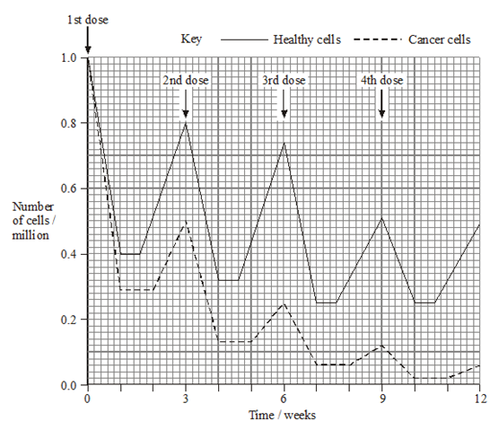

This is a typical exam question in which you are expected to interpret data relating to cancer treatments and how they affect cell division.

It would be possible to kill more cancer cells by administering the drug more frequently or giving a larger dose. Suggest why
The drug was not given more frequently
If frequency was increased healthy cells would not have time to increase numbers to near normal between treatments; Healthy cell count would become too low and patient may die.
The dose of the drug was not increased
Increased dose would kill too many healthy cells each treatment, Healthy cell count would be too low and patient may die

_____________________________________________________________________________________
Exam Questions:
Q1.
Yeast is a single-celled eukaryotic organism. When yeast cells are grown, each cell forms a bud. This bud grows into a new cell. This allows yeast to multiply because the parent cell is still alive and the new cell has been formed.
Scientists grew yeast cells in a culture. They counted the number of cells present and measured the total concentration of DNA in the culture over a period of 6 hours. Their results are shown in the graph.
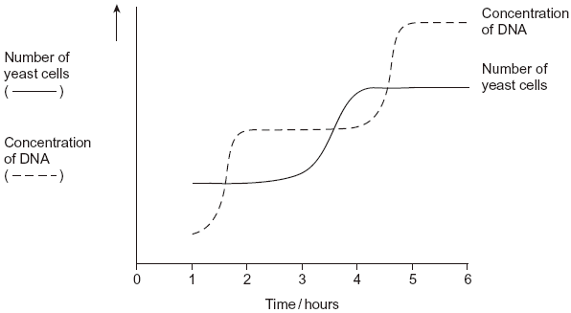
(a) Use your knowledge of the cell cycle to explain the shape of the curve for the number of yeast cells
(i) between 1 and 2 hours
Cells are in interphase;
Accept G phase / S phase.
(1)
(ii) between 3 and 4 hours.
Cells undergoing mitosis / in telophase / cytokinesis;
Accept all named stages but reject prophase, metaphase or anaphase on their own.

(1)
(b) Use the curve for the concentration of DNA to find the length of a cell cycle in these yeast cells. Explain how you arrived at your answer.
Length of cell cycle 3 Hours
Explanation
2. Time between beginnings / endings DNA replication / Increases / levelling outs of DNA concentration / for shape (of curve for replication) to be repeated;
3. (DNA) replication takes place once per cell cycle;
Allow close approximation where candidate attempts to be more accurate.
Principle
What is shown on the graph

(3)
(Total 5 marks)
Q2.
The diagram shows a cell cycle.
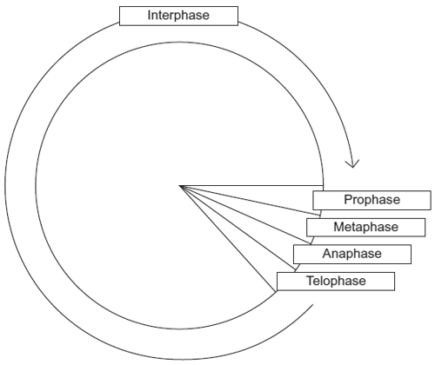
(a) In prophase of mitosis, the chromosomes become visible. Describe what happens in
(i) metaphase
Spindle formed / chromosome / centromere / chromatids
attaches to spindle;
Chromosomes / chromatids line up / move to middle / equator
(of cell);
Do not award second mark for answers referring to chromosomes ‘pairing up’.
Ignore reference to homologous chromosomes unless context suggests pairing which negates second mark.
Neutral: Details on nuclear membrane.
Accept: Diagram for second marking point.

(2)
(ii) anaphase.
Chromosome / centromere splits / chromatids / ‘chromosomes’ separate / pulled apart;
To (opposite) sides / poles / centrioles (of cell);
Reject: Homologous chromosomes separate for first marking point.
Accept: Diagram for second marking point.
Chromatids / ‘chromosomes’ move to poles / sides / centrioles = 2 marks.

(2)
(b) (i) Cells lining the human intestine complete the cell cycle in a short time. Explain the advantage of these cells completing the cell cycle in a short time.
Form / replace cells quickly / rapidly / divide / multiply / replicate rapidly;
Neutral: Repair cells.
Answers must convey idea of ‘speed’.

(1)
(ii) The time required for a cell to complete the cell cycle was 4 hours 18 minutes.
Calculate the time required in minutes for this cell to multiply to produce eight cells.
Show your working.
Correct answer = 774 minutes / 12 hours 54mins = 2 marks;;
Incorrect answer but indicates 3 cell cycles involved = one mark;

Answer ____________________
(2)
(c) Mikanolide is a drug that inhibits the enzyme DNA polymerase. Explain why this drug may be effective against some types of cancer.
Prevents / slows DNA replication / doubling / prevents / slows mitosis;
New strand not formed / nucleotides (of new strand) not joined
together / sugar-phosphate bonds not formed;
First marking point must be in context of DNA replication not cell replication.
Do not negate first marking point if role of DNA polymerase is described incorrectly e.g. Reject: ‘joins bases / strands together’.
Role of DNA polymerase must be correct for last marking point.

(2)
(Total 9 marks)
Q3.
The diagram shows a cell cycle.
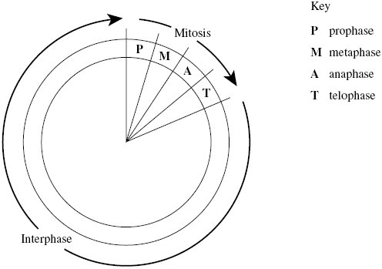
(a) The table shows the number of chromosomes and the mass of DNA in different nuclei.
All the nuclei come from the same animal. Complete this table.

Nucleus | Number of chromosomes | Mass of DNA / arbitrary units
At prophase of mitosis | 26 | 60
At telophase of mitosis | 26 | 30
From a sperm cell | 13 | 15
(4)
(b) If the DNA of the cell is damaged, a protein called p53 stops the cell cycle.
Mutation in the gene for p53 could cause cancer to develop. Explain how.
Cancer cells often have faulty / damaged DNA;
Protein / p53 faulty / not made;
Cell (with faulty / DNA) divides / completes cell cycle;
Uncontrolled division produces cancer;
p53 refers to the protein so do not accept reference to p53 mutating.

(3)
(c) Drugs are used to treat cancer. At what phase in the cell cycle would each of the following drugs act?
(i) A drug that prevents DNA replication
Interphase / S phase / synthesis phase;
(1)
(ii) A drug that prevents spindle fibres shortening
Anaphase / A;

(1)
(Total 9 marks)
Q4.
(a) Boxes A to E show some of the events of the cell cycle.

A
Chromatids seperate

B Nuclear envelopes disappears

C
Cytoplasm divides

D Chromosomes condense and become visible

E Chromosomes on the equator of the spindle
(i) List these events in the correct order, starting with D.
D BEAC
(1)
(ii) Name the stage described in box E.
metaphase;
(1)
(b) Name the phase during which DNA replication occurs.
interphase / S phase;
(1)
(c) Bone marrow cells divide rapidly. As a result of a mutation during DNA replication, a bone marrow cell may become a cancer cell and start to divide in an uncontrolled way. A chemotherapy drug that kills cells when they are dividing was given to a cancer patient. It was given once every three weeks, starting at time 0. The graph shows the changes in the number of healthy bone marrow cells and cancer cells during twelve weeks of treatment.
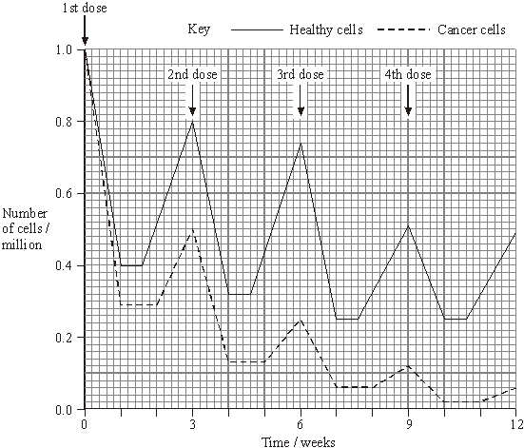
(i) Using the graph calculate the number of cancer cells present at week 12 as a percentage of the original number of cancer cells. Show your working.
0.06 × 100;
6(%);
(correct answer 2 marks)
Answer ____________________%
(2)

(ii) Suggest one reason for the lower number of cancer cells compared to healthy cells at the end of the first week.
More (cancer cells) killed, cancer cells divide more (often)
(so are more likely to be killed, more susceptible);

(1)
(iii) Describe two differences in the effect of the drug on the cancer cells, compared with healthy cells in the following weeks.
longer time to recover;
reduced rate of mitosis / divide more slowly /
increased doubling time;

(2)
(Total 8 marks)
Q5. (a) The following statements describe stages of mitosis.
A chromosomes align at the centre of the cell attached to spindle fibres
B chromatids are in groups at the poles
C chromosomes become visible
D chromatids move towards the poles
Complete the table by entering the appropriate letter.

Stage of mitosis | Letter of description of the stage
Prophase | c
Metaphase | a
Anaphase | b
Telophase | d
(3)
(b) The graph shows changes in the mass of DNA in a cell during one cell cycle.
Five stages have been identified on the graph.
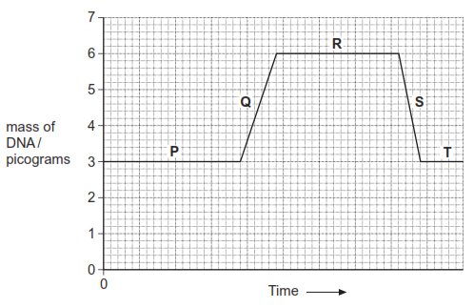
(i) Which letter represents the stage when DNA is replicating? Q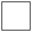
(1)
(ii) Explain the change in the DNA content during stage S.
Cell/nucleus has divided / is dividing (into two);
Accept ‒ mitosis (occurring)
Ignore refs to chromosomes dividing (1)

