Q1.
(a) A student prepared a stained squash of cells from the tip of an onion root and observed it using an optical microscope.
During the preparation of the slide, he:
• cut the first 5 mm from the tip of an onion root and placed it on a glass slide
• covered this tip with a drop of stain solution and a cover slip
• warmed the glass slide
• pressed down firmly on the cover slip.
He identified and counted nuclei in different stages of the cell cycle.
Explain why the student:
1. used only the first 5 mm from the tip of an onion root.
___________________________________________________________________
___________________________________________________________________
___________________________________________________________________
___________________________________________________________________
___________________________________________________________________
2. pressed down firmly on the cover slip.
___________________________________________________________________
___________________________________________________________________
___________________________________________________________________
___________________________________________________________________
___________________________________________________________________
(2)

Figure 1 shows the cells the student saw in one field of view. He used this field of view to calculate the length of time these onion cells spent in anaphase of mitosis.
Figure 1
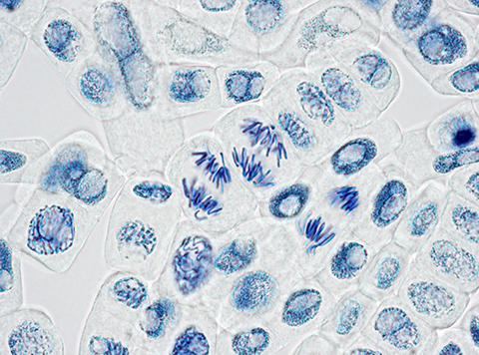
(b) Scientists have found the mean length of time spent by onion cells in anaphase of mitosis is 105 minutes. They also found the cell cycle of cells in the onion root shown in Figure 1 takes 1080 minutes.
32 whole cells are shown in Figure 1.
Use this information and Figure 1 to calculate the length of time the cells of this onion root are in anaphase and then calculate the percentage difference between your answer and the mean length of time found by the scientists.
Show your working.
Answer = ____________________ %
(2)

(c) Tick (✓) the name given to the division of cytoplasm during the cell cycle.

A | Binary fission | 
B | Cytokinesis
C | Phagocytosis
D | Segregation
(1)
(d) Describe and explain what the student should have done when counting cells to make sure that the mitotic index he obtained for this root tip was accurate.
___________________________________________________________________
___________________________________________________________________
___________________________________________________________________
___________________________________________________________________
___________________________________________________________________
(2)
(e) A scientist treated growing tips of onion roots with a chemical that stops roots growing. After 24 hours, he prepared a stained squash of these root tips.
Figure 2 is a drawing showing the chromosomes in a single cell observed in the squash of one of these root tips in anaphase. This cell was typical of other cells in anaphase in these root tips.
Figure 2
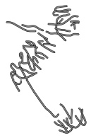

Use all of this information to suggest how the chemical stops the growth of roots.
___________________________________________________________________
___________________________________________________________________
___________________________________________________________________
___________________________________________________________________
___________________________________________________________________
___________________________________________________________________
___________________________________________________________________
___________________________________________________________________
___________________________________________________________________
(3)
(Total 10 marks)
Q2.
Figure 1 shows all the chromosomes present in one human cell during mitosis. A scientist stained and photographed the chromosomes. In Figure 2, the scientist has arranged the images of these chromosomes in homologous pairs.

Figure 1 | Figure 2
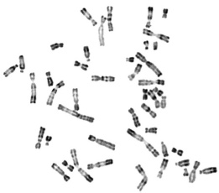 | 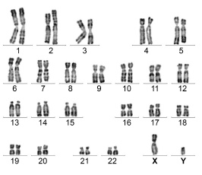
(a) Give two pieces of evidence from Figure 1 that this cell was undergoing mitosis. Explain your answers.
1. _________________________________________________________________
___________________________________________________________________
2. _________________________________________________________________
___________________________________________________________________
(2)

(b) Tick (✓) one box that gives the name of the stage of mitosis shown in Figure 1.

A | Anaphase
B | Interphase
C | Prophase
D | Telophase
(1)
(c) When preparing the cells for observation the scientist placed them in a solution that had a slightly higher (less negative) water potential than the cytoplasm. This did not cause the cells to burst but moved the chromosomes further apart in order to reduce the overlapping of the chromosomes when observed with an optical microscope.
Suggest how this procedure moved the chromosomes apart.
___________________________________________________________________
___________________________________________________________________
___________________________________________________________________
___________________________________________________________________
(2)
(d) The dark stain used on the chromosomes binds more to some areas of the chromosomes than others, giving the chromosomes a striped appearance.
Suggest one way the structure of the chromosome could differ along its length to result in the stain binding more in some areas.
___________________________________________________________________
___________________________________________________________________
___________________________________________________________________
(1)
(e) In Figure 2 the chromosomes are arranged in homologous pairs.
What is a homologous pair of chromosomes?
___________________________________________________________________
___________________________________________________________________
___________________________________________________________________
(1)

(f) Give two ways in which the arrangement of prokaryotic DNA is different from the arrangement of the human DNA in Figure 1.
1. _________________________________________________________________
___________________________________________________________________
2. _________________________________________________________________
___________________________________________________________________
(2)
(Total 9 marks)
Q3.
Patau syndrome is a condition caused by a mutation affecting chromosome number. All the cells of the body will have this mutation.
Figure 1 shows the chromosomes from one of the cells of a female who has Patau syndrome.
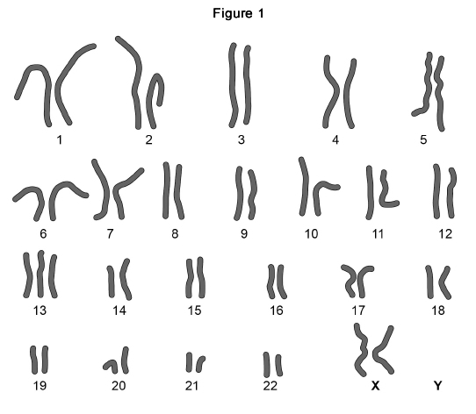

(a) What is the effect of Patau syndrome on the chromosomes of this female?
___________________________________________________________________
___________________________________________________________________
(1)
(b) Describe how the change in chromosome number in Patau syndrome was produced.
___________________________________________________________________
___________________________________________________________________
___________________________________________________________________
___________________________________________________________________
___________________________________________________________________
___________________________________________________________________
___________________________________________________________________
(2)
(c) Explain why all the cells of the body will have this mutation.
___________________________________________________________________
___________________________________________________________________
___________________________________________________________________
___________________________________________________________________
___________________________________________________________________
___________________________________________________________________
___________________________________________________________________
(2)
(d) Most children born with Patau syndrome die in the first 12 months, often due to defects of circulation of blood.
One of these defects is patent ductus arteriosus (PDA). This can result in some of the blood flowing between the aorta and the pulmonary artery.
Figure 2 shows a healthy child’s heart and the heart of a child with PDA.
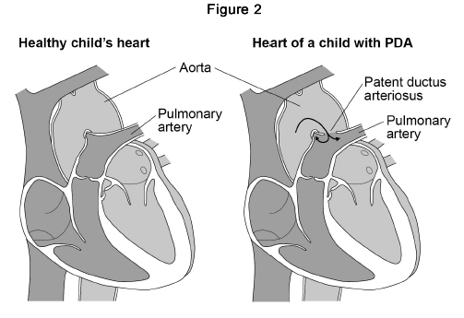

Suggest how the flow of some of the blood between the aorta and pulmonary artery could cause children to die in the first 12 months.
___________________________________________________________________
___________________________________________________________________
___________________________________________________________________
___________________________________________________________________
___________________________________________________________________
___________________________________________________________________
___________________________________________________________________
___________________________________________________________________
(3)
(Total 8 marks)
Q4.
(a) The letters A, B, C, D and E represent stages in mitosis.
• A – anaphase
• B – interphase
• C – metaphase
• D – prophase
• E – telophase
Write one of the letters, A to E, in the box to complete the following statement.
Chromosomes line up on the equator of the mitotic spindle in 
(1)
(b) Scientists looking for treatments for cancer are investigating the use of substances called kinesin inhibitors (KI). These inhibitors prevent successful mitosis. Some kinesin inhibitors cause the development of a monopolar spindle in mitosis.
The diagram below shows chromosomes attached to a normal mitotic spindle and to a monopolar mitotic spindle.
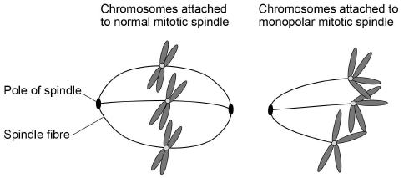
Suggest why the development of a monopolar mitotic spindle would prevent successful mitosis.
___________________________________________________________________
___________________________________________________________________
___________________________________________________________________
___________________________________________________________________
___________________________________________________________________
(2)

(c) Scientists investigated the effect of different concentrations of a kinesin inhibitor (KI) on mitosis of human bone-cancer cells grown in a culture.
The following table shows the scientists’ results.

Concentration of kinesin  inhibitor / nmol dm⁻³ | Percentage of dividing human bone-cancer cells showing a monopolar mitotic spindle
0 | 0
1 | 0
10 | 8
100 | 93
1000 | 100
10 000 | 100

A student who saw these results concluded that in any future trials of this kinesin inhibitor with people, a concentration of 100 nmol dm⁻³ would be most appropriate to use.
Do these data support the student’s conclusion? Give reasons for your answer.
___________________________________________________________________
___________________________________________________________________
___________________________________________________________________
___________________________________________________________________
___________________________________________________________________
___________________________________________________________________
___________________________________________________________________
___________________________________________________________________
(4)

(d) At the start of their investigation, the scientists made a solution of kinesin inhibitor (KI) with a concentration of 10 000 nmol dm⁻³. They used this to make the other concentrations by a series of dilutions with water.
Describe how they made 100 cm³ of 1000 nmol dm⁻³ solution of kinesin inhibitor.
___________________________________________________________________
___________________________________________________________________
___________________________________________________________________
(2)
(Total 9 marks)

Q5.
(a) Describe the appearance and behaviour of chromosomes during mitosis.
___________________________________________________________________
___________________________________________________________________
___________________________________________________________________
___________________________________________________________________
___________________________________________________________________
___________________________________________________________________
___________________________________________________________________
___________________________________________________________________
___________________________________________________________________
___________________________________________________________________
(5)
(b) Describe and explain the processes that occur during meiosis that increase genetic variation.
___________________________________________________________________
___________________________________________________________________
___________________________________________________________________
___________________________________________________________________
___________________________________________________________________
___________________________________________________________________
___________________________________________________________________
___________________________________________________________________
___________________________________________________________________
___________________________________________________________________
(5)
(Total 10 marks)

