Year 1 Test: July 2020
Name:
Topics included: Biodiversity and Population, nutrient cycles, Energy and Ecosystems and Osmoregulation (Kidneys). You will have from 2-3.30pm on Friday 3rd July to complete the test.
PLEASE ADD YOUR ANSWER IN A DIFFERENT COLOURED TEXT
Q1. Ecologists investigated changes in grassland communities on large islands off the coast of Scotland between 1975 and 2010. On each island, they used data from a number of sites to determine the change in mean species richness and the change in mean index of diversity.
(a) Table 1 shows plant species recorded at one site, on one island, in 1975.

Species | Number of individuals
Hydrocotyle vulgaris | 3
Plantago maritima | 19
Ranunculus acris | 3
Hieracium pilosella | 3
Calliergon cuspidatum | 10
Prunella vulgaris | 16
Pseudoscleropodium purum | 6
Calculate the index of diversity for this site using the formula:
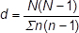

d = __________(2)
(b) Outline a method the ecologists could have used to determine the plant species richness at one site.
___________________________________________________________________
___________________________________________________________________
___________________________________________________________________ (3)
(c) Some of the ecologists’ results are shown in Table 2. They carried out a statistical test to find out whether any differences between the 1975 and 2010 means were significant. The values for P that they obtained are also shown in Table 2.
Island | Change in mean species richness between 1975 and 2010 | Value of P | Change in mean index of diversity between 1975 and 2010 | Value of P
Islay | +8.89 | ≤0.001 | +0.22 | >0.05
Colonsay | +14.70 | ≤0.001 | +2.68 | ≤0.01
Harris | −5.13 | ≤0.001 | −2.44 | ≤0.01
Do these data show that there were any significant changes in the grassland communities on these islands? Give reasons for your answer.
___________________________________________________________________
___________________________________________________________________
___________________________________________________________________
___________________________________________________________________
___________________________________________________________________
___________________________________________________________________
___________________________________________________________________
__________________________________________________________________(3)
Q2.The organic material in household waste can be used to make compost for use as a fertiliser. Scientists investigated changes during one process used to make this compost. The method involved placing the waste in large containers for 150 days. At regular intervals the containers were rotated. The scientists measured the temperature of samples of waste during the investigation. Figure 1 shows the results they obtained. The vertical bars show standard deviations.
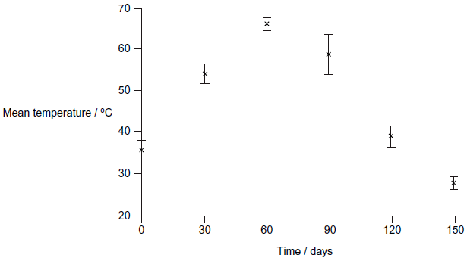
(a) Explain the advantage of showing the data using standard deviations rather than ranges.
___________________________________________________________________
___________________________________________________________________
___________________________________________________________________
___________________________________________________________________(2)
(b) The scientists took a sample of the waste at the start of the process. They then took samples every 30 days. In each sample, they determined the numbers of particular types of bacteria.
Figure 2 shows the changes in the number of three types of bacteria during the process.
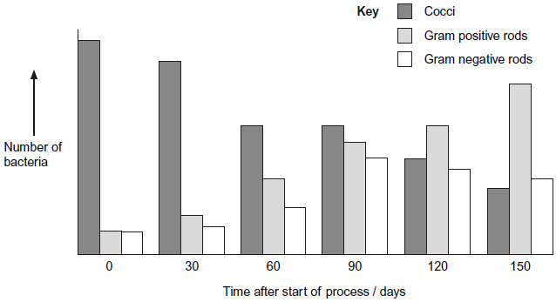
The scientists concluded that the results in Figure 1 and Figure 2 are evidence for a form of succession during the process. Use the information to suggest how they reached this conclusion.
___________________________________________________________________
___________________________________________________________________
___________________________________________________________________
___________________________________________________________________ (3)

Q3.Hydrilla (Hydrilla verticillata) is an aquatic plant which has become a major pest of waterways in parts of the USA. Hydrilla is not a native species of the USA. It was introduced into natural habitats from aquariums. In many freshwater habitats it has rapidly become the dominant plant species.
(a) In many freshwater habitats Hydrilla has rapidly become the dominant plant species.
Suggest two reasons why.
1. _________________________________________________________________
___________________________________________________________________
2. _________________________________________________________________
___________________________________________________________________(2)
(b) The spread of Hydrilla has had economic consequences for commercial activities and for the government’s environmental agency.
Suggest two economic consequences of the spread of Hydrilla.
1. _________________________________________________________________
___________________________________________________________________
2. _________________________________________________________________
___________________________________________________________________(2)
(c) Scientists investigated the effect of the chemical fluridone as a method of controlling Hydrilla. The study was carried out using samples of Hydrilla grown under controlled laboratory conditions. Several samples of the plant were grown at different concentrations of fluridone. The results are shown in the following table.

 | Days of treatment
 | 0 | 20 | 40 | 60
Concentration of  fluridone / μg dm^{–3} | Mean biomass of Hydrilla / g
0.0 | 5.0 | 16.4 | 20.4 | 33.4
0.5 | 5.0 | 14.1 | 18.2 | 31.3
1.0 | 5.0 | 9.7 | 8.9 | 7.4
5.0 | 5.0 | 4.6 | 2.8 | 1.3
25.0 | 5.0 | 3.2 | 1.6 | 0.4
(i) The scientists obtained the biomass of each sample by heating it at 75 °C for 2 hours.
They then weighed the sample, reheated it for 15 minutes and weighed it again. They continued this cycle of reheating and weighing until they found the sample had a constant mass.
Explain how this method helped to provide a reliable measurement of the biomass.
______________________________________________________________
______________________________________________________________ (2)
(ii) A scientist reviewed the results of this investigation. He suggested that fluridone should be used in the habitat at a concentration of 5.0 μg dm^{–3} rather than at the other concentrations tested. Use the information provided and your knowledge of chemical control to explain why he made this suggestion.
______________________________________________________________
______________________________________________________________
______________________________________________________________
______________________________________________________________
______________________________________________________________
______________________________________________________________
______________________________________________________________
_____________________________________________________________(4)
(d) Scientists have also investigated the use of an integrated system to control Hydrilla.
This involved using fluridone and a fungus as a biological control agent. They set up four different experiments.
• Experiment 1 – Hydrilla left untreated
• Experiment 2 – Hydrilla treated with the fungus
• Experiment 3 – Hydrilla treated with fluridone
• Experiment 4 – Hydrilla treated with both fluridone and the fungus.
The scientists determined the biomass of Hydrilla at the end of each experiment.
(i) Experiment 1 acted as a control. Explain why the scientists carried out experiment 1.
______________________________________________________________
______________________________________________________________(1)
Q4. Parasites are organisms that live on or in host organisms. The populations of many organisms may be reduced by the effects of parasites. Feather mites are small parasites found on the wing feathers of many birds. The mites feed on the oil that the birds produce. This oil keeps the feathers in good condition. Birds unable to oil their feathers properly use more energy in maintaining their body temperature. This results in less energy being available for other processes.Scientists investigated the relationship between the numbers of feather mites and the breeding success of one species of bird, the great tit.
(a) Use the information above to suggest how feather mites could affect breeding in great tits.
___________________________________________________________________
___________________________________________________________________
___________________________________________________________________
__________________________________________________________________(2)
(b) The scientists located a large number of great tit nests. They sampled these at random.
For each nest they recorded
• the total number of eggs laid
• the number of chicks that hatched from the eggs
• the number of chicks that survived to leave the nest
• the total number of feather mites on the two parent birds.
(i) The scientists calculated the percentage of each pair’s eggs from which chicks survived to leave the nest. They called this ‘breeding success per pair’.The table shows some of the data that the scientists obtained.

Total number of feather mites on both parent birds | Breeding  success per pair
0 | 86
2 | 100
5 | 64
10 | 82
14 | 70
15 | 85
170 | 42
Do these data support the hypothesis that the presence of feather mites reduces the ability of great tits to reproduce successfully? Give reasons for your answer.
______________________________________________________________
______________________________________________________________
______________________________________________________________
______________________________________________________________
______________________________________________________________(3)
(c) The oil that a great tit puts on its feathers is made in an oil gland at the base of the tail. The bird uses its beak to spread the oil over its feathers. This is called preening. Preening takes place in early morning and evening and empties the oil gland each time. After preening, the oil gland is considerably smaller.
At the same time that the scientists recorded the number of feather mites on each great tit, they also measured the size of the oil gland. The graph shows their results and includes the scientist’s line of best fit.
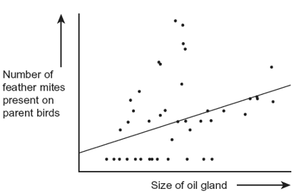
(i) Describe the relationship between the number of feather mites present on each great tit and the size of the oil gland.
______________________________________________________________
______________________________________________________________
______________________________________________________________
______________________________________________________________
______________________________________________________________(2)
(ii) Explain how measuring the oil gland at the same time as counting the feather mites may have affected the reliability of the data.
______________________________________________________________
______________________________________________________________
______________________________________________________________
______________________________________________________________
______________________________________________________________(2)

#

Q5. After harvesting, the remains of crop plants are often ploughed into the soil.
Explain how microorganisms in the soil produce a source of nitrates from these remains.
___________________________________________________________________
___________________________________________________________________
___________________________________________________________________
___________________________________________________________________
___________________________________________________________________
___________________________________________________________________
___________________________________________________________________
___________________________________________________________________
___________________________________________________________________
__________________________________________________________________(5)
Q6.Residual food intake (RFI) is the difference between the amount of food an animal actually eats and its expected food intake based on its size and growth rate. Scientists have selectively bred cattle for low RFI.
(a) (i) Explain the advantage to farmers of having cattle with a low RFI.
______________________________________________________________
______________________________________________________________
______________________________________________________________
______________________________________________________________
______________________________________________________________(2)

(ii) When RFI is calculated, low values are negative. Explain why they are negative.
______________________________________________________________
______________________________________________________________
______________________________________________________________(1)

(b) Scientists have developed a standard procedure for comparing RFI in cattle. They control two factors. These are type of food and environmental temperature. Explain why each of these factors needs to be controlled.
Type of food
___________________________________________________________________
___________________________________________________________________
___________________________________________________________________
Environmental temperature
___________________________________________________________________
___________________________________________________________________
___________________________________________________________________ (4)
Q7. (a) The control of water balance in the body involves negative feedback.
(i) Describe what is meant by negative feedback.
______________________________________________________________
______________________________________________________________
______________________________________________________________(1)
(ii) Water is removed from the body via the kidneys. Give two other ways in which water is removed from the body.
1. ____________________________________________________________
2. ____________________________________________________________(2)
(iii) Name the part of the brain which acts as the coordinator in the control of water balance.
______________________________________________________________(1)
(b) Figure 1 shows the cells lining the collecting duct in a human kidney. ADH molecules bind to the receptor proteins and this triggers the vesicles containing aquaporins to bind with the plasma membrane next to the lumen. Figure 2 shows an aquaporin which is a large channel protein.
Figure 1
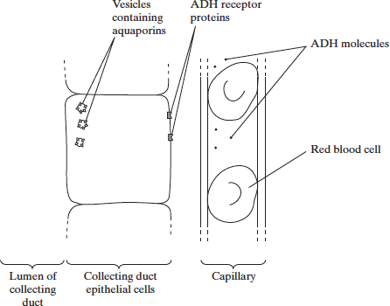
Figure 2
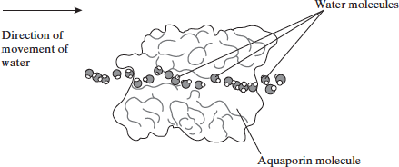
(i) From which gland is ADH released?
______________________________________________________________(1)
(ii) Use the information given to explain how ADH increases the movement of water from the lumen of the collecting duct into the blood.
______________________________________________________________
______________________________________________________________
______________________________________________________________
______________________________________________________________
______________________________________________________________
______________________________________________________________
______________________________________________________________(4)
Q8. Mammals and fish remove nitrogenous waste from their bodies in different forms.
(a) Name two polymers present in mammals and fish that contain nitrogen.
1. _________________________________________________________________
2. _________________________________________________________________(2)
(b) In a mammal urea is removed from the blood by the kidneys and concentrated in the filtrate.
(i) Describe how urea is removed from the blood.
______________________________________________________________
______________________________________________________________
______________________________________________________________
______________________________________________________________(2)
(ii) Explain how urea is concentrated in the filtrate.
______________________________________________________________
______________________________________________________________
______________________________________________________________
______________________________________________________________
______________________________________________________________
______________________________________________________________
______________________________________________________________
______________________________________________________________(4)
(c) The diagram shows one way in which a person who has kidney disease can have the condition managed. In the process a fluid is put into the abdominal cavity. Exchange of materials takes place across the membrane that surrounds the abdominal cavity. This removes waste products from the blood. After five hours the fluid is drained out of the cavity and discarded. The cavity is then refilled with fresh fluid.
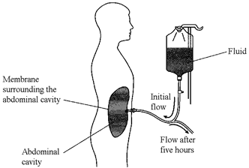
The table shows the concentration of solutes in the fresh fluid.

Solute | Concentration / mmol dm⁻³
Sodium ions (Na⁺) | 132
Chloride ions (Cl⁻) | 96
Calcium ions (Ca²⁺) | 1.25
Magnesium ions (Mg²⁺) | 0.25
Glucose | 76
Urea | 0
(i) By what process does urea enter the fluid in the abdominal cavity from the blood?
______________________________________________________________(1)
(ii) Explain why the fluid is changed every five hours.
______________________________________________________________
______________________________________________________________(1)
(iii) Fluid of the composition shown in the table is used instead of distilled water.
Explain why.
______________________________________________________________
______________________________________________________________
______________________________________________________________
______________________________________________________________(2)

This is the end of the test. You will have till 3pm to upload the completed test AS A PDF document onto connect.
If you are having issues then please email your Biology teacher ASAP.

Total for Exam: 66 marks.

Total: _____/66 %: _______

Mark schemes
Q1.(a) Correct answer of 4.92, 2 marks;
If N(N-1) = 3540, OR ∑n(n-1) = 720, then award 1 mark
Accept 4.916 / 4.917 / 4.9
2
(b) 1. A method of selecting sampling sites at random;
2. Use of quadrat;
3. Identify (plant) species (at site / in each quadrat)
OR
Count number of (different plant) species (at site / in each quadrat);
1. E.g. grid with coordinates selected using random number table
2. Frame or point
3. Reject refs to % cover, or counting individuals
3
(c) 1. Significant increase in species richness on Islay and Colonsay and (significant) fall on Harris;
2. Change in diversity on Islay not significant;
3. Greater than 0.05 / 5% probability of getting this change / difference by chance (on Islay)
OR
(For other differences) less than 0.001 / 0.1% probability of getting this change / difference by chance (for species richness on Colonsay, Harris, Islay)
OR
Less than 0.01/1% probability of getting this change/difference by chance (for diversity index on Colonsay, Harris);
2. Accept converse about significance of differences in other cases
3. Reject results are due / not due to chance
3. Ignore refs to P unqualified
3
[8]
Q2. (b) 1. SD is spread of data around the mean;
Accept: variation around the mean.
Accept: range is difference between highest and lowest values/extremes or range includes anomalies/outliers.
2. (SD) reduces effect of anomalies/ outliers;
Reject: (SD) removes anomalies/outliers.
3. (SD) can be used to determine if (difference in results is) significant/not significant/due to chance /not due to chance;
Ignore: reliability/accuracy/validity.
2 max

(d) 1. Microorganisms change the abiotic conditions/temperature/organic waste /provide nutrients;
Must refer to microorganisms or bacteria/named bacteria causing the change.
Ignore: change the environment.
2. Less hostile conditions;
3. Decline in Cocci and increase in rods;
Accept: ‘decrease in cocci, others are going up’.
Accept: decrease in cocci and increase in either rod type or increase in both types.
4. Gram positive outcompete / better competitors;
Accept: rods outcompete (cocci) / better competitors.
3 max
Q3.(a) 1. No / few consumers / pests / pathogens;
Accept: No / few predators.
Accept: description of competition for a named resource with reference to ‘other species’.
Accept: More resistance to disease.
2. Outcompetes / better competitor for resources / light / CO₂ / abiotic factor / ideal niche;
Neutral: competition for food.
2
(b) 1. (Cost of) control / removal;
2. (Cost of) restoring habitat / conservation;
3. (Loss of income) from fishing;
4. (Loss of income) from boating / tourism / recreation;
Accept: any valid recreational activity e.g. canoeing.
2 max
(c) (i) 1. Removes water;
2. Water content can vary in sample / plant;
Note: Reweighing / constant mass indicates all water removed = 2 marks. ;
2

(ii) 1. 0.5 is not effective / has little effect / 1.0 is less effective (than 5.0) / concentrations below 5.0 less effective;
Accept: for first 3 mark points effect on growth / biomass as a measure of effectiveness.
Accept: references to ‘this concentration’ = 5.0.
Accept: 5.0 is the minimum effective concentration.
1. and 2. 5.0 is the minimum effective concentration that reduces growth = 2 marks.
2. At 5.0 biomass / growth is reduced;
3. Small difference between using 5.0 and 25.0;
4. Using 5.0 is cost effective / using 25.0 is expensive / high concentrations may affect the environment / other organisms / chemical may remain in habitat / bioaccumulation;
Accept: any impact on the habitat e.g. contaminate water supply.
4
(d) (i) To compare / see effect with / without fungus / fluridone / control agent / s;
Neutral: for comparison on its own.
Neutral: to see effect of variables / results / treatments / factors without further qualification.
1
Q4.(a) 1. Breeding less successful;
2. Feathers in poor condition;
3. Less energy for breeding / reproduction / stated aspect of reproduction;
1. Reject cannot breed.
2. Ignore "wings damaged".
2 max
(b) (ii) Accept general statements or statements based on data that make the required points.
1. Correct statement about range of 0 – 15;
2. Correct statement about 0;
3. Correct statement about 170;
4. Correct statement about gap between 15 and 170;
1. e.g. No pattern / no correlation between 0 and 15.
2. e.g. Birds with no feather mites did not have (the) high(est) breeding success / 86%.
3. e.g. Highest number of feather mites linked to lowest breeding success.
4. e.g. No data between 15 and 170.
3 max
(d) (i) 1. The larger the size of the oil gland the larger the number of feather mites;
2. Positive correlation;
3. (Wide) scatter of points / points not on line;
3. Accept any answer that conveys the idea of a wide spread.
Ignore any reference to anomalies.
2max
(ii) No mark for effect on reliability, marks are for explanation.
1. Oil gland size / number of mites could vary;
2. At different times of the day / due to preening;
Ignore responses that state oil gland affects numbers of mites.
Allow preening affects mite numbers / size of oil gland.
2
Q5(b) 1. Protein/amino acids/DNA into ammonium compounds / ammonia;
Accept: any named nitrogen containing compound e.g. urea.
2. By saprobionts;
Accept: saprophytes.
3. Ammonium/ammonia into nitrite;
4. Nitrite into nitrate;
5. By nitrifying bacteria/microorganisms;
Reject: nitrifying bacteria in root nodules.
1, 3 and 4. Accept: marks for conversion even if incorrect type of bacteria named as being involved.
2 and 5. Reject: marks for type of bacteria if linked to incorrect process e.g. nitrite converted to nitrate by saprobionts.
3 and 4. Accept: for one mark ammonia/ammonium into nitrate if neither mark point 3 or 4 awarded.
Note: there are no marks for the role of nitrogen-fixing bacteria as the question refers to producing a source of nitrates from the remains of crops.
5
Q6.(a) (i) Reduced cost;
Less feed / less land use / more growth rate with same
amount of food;
Allow is ‘cost effective’
2
(ii) Amount of food taken in less than expected.
Allow ‘expected food intake is higher,
Allow ‘food intake is lower than it should be’
1
(b) Type of food (not a mark)
1. May vary in protein / fat / carbohydrate / fibre / roughage / vitamins / minerals;
2. May affect absorption / digestibility / energy value / tastiness / growth / overall food intake;
For mark point 1 allow appropriately named food compound e.g. cellulose, glucose
For mark point 2 it must be clear that these factors are affected by the type of food.
Temperature (not a mark)
3. Will affect heat loss / gain / respiration / metabolism;
4. More food / energy can be used for growth;
Note: two maximum marks for effect of temperature.
4
Q7.(a) (i) where a change triggers a response which reduces the effect of a change;
1
(ii) e.g. sweating, breathing, defaecating, other valid example;
(reject respiration
evaporation not acceptable as a 2nd mark if sweating or breathing given)
2 max
(iii) hypothalamus;
1
(b) (i) pituitary;
(ignore anterior pituitary)
1
(ii) 1. ADH causes vesicles containing aquaporins / aquaporins to be inserted into membrane / collecting duct wall / plasma;
2. water enters cell through aquaporins;
3. by osmosis / diffusion / down a water potential gradient;
4. (from cell) to capillary;
5. via interstitial fluid;
4 max
Q8.(a) any two named polymers [subsets = 1 max. (e.g. protein / haemoglobin)]
2
(b) (i) hydrostatic pressure / description of pressure;
causes ultrafiltration at Bowman's capsule / glomeruli / renal capsule;
through basement membrane;
enabled by small size of urea molecule;
max 2
(ii) reabsorption of water; [water out]
by osmosis;
at the PCT / descending LoH;
at the DCT / CD;
active transport of ions / glucose creates gradient (in context);
max 4
(c) (i) by (simple) diffusion;
[reject facilitated]
1
(ii) to maintain concentration gradients / stop reaching equilibrium;
[idea of maintaining concentration gradients]
1
(iii) ions, glucose and amino acids would diffuse into the dialysate;
because of their concentration gradients;
Causing deficiency in these substances;
OR
the WP of the dialysate would be higher / less negative than the WP of the surrounding tissues;
therefore osmosis would take place into the cells surrounding the abdominal cavity;
causing these cells to burst / damaging these cells / cannot be excreted;
max 2
[12]

