Mean, Median and Mode and Rate of Reaction Calculations

The mean is the average of a data set.
The mode is the most common number in a data set.
The median is the middle of the set of numbers.

1. Calculate the mean of the following values:
33.6, 54.8, 46.9, 35.2, 52.6, 45.4, 35.2, 44.7, 48.0, 35.2

_________________ (1 mark)

2. What is the range of those values?

_________________ (1 mark)

3. What is the median of those values?

_________________ (1 mark)

4. What is the mode?

_________________ (1 mark)

5. A student is recording the number of snails in different 10m x 10m areas in the same field.

_________________ (1 mark)

6. These are the number of snails in the first ten plots.
3 4 5 6 2 4 3 7 3 6

- Work out the median.

_________________ (2 marks)

- Calculate the mean.

_________________ (2 marks)

The 11th plot has 4 snails.

- Tick the box which describes what affect this will have on the mean.
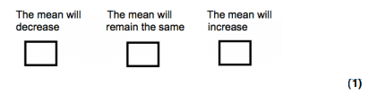
(d) Tick the box which describes what affect this will have on the median.
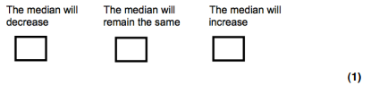
Rates of Reaction

Stating that you walked all the way to London is rather impressive. It’s maybe less impressive if you don’t state how long it took you to get there so others have an idea of how fast you were going.

It’s a similar situation for enzyme reaction graphs – how long did it take to produce a given volume of product? How quickly was the reaction going?

Like the speed or velocity equation from GCSE physics is equal to distance ÷ time, which gives you an idea of rate of travel (or units distance moved per unit time), the rate of a reaction is:

Quantity (volume, mass, etc.) of product formed per unit time (second, minute, etc.)

Quantity of substrate used per unit time.

- For the graph below:

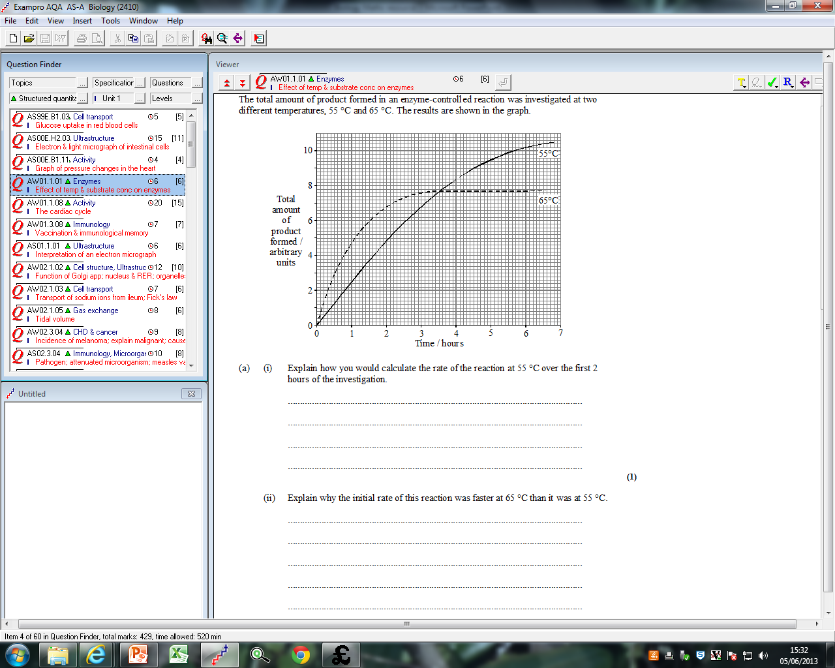
- At 65°C, 6.8 total units of product have been formed by the second hour.
- To find a rate, we need the slope of the curve, or the Quantity of product divided by the time taken.
- The rate per hour is simply:
  - Units of product = 6.8
  - Time taken = 2 hours
  - 6.8 ÷ 2 = 3.4 units hour⁻¹
- Clearly from this graph, the rate at 55°C is slower as the slope of the graph is shallower or less steep.
- Less product is formed in the same period of time (around 4.9 units in two hours for this curve, compared to 6.8 units for the 65°C curve)
- This is equivalent to 2.45 units hour⁻¹

Using Tangents to determine the Rate of Reaction

How to measure rate at a specific point

If at the specific point you are required to measure there is a curved line you will need to draw a tangent and calculate gradient.

- Position ruler at the point you want to know rate.
- Angle the ruler so there is equal space between the ruler and the curve on either side of the point.
- Draw a line along the ruler (this is your tangent)
- Calculate the gradient using formula

Rate of Reaction = Change in y / Change in x

Worked Example: Calculate Rate at 2 minutes

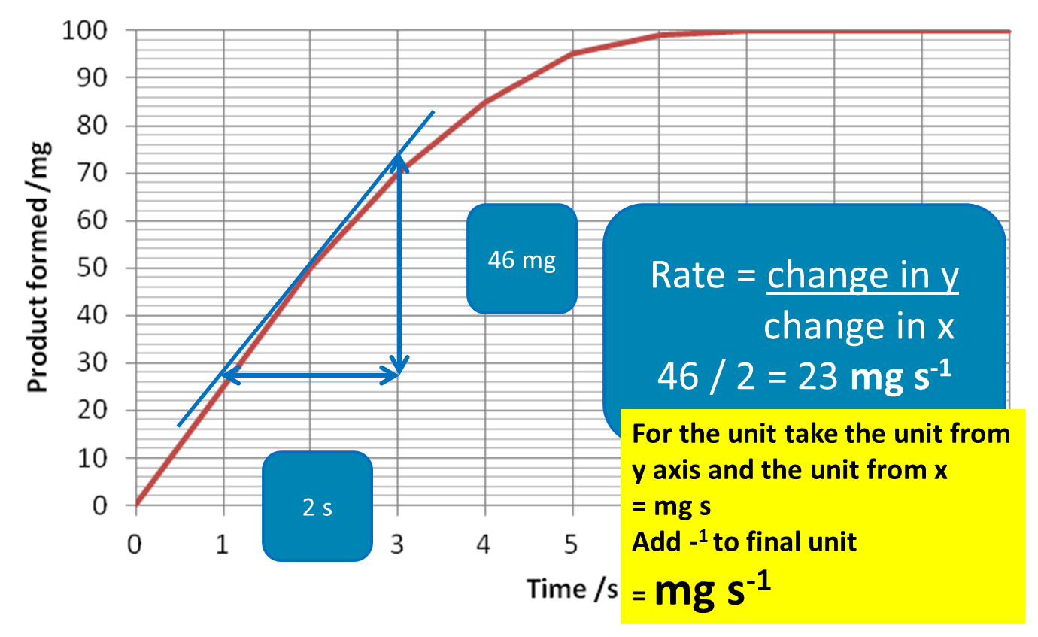

Rates of Reaction practice questions

- A reaction produces 12g of product in 30 minutes.

- What is the rate of reaction in minutes?
- What is the unit for this rate?
- Convert this to seconds and then hours

- Calculate the rate of reaction at 25˚C (include the unit)

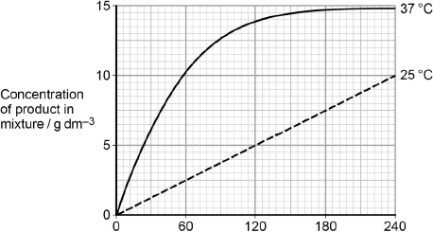

_________________ (2 marks)

- Use the tangent drawn to find the rate of reaction at 40 seconds (include the unit)

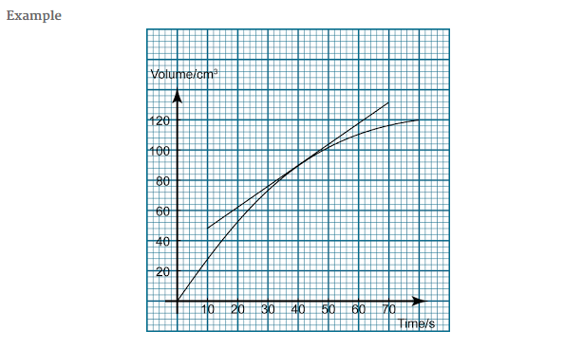

_________________ (2 marks)
- Draw a tangent and calculate the rate of reaction at 60 seconds at 37˚C

_________________ (2 marks)
5.
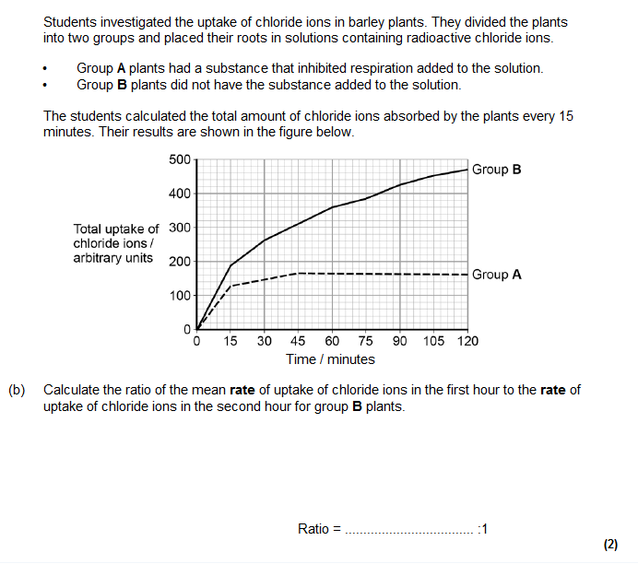
Rates of Reactions Additional Questions

- Describe how you would use a 1.0 mol dm^{–3} solution of sucrose to produce 50 cm³ of a 0.5 mol dm^{–3} solution of sucrose.

______________________________________________________________________________________________________________________________________________________________________________________________
(2 marks)

- Describe how you would use a 2.0 mol dm^{–3} solution of sucrose to produce 30 cm³ of a 0.3 mol dm^{–3} solution of sucrose.

______________________________________________________________________________________________________________________________________________________________________________________________
(2 marks)

- A student wanted to produce a dilution series of a maltose solution so he could plot a calibration curve. He had a stock solution of maltose of concentration 0.8 mol dm–3 and distilled water. He made a series of dilutions from 0.1 to 0.8 mol dm–3.

Complete the table by giving all headings, units and the concentration of the maltose solution produced.

Concentration of maltose solution  /…………………… | Volume of 0.8 mol dm⁻³ maltose solution/cm³ | …………………………. ………………./ ……………………………………………
 | 5 | 15

(3 marks)
- A student wanted to produce a dilution series of a sucrose solution so he could plot a calibration curve. He had a stock solution of sucrose and distilled water. He made a series of dilutions including 0.2mol dm-3 as shown in the table below.

Complete the table by giving all headings, units and the concentration of the sucrose stock solution provided.

Concentration of sucrose solution  /…………………… | …………………………. ………………./ …………………………………………… | …………………………. ………………./ ……………………………………………
 | 5 | 15

(3 marks)

