BTEC Applied Psychology
Unit 1 – Psychological Approaches and Applications

The Biological Approach
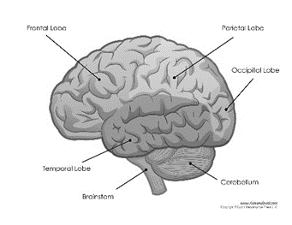
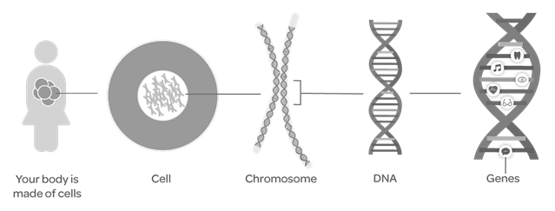

Name
Teacher
MEG

Understand  (A01) | To be able to describe the key features of the social approach.  To be able to recall key assumptions  To be able to explain conformity (normative social influence and informational social influence), types of conformity (internalisation, compliance and identification) and social categorisation (stereotypes).  To be able to explain the research done by Asch, Haney et al. and Chatard et al.  Command words: describe, give, give a reason why, identify, name, state
Apply (A02) | To be able to apply knowledge of conformity (normative social influence and informational social influence), types of conformity (internalisation, compliance and identification) and social categorisation (stereotypes) to research and behaviour in society.  Command words: describe explain, interpret, justify
Evaluate (A03) | To be able to explain strengths and weaknesses of the social approach.  Apply concepts and research to behaviour in society  Command words: analyse, assess, compare, discuss, explain

For Your examination you will need to be able to describe, explain, outline, apply and discuss the following criteria;
Content |  | Notes  Please tick | Revised  Please tick
Biological assumptions: | - Behaviour is influenced by central nervous system (CNS),  - Behaviour is a product of evolution.  - Behaviour can be influenced by genes  - Behaviour can be influenced by neurochemistry
Key concepts: Biological | The influence of biology on behaviour:  - Genes, including the role of genotype phenotype and the SRY gene; Neuroanatomy, including basic localisation of function and sex differences in brain structure;  - Neurochemistry, including the role of sex hormones and neurotransmitters  - Evolutionary psychology, including the environment of evolutionary adaptation, survival of the fittest, sexual selection and genome lag.
Key Studies:  Biological | Key studies:  - Buss et al (1992) Sex Differences in Jealousy: Evolution, Physiology, and Psychology  - Deady et al (2006) Maternal personality and reproductive ambition in women is associated with salivary testosterone levels  - Harlow J M (1848) Passage of an iron rod through the head – the case study of Phineas Gage.

You will also begin to learn some the answers to the following questions:
- How can the biological approach be used to explain aggression?
- How can the biological approach help us to understand gender development?
- How can the biological approach help us understand neuromarketing (scanning techniques to detect brain changes in consumer decision making).



The assumptions of the Biological Approach
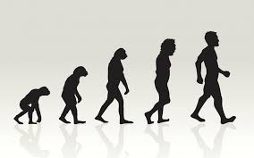
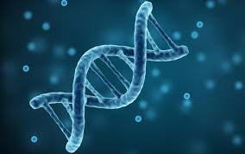

- The biological approach has certain assumptions about behaviour. It believes that behaviour is mostly beyond our conscious control.
- This approach believes that everything that is psychological is firstly biological – our behaviours, thoughts and feelings have a physical basis.
- The biological approach believes that most of our behaviour can be explained by examining and researching the following;

- The central nervous system – your brain and spinal cord. This is the control centre of your body. Different areas and regions of the brain perform different functions (e.g. language, aggression, vision, emotions). Damage to the brain/CNS can seriously affect these functions.
- Genes – a unit of inheritance. Biological units of DNA inherited from our parents. These interact with environmental influences. Many behaviours are in part passed on from one generation to the next.
- Neurochemisty – refers to chemicals called neurotransmitters that are active in the brain and affect behaviour.
- Evolution – according to Charles Darwin (1859), genetically-determined behaviours continue into future generations (e.g. they are inherited). The behaviours that continue are those that are naturally selected, because they enhance the individual’s chances of survival and particularly reproduction.

Key Words
- Genotype – an individual’s total set of genes.
- Phenotype – the observable characteristics which result from the interaction between a person’s genotype and environmental factors.
- SRY – sex-determining region Y gene which triggers the appearance of testes in an embryo and the development of that individual into a biological mule.
- Localisation of function – specific brain areas control and regulate specific physical and psychological activities.
- Neuroanatomy – structure of the brain and other parts of the nervous system.
- Sex differences – the ways in which males and females are not the same.
- Neurochemistry – relating to substances in the brain and other parts of the nervous system that regulate psychological functioning.
- Neurotransmitters – chemicals (e.g. serotonin) in the brain and nervous system that transmit signals from one neuron to another across synapses.
- Sex hormones – chemicals circulating in the bloodstream that affect the physical development, sexual development, and behaviour of females (oestrogen) and males (testosterone).
- Environment of evolutionary adaptation (EEA) – the habitat in which a species evolved its most recent adaptations.
- Genome leg – changes to the environment occur much more rapidly than changes to our genes.
- Sexual selection – attributes or behaviours that increase reproductive success are more likely to be passed on and may become exaggerated over the next generations.
- Survival of the fittest – natural selection selects the genes giving rise to characteristics that promote survival and reproduction so they are retained in the population.

Key Concept: Genes


Genotype
Phenotype

What are genes?
Genes are located on chromosomes and humans have 46 chromosomes (23 pairs). Each gene is made up of strands of DNA.
Genes carry instructions relating to characteristics of living organisms (physical and non-physical) such as hair colour, and temperament. Typically each individual inherits two copies (called alleles) of every gene, one from each parent.
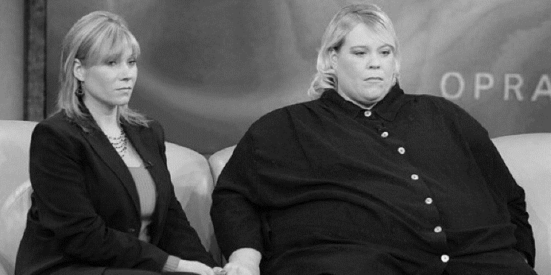
Twins:
Identical twins have the same genotype because they have inherited exactly the same genes. BUT the expression of their phenotype differs.
For example, they may look physically different because one twin might go to the gym and the other may not. As a result, one may develop muscles, which the other could also do, if they too changed their environment (went to the gym).

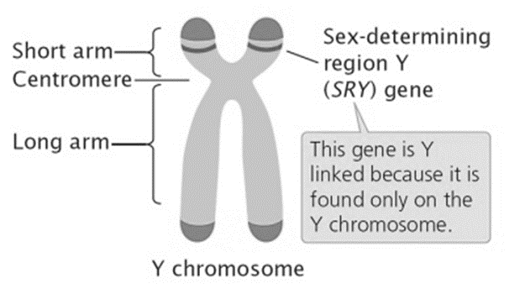
The SRY gene
One pair of chromosomes determines biological sex – XX for female and XY for males.
Located on the Y chromosome is a gene called the sex-determinig region Y gene (SRY gene). In typical development, the SRY gene switched on other genes causing an XY embryo to develop testes, which produce male sex hormones and cause the embryo to become biologically male. Without the SRY gene, other genes remain switched off so the embryo develops into a female.

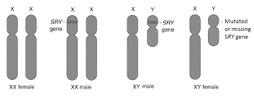


Evaluation (strengths & limitations) of genetics.
Exam Hints
Each strength & limitation is divided into THREE sections (PEC) in order for you to write an effective evaluation.
- POINT: State your strength or limitation.
- ELABORATE: Explain your point- include examples/evidence to support your point.
- COMMENT: This is your concluding/summary statement.. use of words such as “this shows/suggests that…,” “this is a strength/limitation because…”
You will need to revise 1 strength and 1 limitation for each assumption.


Evaluating Genes
Strengths | Limitations
An Interactionist Approach | Risk of Oversimplification
P: One strength of understanding genotype and phenotype is that these concepts support interactionism in psychology.  E: For example, one version of the BRAC1 gene has been liked to breast cancer risk in women. However, not every woman with the BRAC1 gene develops breast cancer, yet others without do. This suggest there may be an interaction of other factors such as stress, interact with the genotype to develop breast cancer.  T: This is a strength because taking into account the interactions between nature and nurture provides a much fuller and richer explanation of human behavior. | P: One weakness is that some research oversimplifies the influence of genes.  E: It is very rare that only one gene determines a behavior. Instead many genes make small but important contributions in complex interactions with each other. Also, genes do not produce effects in isolation. They interact with influences in the environment to develop the phenotype (as with the BRAC1 gene).  T: This is a limitation because it suggests that oversimplified explanations of how genes work exaggerate the role of nature and present a misleading view of the causes of behaviour.

Exam Style Questions

- State what is meant by the term “genes”. (1)
_________________________________________________________________________________________________________________________________________________________________________________________________________

- Using at least one example, explain how biology influences behaviour. (3)
__________________________________________________________________________________________________________________________________________________________________________________________________________________________________________________________________________________________________________________________________________________________________________________________________________________

- Explain one difference between genotype and phenotype. (2)
__________________________________________________________________________________________________________________________________________________________________________________________________________________________________________________________________________________________________________________________________________________________________________________________________________________
Apply your knowledge:
Wanda is pregnant and having her second ultrasound scan. She wants to know the biological sex of the baby. “It’s a boy” the doctor tells her. Explain how a biological psychologist might account for the biological sex of the baby. Use the concepts of genes in your answer.
Key Concept: Neuroanatomy
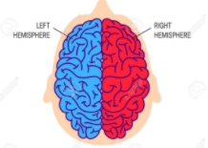
What is neuroanatomy?
Neuroanatomy refers to the structure of the brain and nervous system. The most basic neuroanatomical feature of the brain is that it is divided into two halves, called hemispheres (left and right). The brains outer layer is called the cortex.
Biological psychologists argue that damage to different areas of the brain can affect behaviour.
The central nervous system is made up of the brain and spinal cord.

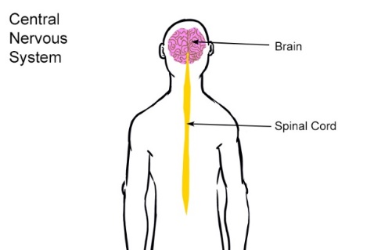

Localisation of Brain Function
What is localisation of function?
__________________________________________________________________________________________________________________________________________________________________________________________________________________________________________________________________________________________________________________________________________________________________________________________________________________
 | Function of area
Motor Area | Each hemisphere has a motor area which controls the voluntary movements of the opposite side of the body. Damage can cause a loss of control over fine movements.
Somatosensory area | This is again in both hemispheres. Sensory information from the skin is represented here (e.g. touch, heat) in proportion to the sensitivity of the body part (e.g. the regions for the face and hands account for over half of the somatosensory area).
Visual area | This is at the back of the brain in both hemispheres. Each eye sends information from the right “half” of the visual field to the left visual area, and from the left “half” of the visual field to the right visual area.
Localised Functions in the brain :

Sex Differences in Brain Structure
The average brains of women and men are not identical.
According to research by Ruigrok et al (2014) males and females differ in some aspects of their brains, notably the overall difference in size with men having larger brains on average (between 8% and 13% larger). There are also volume differences in specific parts of the brain e.g. the thalamus (which controls signals from the sense organs), is larger in females. Women also have stronger nerve connections between the brain hemispheres.
Ritchie et al (2018) also found that the cortex is thicker in females across almost the whole brain.
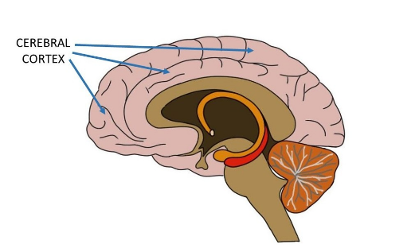
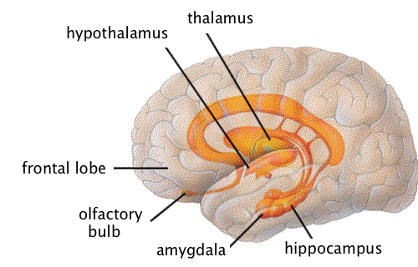

Evaluating Neuroanatomy
Strengths | Limitations
Support for sex differences | Structure not function
P: One strength comes from evidence that women’s and men’s brains are structured differently.  E: Ingalhalikar et al (2014) used a brain scanning method called MRI and found that women’s brains had stronger connections between the brain hemispheres, but men’s brains had stronger connections within hemispheres.  T: This is a strength as it supports the research of Ruigrok et al (2014) and suggests that there may be some truth in the stereotype that women are more able than men to cope with several tasks at once. | P: One weakness is that, just because the brains of females and males differ in structure, it does not mean they function differently.  E: For example, some sex differences in brain structure definitely exist, but research has to the show that these are linked to differences in brain functioning (and also behaviour). Research is ongoing and very few conclusions have been reached.  T: This is a weakness as it means that there has been a lot of unjustified speculation about differences between women and men, unsupported by evidence.

Key Study: Harlow (1868) – Recovery from the passage of an iron bar through the head.
This study was conducted to report the unusual case of a man named Phineas Gage who suffered a severe brain injury when working on the railroad in the USA. Whilst filling holes with gunpowder and pressing down on it with a long iron bar, the powder exploded and the bar was forced all the way through Gage’s skull, fracturing bones and removing parts of the brain.
Aim | The aim of the study was to report the unusual case of Phineas P. Gage and the implications for understanding how the brain works.
Method/Procedure | Harlow recorded the details of the case.
Results | Gage recovered physically, but after 7 months, his change in personality was very great. Gage had previously been hard working but he became stubborn, swearing often and became “childlike in his capacity”. He would often make grand plans and then suddenly change his mind. His friends said he was no longer himself.
Conclusion | Harlow believed that Gage’s intellectual ability had been severely impaired by the accident but not lost. The accident damaged part of the left side of his brain, affecting its function. The corresponding area on the right side was unaffected but could not completely make up for damage to the left side. Harlow recognised that some functions and behaviours must be localised in the brain.

Evaluation (strengths and limitations) of Harlow (1868).
Exam Hints
Each strength & limitation is divided into THREE sections (PEC) in order for you to write an effective evaluation.
- POINT: State your strength or limitation.
- ELABORATE: Explain your point- include examples/evidence to support your point.
- COMMENT: This is your concluding/summary statement.. use of words such as “this shows/suggests that…,” “this is a strength/limitation because…”
You will need to revise 1 strength and 1 limitation for each assumption.

Evaluating Harlow (1868)
Strengths | Limitations
Ahead of his time | Unjustified conclusions
P: One strength is that Harlow made careful observations of Gage’s recovery.  E: For example, he made efforts to link the area of Gage’s brain injury to the changes in his personality and intellectual functioning.  T: This is a strength as it suggests that Harlow was ahead of his time in providing support for localisation as a theory of brain function.  A further strength is that this is a case study. This is a strength as it means that a lot of detailed data was collected about Phineas Gage, making it high in validity. | P: One weakness is that there is not enough information from the study to draw firm conclusions about localisation.  E: For example, little is known about Gage before his accident so it is hard to judge how much he changed afterwards. He may not have changed drastically as after the accident he was able to hold down a challenging job for at least 9 years.  T: This is a weakness as it means it is hard to link brain functions to changes in Gage’s behaviour and these changes may have been exaggerated. They are also unique to Gage and so cannot be applied to others.


Apply the knowledge:
Sam was stabbed with a knife through the front of his brain’s left hemisphere. He survived the attack and recovered, but his friends noticed that his personality had changed and his college work was nowhere near as good as before.
Evaluate neuroanatomy with reference to this scenario. In your answer you should consider: a) basic localisation of function, and b) the key study by Harlow (1868)
__________________________________________________________________________________________________________________________________________________________________________________________________________________________________________________________________________________________________________________________________________________________________________________________________________________________________________________________________________________________________________________________________________________________________________________________________________________________________________________________________________________________________________________________________________________________________________________________________________________________________________________________________________________________________________________________________________________________________________________________________________________________________________________________________________________________

Condense the Research:
Condense Harlow’s research below. This will make it easier to remember in the exam. Remember to use P.E.T in your evaluation for maximum A03 marks!
Aim
Method/Procedure
Results
Conclusion
Evaluation
1 strength

1 weakness

Does it matter if men and women’s brains are different?
In your experience, how different are men and women? How do you think biological psychologists would explain your experiences?

Key Concept: Neurochemistry
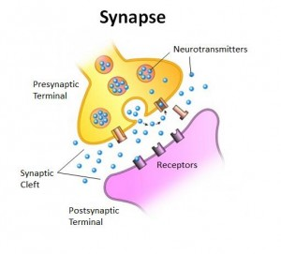
Neurochemistry concerns the activity of substances in the nervous system. Nerves communicate to one another to pass messages throughout the body. Psychologists are interested in how these substances affect the functioning of the brain and how this in turn influences our thinking, emotions and behaviour.
Neurotransmitters (chemical substances) allow communication between nerve cells (called neurons). There are gaps in between the neurons called synapses. Although neurons use electrical impulses to send messages, they cannot travel across synapses and so neurotransmitters travel across and generate an impulse on the other side.

Serotonin | Serotonin is one of the main neurotransmitters in the body. It has been linked to a number of behaviours and disorders including depression. Serotonin levels are thought to be reduced in individuals with depression. As a result, some drugs that treat depression work by increasing the levels of serotonin in the synapses.
Dopamine | Dopamine helps to regulate motivational behaviours and our experience of reward.

Sex Hormones
Sex hormones are chemicals produced by testes (in males) and ovaries (in females). They circulate in the bloodstream and target specific organs, affecting physical and sexual development and behaviour. There are two main sex hormones.
Oestrogen | .
Testosterone
Use the information in your handout to complete the table below. Ensure that your notes include links to differences in behaviour in males and females.

Evaluating Neurochemistry
Strengths | Limitations
Support for sex hormones | Contradictory research
P: One strength is that many studies demonstrate the importance of sex hormones.  E: For example, Van Goozen et al (1995) found that transgender women (transitioning from male to female) who were receiving female hormones, showed lower levels of aggression and visuo-spatial skills, whereas transgender men showed the opposite results.  T: This is a strength as these findings illustrate the very significant impact that sex hormones can have on behaviour. | P: One weakness is that other studies have produced conflicting findings.  E: For example, in a follow up study to Van Goozen et al’s, Slabbekoorn et al (1999) found that sex hormones did not have a consistent effect on visuo-spatial skills in transitioning people. Furthermore, transitioning people are not representative of the population as whole.  T: This is a weakness as it suggests that neurochemistry alone cannot account for behaviour and so non-biological factors are also influential.

Key Study: Deady et al (2006) – Maternal personality and reproductive ambition in women.

Aim | Deady et al wanted to see if there was a link between testosterone levels and reproductive ambition/broodiness in women.
Method/Procedure | 27 female college students completed a measure of how masculine or feminine a person perceives themselves to be. Participants also answered questions about their “maternal personality” (e.g. how important it was for them to have children), reproductive ambition (e.g. how many children they wanted) and career orientation (how important a career was). Finally, the level of testosterone in their saliva was analysed.
Results | Findings of the measure conducted showed that women who perceived themselves as more masculine has higher testosterone and lower maternal personality scores and reproductive ambition. Testosterone levels were lower in those who perceived themselves as less masculine.
Conclusion | Researchers concluded that women’s maternal tendencies (e.g. desire to have children) are moderated partly by the male sex hormone testosterone. This suggests that maternal personality and reproductive ambition have a biological basis and are not just due to psychological or social factors.

Evaluation (strengths and limitations) of Deady et al. (2006)
Exam Hints
Each strength & limitation is divided into THREE sections (PEC) in order for you to write an effective evaluation.
- POINT: State your strength or limitation.
- ELABORATE: Explain your point- include examples/evidence to support your point.
- COMMENT: This is your concluding/summary statement.. use of words such as “this shows/suggests that…,” “this is a strength/limitation because…”
You will need to revise 1 strength and 1 limitation for each assumption.

Evaluating Deady et al. (2006)
Strengths | Limitations
Support from other research | Correlation not causation
P: One strength of this research is that is supported by other research.  E: For example, Dabbs and Hargrove (1997) found that females who used aggression to enforce dominance within prison had higher testosterone levels than other prisoners.  T: This is a strength as it means that biological psychologists can have greater confidence that the effect of testosterone on female behaviour is a real one. | P: One weakness is that researchers found several correlations in their data.  E: For example, maternal personality and testosterone were linked together, but this does not mean that one causes the other. The research cannot show that testosterone causes women to have an unmaternal personality. Other factors may be involved.  T: This is a weakness as it means that in order for the research to be able to draw strong conclusions, it must be supported by non-correlational data.

Apply the knowledge:
Rolando went to his doctor because he was very depressed. But since taking the antidepressant medication, his doctor prescribed he has been feeling quite a bit better.
Outline the role of neurotransmitters in behaviour which reference to Rolando’s experience. (3)
______________________________________________________________________________________________________________________________________________________________________________________________________________________________________________________________________________________________________________________________________________________________________________________________________________________________________________________________________________________________________________________________________________________________________________________________________________________________________________________

Sofia has a very regular menstrual cycle but each month just before her period she becomes irritable and experiences severe abdominal cramps.
- Explain what Sofia’s experience tells us about the role of sex hormones. (3)
____________________________________________________________________________________________________________________________________________________________________________________________________________________________________________________________________________________________________________________________________________________________________________________________________________________________________
- Explain one weakness of the key study by Deady et al. (2006) Refer to Sofia’s experience in your answer.
______________________________________________________________________________________________________________________________________________________________________________________________________________________________________________________________________________________________________________________________________________________________________________________________________________________________________________________________________________________________________________________________________________________________________________________________________________________________________________________

Condense the Research:
Condense Harlow’s research below. This will make it easier to remember in the exam. Remember to use P.E.T in your evaluation for maximum A03 marks!
Aim
Method/Procedure
Results
Conclusion
Evaluation
1 strength

1 weakness

What are the implications for a criminal if biological psychologists suggest that we are controlled by our hormones?

Key concept: Evolutionary Psychology
Sexual Selection | Attributes or behaviours that increase reproductive success are more likely to be passed on and may become exaggerated over succeeding generations of offspring.
Survival of the fittest | Natural selection selects the genes giving rise to characteristics that promote survival and reproduction, so they are retained in the population.
Environment of evolutionary adaption (EEA) | The habitat in which a species evolved its most recent adaptations.
Genome Lag | Changes to the environment occur much more rapidly than changes to our genes.

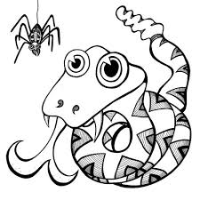
The most common phobias are snakes, spider and height- these are thought to have an evolutionary basis. Why do you think that this will be the case?

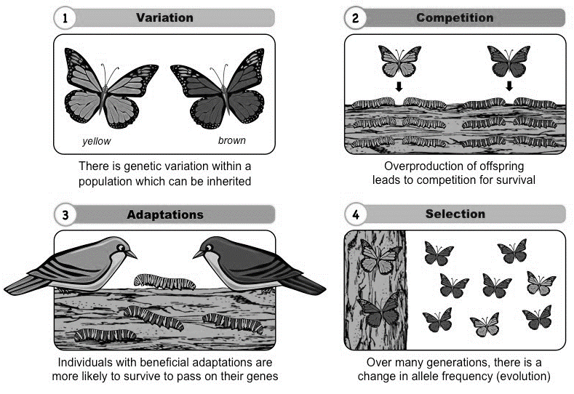
Process of Natural Selection
Why might we have evolve to be aggressive?

Aggression maybe seen as a maladaptive behaviour – what does this mean?

What is meant by the genome lag? How might this link to behaviours like aggression and depression?

Sexual Selection
Male To Male Competition | 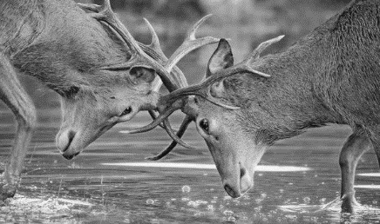  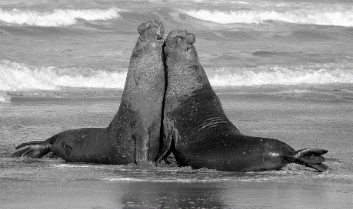 | What does this mean? (sexual selection)
Female Choice | 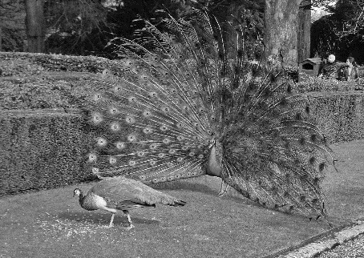  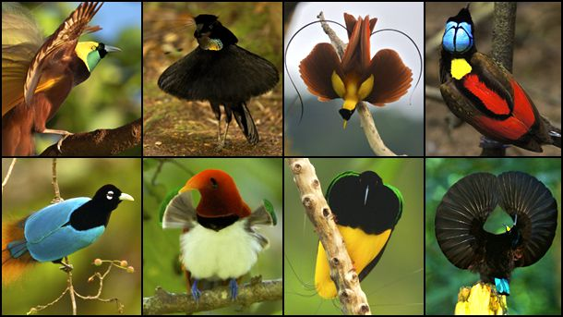 | What does this mean (sexual selection)

How might sexual selection link to aggression? – think about the assumption of evolution and behaviour.

Evaluation (strengths and limitations of evolution).
Strengths | Limitations
Support for genome lag | Problems with EEA concept
P: One strength is support for the concept of genome lag from research into partner preferences.  E: For example, over the last 100 years, women have a greater role in the workplace that had made many women less dependent on a man to provide for them. So women’s preferences are now less dictated by resource considerations.  T: This is a strength because it suggests that a behaviour important to survival (choosing a mate) has been influenced by cultural changes while the genome has changed hardly at all. | P: One weakness is that the concept of the EEA implies that significant evolution of human characteristics stopped 10,000 years ago.  E: However some research suggests that this is not the case. For example, most humans are lactose intolerant, but some are not. This suggests that the gene that allows us to digest milk has been naturally selected and passed on. This will have been around 10,000 years ago.  T: This suggests/This is a limitation because it suggests that some human characteristics may be the outcomes of evolutionary pressures operating much more recently than the EEA. This undermines the EEA as a key concept of evolutionary psychology.

Key Study: Buss et al. (1992) – Sex differences in jealousy: Evolution, physiology and psychology.

Aim | Buss et al (1992) wanted to see if males and females experience different forms of jealousy (sexual or emotional) in response to thoughts of infidelity.
Method/Procedure | Male and female participants (American students) were asked to think of a current or former partner becoming involved with somebody else (person X).  They were asked which would be more upsetting:  - Their partner forming a deep emotional attachment with X?  - Their partner having passionate sexual intercourse with X?  Some participants imagined the two scenarios while their physiological responses were measured (e.g. pulse rate).
Results | 60% of men (17% of women) were more distressed by the sexual infidelity scenario than the emotional infidelity scenario than the sexual one. Men showed more physiological activity in the sexual infidelity scenario compared with the emotional one. Women showed the opposite but the differences were not as strong as they were for men.
Conclusion | The findings support an evolutionary explanation of jealousy.  Male sexual jealousy defends against raising another mans child which would not enhance their own reproductive success. Therefore, sensitivity to sexual infidelity is a trait that would be selected in men.  Female emotional jealousy defends losing a male partner to another woman, and the loss of supports raising a child. Emotional infidelity would reduce successful reproduction and thus would be selected in women.
Evaluation (strengths and limitations) of Buss et al. (1992)
Strengths | Limitations
Support for genome lag | Problems with EEA concept
P: One strength is that Buss et al. measured physiological activity as well as feelings of distress.  E: The question posed to participants required a subjective answer, whereas the physiological measures were objective, showing that sex difference in jealousy has a biological basis. This is what we would expect to find if the evolutionary explanation is correct.  T: This suggests/This is a strength because it suggests that the findings are more convincing because they are supported by two lines of evidence rather than just one. | P: One weakness is that the participants were from a single culture.  E: Evolutionary psychology is problematic because it deals in universals, claiming that all humans must show the same behaviours because they are all exposed to the same selective pressures. However, Buss et al. only investigated jealousy in American students and their behaviour may have bee determined by social norms.  T: This suggests/This is a limitation because it suggests that the study only focused on one culture and so can not fully support an evolutionary explanation of jealousy.

Practice exam questions
State what is meant by the term “survival of the fittest. (1)
__________________________________________________________________________________________________________________________________________________________________________________________________________________
A group of school children are visiting the zoo. They see a peacock unfurl his magnificent tail. One child says, “I don’t know how he manages to get around carrying that”.
With reference to the child’s comment, explain how the peacock’s tail supports the concept of sexual selection. (3)
____________________________________________________________________________________________________________________________________________________________________________________________________________________________________________________________________________________________________________________________________________________________________________________________________________________________________
Explain what the key study by Buss et al. (1992) can tell us about evolutionary psychology. (3)
____________________________________________________________________________________________________________________________________________________________________________________________________________________________________________________________________________________________________________________________________________________________________________________________________________________________________
Explain one strength or one weakness of the key study by Buss et al. (1992) (3)
____________________________________________________________________________________________________________________________________________________________________________________________________________________________________________________________________________________________________________________________________________________________________________________________________________________________________

Apply the knowledge: 9 MARK QUESTION:
Humans have adapted to live in a very different environment from the ones we live now. Many behaviours that evolved a long time ago are still helping us to survive today.
Discuss the view that evolutionary pscyhology can explain human behaviour. In your answer you should consider at least two of the following: a) environment of evolutionary adaptation, b) genome lag, c) survival of the fittest, and d) sexual selection. (9)
________________________________________________________________________________________________________________________________________________________________________________________________________________________________________________________________________________________________________________________________________________________________________________________________________________________________________________________________________________________________________________________________________________________________________________________________________________________________________________________________________________________________________________________________________________________________________________________________________________________________________________________________________________________________________________________________________________________________________________________________________________________________________________________________________________________________________________________________________________________________________________________________________________________________________________________________________________________________________________________________________________________________________________________________________________________________________________________________________________________________________________________________________________________________________________________________________________________________________________________________________________________________________________________________________________

Condense the Research:
Condense Harlow’s research below. This will make it easier to remember in the exam. Remember to use P.E.T in your evaluation for maximum A03 marks!
Aim
Method/Procedure
Results
Conclusion
Evaluation
1 strength

1 weakness

Aggression
‘Behaviour that is intended to cause psychological or physical injury’

Types of Aggression – Match the type of aggression to it’s definition.
Reactive, often angry aggression in response to a perceived threat. It has an emotional basis.
Aggression that serves a purpose. It could be described as cold-blooded; it is rational in order to accomplish an aim.
Aggression in which harm is caused by damaging someone's relationships or social status.

The Biological Approach to Explaining Aggression in Society
The biological approach to aggression centers on explaining aggression as the result of either evolution, brain structures and/or genes.

Why might it be an evolutionary advantage to be aggressive?

Key terms:
- Brain structures: physical components that make up the neuroanatomy of the brain, including the amygdala and the orbitofrontal cortex (OFC).
- Evolution: the changes in inherited characteristics in a biological population over successive generations.
- Genes: A unit of inheritance.
- Neurochemistry: Relating to substances in the brain and other parts of the nervous system that regulate psychological functioning.


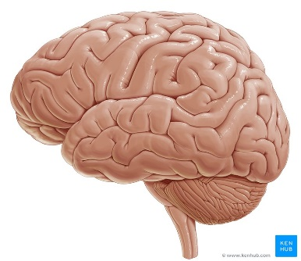

Evolution of Aggression | Brain Structures and Genes in Aggression | Neurochemistry of Aggression
 | The Amygdala:  The Orbitofrontal cortex:  Genes:  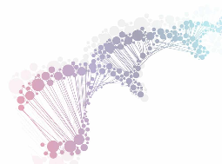 | Serotonin:  Dopamine:
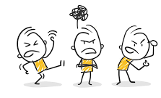

Evaluation of the Biological Approach to Explaining Aggression in Society

Research support for the evolutionary explanation. | P: One strength of the evolutionary explanations is support from studies of intimate partner violence (IPV).  E: Shackleford et al (2005) found that men who used mate retention behaviours (e.g. direct guarding) in heterosexual relationships were more likely to be physically violent towards their partners (a strong positive correlation). Retention behaviour was a reliable predictor of aggression.  T: This is a strength because these findings support the evolutionary view that predicts a link between risk of infidelity, sexual jealousy and aggression.
Research support for the role of the amygdala. | P: A further strength of the biological approach is evidence supporting the amygdala’s role in aggression.  E: Pardini et al (2014) found that brain scans showed smaller amygdala volumes in both childhood and adulthood were associated with greater aggression.  T: This is a strength because it supports the role of the amygdala because amygdala volume was found to predict aggressive behaviour.
Correlation not Causation. | P: One weakness is that many research studies into biological factors are correlational.  E: For example, two studies described above found strong correlations between aggression and the other variables (mate retention, amygdala volume). Correlational research is helpful but it is not causation.  T: This is a weakness because we cannot know for sure if a biological factor (e.g. amygdala volume) is a cause of aggression, an effect of it, or if a third variable is involved.
Simplistic view of Genes. | P: Another weakness is that the influence of genes on aggression is very complex, with no simple answers.  E: Studies show that the role of MAOA gene is important but probably exaggerated. For instance, in the study by Stuart et al. IPV was associated not just associated not just with the MAOA gene but also with the serotonin transporter gene (the 5-HTT gene). Vassos et al. (2014) reviewed 185 studies but found no single gene was associated with aggression.  T: The conclusion is that aggressive behaviour is the outcome of hundreds or thousands of genes (genotype) all interacting with each other and with environmental factors to produce the aggressive phenotype.

Practice Exam Questions

- Explain how the biological approach accounts for aggression. Use the concept of genes in your answer. (2)

_____________________________________________________________________________________________________________________________________________________________________________________________________________________________________________________________________________________________________________________________________________________________________________

- Give three features of the biological approach that can explain aggression. (3)

_____________________________________________________________________________________________________________________________________________________________________________________________________________________________________________________________________________________________________________________________________________________________________________

- Harlow’s (1868) study of Phineas Gage showed how injury to the brain can change behaviour. Explain how the findings of Harlow (1868) support the view that aggression is linked to neuroanatomy. (3)

________________________________________________________________________________________________________________________________________________________________________________________________________________________________________________________________________________________________________________________________________________________________________

- Explain one strength OR one weakness of the biological approach to explaining aggression. (3)

________________________________________________________________________________________________________________________________________________
________________________________________________________________________________________________________________________________________________
________________________________________________________________________________________________________________________________________________

- Graham doesn’t like his partner Pippa leaving the house. He asks her lots of questions when she returns, such as “Where have you been?” and “who did you see?”. He is planning to install a tracking app on her mobile. Graham has also used physical force to keep Pippa under his control.
- Describe the type of aggression shown by Graham (2).
________________________________________________________________________________________________________________________________________________________________________________________________________________________________________________________________________________________________________________________________________________________________________
- Use one aspect of the biological approach to explain Graham’s behaviour. (2)
________________________________________________________________________________________________________________________________________________________________________________________________________________________________________________________________________________________________________________________________________________________________________

- Discuss the view that aggressive people are born not made. In your answer you should consider: i) the concept of evolution, and ii) reference to Graham’s behaviour. (9)

________________________________________________________________________________________________________________________________________________________________________________________________________________________________________________________________________________________________________________________________________________________________________________________________________________________________________________________________________________________________________________________________________________________________________________________________________________________________________________________________________________________________________________________________________________________________________________________________________________________________________________________________________________________________________________________________________________________________________________________________________________________________________________________________________________________________________________________________________________________________________________________________________________________________________________________________________________________________________________________________________________________________________________________________________________________
________________________________________________________________________________________________________________________________________________

Application task

A probation officer reflects
Erwin is a probation officer working with high-risk offenders who have been in prison for violent crimes. He has worked in this field for over 20 years and has a lot of experience of criminals and their families.
Erwin has noticed that a high proportion of the people he works with have a medical history that includes brain injury. Others come from families where violent behaviour goes back several generations. Many of the people on his current caseload are addicted to drugs. He has even dealt with cases of murder and attempted murder with a large element of jealousy.
Erwin wonders if there could be a biological basis to a lot of aggressive behaviour.

Write a brief outline of the biological causes of aggression that would address Erwin’s question and that he could share with his probation officer colleagues.

Consumer Behaviour
‘The study of all the activities associated with the purchase and use of goods and services’
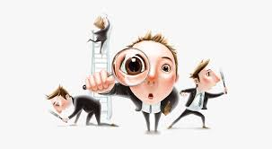
Consumer behaviour refers to the way people make decisions about what services and products to buy and the activities that influence those decisions, including advertising.

There are two key terms related to consumer behaviour and biological explanations of it that you are required to know.
Neuromarketing | The application of the scientific study of the brain (neuroscience) to marketing e.g. advertising.
Scanning Techniques | Methods used to investigate the brain and other parts of the body. Images are taken of the living brain and sometimes regions of the brain are matched to behaviour by asking participants to engage in particular activities whilst the scan is done.

Where do you think your eyes may be drawn when entering a shop? Why might advertisers want to know this?

The Biological Approach to Explaining Consumer Behaviour

Neuromarketing | Functional Magnetic Resonance Imaging (fMRI) | Eye Tracking
 | Electroencephalogram (EEG)  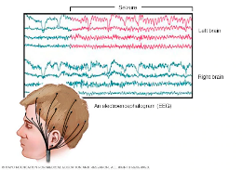 | 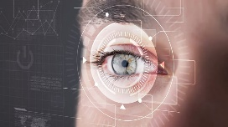  Facial Coding

Evaluating the Biological Approach to Explaining Consumer Behaviour
Neuromarketing techniques are more useful than self-report. | P: One strength is that neuromarketing techniques (e.g. fMRI and EEG) can be useful alternatives to self-report methods such as questionnaires.  E: This is because sometimes people are not consciously aware of their responses. For instance, Berns and Moore (2012) used fMRI with adolescents, they found that activity in a “reward” area of the brain was closely correlated with the popularity of songs three years later. But the participants conscious responses (how much they said that they liked the songs) did not correlate with sales figures.  T: This is a strength as it suggests that the techniques of neuromarketing can sometimes reveal more about consumer behaviour than traditional methods.
Neuromarketing is not the most effective technique. | P: One weakness is that there is poor evidence that neuromarketing can actually predict consumer behaviour.  E: For example, Venkatraman et al (2015) asked participants to watch genuine adverts. The researchers used fMRI, EEG, eye tracking and facial coding to measure participants’ responses. They also used focus groups (small groups discussing their opinions of adverts), which were found to be the best technique for predicting advertising success. fMRI was the only neuromarketing technique that was at all effective.  T: This is a weakness as it suggests that fMRI may have some usefulness but methods that don’t rely on technology, may be more effective.
Ethics of neuromarketing. | P: Another weakness is that neuromarketing techniques raise ethical concerns.  E: One ethical concern is that neuromarketing may use neuroscientific findings to manipulate responses that people are not aware of and over which they have no control. There is also concern about the unethical use of neuroscientific findings to make inflated claims in order to sell “expertise” to companies and advertisers.  T: This is a weakness as it is an unethical manipulation of consumers worries and so many researchers believe that neuromarketing should be regulated by law.
Neuromarketing claims are exaggerated with little supportive evidence. | P: A further weakness of biological approaches in explaining consumer behaviour is that there is a serious disconnect between research findings on neuroscience and the claims made by neuromarketeers.  E: For example, some neuromarketers have argued that their techniques allow them to “read minds”, that is to directly measure attention, memory, decision-making, and emotions in the brain. However, neuroscience researchers do not push their claims anywhere near this far. They measure brain activity in response to stimuli and correlate it with other variables such as expressed feelings about a product or behaviours such as buying. But this is not the same as “seeing” emotion in the brain, for instance.  T: This is a weakness as it suggests that currently, many of neuromarketing’s clams are hype and future research is needed to actually produce greater support.

Practice Exam Questions

- In the context of consumer behaviour, explain what is meant by the term “neuromarketing”. (2)

_____________________________________________________________________________________________________________________________________________________________________________________________________________________________________________________________________________________________________________________________________________________________________________

- Explain how the biological approach accounts for consumer behaviour. (3)

_____________________________________________________________________________________________________________________________________________________________________________________________________________________________________________________________________________________________________________________________________________________________________________

- Explain ONE way in which the biological approach can inform strategies to change behaviour. (3)

________________________________________________________________________________________________________________________________________________________________________________________________________________________________________________________________________________________________________________________________________________________________________

- Describe one scanning technique to detect brain changes in consumer decision-making. (2)

________________________________________________________________________________________________________________________________________________________________________________________________________________________________________________________________________________________________________________________________________________________________________

- Kenan and Heather volunteered for a research study into advertising. Kenan had a skull cap with lots of electrodes fitted onto his head. It was attached to a computer screen that showed several wave patterns. The researchers used a scanner with Heather. Both were shown brief adverts.

- Identify the neuromarketing technique used with Kenan. (1)

________________________________________________________________________________________________________________________________________________________________________________________________________________________________________________________________________________________________________________________________________________________________________

- Explain how the technique used with Heather works. (3)
________________________________________________________________________________________________________________________________________________
________________________________________________________________________________________________________________________________________________

c)Discuss techniques based on the biological approach that are used to change consumer behaviour. In your answer you should consider: i) neuromarketing, and ii) reference to Kenan and Heather. (9)

________________________________________________________________________________________________________________________________________________________________________________________________________________________________________________________________________________________________________________________________________________________________________________________________________________________________________________________________________________________________________________________________________________________________________________________________________________________________________________________________________________________________________________________________________________________________________________________________________________________________________________________________________________________________________________________________________________________________________________________________________________________________________________________________________________________________________________________________________________________________________________________________________________________________________________________________________________________________________________________________________________________________________________________________________________________________________________________________________________________________________________________________________________________________________________________________________________________________________________________________________________________________________________________________________________________________________________________________

Application task

Design your own
Many companies are known to use adverts based on neuroscientific research. The research has helped advertisers to understand what consumers “like” even when they do not know themselves. The adverts that have been produced used sound, colour, and fonts in creative ways. They “direct” the viewer to the most important parts of the advert. They try to manipulate emotions (e.g. with a voiceover) so viewers feel more positively about the product.

Think about the neuromarketing techniques described in this section. Explain how you could use them to design an advert for a mobile phone (you could use virtual reality).

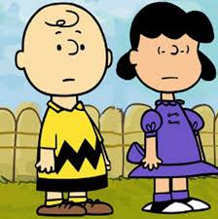
Gender
Define gender:
Gender – being a male or a female. This is a psychological construct, a person’s gender may not always be the same as the person’s biological sex. (xx – female or xy – male chromosomes).
Remember, gender can be considered typical and atypical.
Earlier in this topic, we looked at various biological explanations for behaviour which can also be applied to gender. These include hormones and evolution, particularly in the form of sexual selection.

Neurochemistry | Research highlights the importance of the hormone testosterone in male and female gender development.  What do we already know about testosterone and behaviour?
Sexual Selection | Sexual selection focuses on behaviours in males and females that enhance their reproductive success. Gender behaviours and identities can be related to sexual selection e.g. human females are caring are more likely to reproduce as it is important that they care for their offspring, important during the time of EEA. Over time this trait is sexually selected in females and continues throughout generations.
Use the space below to note your typical ideas on what is masculine and feminine. How do you think they may be explained using your knowledge of the biological approach.
Biological Approach to Explaining Gender

Role of Sex Hormones in Gender | Evolutionary explanations for masculinity/femininity
Testosterone and Gender  Testosterone and Atypical Development | Dominant Male Theory  Division of labour in the EEA

Evaluation of Biological Explanations of Gender
Support for the role of testosterone. | P: One strength of biological explanations of gender is that testosterone is strongly associated with masculine-typical gender identity in females.  E: For example, Baucom et al (1985) found that high levels of salivary testosterone correlate with high masculinity in their female participants, whereas a feminine identity was associated with low levels of testosterone. Those with high levels of testosterone saw themselves as more independent, active and resourceful.  T: This is a strength as it supports the role of a testosterone (a biological factor) in gender identity.
Neglects social and cultural factors. | P: One weakness of biological explanations of gender is that gender differences across and within cultures, with important differences in what are considered gender-typical behaviours.  E: For example, Ashcraft and Belgrave (2005) argue that African American girls identify closely with masculine-typical and androgynous gender roles, and link this to the structure of African American families. This suggests there is a social context and learning of gender which may be better described by other theories.  T: This is a weakness for biological explanations as it suggests that they may be too simplistic and that better explanations of gender may come from a combination of biological and social/cultural factors, with more research needed.
Evidence undermining evolutionary theory. | P: One weakness of biological explanations of gender is that evolutionary explanations argue that gender is binary (male or female), which is contradicted by evidence of a third gender in some cultures.  E: For example, the fa’afafine of Samoa are biologically male but choose to adopt a feminine-typical gender role, dressing as women, performing domestic tasks and caring for their family. They can also have sex with a non fa’afafine man, without either of them being considered gay.  T: This is a weakness as it shows that there are instances of culturally-accepted gender fluidity, which is difficult for evolutionary explanations to account for.
Incorrect assumptions about the EEA. | P: Another weakness of biological explanations of gender is that the evolutionary approach suggests that gender behaviours/identity is inherited from social structures existing in the EEA.  E: In evolutionary explanations, men were hunters and women were gatherers/homemakers, with each developing gender appropriate behaviours based on these roles. More recent research by Eagly and Wood (1999) however contradicts this, finding that in existing hunter-gatherer societies, there was a larger variety of gender-appropriate behaviours than the evolutionary approach would suggest.  T: This is a weakness as it suggests that assumptions made by the evolutionary theory regarding gender have little supportive evidence.

Link it:
How might sex differences in brain structure contribute to gender?
Does the study by Deady et al. (2006) support a biological explanation of gender? Explain your answer.
What do Buss et al’s (1992) findings about sexual and emotional jealousy tell us about gender?

Practice Exam Questions

- In the context of the biological approach, what is meant by the term “sex hormone”? Refer to gender in your answer. (2)

_____________________________________________________________________________________________________________________________________________________________________________________________________________________________________________________________________________________________________________________________________________________________________________

- Explain how the biological approach accounts for gender. Use the concept of evolution in your answer. (3)

_____________________________________________________________________________________________________________________________________________________________________________________________________________________________________________________________________________________________________________________________________________________________________________

- Explain ONE evolutionary reason for traditional masculine gender behaviour. (3)

________________________________________________________________________________________________________________________________________________________________________________________________________________________________________________________________________________________________________________________________________________________________________

- Give THREE features of the biological approach that can explain gender. (3)

_______________________________________________________________________________________________________________________________________________________________________________________________________________________________________________________________________________________________________________________________________________________________________________________________________________________________________________________________________________________________________________________________________________________________________________________________________________________________________________________________________________________________________________________________________________

- Explain how the findings of Deady et al’s (2006) study support the biological approach to gender. (3)

________________________________________________________________________________________________________________________________________________________________________________________________________________________________________________________________________________________________
________________________________________________________________________________________________________________________________________________

- Sven sees himself as a bit of a “man’s man”. He is extremely competitive and enjoys beating his male friends in various sports and in “banter”. His approach to work is aggressive and he sees dating as a competition. He believes that women find him very attractive.

With reference to Sven, analyse the view that gender is biologically determined. In your answer you should consider: a) sex hormones, and b) evolutionary explanations of masculinity/feminity. (9)

________________________________________________________________________________________________________________________________________________________________________________________________________________________________________________________________________________________________________________________________________________________________________________________________________________________________________________________________________________________________________________________________________________________________________________________________________________________________________________________________________________________________________________________________________________________________________________________________________________________________________________________________________________________________________________________________________________________________________________________________________________________________________________________________________________________________________________________________________________________________________________________________________________________________________________________________________________________________________________________________________________________________________________________________________________________________________________________________________________________________________________________________________________________________________________________________________________________________________________________________________________________________________________________
________________________________________________________________________________________________________________________________________________

Application task

Men and Women are born different
In 2017 James Danmore, a software engineer at Google, wrote a memo which he sent to his colleagues. In it, he argued that men and women have different interests, preferences, abilities and identities that are biologically-determined and rooted in evolution. He wrote, “On average, men and women biologically differ in many ways. These differences aren’t jut socially constructed because... They’re universal across human cultures... they often have clear biological causes and links to prenatal testosterone... they’re exactly what we would predict from an evolutionary psychology perspective”.

Write a memo in response to Danmore’s message. You can either support of challenge his arguments, but your memo must be based firmly on the evidence.

