Limiting factor and Enzyme theory recap:
Definition: ___________________________________________________________________________________
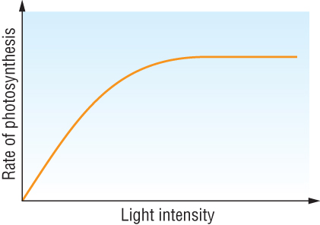
Limiting factors in B is ______________
Because ___________________________________________________
Limiting factors in A is ______________
Because ___________________________________________________
Year 1 enzyme theory recap:
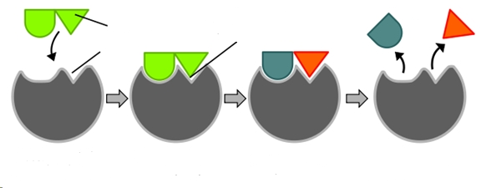
Enzyme mnemonic:
Draw a denatured protein:

Explain denaturation of a protein:
__________________________________________________________________________________________________________________________________________________________________________________________
Draw effect of temperature graph

Explain the effect of increasing the temperature on the rate of an enzyme-controlled reaction
Up to optimum: ________________________________________________________________________________
_____________________________________________________________________________________________
Above optimum: ______________________________________________________________________________
_____________________________________________________________________________________________

Year 2 Enzyme recap exam questions. _______/ = _______ %
Q1.(a) Describe how a peptide bond is formed between two amino acids to form a dipeptide.
___________________________________________________________________
___________________________________________________________________
___________________________________________________________________
___________________________________________________________________(2)
(b) The secondary structure of a polypeptide is produced by bonds between amino acids.Describe how.
___________________________________________________________________
___________________________________________________________________
___________________________________________________________________
___________________________________________________________________(2)
(c) Two proteins have the same number and type of amino acids but different tertiary structures.Explain why.
___________________________________________________________________
___________________________________________________________________
___________________________________________________________________
___________________________________________________________________(2)
Q2.A technician investigated the effect of temperature on the rate of an enzyme-controlled reaction. At each temperature, he started the reaction using the same concentration of substrate.The following graph shows his results.
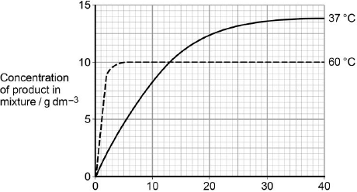
Time after start of reaction / minutes
(a) Give two other factors the technician would have controlled.
1. _________________________________________________________________
2. _________________________________________________________________(1)
(b) Draw a tangent on each curve to find the initial rates of reaction.
Use these values to calculate the ratio of the initial rates of reaction at 60 °C : 37 °C.
Show your working.

Ratio = ____________________ :1. (2)
(c) Explain the difference in the initial rate of reaction at 60 °C and 37 °C.
___________________________________________________________________
___________________________________________________________________
___________________________________________________________________
___________________________________________________________________(2)
(d) Explain the difference in the rates of reaction at 60 °C and 37 °C between 20 and 40 minutes.
___________________________________________________________________
___________________________________________________________________
___________________________________________________________________
___________________________________________________________________
__________________________________________________________________(4)
Q3.(a) Explain how the shape of an enzyme molecule is related to its function.
___________________________________________________________________
___________________________________________________________________
___________________________________________________________________
___________________________________________________________________(3)
(b) Bacteria produce enzymes which cause food to decay. Explain how vinegar, which is acidic, can prevent the action of bacterial enzymes in some preserved foods.
___________________________________________________________________
___________________________________________________________________(3)
Q4.A student investigated the effect of substrate concentration on the initial rate of an enzyme-catalysed reaction. She added 10 cm³ of an enzyme solution to 10 cm³ of substrate solutions of different concentrations. At 30-second intervals, she tested samples of each mixture for the presence of substrate.
• A – in the absence of an inhibitor.
• B – with a competitive inhibitor added to the substrate solution.
• C – with a non-competitive inhibitor added to the substrate solution.
Her results are shown in the graph below.
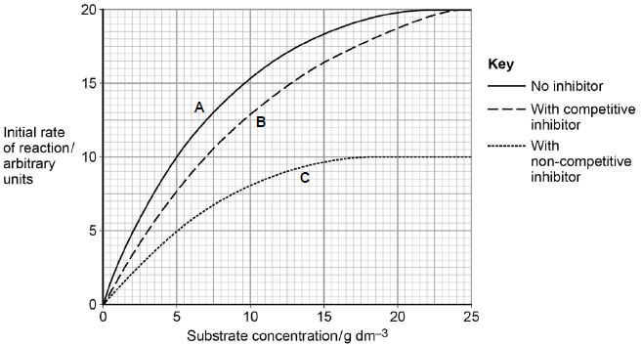
(a) Explain the results without inhibitor (curve A) shown in the graph.
___________________________________________________________________
___________________________________________________________________
___________________________________________________________________
___________________________________________________________________
___________________________________________________________________(2)
(b) The graph shows that the maximum initial rate of reaction (V_{max}) when a competitive inhibitor was present (curve B) is different from that when a non-competitive inhibitor was present (curve C).Explain this difference.
___________________________________________________________________
___________________________________________________________________
___________________________________________________________________
___________________________________________________________________(4)
(c) The Michaelis constant (K_{m}) is the substrate concentration at which the initial rate of reaction is half its maximum value (V_{max}). How could you use the Michaelis constant to determine the type of inhibition occurring in an enzyme-catalysed reaction?
Use information from the graph to support your answer.
___________________________________________________________________
___________________________________________________________________
___________________________________________________________________(1)
Q5.In an investigation into carbohydrase activity, the contents from part of the gut of a small animal were collected. The contents were added to starch solution at pH 7 and kept in a water bath at 25°C. At one-minute intervals, samples were removed and added to different test tubes containing dilute iodine solution. The colour intensity of each sample was determined. The graph shows the results.
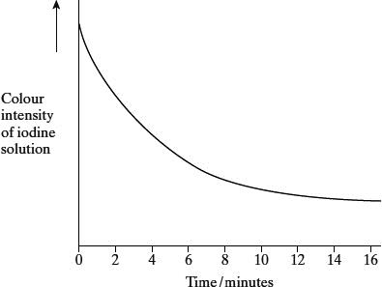
(a) Explain the change in colour intensity.
___________________________________________________________________
___________________________________________________________________
___________________________________________________________________(2)
(b) Draw clearly labelled curves on the graph to show the expected result if the experiment was repeated
(i) at 35 °C;
(ii) at pH 2.
(2)
(c) Explain how
(i) raising the temperature to 35 °C affects carbohydrase activity;
______________________________________________________________
______________________________________________________________
______________________________________________________________
(ii) decreasing the pH affects carbohydrase activity.
______________________________________________________________
______________________________________________________________
______________________________________________________________
______________________________________________________________
______________________________________________________________(7)

Application of knowledge: Limiting factors and enzyme action applied to photosynthesis
Q6.Scientists investigated the effect of temperature on the activity of two enzymes isolated from the leaf cells of cotton plants.
• Rubisco
• Rubisco activase – an enzyme that activates rubisco
Figure 1 and Figure 2 show their results.
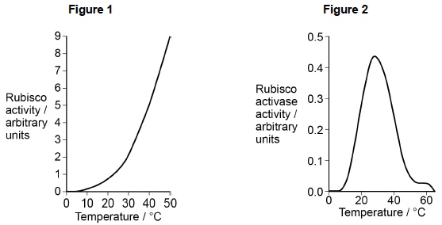
(d) The scientists concluded that heat stress reduces the activity of rubisco in plant leaves by affecting rubisco activase. Use all the information to evaluate their conclusion.
___________________________________________________________________
___________________________________________________________________
___________________________________________________________________
___________________________________________________________________
___________________________________________________________________
___________________________________________________________________(4)
Q7.An investigation was carried out to find the effect of increasing carbon dioxide concentration on the rate of photosynthesis in a particular type of plant. The graph shows the results.
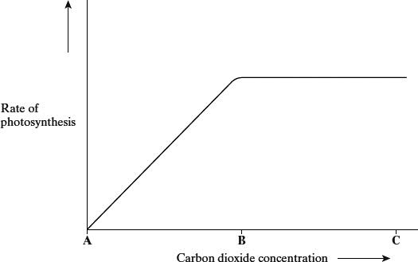
(a) (i) In this investigation, temperature was kept constant. Explain why.
______________________________________________________________
______________________________________________________________(1)
(ii) Suggest suitable units for measuring the rate of photosynthesis in this investigation.
______________________________________________________________(2)
(b) (i) Give the evidence from the graph that carbon dioxide is limiting the rate of photosynthesis between A and B.
______________________________________________________________
______________________________________________________________(1)
(ii) Explain the shape of the curve between B and C.
______________________________________________________________
______________________________________________________________
______________________________________________________________(2)

Q8.An investigation was carried out into the effect of carbon dioxide concentration and light intensity on the rate of photosynthesis in a species of plant.
(a) The temperature was kept constant during this investigation. Explain why.
___________________________________________________________________
___________________________________________________________________(2)

(b) The table shows the effect of increasing carbon dioxide concentration on the rate of photosynthesis in maize.

Carbon dioxide  concentration / arbitrary units | Rate of photosynthesis / arbitrary  units
30 | 10
60 | 20
100 | 30
150 | 40
230 | 50
300 | 60
400 | 60
Describe and explain the effect of increasing carbon dioxide concentration on the rate of photosynthesis.
___________________________________________________________________
___________________________________________________________________
___________________________________________________________________
__________________________________________________________________(3)
Q9.Scientists investigated the effects of temperature and light intensity on the rate of photosynthesis in creeping azalea. They investigated the effect of temperature on the net rate of photosynthesis at three different light intensities. They also investigated the effect of temperature on the rate of respiration. The graph shows the results.
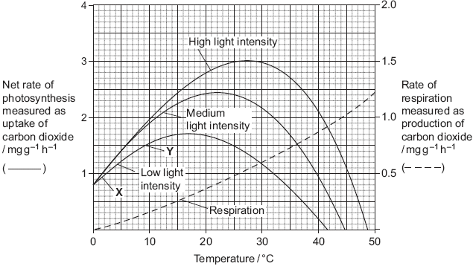
(a) (i) Name the factors that limited the rate of photosynthesis between X and Y.
______________________________________________________________(1)
(ii) Use information from the graph to explain your answer.
______________________________________________________________
______________________________________________________________
______________________________________________________________
______________________________________________________________
______________________________________________________________(2)
(b) Use information from the graph to find the gross rate of photosynthesis at 20°C and medium light intensity.

Answer ____________________(1)
(c) Creeping azalea is a plant which grows on mountains. Scientists predict that in the area where this plant grows the mean summer temperature is likely to rise from 20 °C to 23 °C. It is also likely to become much cloudier. Describe and explain how these changes are likely to affect the growth of creeping azalea.
___________________________________________________________________
___________________________________________________________________
___________________________________________________________________
___________________________________________________________________
___________________________________________________________________
___________________________________________________________________(3)

