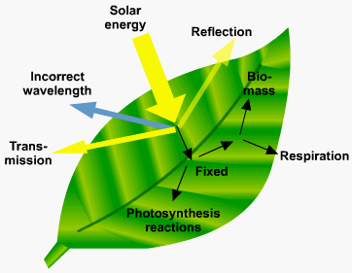
3.5 Energy transfer in and between organisms

Biology Homework November term

3.5.1 Photosynthesis, 3.5.2 Respiration.
Title | Deadline | Score (%)
Muscles 1 |  | /26
Muscles 2 |  | /28
Photosynthesis 1 |  | /19
Photosynthesis 2 (with comprehension practice) |  | /39
Respiration 1 |  | /29
Respiration 2 (with practical paper 3 questions practice) |  | /43

Muscles homework 1: Microscopic muscle structure and contraction.
Q1. (a) A sarcomere is made up of different molecules.
Complete the table by naming the molecule that carries out the function described.

 | Function | Name
 | Attaches to Z line at the end of the sarcomere
 | Breaks down ATP
 | Covers binding site on actin in relaxed myofibril
(3)
(b) The diagram shows the arrangement of actin and myosin in a sarcomere.
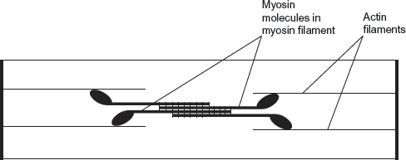
One form of muscle disease is caused by a mutated allele of a gene. This leads to production of myosin molecules that are unable to bind to other myosin molecules.
If myosin molecules are unable to bind to other myosin molecules, this prevents muscle contraction.
Use the diagram and your knowledge of how muscles contract to suggest why.
........................................................................................................................
........................................................................................................................
........................................................................................................................
................................................................................................................. (3)
Q2. (a) Describe the role of each of the following in muscle contraction.
(i) Tropomyosin
.............................................................................................................
............................................................................................................(2)
(ii) ATP
.............................................................................................................
.............................................................................................................
............................................................................................................(2)
(b) Explain how muscles maintain posture.
.......................................................................................................................
.......................................................................................................................
.......................................................................................................................
.......................................................................................................................
.......................................................................................................................(3)
Q3. The diagram shows two relaxed sarcomeres from skeletal muscle.
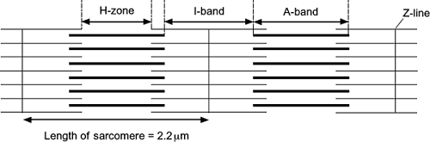
(a) When the sarcomeres contract, what happens to the length of
(i) the I-band
...............................................................................................................
(1)
(ii) the A-band?
...............................................................................................................
(1)
(b) The length of each sarcomere in the diagram is 2.2 μm. Use this information to calculate the magnification of the diagram. Show your working.

Magnification .....................................
(2)
(c) People who have McArdle’s disease produce less ATP than healthy people. As a result, they are not able to maintain strong muscle contraction during exercise. Use your knowledge of the sliding filament theory to suggest why.
........................................................................................................................
........................................................................................................................
........................................................................................................................
........................................................................................................................
........................................................................................................................
........................................................................................................................
(3)
Q4.
(a) What is the role of ATP in myofibril contraction?
.............................................................................................................................
.............................................................................................................................
.............................................................................................................................
.............................................................................................................................
(2)
(b) Scientists investigated the effect of not being able to produce creatine on the force produced by muscle. They used mice with a mutation that made them not able to produce creatine.
The force produced when these mice gripped with their paws was compared with the force produced by normal mice that were able to produce creatine.
The graph shows the scientists’ results.
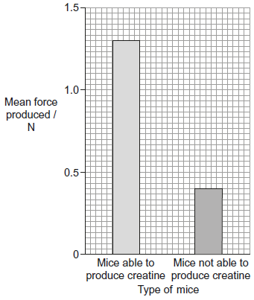
- What was the percentage fall in the mean force produced by mice not able to produce creatine, compared with the normal mice? Show your working.

Answer ........................... % (2)
(ii) Suggest an explanation for these results.
...................................................................................................................
...................................................................................................................
...................................................................................................................
..................................................................................................................(2)

Muscles homework 2: Slow and Fast twitch muscles.

Q1. Slow and fast skeletal muscles both contain slow and fast muscle fibres but in different proportions. The proportion can be determined by observing stained sections of muscle under a microscope. The stain used reacts with an ATPase enzyme. Muscle fibres containing a lot of this ATPase stain brown. Fibres containing little ATPase stain yellow.
The diagram shows stained muscle fibres in a section taken from a muscle.
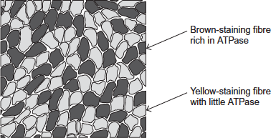
(a) Both slow and fast muscle fibres contain ATPase.
Explain why.
........................................................................................................................
........................................................................................................................
........................................................................................................................
........................................................................................................................
(2)
(b) The tissue in the diagram came from muscle with a high proportion of brown-staining fibres. Was the tissue removed from slow or fast skeletal muscle?
Explain your answer.
........................................................................................................................
........................................................................................................................
........................................................................................................................
(1)

(c) The muscle tissue in the diagram had been stained for viewing with a microscope.
What is the evidence that it had been stained for viewing with an optical (light) microscope? Explain your answer.
........................................................................................................................
........................................................................................................................
........................................................................................................................ (2)
Q2. It is believed that each person is born with a certain percentage of slow and fast muscle fibres in their skeletal muscles. Most people have about 50% slow fibres and 50% fast fibres.
A sports scientist wondered if these percentages could change over time depending on the type of sport in which a person was involved. He knew from previous investigations that:
• the number of mitochondria within a fibre can change
• the diameter of a fibre can change
• the number of muscle fibres in a skeletal muscle remains constant over time.
He determined the mean percentages of slow and fast fibres in skeletal muscles of different types of athletes. His results are shown in the graph below in the form in which he presented them.
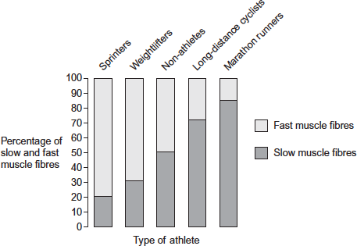
(a) (i) In which type of athlete would the sports scientist expect to find muscle fibres with the highest number of mitochondria?
...............................................................................................................
(1)
(ii) Explain the reason for your choice of athlete.
...............................................................................................................
...............................................................................................................
............................................................................................................... (2)
(b) The leg muscles of long-distance cyclists are usually larger than the leg muscles of non-athletes.
Suggest why.
........................................................................................................................
........................................................................................................................
........................................................................................................................
........................................................................................................................(3)

(c) A reader of the sports scientist’s results stated that ‘the results show that regular weightlifting changes your proportion of slow and fast skeletal muscle fibres.’
Do you agree with this statement? Explain your answer.
........................................................................................................................
........................................................................................................................
........................................................................................................................
........................................................................................................................
...................................................................................................................(2)
Q3. The diagram shows part of a myofibril from a relaxed muscle fibre.
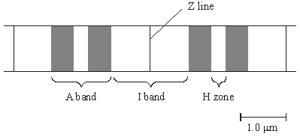
(a) When the muscle fibre contracts, which of the A band, I band and H zone
(i) remain unchanged in length,
.............................................................................................................(1)
(ii) decrease in length?
.............................................................................................................(1)

(b) Explain what caused the decrease in length in part (a)(ii).
......................................................................................................................
......................................................................................................................
......................................................................................................................(2)
(c) The whole muscle fibre is 30 mm long when relaxed. Each sarcomere is 2.25 µm long when contracted. Use the scale given on the diagram to calculate the length of the contracted muscle fibre in millimetres.

Length of contracted fibre = ...................................... mm (2)

(d) The table gives some properties of the two different types of muscle fibre found in skeletal muscle.
(i) Complete the table by writing the words ‘high’ or ‘low’ for the remaining three properties of each type of muscle fibre.

 | Type of muscle fibre
 | Type 1 | Type 2
Speed of contraction | high | low
Force generated | high | low
Activity of the enzymes of glycolysis | high | low
Number of mitochondria
Activity of Krebs cycle enzymes
Rate of fatigue
(3)
(ii) The myosin-ATPase of type 1 muscle fibres has a faster rate of reaction than that in type 2 fibres. Use your knowledge of the mechanism of muscle contraction to explain how this will help type 1 muscle fibres to contract faster than type 2.
.............................................................................................................
.............................................................................................................
.............................................................................................................
............................................................................................................. (4)
(iii) The blood leaving an active muscle with a high percentage of type 1 muscle fibres contained a higher concentration of lactate than that leaving a muscle with a high percentage of type 2 muscle fibres. Explain why.
.............................................................................................................
.............................................................................................................
......................................................................................................... (2)

Photosynthesis homework 1: Light dependent stage
Q1.Plants have pigments that absorb light energy for photosynthesis. These pigments include two types of chlorophyll and a group of pigments known as carotenoids. Different species of plant contain different amounts of these pigments. The pigments that each plant species has are adaptations to where and how they live; their ecological niche. Figure 1 shows the absorption of light of different wavelengths by chlorophyll a, chlorophyll b and carotenoids.
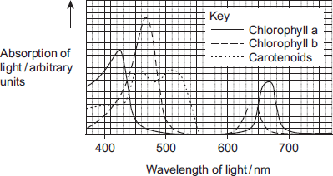
A scientist investigated the energy in light of different wavelengths reaching the ground in a forest. She measured the energy in
• direct sunlight
• sunlight that had passed through the leaves of trees.
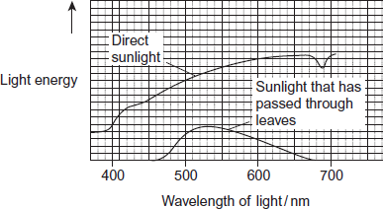
Beech trees have two types of leaves called sun leaves and shade leaves. Sun leaves grow on branches exposed to direct sunlight, shade leaves grow on branches exposed to light that has passed through leaves. An ecologist collected sun leaves and shade leaves from beech trees and determined the mean mass of each photosynthetic pigment in both types of leaf. His results are shown in Figure 3.

Photosynthetic pigment | Mean mass of each pigment per m² of leaf  area / μg (± standard deviation)
Photosynthetic pigment | Sun leaves | Shade leaves
Chlorophyll a | 299.3 (± 2.1) | 288.9 (± 0.1)
Chlorophyll b | 90.7 (± 2.1) | 111.1 (± 0.1)
Carotenoids | 0.10 (± 0.01) | 0.07 (± 0.01)
(a) It is an advantage to beech trees to produce more chlorophyll b in the shade leaves. Suggest and explain why.
___________________________________________________________________
___________________________________________________________________
___________________________________________________________________
___________________________________________________________________ (2)
(b) There are two hypotheses about the advantage to plants of producing carotenoids.
Hypothesis 1: Carotenoids help shade leaves to absorb more light of wavelengths 480 nm to 520nm for photosynthesis.
Hypothesis 2: Carotenoids prevent damage to chlorophyll from very bright light.
(i) Which hypothesis do the data provided on the resource sheet support? Explain your answer.
Hypothesis ____________________
Explanation ____________________________________________________
______________________________________________________________
______________________________________________________________
______________________________________________________________(2)
(ii) Suggest one other piece of experimental evidence you would need in order to be more confident about drawing your conclusion in (b)(i).
______________________________________________________________
______________________________________________________________(1)

Q2. The graph shows the absorption of different wavelengths of light by three photosynthetic pigments in a red seaweed.
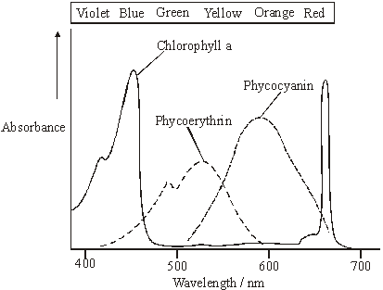
(a) (i) Describe what the graph shows about the properties of chlorophyll a.
______________________________________________________________
______________________________________________________________(1)
(ii) Describe the part played by chlorophyll in photosynthesis.
______________________________________________________________
______________________________________________________________
______________________________________________________________(3)
(b) The red seaweed lives under water at a depth of 2 metres. Suggest an advantage to the red seaweed of having other pigments in addition to chlorophyll a.
___________________________________________________________________
___________________________________________________________________
___________________________________________________________________(2)
Q3. Herbicides can be used to reduce the growth of weeds.
Scientists completed seven studies to determine how the use of the herbicide Atrazine affected the yield of sugarcane. In each study, some plots were treated with Atrazine and some plots were not treated with Atrazine. The graph below shows the scientists’ results. (1 hectare = 10 000 m²)
(a) Calculate the percentage decrease in yield caused by the use of Atrazine in study G.
Answer = _________________ % (1)

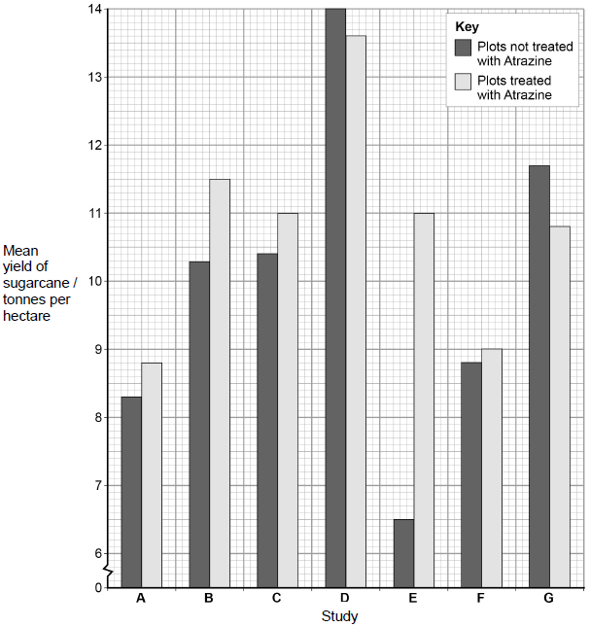
(b) A teacher studying these data with her students told her class that no definite conclusions could be drawn when comparing the mean values in the graph. Suggest why the teacher said this.
___________________________________________________________________
___________________________________________________________________
___________________________________________________________________
__________________________________________________________________ (2)
(c) Atrazine binds to proteins in the electron transfer chain in chloroplasts of weeds, reducing the transfer of electrons down the chain. Explain how this reduces the rate of photosynthesis in weeds.
___________________________________________________________________
___________________________________________________________________
___________________________________________________________________
___________________________________________________________________
___________________________________________________________________ (4)
(d) When treated with Atrazine, weeds have been shown to give off small amounts of heat. Suggest an explanation for this observation.
___________________________________________________________________
___________________________________________________________________ (1)
Photosynthesis homework 2:Light independent stage, limiting factors
Q4.Scientists investigated the effect of the water potential of soil water on plant growth. They investigated the effect of this water potential on several plant processes.
The figure below shows their results in the form they were presented. The bars show whether or not each process was occurring. The plants stopped growing when the water potential of the soil water was below –0.7 mPa. All of the changes in the plants were related to the ability of the roots to take up water from the soil.
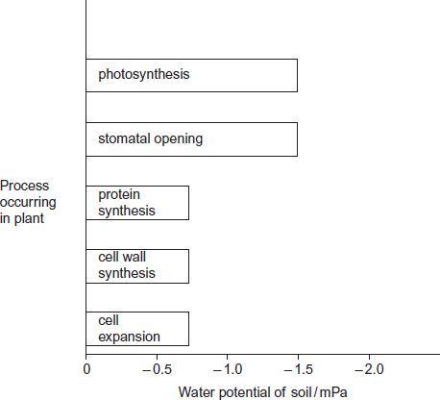
(a) Describe the results in the figure.
___________________________________________________________________
___________________________________________________________________
___________________________________________________________________
___________________________________________________________________(2)
(b) Explain the relationship between stomatal opening and photosynthesis.
___________________________________________________________________
___________________________________________________________________
___________________________________________________________________(2)
(c) Although photosynthesis is still occurring, plants stop growing when the soil water potential falls below –0.7 mPa. Use information from the figure above to suggest two reasons why.
___________________________________________________________________
___________________________________________________________________
___________________________________________________________________ (3)
Q5.During photosynthesis, carbon dioxide reacts with ribulose bisphosphate (RuBP) to form two molecules of glycerate 3-phosphate (GP). This reaction is catalysed by the enzyme Rubisco. Rubisco can also catalyse a reaction between RuBP and oxygen to form one molecule of GP and one molecule of phosphoglycolate. Both the reactions catalysed by Rubisco are shown in Figure 1.
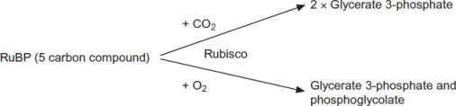
(a) (i) Where exactly in a cell is the enzyme Rubisco found?
______________________________________________________________(1)
(ii) Use the information provided to give the number of carbon atoms in one molecule of phosphoglycolate.
 (1)
(b) Scientists investigated the effect of different concentrations of oxygen on the rate of absorption of carbon dioxide by leaves of soya bean plants. Their results are shown in Figure 2.
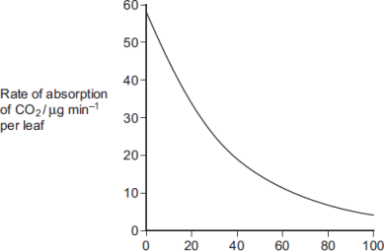
Concentration of oxygen / %
Use Figure 1 to explain the results obtained in Figure 2.
___________________________________________________________________
___________________________________________________________________
___________________________________________________________________
___________________________________________________________________(2)

(c) Use the information provided and your knowledge of the light-independent reaction to explain why the yield from soya bean plants is decreased at higher concentrations of oxygen. Phosphoglycolate is not used in the light-independent reaction.
___________________________________________________________________
___________________________________________________________________
___________________________________________________________________
___________________________________________________________________(3)
Q6.The diagram shows the energy flow through a freshwater ecosystem.
All units are kJ m^{–2}year^{–1}.
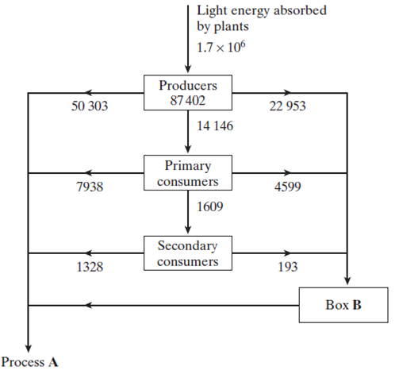
(a) Name
(i) process A;
______________________________________________________________(1)
(ii) the group of organisms represented by box B.
______________________________________________________________(1)
(b) Calculate the percentage efficiency with which light energy is transferred to energy in producers. Show your working.

Answer ____________________(2)
(c) Describe the effect of light energy in the light-dependent reaction of photosynthesis.
___________________________________________________________________
___________________________________________________________________
___________________________________________________________________ (2)
(d) If a plant is kept in the dark it is still able to produce carbohydrates, as long as it is provided with two products of the light-dependent reaction of photosynthesis. Give the name of these products and explain their function in the light-independent reaction of photosynthesis.
Name _____________________________________________________________
Function ___________________________________________________________
___________________________________________________________________
Name _____________________________________________________________
Function ___________________________________________________________
___________________________________________________________________(4)
Q7.An investigation was carried out into the effect of carbon dioxide concentration and light intensity on the rate of photosynthesis in a species of plant.
(a) The temperature was kept constant during this investigation. Explain why.
___________________________________________________________________
___________________________________________________________________(2)
(b) The table shows the effect of increasing carbon dioxide concentration on the rate of photosynthesis in maize.

Carbon dioxide  concentration / arbitrary units | Rate of photosynthesis / arbitrary  units
30 | 10
60 | 20
100 | 30
150 | 40
230 | 50
300 | 60
400 | 60

Describe and explain the effect of increasing carbon dioxide concentration on the rate of photosynthesis.
___________________________________________________________________
___________________________________________________________________
___________________________________________________________________
___________________________________________________________________ (3)
Q8. Comprehension Practice
Resource A – D relate to a single investigation.
Scientists investigated the effect of supplying extra carbon dioxide on the yield of tomatoes growing in a glasshouse. They compared the mean yield of tomatoes from 1995 to 1997 when no extra carbon dioxide was supplied with the mean yield of tomatoes from 1998 to 2000 when extra carbon dioxide was supplied.
Resource A Tomato plants were grown in two glasshouses, each with an area of 2000 m². Figure 1 shows the mean number of hours of sunshine per month during fruit production.

 | 1995 - 1997  (no extra carbon dioxide) | 1998 - 2000  (extra carbon dioxide)
Mean number of hours of  sunshine per month | 148.91 | 147.00
• The scientists used heating to maintain the tempera ture inside the glasshouses above 18 °C. They opened the windows to keep the tempera ture below 30 °C.
• From 1998 to 2000 they maintained the carbon dioxide concentration between 0.06 % and 0.08 % when the windows were closed and between 0.04 % and 0.05 % when the windows were open.
• The carbon dioxide concentration in the air outside the glasshouse was 0.04 %.
Resource B Figure 2 shows the mean difference between the yield of tomatoes with extra carbon dioxide and the yield with no extra carbon dioxide for each week during the harvesting period.
If the yield is greater when extra carbon dioxide is supplied, the difference in yield is shown as an increase. If the yield is lower when extra carbon dioxide is supplied, the difference is shown as a decrease.
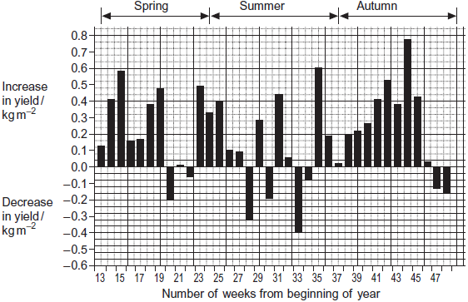
Resource C Figure 3 shows the relationship between the time when the tomatoes were harvested and the yield.

Number of weeks from  beginning of year | Mean yield per week with  extra carbon dioxide / kg m^{–2} | Mean yield per week without  extra carbon dioxide / kg m^{–2}
13 – 19 | 1.25 | 0.83
20 – 25 | 1.62 | 1.47
26 – 48 | 1.23 | 1.06
The commercial price for tomatoes varies with the time of year. The highest price is paid for tomatoes between weeks 13 and 19. The lowest price is paid between weeks 26 and 48.
Resource D Whiteflies are an important insect pest of tomatoes. The adults can fly from plant to plant. Their young do not have wings. The adults and young feed on the plant sap and introduce viruses into the tomato plants. Feeding and the introduction of viruses both reduce the yield of tomatoes. The scientists controlled the number of whitefly in the glasshouses by releasing parasitic wasps. The wasps lay their eggs in the young of the whitefly. The wasp eggs hatch and feed on the young whitefly, killing them.
(a) (i) An increase in carbon dioxide concentration affected the yield of tomatoes in week 35. Use Figure 2 to describe how.
______________________________________________________________
______________________________________________________________(1)
(ii) There was a decrease in yield when extra carbon dioxide was supplied during some weeks of the year. Use information from Resource A to suggest why.
______________________________________________________________ (1)

(b) Using Figure 3, calculate the percentage increase in yield when extra carbon dioxide was added for weeks 13 to 19. Show your working.

Percentage increase ____________________(2)
(c) Additional information is required for tomato growers to decide whether it is economically profitable to add extra carbon dioxide to produce very early tomatoes.
Give two pieces of information that the growers would require.
1. _________________________________________________________________
___________________________________________________________________
2. _________________________________________________________________
___________________________________________________________________(2)
(d) Adding extra carbon dioxide during the summer (weeks 24 – 36) is unlikely to be profitable. Use data from the resource sheet explain why.
___________________________________________________________________
___________________________________________________________________
___________________________________________________________________
___________________________________________________________________(2)
(e) The control experiment in this investigation was when data were collected with no extra carbon dioxide added. Some scientists said this control experiment was not satisfactory. Explain how you could improve the control experiment.
___________________________________________________________________
___________________________________________________________________
___________________________________________________________________
___________________________________________________________________(2)

Respiration Homework 1: Aerobic Respiration
Q1.(a) Describe the part played by the inner membrane of a mitochondrion in producing ATP.
___________________________________________________________________
___________________________________________________________________
___________________________________________________________________
___________________________________________________________________
___________________________________________________________________
________________________________________________________________(3)
(b) A scientist investigated ATP production in a preparation of isolated mitochondria. He suspended the mitochondria in an isotonic solution and added a suitable respiratory substrate together with ADP and phosphate. He bubbled oxygen through the preparation.
(i) Why was the solution in which the mitochondria were suspended isotonic?
______________________________________________________________
____________________________________________________________(1)
(ii) Explain why the scientist did not use glucose as the respiratory substrate.
______________________________________________________________
______________________________________________________________
______________________________________________________________
______________________________________________________________
___________________________________________________________(2)
(iii) Explain why the oxygen concentration would change during this investigation.
______________________________________________________________
____________________________________________________________(1)

Q2.(a) The flow chart shows the main stages in aerobic respiration.
(i) Complete the flow chart by writing, in the appropriate boxes, the number of carbon atoms in substance P and the name of substance Q.(2)
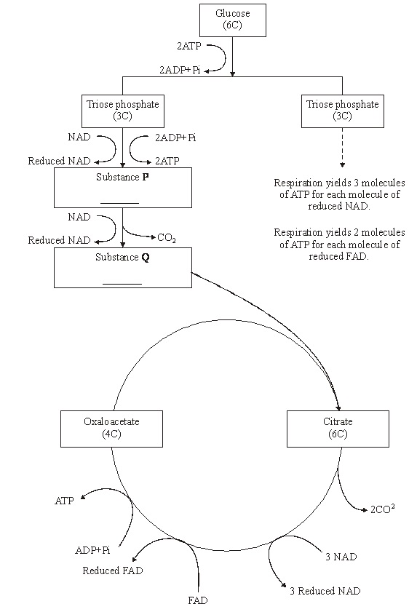
(ii) Some ATP is formed in the cytoplasm and some in the mitochondria. Use the information given to calculate the number of molecules of ATP formed in a mitochondrion from one molecule of glucose in aerobic respiration. Show how you arrived at your answer.

Answer___________________(2)
(iii) In the presence of oxygen, respiration yields more ATP per molecule of glucose than it does in the absence of oxygen. Explain why.
______________________________________________________________
___________________________________________________________ (3)
Q3.(a) Describe how acetylcoenzyme A is formed in the link reaction.
___________________________________________________________________
___________________________________________________________________
___________________________________________________________________
___________________________________________________________________
___________________________________________________________________
(2)
(b) In the Krebs cycle, acetylcoenzyme A combines with four-carbon oxaloacetate to form six-carbon citrate. This reaction is catalysed by the enzyme citrate synthase.
(i) Oxaloacetate is the first substrate to bind with the enzyme citrate synthase. This induces a change in the enzyme, which enables the acetylcoenzyme A to bind.Explain how oxaloacetate enables the acetylcoenzyme A to then bind to the enzyme.
______________________________________________________________
______________________________________________________________
____________________________________________________________(2)
(ii) Another substance in the Krebs cycle is called succinyl coenzyme A. This substance has a very similar shape to acetylcoenzyme A.Suggest how production of succinyl coenzyme A could control the rate of the reaction catalysed by citrate synthase.
______________________________________________________________
____________________________________________________________ (2)
Q4.(a) The table contains statements about three stages of respiration.
Complete the table with a tick if the statement in the first column is true for each stage of respiration in an animal.

 | Glycolysis | Link reaction | Krebs cycle
Occurs in
mitochondria
Carbon dioxide
produced
NAD is reduced
(3)

(b) The following reaction occurs in the Krebs cycle.
A scientist investigated the effect of the enzyme inhibitor malonate on this reaction. The structure of malonate is very similar to the structure of succinate. The scientist added malonate and the respiratory substrate, pyruvate, to a suspension of isolated mitochondria. She also bubbled oxygen through the suspension.
(i) Explain why the scientist did not use glucose as the respiratory substrate for these isolated mitochondria.
______________________________________________________________
______________________________________________________________
______________________________________________________________
______________________________________________________________
______________________________________________________________
(2)
(ii) Explain how malonate inhibits the formation of fumarate from succinate.
______________________________________________________________
______________________________________________________________
______________________________________________________________
______________________________________________________________
______________________________________________________________
(2)
(iii) The scientist measured the uptake of oxygen by the mitochondria during the investigation. The uptake of oxygen decreased when malonate was added. Explain why.
______________________________________________________________
______________________________________________________________
______________________________________________________________
______________________________________________________________
______________________________________________________________
(2)

Respiration homework 2- Anaerobic respiration and limiting factors
Q1.The diagram summarises the process of anaerobic respiration in yeast cells.
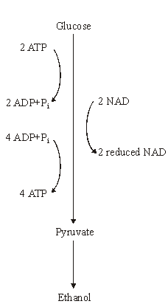
(a) (i) In anaerobic respiration, what is the net yield of ATP molecules per molecule of glucose?
___________________________________________
(1)
(ii) Give two advantages of ATP as an energy-storage molecule within a cell.
- _____________________________________

2. ______________________________________ (2)

(b) Describe how NAD is regenerated in anaerobic respiration in yeast cells.
___________________________________________________________________
___________________________________________________________________(1)
Q2.When one mole of glucose is burned, 2800 kJ of energy are released. However, when one mole of glucose is respired aerobically, only 40% of the energy released is incorporated into ATP. Each mole of glucose respired aerobically produces 38 moles of ATP.
(a) (i) Calculate how much energy is incorporated into each mole of ATP. Show your working.

Answer ____________________ kJ(2)
(ii) When glucose is respired what happens to the energy which is not incorporated into ATP?
______________________________________________________________(1)
(b) (i) When one mole of glucose is respired anaerobically, only 2 moles of ATP are produced. Explain why less energy is released in anaerobic respiration.
______________________________________________________________(1)

(ii) At the end of a sprint race, a runner continues to breathe rapidly for some time. Explain the advantage of this.
______________________________________________________________
______________________________________________________________
______________________________________________________________
______________________________________________________________(2)
Q3.(a) The table contains statements about three biological processes. Complete the table with a tick if the statement in the first column is true, for each process.

 |  | Photosynthesis | Anaerobic respiration | Aerobic respiration
 | ATP produced
 | Occurs in organelles
 | Electron transport chain involved
(3)
(b) Write a simple equation to show how ATP is synthesised from ADP.
___________________________________________________________________(1)
(c) Give two ways in which the properties of ATP make it a suitable source of energy in biological processes.
1. _________________________________________________________________
___________________________________________________________________
2. _________________________________________________________________
__________________________________________________________________(2)
(d) Humans synthesise more than their body mass of ATP each day. Explain why it is necessary for them to synthesise such a large amount of ATP.
___________________________________________________________________
___________________________________________________________________
___________________________________________________________________
___________________________________________________________________
__________________________________________________________________(2)

Q4.
Yeast cells can respire aerobically or anaerobically. A student used the apparatus shown in Figure 1 to measure the rate of respiration in yeast.She:
• positioned the flask in a water bath so that the yeast culture reached a constant temperature
• then left the apparatus for one hour before starting her investigation. Figure 1
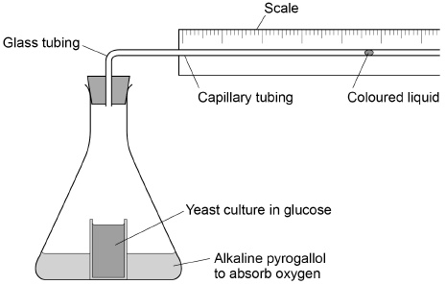
(a) Suggest one reason why it was important that the student left the apparatus for one hour after the yeast culture reached a constant temperature.
___________________________________________________________________
__________________________________________________________________(1)
(b) During her investigation, the coloured liquid moved to the right.Explain why it moved to the right.
___________________________________________________________________
___________________________________________________________________
___________________________________________________________________
___________________________________________________________________
__________________________________________________________________(2)
(c) The student found that the coloured liquid moved 1.5 cm in 24 hours. The diameter of the lumen (hole) of the capillary tubing was 1 mm.
The volume of a capillary tubing is given by πr²l, where π is 3.14 and l = length.
Calculate the volume of gas produced in cm³ hour^{–1}.
Show your working.

Answer = ____________________ cm³ hour^{–1}
(2)

Figure 2 shows a typical population growth curve for yeast under laboratory conditions.
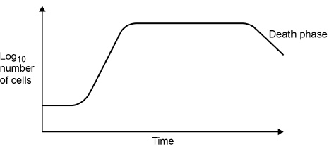
(d) Explain why a log scale is used to record the number of cells.
___________________________________________________________________
___________________________________________________________________(1)
(e) Many yeast cells die during the death phase.Suggest one reason why.
___________________________________________________________________
_________________________________________________________________ (1)
(f) The following equation can be used to make predictions of the growth in the population of yeast cells under ideal laboratory conditions.
X_{t} = X₀ e^{rt}
X_{t} = the population after a certain time
X₀ = the population at the start
e = 2.72 (base of natural logarithm)
r = growth rate
t = time period in hours over which r applies
A population of 2000 yeast cells was left for 10 hours.
The value for the growth rate was 0.5
Assuming no yeast cells died, calculate the predicted size of the population after 10 hours. Show your working.
Answer = ____________________
(2)
Q5.A scientist investigated the use of a new source of carbohydrate in the production of ethanol for biofuel. He wanted to find the optimum time to leave a mixture of yeast and this carbohydrate to produce ethanol. The scientist set up an airtight container containing yeast and this carbohydrate. He then measured the oxygen, carbon dioxide and ethanol concentrations over 8 hours.
The results of his investigation are shown in the graph below.
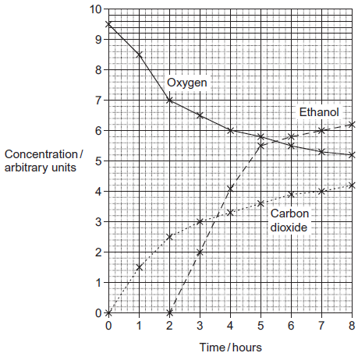
(a) The scientist used a container that was airtight.
Give two explanations why the container had to be airtight.
1. _________________________________________________________________
___________________________________________________________________
___________________________________________________________________
2. _________________________________________________________________
___________________________________________________________________
__________________________________________________________________(4)
(b) Explain the relationship between the concentration of oxygen and the concentration of carbon dioxide between 0 and 3 hours.
___________________________________________________________________
___________________________________________________________________
___________________________________________________________________
___________________________________________________________________
___________________________________________________________________
__________________________________________________________________(2)
(c) The scientist concluded that yeast starts to respire anaerobically when the oxygen concentration falls below a certain concentration. What is the oxygen concentration when the yeast starts to respire anaerobically? Explain your answer.
___________________________________________________________________
___________________________________________________________________
___________________________________________________________________
___________________________________________________________________
___________________________________________________________________(2)
(d) (i) The scientist worked for a biofuel company. Give two suggestions for further work he should do to make sure that the results he presented to the company were reliable.
Explain how each of your suggestions would make the results more reliable.
Suggestion_____________________________________________________
______________________________________________________________
Explanation ____________________________________________________
______________________________________________________________
Suggestion_____________________________________________________
______________________________________________________________
Explanation ____________________________________________________
______________________________________________________________(4)
(ii) The scientist recommended that when the ethanol is produced commercially as biofuel the reaction should be stopped at 6 hours. Use the graph to suggest why.
______________________________________________________________
______________________________________________________________
______________________________________________________________
______________________________________________________________
______________________________________________________________(2)
(iii) The scientist’s work was funded by a biofuel company. Explain why the source of funding can cause problems with scientific work.
______________________________________________________________
______________________________________________________________
______________________________________________________________
______________________________________________________________
______________________________________________________________(2)

