Review questions:
- Draw out the light dependent reaction in the space below

- List the products of the light dependent reaction.
________________________________________________________________________________________
- Define oxidation and reduction
________________________________________________________________________________________________________________________________________________________________________________
Youtube link:
Watch the youtube link and answer the questions below. https://youtu.be/JBQANaPMGao
- Name the chemical that replaces the NADP?
________________________________________________________________________________________
- State the colour of this chemical when it is oxidised
________________________________________________________________________________________
- State the colour of this chemical when it is reduced.
________________________________________________________________________________________
- Fill in the gaps:
The ______________________ rate of _________________________ by dehydrogenase enzyme, the more _____________________ flow along the ________________ so the greater the rate of ____________________ of DCPIP from _____________ to ______________________.

The video now explains how to isolate the chloroplast suspension. This is linked to Year 1 Cell structure booklet.

- Describe the 2 control tubes.
________________________________________________________________________________________
_______________________________________________________________________________________
________________________________________________________________________________________
- Explain the importance of the coloured filters
_________________________________________________________________________________
A-level Biology required practical No. 8- Investigation into the effect of known wavelength of light on the rate of dehydrogenase activity in extracts of chloroplasts.
An investigation into the effect of wavelength of chloroplast extract.

CPAC assessed:

4a- Make accurate observations.
5a- Use appropriate software/tool to process data

Dichlorophenolindophenol (DCPIP) can be used to investigate the light-dependent stage of
photosynthesis. It is useful as it is a dye that changes colour depending on whether it is oxidised or reduced:

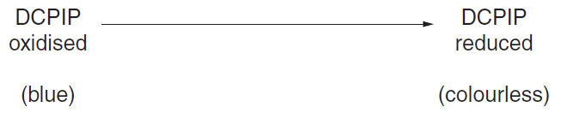
DCPIP takes part in the same oxidation-reduction reactions that normally involve the coenzyme NADP.

Oxidised (blue) DCPIP can be added to a sample of green leaf extract before being exposed to light of a specific wavelength. This produces a blue-green colour.

If the blue-green mixture is exposed to light, the dye is reduced to a colourless form and the
final colour observed is the green of the leaf extract. The time taken for this gradual colour change from blue-green to green is a measure of the rate at which the light-dependent stage of photosynthesis occurs.

Method
Materials
You are provided with the following materials:
• filtered leaf extract in a buffer solution, labelled leaf extract
• DCPIP solution, labelled DCPIP. Toxic

Safety
Take care when handling DCPIP solution.
In the event of contact with the skin, flush with water.
Take care when handling the lamp. Do not use wet hands.

• permanent marker pen
• seven capillary tubes
• one dropping pipette
• one glass rod
• white tile (or white paper)
• timer
• bench lamp
• foil to wrap round the container
• ruler
• coloured filters folded lengthways

- Stir the leaf extract. Insert a capillary tube into the green extract place your finger over the end of the capillary tube and remove the capillary tube. You should have a sample that has been drawn approximately 2 cm up the tube, wipe off any extract on the outside

- Place the capillary tube uncovered on the white tile. This will be used as the colour standard for comparison throughout the investigation.

- Add DCPIP solution, 2-3 drops at a time, to the remaining leaf extract. Swirl the container gently as you add the drops. Continue until the colour of the extract just turns from green to a distinct blue-green and remains this colour after the final swirl.
The addition of DCPIP is critical – insufficient will result in too rapid a reaction and too much will mean that the reaction will take too long to complete. If your sample has gone blue you have added too much.

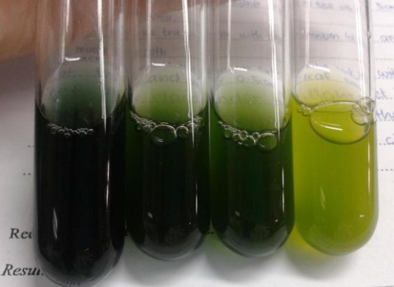

Correct volume Too little DCPIP
Of DCPIP added added

- Immediately wrap the container with the foil provided and make a lid to place over the container so that light is prevented from reaching the leaf extract-DCPIP mixture. As far as possible, this mixture should be kept in the dark throughout the practical.

- Set up and position a bench lamp so that light will shine at a distance of approximately 15 – 20 cm from the white tile. Leave the lamp switched off until step 7.

- Using a fresh capillary tube, remove a sample of the leaf extract-DCPIP mixture. This is the experimental reaction tube. Wipe the outside of this tube, place it on the white tile beside the colour-standard tube, and immediately place the purple filter over both the colour standard and experimental reaction capillary tubes.

- Switch on the lamp and start the timer. Record in a suitable table the time it takes for the colour in the reaction tube to return to and match the green colour in the colour standard.

- Lift the filter briefly when making colour comparisons. Switch off the light.

- Repeat steps 6 - 8 using each of the four remaining filters. Note that the same colour standard tube should be used each time.

- Work out the rate of photosynthesis using your recorded results, add the rate for the different wavelengths to your table.

How to calculate rate: 5a- Use appropriate software/tool to process data

The rate of reduction of DCPIP can be calculated by using the formula:

rate = 1000/t where t = time in seconds

A result recorded as infinity (∞) is equivalent to a rate of ‘0’.
Calculate the rate for the data in the table, show your working for each rate calculation.

Filter colour | Wavelength (nm) | Time taken to decolourise (s) | Mean time (s) | Rate of decolourisation (s-1)
Purple | 425 | 102  110  115  108  101
Blue | 450 | 110  115  125  130  132
Green | 525 | 213  211  212  213  210
Orange | 625 | 68  65  62  67  65
Red | 675 | 40  41  40  42  45  43

Describe the results: 4a- Make accurate observations.
When describing results, you need to say what you need and quote data WITH UNITS. Remember to use contrasting words.
____________________________________________________________________________________________________________________________________________________________________________________________________________________________________________________________________________________________________________________________________________________________________________________________

Explain the results: Use the following key terms in your explanation.
Different wavelengths | Photolysis | Oxidation | Reduction
Different pigments | Rate of photosynthesis | NADP | ETC
Absorption of light energy | Decolourisation | DCPIP
____________________________________________________________________________________________________________________________________________________________________________________________________________________________________________________________________________________________________________________________________________________________________________________________

