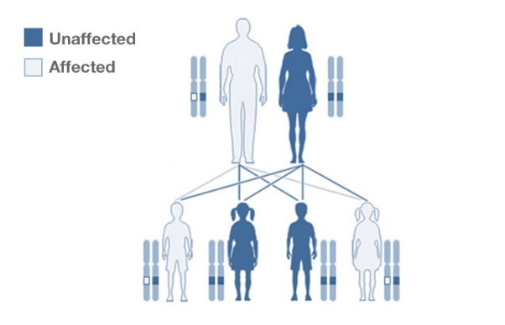
3.7 Genetics/Population/Evolution/Ecosystems

Biology Homework January term

3.7.1- Inheritance & Genetic crosses. 3.7.2- Hardy Weinberg. 3.8.4- Gene technologies
Title | Deadline | Score (%)
Inheritance 1- Monohybrid |  | /26
Inheritance 2- Monohybrid & Pedigree |  | /27
Inheritance 3- Dihybrid & calculations |  | /29
Recombinant DNA 1 |  | /30
Recombinant DNA 2 |  | /26

Inheritance homework 1.
Q1.Researchers investigated some characteristics of people from different parts of England. In the north of England they selected 200 people and recorded their phenotypes for three different characteristics.Their results are shown in the figure below.

Phenotype produced  by dominant allele | Number of  people | Phenotype produced  by recessive allele | Number of  people
Tongue roller | 131 | Non-tongue roller | 58
Right-handed | 182 | Left-handed | 14
Straight thumb | 142 | Hitch-hiker thumb | 50
(a) Calculate the ratio of straight thumb to hitch-hiker thumb in this study.

Ratio = ____________________(1)
(b) The numbers for the tongue rolling and thumb characteristics do not add up to 200.
For each characteristic suggest one reason why the numbers do not add up to 200.
Tongue rolling _______________________________________________________
___________________________________________________________________
Thumb _____________________________________________________________
__________________________________________________________________(2)
(c) One student looked at the researchers’ results and concluded that 91% of people in the UK are right-handed.Do you agree with this conclusion? Give reasons for your answer.
___________________________________________________________________
___________________________________________________________________
___________________________________________________________________
__________________________________________________________________ (2)
Q2.Lactose is the main sugar in milk and is hydrolysed by the enzyme lactase. Lactase is essential to newborn mammals as milk is their only source of food. Most mammals stop producing lactase when they start feeding on other food sources. Humans are an exception to this because some continue to produce lactase as adults. The ability to continue producing lactase is known as lactase persistence (LP) and is controlled by a dominant allele. A number of hypotheses based on different selection pressures have been put forward to explain LP in humans.

(a) One hypothesis for LP in humans suggests that the selective pressure was related to some human populations farming cattle as a source of milk.Describe how farming cattle as a source of milk could have led to an increase in LP.
___________________________________________________________________
___________________________________________________________________
___________________________________________________________________
___________________________________________________________________
___________________________________________________________________
___________________________________________________________________ (4)
(b) Use the information provided to explain why the number of people showing LP would rapidly increase once selection for this condition had been established.
___________________________________________________________________
___________________________________________________________________
___________________________________________________________________
___________________________________________________________________ (2)
(c) Lactase persistence is caused by a mutation in DNA. This mutation does not occur in the gene coding for lactase.Suggest and explain how this mutation causes LP.
___________________________________________________________________
___________________________________________________________________
___________________________________________________________________
___________________________________________________________________ (2)
Q3.The inheritance of body colour in fruit flies was investigated. Two fruit flies with grey bodies were crossed. Of the offspring, 152 had grey bodies and 48 had black bodies.
(a) Using suitable symbols, give the genotypes of the parents. Explain your answer.
Genotypes __________________________________________________________
Explanation _________________________________________________________
___________________________________________________________________
___________________________________________________________________
__________________________________________________________________(2)
(b) Explain why a statistical test should be applied to the data obtained in this investigation.
___________________________________________________________________
___________________________________________________________________(2)
(c) A species of insect, only found on a remote island, has a characteristic controlled by a pair of codominant alleles, C^{M} and C^{N}.

(i) What is meant by codominant?
______________________________________________________________
______________________________________________________________(1)
(ii) There were 500 insects in the total population. In this population, 300 insects had the genotype C^{M} C^{M}, 150 had the genotype C^{M} CN and 50 had the genotype C^{N} C^{N}. Calculate the actual frequency of the allele C^{N} by using these figures. Show your working.

Answer ____________________(2)
Q4.Figure 1 shows all the chromosomes present in one human cell during mitosis. A scientist stained and photographed the chromosomes. In Figure 2, the scientist has arranged the images of these chromosomes in homologous pairs.

Figure 1 | Figure 2
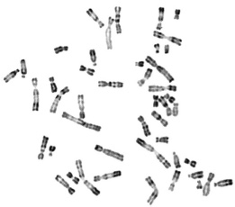 | 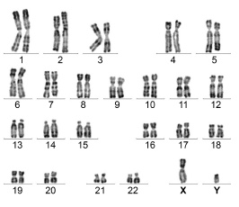
(a) Give two pieces of evidence from Figure 1 that this cell was undergoing mitosis. Explain your answers.
1. _________________________________________________________________
___________________________________________________________________
___________________________________________________________________
2. _________________________________________________________________
___________________________________________________________________
___________________________________________________________________
___________________________________________________________________ (2)

(b) Tick (✓) one box that gives the name of the stage of mitosis shown in Figure 1.

A | Anaphase | 
B | Interphase
C | Prophase
D | Telophase
(1)
(c) When preparing the cells for observation the scientist placed them in a solution that had a slightly higher (less negative) water potential than the cytoplasm. This did not cause the cells to burst but moved the chromosomes further apart in order to reduce the overlapping of the chromosomes when observed with an optical microscope. Suggest how this procedure moved the chromosomes apart.
___________________________________________________________________
___________________________________________________________________
___________________________________________________________________
___________________________________________________________________
___________________________________________________________________
___________________________________________________________________ (2)
(e) In Figure 2 the chromosomes are arranged in homologous pairs.
What is a homologous pair of chromosomes?
___________________________________________________________________
___________________________________________________________________
___________________________________________________________________
___________________________________________________________________
___________________________________________________________________(1)

Inheritance homework 2
Q1. Li-Fraumeni syndrome is a rare inherited condition. It makes someone much more likely to develop cancer at an early age. The diagram shows part of the family history of a family affected by Li-Fraumeni syndrome. Li-Fraumeni syndrome is caused by the dominant allele of a gene. The gene is not sex-linked.
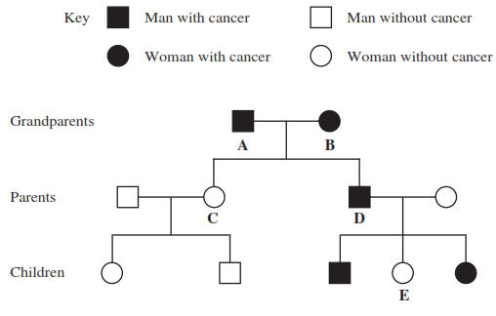
The grandparents, A and B, had two children, girl C and boy D. Explain how the phenotypes of these children provide evidence that Li-Fraumeni syndrome is
(a) caused by a dominant allele
___________________________________________________________________
___________________________________________________________________
___________________________________________________________________(2)
(b) not sex-linked.
___________________________________________________________________
___________________________________________________________________
___________________________________________________________________(2)
Q2.Human ABO blood groups are determined by the presence or absence of two antigens (A and B) on the plasma membrane of the red blood cells. The inheritance of these blood groups is controlled by three alleles:
I ^{A} – determines the production of antigen A
I ^{B} – determines the production of antigen B
I º – determines the production of no antigen
Alleles I ^{A} and I ^{B} are codominant. Allele I º is recessive to both.
The pedigree shows the pattern of inheritance of these blood groups in a family over three generations.
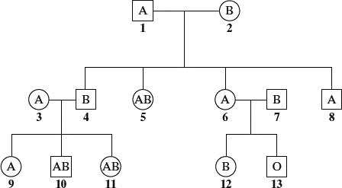
(a) (i) How many antigen-determining alleles will be present in a white blood cell? Give a reason for your answer.
______________________________________________________________
______________________________________________________________(1)
(ii) Which antigen or antigens will be present on the plasma membranes of red blood cells of individual 5?
______________________________________________________________(1)
(b) If individuals 6 and 7 were to have another child, what is the probability that this child would be male and blood group A? Explain your answer.
___________________________________________________________________
___________________________________________________________________
___________________________________________________________________
___________________________________________________________________
___________________________________________________________________
___________________________________________________________________(3)
Q3. The diagram shows the inheritance of cystic fibrosis in one family.
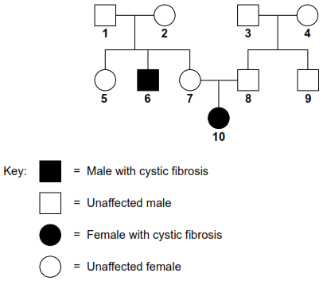
(a) Cystic fibrosis is caused by a recessive allele. Explain the evidence for this given in the diagram.
___________________________________________________________________
___________________________________________________________________
___________________________________________________________________
___________________________________________________________________ (2)
(b) Couple 7 and 8 decide to have another child. What is the probability that this child will be a girl with cystic fibrosis?
Complete the genetic diagram to explain your answer. Use the symbols N for the dominant allele and n for the recessive allele.

 | 7 | 8
Parental phenotypes  Parental genotypes  Genotypes of gametes | Unaffected  ________  ________ | Unaffected  ________  ________

Offspring genotypes _______________________________
Offspring phenotypes _______________________________
Probability of girl with
cystic fibrosis _______________________________
(4)

Q4. (a) A protein found on red blood cells, called antigen G, is coded for by a dominant allele of a gene found on the X chromosome. There is no corresponding gene on the Y chromosome. The members of one family were tested for the presence of antigen G in the blood. The antigen was found in the daughter, her father and her father’s mother, as shown in the genetic diagram below. No other members had the antigen.

Grandmother Grandfather Grandmother Grandfather
(has antigen G)

Genotypes ______or______ ______ ______ ______

Gamete ______or______ ______ ______ ______
genotype
Father Mother
(has antigen G)
Genotypes ______ ______

Gamete ______ ______
genotypes
Daughter
(has antigen G)
Genotype ______

(i) One of the grandmothers has two possible genotypes. Write these on the genetic diagram, using the symbol X^{G} to show the presence of the allele for antigen G on the X chromosome, and X^{g} for its absence.
(1)
(ii) Complete the rest of the diagram.
(3)
(b) During meiosis, when the X and Y chromosomes pair up, they do not form a typical bivalent as do other chromosomes. Explain why.
___________________________________________________________________
___________________________________________________________________
__________________________________________________________________ (2)

Q5. A sex-linked gene controls fur colour in cats. Ginger-coloured fur is controlled by the allele G, and black-coloured fur is controlled by the allele g. Some female cats have ginger and black patches of fur. They are described as tortoiseshell. Male cats cannot be tortoiseshell.
(a) What is meant by a sex-linked gene?
___________________________________________________________________
___________________________________________________________________(1)
(b) A male cat with the genotype X^{g} Y mates with a tortoiseshell female.
(i) Give the phenotype of the male.
______________________________________________________________(1)
(ii) Give the genotype of the tortoiseshell female.
______________________________________________________________(1)
(iii) Complete the genetic diagram to show the genotypes and the ratio of phenotypes expected in the offspring of this cross.
Parents Male Tortoiseshell female
Parental genotypes X^{g} Y __________

Parental gametes

Offspring genotypes

Offspring phenotypes

Ratio

(3)

Inheritance homework 3
Q1.A species of flowering plant can have white, red or purple flowers. The colour of the flowers is controlled by two genes. Each gene is found on a different chromosome, and is responsible for one step in a biosynthetic pathway. The biosynthetic pathway is
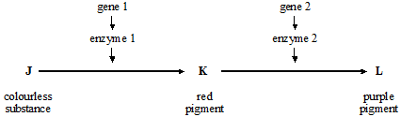
Gene 1 has the dominant allele A and the recessive allele a. Gene 2 has the dominant allele B and the recessive allele b. In both cases, the dominant allele needs to be present for the production of the associated enzyme.
(a) Explain how the two genes are involved in producing white, red or purple flowers.
___________________________________________________________________
___________________________________________________________________
___________________________________________________________________
___________________________________________________________________
___________________________________________________________________
___________________________________________________________________
___________________________________________________________________
___________________________________________________________________
___________________________________________________________________
___________________________________________________________________(6)
(b) (i) A homozygous red-flowered plant was crossed with a homozygous white-flowered plant. All the flowers of the offspring were purple. What was the genotype of
the red-flowered parent;
______________________________________________________________
the white-flowered parent?
______________________________________________________________(2)

(ii) The purple-flowered offspring were crossed. What phenotypic ratio would you expect in the next generation? Use a genetic diagram to explain your answer.

(4)
(c) (i) Genetically, there are different types of white-flowered plants of this species. Give their different genotypes.
______________________________________________________________(1)
(ii) You have samples of fresh petals from the two homozygous types of white flowers, and a pure sample of the red pigment, K. Explain, in outline, how you might distinguish the two types of petal from each other.
______________________________________________________________
______________________________________________________________
______________________________________________________________
______________________________________________________________
_____________________________________________________________(2)
Q2.Coat colour in mice is controlled by two genes, each with two alleles. The genes are on different chromosomes.
One gene controls the pigment colour. The presence of allele A results in a yellow and black banding pattern on individual hairs, producing an overall grey appearance called agouti. Mice with the genotype aa do not make the yellow pigment and are, therefore, black. The other gene determines whether any pigment is produced. The allele D is required for development of coat colour. Mice with the genotype dd produce no pigment and are called albino.
(a) What type of gene interaction is occurring between the two genes? Explain your answer.
___________________________________________________________________
___________________________________________________________________
___________________________________________________________________
___________________________________________________________________(2)
(b) Give all the possible genotypes for a black mouse.
___________________________________________________________________(1)

(c) An agouti mouse of unknown genotype was crossed with an albino mouse of unknown genotype. Their offspring included albino, agouti and black mice.
(i) What was the genotype of the agouti parent?
______________________________________________________________(1)
(ii) Give two possible genotypes for the albino parent.
______________________________________________________________(1)
(iii) Suggest how the actual genotype of the albino parent could be determined.
______________________________________________________________
______________________________________________________________
______________________________________________________________
______________________________________________________________(2)
Q3.Sea otters were close to extinction at the start of the 20th century. Following a ban on hunting sea otters, the sizes of their populations began to increase. Scientists studied the frequencies of two alleles of a gene in one population of sea otters. The dominant allele, T, codes for an enzyme. The other allele, t, is recessive and does not produce a functional enzyme.
In a population of sea otters, the allele frequency for the recessive allele, t, was found to be 0.2.
(a) (i) Use the Hardy-Weinberg equation to calculate the percentage of homozygous recessive sea otters in this population. Show your working.

Answer ____________________ % (2)
(ii) What does the Hardy-Weinberg principle predict about the frequency of the t allele after another 10 generations?
______________________________________________________________
______________________________________________________________(1)
(b) Several years later, scientists repeated their study on this population. They found that thefrequency of the recessive allele had decreased.
(i) A statistical test showed that the difference between the two frequencies of the t allele was significant at the P = 0.05 level. Use the terms probability and chance to help explain what this means.
______________________________________________________________
______________________________________________________________ (2)
(ii) What type of natural selection appears to have occurred in this population of sea otters? Explain how this type of selection led to a decrease in the frequency of the recessive allele.
Type of selection ________________________________________________
Explanation ____________________________________________________
______________________________________________________________
______________________________________________________________
_____________________________________________________________(2)

Recombinant DNA 1
Q1. Read the following passage.
Malaria is a disease so deadly that it has devastated armies and destroyed great civilisations.
It has been estimated that in the course of history malaria has been responsible for the death
of one out of every two people who have ever lived. Even today, with all the advantages of
modern technology, it is still responsible for some three million deaths a year.
5 The first half of the twentieth century was a time of hope for malarial control. The drugs
chloroquine and proguanil had just been discovered and there seemed a real possibility of a
malaria-free world. Unfortunately, this honeymoon ended almost as soon as it had started,
with the emergence of drug-resistant parasite populations. Scientists now accept that whatever
new drug they come up with, it is likely to have a very limited effective life. As a result, they
10 are increasingly looking at combinations of drugs.
The approach to malaria control which holds the best hope is the production of a vaccine. One
of these is being developed by a researcher in South America. His vaccine is based on a small
synthetic polypeptide called SPf66 which is dissolved in a saline solution and given as an
injection. A series of early trials on human volunteers produced confusing results. In one trial
15 the effectiveness of the vaccine was claimed to be 80% while, in others, the results were
statistically insignificant. Not only were the results inconclusive but the methods used were
challenged by other scientists. In particular, the controls were considered inappropriate.
Another, possibly more promising, approach has been the development of a DNA-based
vaccine. In theory, all that is required is to identify the DNA from the parasite which encodes
20 key antigens. Unfortunately, scientists have hit snags. Although they have succeeded in
sequencing the human genome, the genome of the malarial parasite has created major
difficulties. This is partly because of the very high proportion of the bases adenine and
thymine. In some places these two bases average 80%, and on chromosomes 2 and 3 nearly
100% of the bases present are adenine and thymine. Because of this, it has proved impossible
25 to cut the relevant DNA with the commonly available restriction enzymes into pieces of a
suitable size for analysis.
Use information from the passage and your own knowledge to answer the following questions.
(a) Explain how a resistant parasite population is likely to arise and limit the life of any new anti-malarial drug (lines 8 - 9).
___________________________________________________________________
___________________________________________________________________
___________________________________________________________________
___________________________________________________________________
___________________________________________________________________
___________________________________________________________________(3)

(b) A person has a 1 in 500 probability of being infected by a chloroquine-resistant strain of malarial parasite and a 1 in 500 probability of being infected by a proguanil-resistant strain. Use a calculation from these figures to explain why scientists are “increasingly looking at combinations of drugs” (lines 9 - 10).
___________________________________________________________________
___________________________________________________________________
___________________________________________________________________
___________________________________________________________________(2)
(c) (i) Explain why trials of the SPf66 vaccine needed a control.
______________________________________________________________
______________________________________________________________(1)
(ii) The controls for the SPf66 vaccine trials were considered inappropriate (line 17). Suggest how the control groups in these trials should have been treated.
______________________________________________________________
______________________________________________________________
______________________________________________________________
______________________________________________________________(2)
(d) In some of the DNA of a malarial parasite, the proportion of adenine and thymine bases averages 80% (lines 22 - 23). In this DNA what percentage of the nucleotides would you expect to contain
(i) phosphate; ____________________________________________________
(ii) guanine? ______________________________________________________(2)
(e) (i) Use your knowledge of enzymes to explain why restriction enzymes only cut DNA at specific restriction sites.
______________________________________________________________
______________________________________________________________
______________________________________________________________
______________________________________________________________
______________________________________________________________(3)
(ii) Restriction enzymes that can cut the DNA of chromosomes 2 and 3 produce pieces that are too small for analysis. Explain why these restriction enzymes produce small DNA fragments.
______________________________________________________________
______________________________________________________________
______________________________________________________________
______________________________________________________________(2)
Q2. (a) (i) Some human DNA was cut into separate pieces using a restriction enzyme which produced a staggered cut. A scientist wanted to insert these pieces of DNA into plasmids and used the same restriction enzyme to cut the plasmids. Explain why the pieces of human DNA would be able to join to the cut DNA of the plasmids.
______________________________________________________________
______________________________________________________________
______________________________________________________________(2)
(ii) Which other enzyme must the scientist have added to the mixture to form recombinant plasmids?
______________________________________________________________
______________________________________________________________(1)
(b) A plasmid may be used as a vector. Explain what is meant by a vector in this context.
___________________________________________________________________
___________________________________________________________________
___________________________________________________________________(2)
(c) Molecular biologists often use plasmids which contain antibiotic resistance genes. Explain the reason for this.
___________________________________________________________________
___________________________________________________________________
___________________________________________________________________(2)
Q3.Research scientists can increase the nutritional value of potatoes by genetically engineering potato plants. A gene which results in increased protein production has been removed from cells of an amaranth plant and inserted into cells of a potato plant.
(a) Describe how a gene could be removed from cells of an amaranth plant and inserted into cells of a potato plant.
___________________________________________________________________
___________________________________________________________________
___________________________________________________________________
___________________________________________________________________
___________________________________________________________________
___________________________________________________________________
___________________________________________________________________ (6)
(b) Whole potato plants can be produced from genetically identical potato cells grown in a tissue culture. Use your knowledge of genes to suggest how different cells, such as leaf and root cells, can develop from genetically identical cells.
___________________________________________________________________
___________________________________________________________________
___________________________________________________________________
___________________________________________________________________
___________________________________________________________________
___________________________________________________________________(2)

Recombinant DNA 2
Q4. (a) An antigen in a vaccine leads to the production of antibodies. Describe the part played by B lymphocytes in this process.
___________________________________________________________________
___________________________________________________________________
___________________________________________________________________
___________________________________________________________________
___________________________________________________________________
___________________________________________________________________
___________________________________________________________________(4)
(b) Hepatitis B vaccine contains a viral antigen produced by genetically modified bacteria. Describe how the isolated gene that codes for a protein in the virus’s coat could be transferred to the bacterial cells.
___________________________________________________________________
___________________________________________________________________
___________________________________________________________________
___________________________________________________________________
___________________________________________________________________
___________________________________________________________________
___________________________________________________________________(3)
Q5. (a) Plasmids can be modified by genetic engineering and inserted into bacteria. These bacteria can then make useful substances normally made by another organism. Explain how modified plasmids are made by genetic engineering and how the use of markers enable bacteria containing these plasmids to be detected.
___________________________________________________________________
___________________________________________________________________
___________________________________________________________________
___________________________________________________________________
___________________________________________________________________
___________________________________________________________________
___________________________________________________________________ (6)
(b) In gene therapy, genes are introduced into a person who has defective genes which do not produce an important substance. Three experiments were done to compare techniques for introducing an important substance into a person with defective genes.
1. The substance was injected directly.
2. Harmless viruses carrying genes coding for the substance were injected.
3. The genes were put into a protein capsule which was inserted into the tissues.
The graph shows results of the experiments.
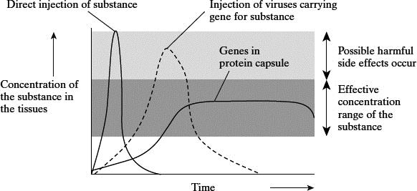
Takahiro Ochiya et al, Biomaterials for Gene Delivery: Studies on Metastasis,
(National Cancer Centre, Research Institute, Tokyo, Japan) 1999
(i) Describe the results of the three experiments.
______________________________________________________________
______________________________________________________________
______________________________________________________________
______________________________________________________________
______________________________________________________________
______________________________________________________________(3)
(ii) Using the information in the graph, suggest one advantage and one disadvantage of the capsule method compared to the others.
Advantage ____________________________________________________
______________________________________________________________
Disadvantage __________________________________________________
______________________________________________________________(2)

Q6. (a) Agrobacterium is a bacterium used in genetic engineering of plants. The diagram shows stages in the transfer of a gene into a plant.
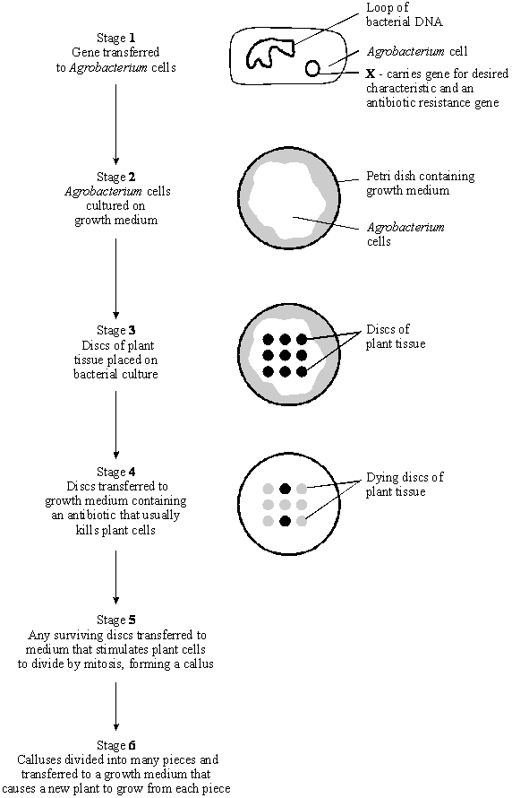
(i) Name structure X in stage 1.
______________________________________________________________(1)
(ii) In stage 2, explain why the bacteria are cultured before the plant tissue is added.
______________________________________________________________ (1)
(iii) In stage 4, explain why the growth medium contains antibiotic.
______________________________________________________________
______________________________________________________________
______________________________________________________________
______________________________________________________________(2)
(iv) Suggest why stages 5 and 6 are necessary for the commercial production of genetically engineered plants.
______________________________________________________________
______________________________________________________________
______________________________________________________________
______________________________________________________________(2)
(b) (i) A toxin that kills insects can be sprayed directly onto the leaves of crop plants. A gene has now been transferred into crop plants that makes their leaves produce this toxin.
Explain one advantage to farmers of growing the genetically engineered crop plants, rather than spraying leaves with the toxin.
______________________________________________________________
______________________________________________________________(1)
(ii) Suggest one reason why some people are concerned that the toxin gene might get transferred to wild plants that are related to the crop plants.
______________________________________________________________
______________________________________________________________(1)

