A-level Biology required practical No. 11: Production of a dilution series of a glucose solution and use of colorimetric techniques to produce a calibration curve

CPAC assessed:
2c- Identify control variables
2d- Select appropriate equipment to produce accurate results.
4b- Obtain accurate and precise data and record methodically
5a- Use appropriate software/tool to process data

A calibration curve can be used to identify the concentration of an unknown solution. The results then be used to diagnose diseases such as diabetes. Glucose concentration in the urine can be the first sign of diabetes.

Serial dilutions.
What is a dilution factor?
A way of expressing a dilution as a ratio of the parts of solute to the total number of parts in the solution.

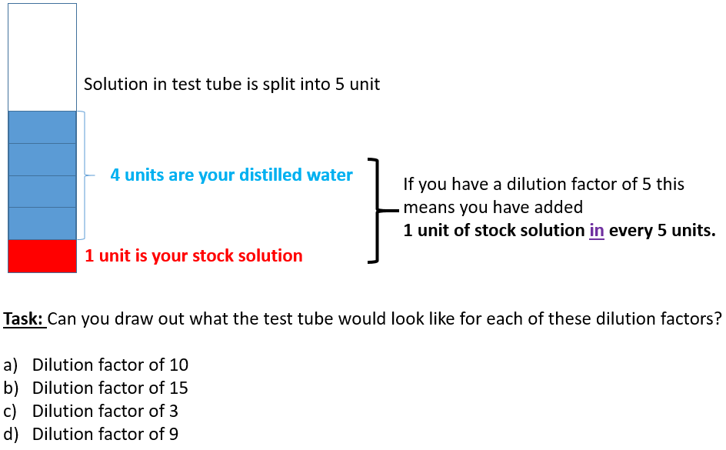

- 10 B- 15 C- 3 D- 9

How to work out volumes in a test tube.
Test tube | Dilution factor | Total volume of solution (cm³) | Volume per unit (cm³) | Volume of distilled water required (cm³) | Volume of stock solution required (cm³)
A | 10 | 20
B | 15 | 30
C | 3 | 36
D | 9 | 15

What is the equation you can use?
How to work out the concentration.

Test tube | Total volume required in test tube (cm3) | Dilution factor | Concentration of stock solution (Mol dm³) | Concentration of diluted solution (Mol dm³)
A | 20 | 1 in 10 | 12
B | 30 | 1 in 15 | 6
C | 36 | 1 in 3 | 3
D | 15 | 1 in 9 | 0.6

What is the equation you should use?

Exam question:
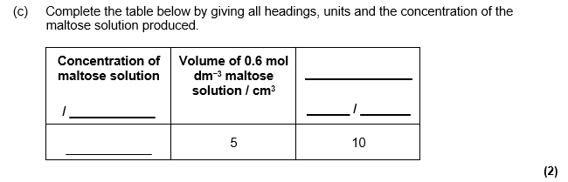

When do we use serial dilutions?
_______________________________________
_______________________________________
_______________________________________

Why do we use serial dilutions?
_____________________________________________________________________________________________________________________________________________________________________________________________________________________________________________________________________________________________

Example:
If you were asked to make 1:10 serial dilutions to a volume of 10cm³ how would you do this? Show your working on the diagram below.
Can you work out the concentration of each test tube?
What is the dilution of the final test tube 4?
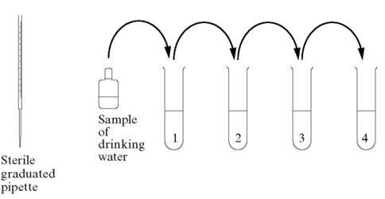
Exam question:
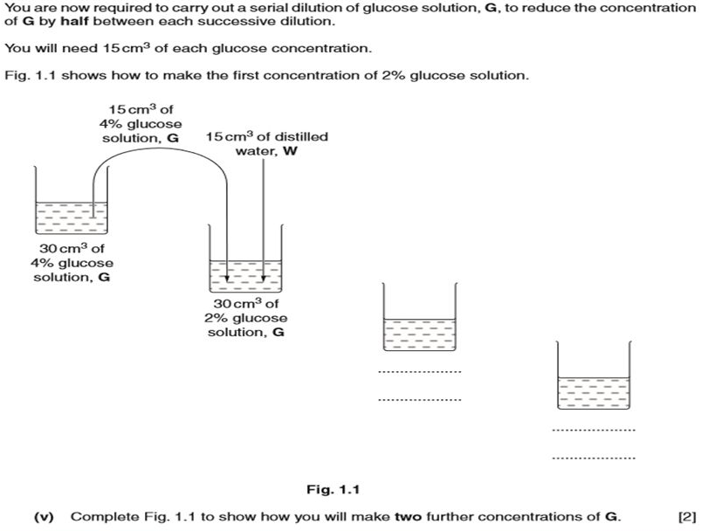

Precision and accuracy.
When taking scientific measurements, the goals are to measure accurately and with precision.
Definition:
- Accuracy indicates the closeness of the measurements to the true or mean value. This means how close your repeated results are to the true or mean value.

- Precision is the closeness of the results to others obtained in exactly the same way. This means are your repeated results similar? This does not have anything to do with the true or mean value.

In this image, the bull’s-eye represents the accepted true or mean value. Each cross represents a repeated result.
2 of the descriptions have been completed for you.
Complete the other 2 descriptions to EXPLAIN the precision and accuracy of the results.

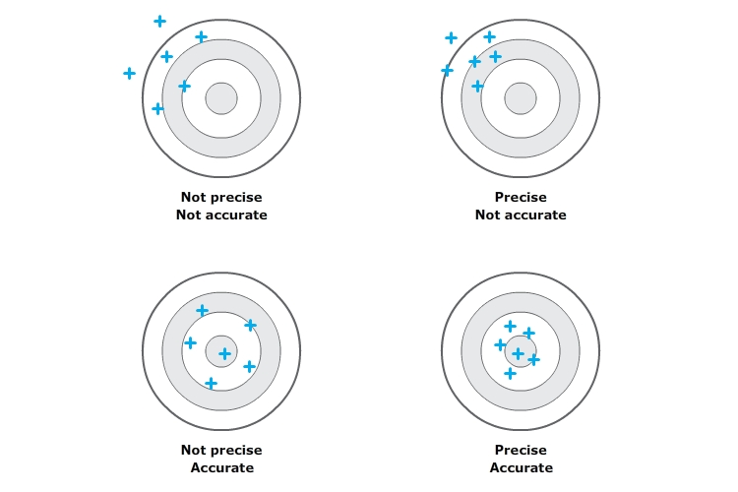
Not accurate: Your results are not close to the bulls eye (true/mean value)

Not precise: Your results are not close to each other.
Accurate: Your results are close to the bulls eye (true/mean value)

Not precise: Your results are not close to each other.
Coin diameter example
A gold coin has an ‘accepted/true’ diameter of 28.054 mm.

Two students are asked to measure the diameter of four gold coins. Student A uses a simple plastic ruler. Student B uses a precision measuring tool called a micrometer.

Student A – plastic ruler (mm) | Student B – micrometer
27.9  28.0  27.8  28.1 | 28.246  28.244  28.246  28.248

- Calculate the mean value for each set of measurements: A; ________ B:_____________

- Compare the mean value for each set with the accepted/true value:

- Which student’s data is more accurate?
________________________________________________________________________________________________________________________________________________________________________________

- Which student’s data is more precise?
________________________________________________________________________________________________________________________________________________________________________________

- Look closely at the table. Suggest why the micrometer is said to be a more “precise” measuring tool than the plastic ruler.
________________________________________________________________________________________________________________________________________________________________________________

Precision of equipment
James has been asked to heat 30cm³ of water and measure the temperature at which it boils- this should be 100°C at a pressure of 1 atmosphere. James had a choice of different equipment he could use; different sized beakers, conical flasks, measuring cylinders and thermometers.

Chose which pieces of equipment should be used. Under each piece of equipment give a reason for it NOT being used – this is how you JUSTIFY your answer. 2d- Select appropriate equipment to produce accurate results.

Beaker to measure water Beaker for heating water
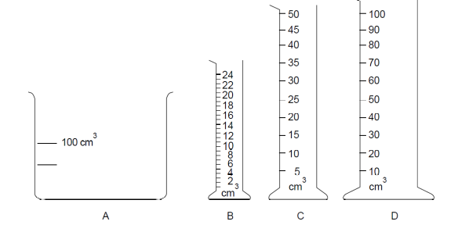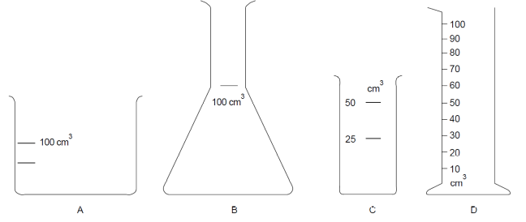

Thermometers for measuring temperature
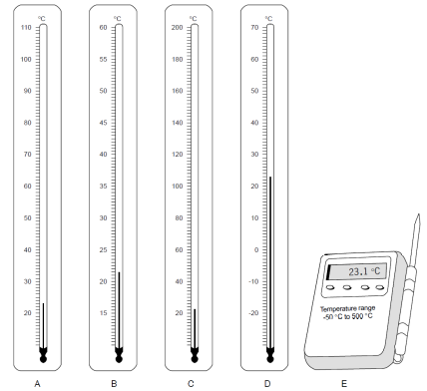

- Would choosing the right equipment make the results more accurate or more precise? Explain your answer. 2d- Select appropriate equipment to produce accurate results.
_____________________________________________________________________________________________________________________________________________________________________________________________________________________________________________________________________________________________

Method

You are provided with the following:

- 10 mmol dm⁻³ glucose standard.
- Distilled water
- Urine samples from Tom, Mo and Harry
- Benedict’s solution
- Graduated pipettes (2 cm³ and 1 cm³) and pipette filler
- Test tubes and test-tube rack
- Water bath set at 90 ºC
- Colorimeter and cuvettes.

Read through the method below and complete the table to identify variables. 2c- Identify control variables.
Variable | Control
Volume of urine sample | Use graduated pipette to ensure volume is consistent.

Prepare urine samples for testing

- Label the test tubes with the name of the patient and add 2 cm³ urine samples from each patient.
- To each test tube add 2 cm³ Benedict’s solution. Mix the contents of the tube.

Prepare the glucose calibration curve

- Label six test tubes 0 to 10 mmol dm⁻³ as shown in the table below.
- Calculate the required volumes to dilute the glucose standard (10 mmol dm⁻³) with water to achieve each concentration; complete the table to show volumes used.
- Now make the solutions by add the appropriate volumes to each labelled test tube. 5a- Use appropriate software/tool to process data. Complete the table to show the volume of water and volume of glucose required.

Concentration of final solution  / mmol dm⁻³ | 0.0 | 2.0 | 4.0 | 6.0 | 8.0 | 10.0
Volume of water/  cm³ | 2.0
Volume of glucose  standard /cm³ | 0.0

- Add 2 cm³ of Benedict's solution to each tube. Mix the contents of each tube.
- Place all the test tubes into the water bath together (including the tubes with the urine samples) and time for 6 minutes. Allow to cool before decanting liquid into cuvettes and taking readings from the colorimeter.
- Use the contents of the 0.0 mmol dm⁻³ glucose solution tube, which you have heated with Benedict's, as a blank to calibrate the colorimeter to zero absorbance. Place the remaining samples in cuvettes into the colorimeter and read the absorbance.
- A set of results has been provided for you below. Use these results to produce a graph. 4b- Obtain accurate and precise data and record methodically.
- Draw a dot-to-dot line between your results to produce your calibration curve.

Concentration of final solution / mmol dm⁻³ | Percentage absorption /%
0.0 | 0
2.0 | 9
4.0 | 16
6.0 | 24
8.0 | 42
10.0 | 61

- Tom, Mo and Harry’s results are shown below. Use your graph to work out the concentration of glucose in the urine samples.
Tom’s sample had a % absorption of 33%
Mo’s sample had a % absorption of 3%
Harry’s sample had a % absorption of 12%
- Plot these results onto your calibration curve on your graph. Record the concentration of glucose in the urine for Tom, Mo and Harry. Show your working on your graph.

A-level Biology required practical No. 11: Production of a dilution series of a glucose solution and use of colorimetric techniques to produce a calibration curve
Practice Exam Questions

Name: __________________________________
Total: ________/19 %: ______ (A01: _______, A02: __________, A03:__________)
Skills I need to develop: ___________________________________________________________________________
_______________________________________________________________________________________________
Q1.(a) Name the monomers from which a maltose molecule is made.
___________________________________________________________________(1)
(b) Name the type of chemical bond that joins the two monomers to form maltose.
___________________________________________________________________(1)
A student wanted to produce a dilution series of a maltose solution so he could plot a calibration curve. He had a stock solution of maltose of concentration 0.6 mol dm⁻³ and distilled water. He made a series of dilutions from 0.1 to 0.6 mol dm⁻³.
(c) Complete the table below by giving all headings, units and the concentration of the maltose solution produced.

Concentration of maltose solution  / ____________ | Volume of 0.6 mol dm⁻³ maltose solution / cm³ | _______________  ______ / _______
____________ | 5 | 10
(2)
The student performed the Benedict’s test on six maltose solutions ranging from 0.1 mol dm⁻³ to 0.6 mol dm⁻³. He placed a sample of each solution in a colorimeter and recorded the light absorbance.
His results are shown in the graph below.
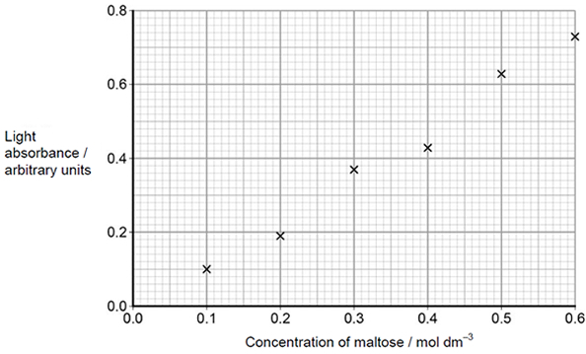
(d) Explain how you would use the graph to determine the maltose concentration with a light absorbance of 0.45 arbitrary units.
___________________________________________________________________
___________________________________________________________________
___________________________________________________________________
___________________________________________________________________
___________________________________________________________________(2)
Q2. (a) A student used a dilution series to investigate the number of cells present in a liquid culture of bacteria.
Describe how he made a 1 in 10 dilution and then used this to make a 1 in 1000 dilution of the original liquid culture of bacteria.
___________________________________________________________________
___________________________________________________________________
___________________________________________________________________
___________________________________________________________________
___________________________________________________________________
___________________________________________________________________
___________________________________________________________________
___________________________________________________________________(3)

(b) Using an optical microscope, the student determined there were 15 cells in 0.004 mm³ of the 1 in 1000 dilution of the culture. Calculate the number of cells in 1 cm³ of undiluted liquid culture.
Answer = ____________________ Number of cells (2)
(c) The student looked at cells in the 1 in 10 dilution during his preliminary work. He decided not to use this dilution to determine the number of cells in the undiluted liquid culture.
Suggest an explanation for the student’s decision.
___________________________________________________________________
___________________________________________________________________
___________________________________________________________________
___________________________________________________________________
___________________________________________________________________
___________________________________________________________________ (2)
Q2. Scientists investigated how the concentration of protein in blood plasma changes in people between the ages of 60 and 95. The graph shows the scientists’ results. The bars show ±1 standard deviation.
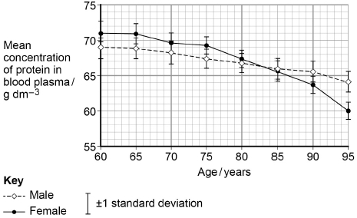
(a) What is the difference between males and females in the fall in mean concentration of protein in blood plasma between 60 and 95 years?
Answer = ___________ g dm⁻³ (1)
(b) Use the graph above to calculate the rate of change of the mean concentration of protein in the blood plasma of males between the ages of 60 and 95.
Show your working.
Answer = ___________ g dm⁻³ year⁻¹
(2)
(d) The scientists measured the absorption of each sample of blood plasma using a colorimeter. They used a calibration curve to find the concentration of protein in samples of blood plasma.
Describe how the scientists could obtain data to produce a calibration curve and how they would use the calibration curve to find the concentration of protein in a sample of blood plasma.
___________________________________________________________________
___________________________________________________________________
___________________________________________________________________
___________________________________________________________________
___________________________________________________________________
___________________________________________________________________
___________________________________________________________________
___________________________________________________________________
(3

