3.2.4 Cell recognition and the immune system

Name __________________________________

Reflection on learning outcomes | or | Target
Define an antigen and identify cells and molecules that can serve as antigens.
Explain the effect of antigen variability on disease and disease prevention.
Describe the phagocytosis of pathogens and the subsequent destruction of ingested pathogens by lysozymes.
Describe the role of T lymphocytes to a foreign antigen (the cellular response) including:
The role of antigen-presenting cells.
The role of helper T cells (T_{H} cells) in stimulating cytotoxic T cells (T_{C} cells), B cells and phagocytes.
Describe the response of B lymphocytes to a foreign antigen, clonal selection and the release of monoclonal antibodies (the humoral response).
Define an antibody and describe the structure of an antibody.
Explain how the formation of an antigen-antibody complex leads to the destruction of the antigen by agglutination and phagocytosis of bacterial cells.
Explain the roles of plasma cells and memory cells in producing primary and secondary immune responses.
Explain how the use of vaccines provide protection for individuals and populations against disease. Describing the concept of herd immunity.
Explain the differences between active and passive immunity.
Describe the structure of the human immunodeficiency virus (HIV) and its replication in T helper cells.
Explain how HIV causes the symptoms of AIDS. Why antibiotics are ineffective against viruses.
Explain the use of monoclonal antibodies in:
Targeting medication to specific cells types by attaching a therapeutic drug to an antibody.
Use in medical diagnosis.
Discuss the ethical issues associated with the use of vaccines and monoclonal antibodies.
Describe how antibodies are used in an ELISA test.

Outcome:
- Define an antigen and identify cells and molecules that can serve as antigens.
- Describe the phagocytosis of pathogens and the subsequent destruction of ingested pathogens by lysozymes.

- Introduction to Immunity and Phagocytosis
Recap questions:

- Function of lysosomes? (1 mark)

_____________________________________________________________________________________
_____________________________________________________________________________________

- Why is the cell surface membrane described as a ‘fluid mosaic?’ (2 marks)

_____________________________________________________________________________________
_____________________________________________________________________________________

- What is the definition of hydrolysis? (1 mark)

_____________________________________________________________________________________
_____________________________________________________________________________________

- Function of glycoproteins in cell membranes (1 mark)

_____________________________________________________________________________________
_____________________________________________________________________________________
Definition:
Pathogen: ___________________________________________________________________________________
___________________________________________________________________________________
Antigen:
___________________________________________________________________________________
___________________________________________________________________________________
Examples where antigens can be found:
___________________________________________________________________________________

The Immune System

_____________________________________________________________________________________
_____________________________________________________________________________________

Stages of defence

1._____________________________________________________________________________________
2._____________________________________________________________________________________
3._____________________________________________________________________________________

Phagocytosis
1. Phagocyte attracted to pathogen by chemicals/recognise antigens on pathogen as non-self.
2. Phagocyte engulfs the pathogen.
3.The pathogen in membrane bound pocket called a phagosome.
5. Lysosomes fuse with the phagosome and release digestive (hydrolytic) enzymes into phagosome.
6. The enzymes digest (hydrolyse) the pathogen destroying it.
7. Antigens from the pathogen are displayed on the surface membrane.

In the space below draw and label the mark scheme for phagocytosis.

_______________________________________________________________________________________
Exam questions:

a) What is a pathogen?

_____________________________________________________________________________________
_____________________________________________________________________________________

(1)

b) What is an antigen?

________________________________________________________________________________

________________________________________________________________________________

(2)

c) What is an antibody?

________________________________________________________________________________

________________________________________________________________________________

(2)

d) Describe how phagocytosis of a virus leads to presentation of its antigens.

________________________________________________________________________________

________________________________________________________________________________

________________________________________________________________________________

________________________________________________________________________________

________________________________________________________________________________

________________________________________________________________________________

(3)

e) Give two structures a bacterial cell may have that a white blood cell does not have.
_____________________________________________________________________________________
_____________________________________________________________________________________
_____________________________________________________________________________________

(2)

Outcome:
- Describe the role of T lymphocytes to a foreign antigen (the cellular response) including:
- The role of antigen-presenting cells.
- The role of helper T cells (T_{H} cells) in stimulating cytotoxic T cells (T_{C} cells), B cells and phagocytes.

The specific immune response and cell mediated immunity
Overview of the specific immune response

Words: specific, slower, one, B lymphocytes, T lymphocytes, humoral, cell mediated

The response is ___________ and ____________ for _____ pathogen.

Could be:

_____________ response by _______________ (immunity involving body cells).
____________ response by _______________(produce proteins called antibodies that aid in the destruction).

It is specific because:

Each pathogen has a specific shaped antigen on its surface. These are different for different types or species of pathogen.

It is slower because:

Specific lymphocytes exist in the body already, there are millions of different types which each recognise a different antigen. They have proteins (receptors) on the surface that bind to proteins (antigens) recognised as foreign on a pathogen.

It is receptor is specific to- and responds to- one antigen only because:

There are millions of different types of lymphocyte each with a different receptor.
There’s only a few of each so not enough to overcome an invasion so specific lymphocytes need to divide by mitosis to produce large numbers of clones (clonal selection). This takes time.

Where are the two types of lymphocytes made and matured?

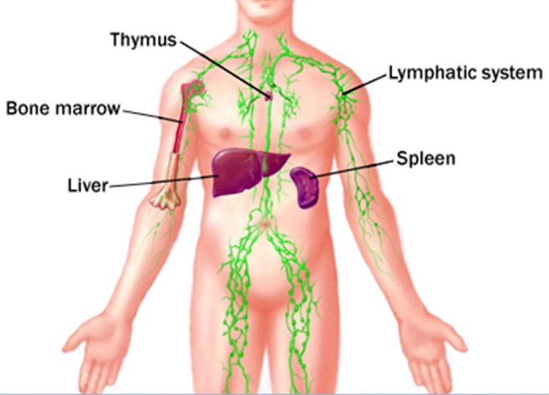
T- lymphocytes:

Made in: _______________
Matured in: _______________

B-lymphocytes:

Made in: _______________
Matured in: ________________

- Cell-mediated immunity

This type of immunity involves _______________________

T cells only respond to __________________ which are ______________________

What cells can display the antigens of non-self antigens on their surface?

1. ______________________
2. ______________________
3. ______________________
4. ______________________

What are these called? _________________________

The ‘helper’ T cell

The receptor on a T cell binds to antigens present on body cells.
It activates other cells to divide rapidly by mitosis (clonal selection).

These cloned T cells can take one of 4 roles…

1._____________________________________________________________________________________
2._____________________________________________________________________________________
3._____________________________________________________________________________________
4._____________________________________________________________________________________

Stage name | T lymphocytes
Clonal selection | - APC/ infected cell presents antigen  - Antigen binds to comp receptor on cell surface of T-helper
Clonal expansion | - T-lymph reproduces by mitosis  - Produces T-lymph clones
Differentiation | - T-lymph differentiate  - 1) T-helper cells  - Secrete cytokines which stimulate phagocytosis/B-lymph to mitosis  - 2) T-cytotoxic cells  - Secrete hydrogen peroxide to destroy body’s infected cells  - 3) T-memory cells which remain in the body for many year
Immunological memory (response to same antigen) | - Large no. of clones (memory cells) of T-lymph with specific receptor to antigen  - Quicker clonal expansion  - More clones differentiate  - More T-helper to stimulate mitosis/ More T-cytotoxic to destroy infected cells

What type of pathogens are T cells most effective against and why?

_____________________________________________________________________________________
_____________________________________________________________________________________

Exam question

Explain the role of T-lymphocytes in the defence of the body against a virus infection. (6 marks)
_____________________________________________________________________________________
_____________________________________________________________________________________
_____________________________________________________________________________________
_____________________________________________________________________________________
_____________________________________________________________________________________
_____________________________________________________________________________________

Quiz

- Which type of WBC engulf pathogens? (1)
_____________________________________________________________________________________

- What is an antigen? (1)

_____________________________________________________________________________________

- Which cells are involved in cell-mediated immunity? (1)

_____________________________________________________________________________________

- State 2 roles of a T helper cell. (2)

_____________________________________________________________________________________
_____________________________________________________________________________________

- Explain the role of a cytotoxic killer T cell (2)

_____________________________________________________________________________________
_____________________________________________________________________________________

- State 2 types of cell that might display antigens from a pathogen on their surface (2)

_____________________________________________________________________________________
_____________________________________________________________________________________

Outcome:
- Describe the response of B lymphocytes to a foreign antigen, clonal selection and the release of monoclonal antibodies (the humoral response).

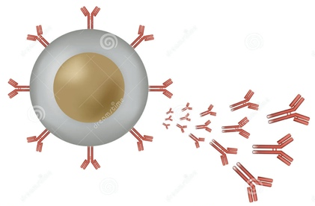
- Humoral immunity

B lymphocytes:
- Plasma B cells produce antibodies.
- Different shaped antibodies are produced by different B cells.
- B cells have surface receptors that are the same shape as the antibody that they make.
- Surface receptors are complementary to specific antigens.

B lymphocytes | Stage name | T lymphocytes
- Pathogen’s antigen presented to B-lymph  - Antigen binds to comp receptor on cell surface of B-lymph | Clonal selection | - APC/ infected cell presents antigen  - Antigen binds to comp receptor on cell surface of T-helper
- B-lymph reproduces by mitosis  - Produces B-lymph clones | Clonal expansion | - T-lymph reproduces by mitosis  - Produces T-lymph clones
- B-lymph differentiate into 1) Plasma cells  - Which secrete antibodies specific to pathogen’s antigen  - Into 2) B-Memory cells which remain in the body for many year | Differentiation | - T-lymph differentiate  - 1) T-helper cells  - Secrete cytokines which stimulate phagocytosis/B-lymph to mitosis  - 2) T-cytotoxic cells  - Secrete hydrogen peroxide to destroy body’s infected cells  - 3) T-memory cells which remain in the body for many year
- Large no. of clones (memory cells) of B-lymph with specific receptor to antigen  - Quicker clonal expansion  - More clones differentiate  - More plasma cells  - More antibodies secreted into blood | Immunological memory (response to same antigen) | - Large no. of clones (memory cells) of T-lymph with specific receptor to antigen  - Quicker clonal expansion  - More clones differentiate  - More T-helper to stimulate mitosis/ More T-cytotoxic to destroy infected cells
Response to Bacterial pathogen |  | Response to Viral pathogen

What are the similarities and differences between the different stages in the table?

_____________________________________________________________________________________
_____________________________________________________________________________________
_____________________________________________________________________________________
_____________________________________________________________________________________
_____________________________________________________________________________________
_____________________________________________________________________________________
_____________________________________________________________________________________
_____________________________________________________________________________________
_____________________________________________________________________________________
_____________________________________________________________________________________
_____________________________________________________________________________________

_______________________________________________________________________________________
Exam Questions:

(a) The drawings show the changes in a B lymphocyte after stimulation by specific antigens.

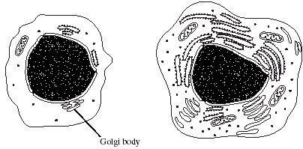

B lymphocyte before stimulation B lymphocyte after stimulation

Explain how the changes shown in the drawings are related to the function of B lymphocytes.

_____________________________________________________________________________________
_____________________________________________________________________________________
_____________________________________________________________________________________
_____________________________________________________________________________________
_____________________________________________________________________________________
_____________________________________________________________________________________

(4)

(b) Describe how B-lymphocytes respond when they are stimulated by antigens.
___________________________________________________________________
___________________________________________________________________
___________________________________________________________________
___________________________________________________________________
___________________________________________________________________
___________________________________________________________________
___________________________________________________________________
(4)

Outcome:
- Define an antibody and describe the structure of an antibody.
- Explain how the formation of an antigen-antibody complex leads to the destruction of the antigen by agglutination and phagocytosis of bacterial cells.

- Antibodies

Definition:

Antibody - A protein that is specific to an antigen that is produced by B cells.
Monoclonal antibodies- Antibodies made from a hybridoma which all the antibodies are the same.
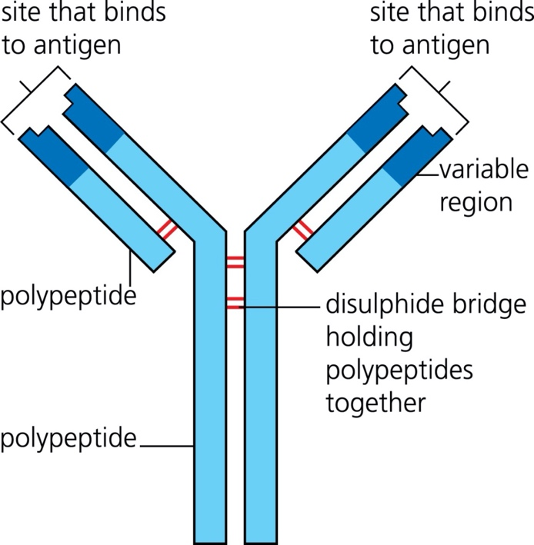
Structure of an antibody

Antibodies are proteins

They are made up of 4 polypeptide chains.
2 long, heavy chains

2 short, light chains

The variable region is specific to an antigen.

- Draw a picture of an antibody-antigen complex

- What is agglutination?
_____________________________________________________________________________________
_____________________________________________________________________________________

- Suggest why antibodies are made from protein.

_____________________________________________________________________________________
_____________________________________________________________________________________
_____________________________________________________________________________________
_____________________________________________________________________________________

- Why could a single type of bacterium stimulate many different B cells to divide and produce many different clones of antibody producing plasma cells?

_____________________________________________________________________________________
_____________________________________________________________________________________

Monoclonal antibodies

When a pathogen enters the body it is likely to have many hundreds of different antigens which will all stimulate different B cells to multiple and form a clone of itself. Each clone will produce a different antibody. It is of large medical value to be able to produce antibodies outside of the body and if one type of antibody can be isolated and cloned. A single type of antibody produced from one type of plasma cell is called a monoclonal antibody.

Toole and toole textbook pages 112-113
Explain how monoclonal antibodies are used to:

1.Treat cancer
_____________________________________________________________________________________
_____________________________________________________________________________________
_____________________________________________________________________________________
_____________________________________________________________________________________
_____________________________________________________________________________________
_____________________________________________________________________________________

2. In medical diagnosis
_____________________________________________________________________________________
_____________________________________________________________________________________
_____________________________________________________________________________________
_____________________________________________________________________________________

3.In pregnancy testing

_____________________________________________________________________________________
_____________________________________________________________________________________
_____________________________________________________________________________________
_____________________________________________________________________________________
_____________________________________________________________________________________
_____________________________________________________________________________________
_____________________________________________________________________________________
_____________________________________________________________________________________
Ext: Application questions for antibodies (page 114).

Exam questions:

- The diagram shows an antibody molecule.

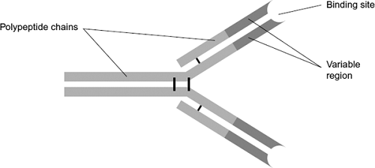
- What is the evidence from the diagram that this antibody has a quaternary structure?

_____________________________________________________________________________________
_____________________________________________________________________________________

(1)

(b) Scientists use this antibody to detect an antigen on the bacterium that causes stomach ulcers. Explain why the antibody will only detect this antigen.
_____________________________________________________________________________________
_____________________________________________________________________________________
_____________________________________________________________________________________
_____________________________________________________________________________________

(3)

2. (a) NMO is a disease that leads to damage to nerve cells in the spinal cord.

A person with NMO produces anti-AQP4 antibody that attacks only these nerve cells. Explain why the anti-AQP4 antibody only damages these cells.
_____________________________________________________________________________________
_____________________________________________________________________________________
_____________________________________________________________________________________
_____________________________________________________________________________________
_____________________________________________________________________________________

(4)

(b) Scientists measured the concentration of anti-AQP4 antibody in the blood of people with NMO.The spinal cord is surrounded by small bones called vertebrae. For each person, the scientists also determined the number of vertebrae surrounding damaged nerve cells.Their results are shown in the graph.

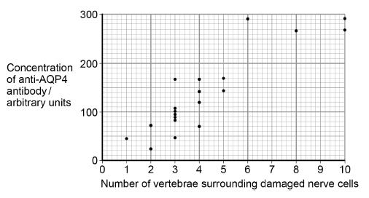

A scientist suggested that the concentration of anti-AQP4 antibody in a person’s blood could be used to predict the number of vertebrae surrounding damaged nerve cells they are likely to have. Use the graph above to suggest reasons why this suggestion might not be valid.
_____________________________________________________________________________________
_____________________________________________________________________________________
_____________________________________________________________________________________
_____________________________________________________________________________________

(3)

(c) A new treatment for NMO involves using a monoclonal antibody. The structure of the variable region of this monoclonal antibody is identical to the variable region of an anti-AQP4 antibody, but the rest of its structure is different. Use this information and your knowledge of antigen-antibody complexes to suggest how this monoclonal antibody prevents anti-AQP4 damaging nerve cells.

_____________________________________________________________________________________
_____________________________________________________________________________________
_____________________________________________________________________________________

(2)

3. Malaria is a disease caused by parasites belonging to the genus Plasmodium. Two species that cause malaria are Plasmodium falciparum and Plasmodium vivax.

A test strip that uses monoclonal antibodies can be used to determine whether a person is infected by Plasmodium. It can also be used to find which species of Plasmodium they are infected by.

• A sample of a person’s blood is mixed with a solution containing an antibody, A, that binds to a protein found in both species of Plasmodium. This antibody has a coloured dye attached.

• A test strip is then put into the mixture. The mixture moves up the test strip by capillary action to an absorbent pad.

• Three other antibodies, B, C and D are attached to the test strip. The position of these antibodies and what they bind to is shown in Figure 1.

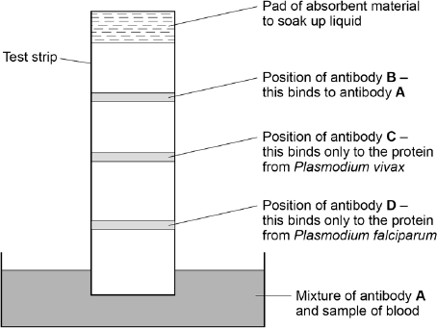
- Explain why antibody A attaches only to the protein found in species of Plasmodium.

_____________________________________________________________________________________
_____________________________________________________________________________________

(2)

(b) Antibody B is important if this test shows a person is not infected with Plasmodium. Explain why antibody B is important.
_____________________________________________________________________________________
_____________________________________________________________________________________

(2)

(c) One of these test strips was used to test a sample from a person thought to be infected with Plasmodium. Figure 2 shows the result.

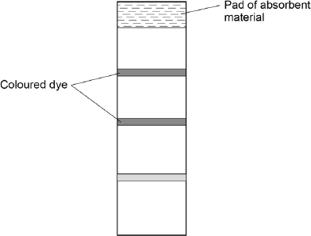

What can you conclude from this result? Explain how you reached your conclusion.
_____________________________________________________________________________________
_____________________________________________________________________________________
_____________________________________________________________________________________ (4)
Outcome:
- Explain how the use of vaccines provide protection for individuals and populations against disease. Describing the concept of herd immunity.
- Explain the differences between active and passive immunity.
- Discuss the ethical issues associated with the use of vaccines and monoclonal antibodies.

- Vaccinations

What is a vaccine?
_____________________________________________________________________________________
What is an attenuated microorganism?
_____________________________________________________________________________________
What is herd immunity?
_____________________________________________________________________________________
Describe how a vaccination can lead to the production of antibodies against a specific pathogen

- Vaccine contains antigen (from specific pathogen)
- Displayed on antigen-presenting cells (phagocytes, B cells)
- Specific helper T cell detects antigen and stimulates specific B cell.
- B cell divides and forms clones to give plasma cells.
- Plasma cells produce antibodies.

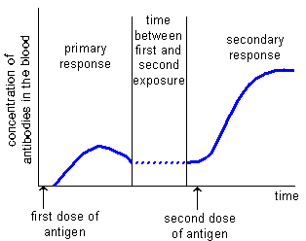

Describe the differences between the primary and secondary response.
_____________________________________________________________________________________
_____________________________________________________________________________________

Explain the differences.
_____________________________________________________________________________________
_____________________________________________________________________________________
_____________________________________________________________________________________
_____________________________________________________________________________________
What is antigenic variation?
_____________________________________________________________________________________
_____________________________________________________________________________________
Each year, the population is offered a flu vaccination. Why does this need to be given each year?
_____________________________________________________________________________________
_____________________________________________________________________________________
_____________________________________________________________________________________
_____________________________________________________________________________________

Types of immunity
What is active immunity?
_____________________________________________________________________________________
_____________________________________________________________________________________
Natural: Artificial:

What is Passive immunity?
_____________________________________________________________________________________
_____________________________________________________________________________________
Natural: Artificial:

Differences between active and passive immunity
Active Immunity | Passive Immunity

Research the ethical uses of vaccines and antibodies and list them in the table below.
Ethical Issues Of Vaccines | Ethical Issues Of monoclonal Antibody Therapy

Exam questions:

- (a) When a vaccine is given to a person, it leads to the production of antibodies against a disease-causing organism. Describe how.
_____________________________________________________________________________________
_____________________________________________________________________________________
_____________________________________________________________________________________
_____________________________________________________________________________________
_____________________________________________________________________________________
_____________________________________________________________________________________

(5)

(b) Describe the difference between active and passive immunity.
_____________________________________________________________________________________
_____________________________________________________________________________________
_____________________________________________________________________________________
_____________________________________________________________________________________
_____________________________________________________________________________________
_____________________________________________________________________________________

(5)

2. Whooping cough is a disease that affects some infants. Doctors collected data relating to whooping cough between 1965 and 1996.

They collected data for:

• the number of cases of whooping cough reported

• the percentage of infants vaccinated against whooping cough.

The graph shows the data collected by the doctors.

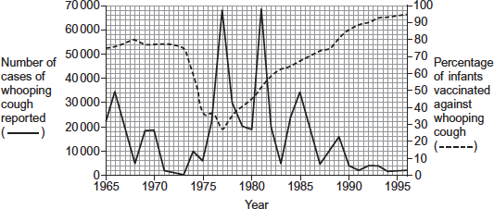

(a) Suggest two reasons why the percentage of infants vaccinated decreased between 1973 and 1975.
_____________________________________________________________________________________
_____________________________________________________________________________________
_____________________________________________________________________________________
_____________________________________________________________________________________

(2)

(b) Between 1980 and 1990, there were three peaks in the number of reported cases of whooping cough. After 1981, the number of cases of whooping cough in each peak decreased. Use the information from the graph to suggest why.
_____________________________________________________________________________________
_____________________________________________________________________________________
_____________________________________________________________________________________
_____________________________________________________________________________________

(2)

(c) The percentage of the population vaccinated does not need to be 100% to be effective in preventing the spread of whooping cough. Suggest why.
_____________________________________________________________________________________
_____________________________________________________________________________________
_____________________________________________________________________________________
_____________________________________________________________________________________

(2)

Outcomes:
- Describe the structure of the human immunodeficiency virus (HIV) and its replication in T helper cells.
- Explain how HIV causes the symptoms of AIDS. Why antibiotics are ineffective against viruses.
- Describe how antibodies are used in an ELISA test.

- HIV

You could be asked to identify components of a HIV virus in your exam. Add the functions around the diagram

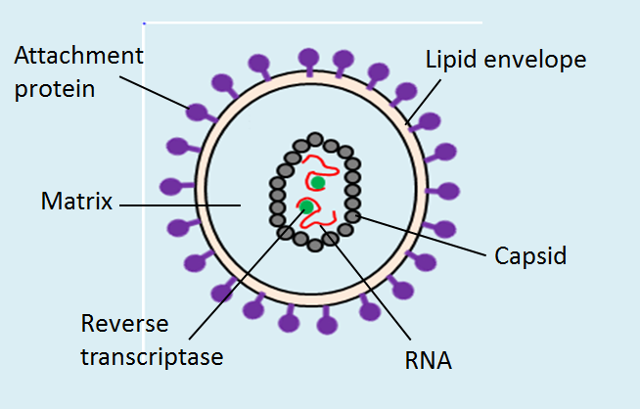

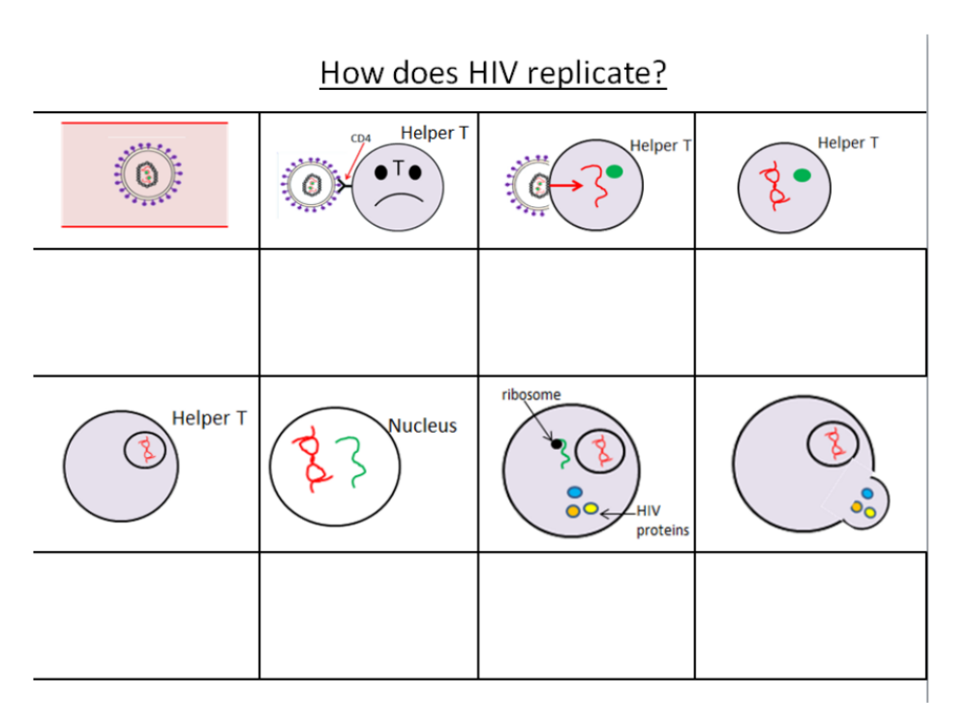

HIV kills or interferes with the normal functioning of T helper cells. What do you think is the consequence of this?
_____________________________________________________________________________________
_____________________________________________________________________________________
_____________________________________________________________________________________
_____________________________________________________________________________________
_____________________________________________________________________________________
_____________________________________________________________________________________
When the T cell count is very low, and the body cannot fight infections – the person is said to have AIDS. Why are antibiotics ineffective against viruses?
_____________________________________________________________________________________
_____________________________________________________________________________________
_____________________________________________________________________________________
_____________________________________________________________________________________

ELISA (enzyme-linked immunosorbent assay)
In the space below draw out the process of an Elisa test and write stages.

Exam Questions:
- Read the following passage.

Azidothymidine (AZT) is a drug used to treat people infected with human

immunodeficiency virus (HIV). It inhibits the enzyme that synthesises

DNA from HIV RNA. This does not destroy HIV in the body but stops or

slows the development of AIDS.

5 In the past, some people who took AZT on its own eventually developed

AIDS. Some of the HIV in their bodies had become resistant to AZT.

To prevent this from happening, people infected with HIV are now treated

with highly active antiretroviral therapy (HAART). This involves taking AZT

with other anti-HIV drugs at the same time.

10 AZT is taken in low doses. This is because people who took high doses

over long periods of time suffered muscle wastage. It was found that high

doses of AZT inhibit replication of mitochondria.

Use information from the passage and your own knowledge to answer the questions.
- Suggest and explain why AZT does not destroy HIV in the body but stops or slows the development of AIDS (lines 3–4).

_____________________________________________________________________________________
_____________________________________________________________________________________
_____________________________________________________________________________________
_____________________________________________________________________________________

(4)

(b) Suggest and explain two advantages of using HAART (lines 7–9).
_____________________________________________________________________________________
_____________________________________________________________________________________
_____________________________________________________________________________________

(4)

(c) Suggest why high doses of AZT lead to muscle wastage (lines 10–11).
_____________________________________________________________________________________
_____________________________________________________________________________________

(2)

2. The figure below shows a test that has been developed to find out if a person has antibodies to the human immunodeficiency virus (HIV) antigen.

Step 1 | HIV antigens are attached to a test well in a dish.
Step 2 | A sample of blood plasma is added to the well.  If HIV antibodies are present, they bind to the HIV antigen.
Step 3 | The well is washed.  A second antibody with an enzyme attached is then added.  This binds specifically to the HIV antibody.
Step 4 | The well is washed again.  A yellow solution is added, which changes to blue if the enzyme is present. A blue colour shows that the person has HIV antibodies.
- This test only detects the presence of HIV antibodies. Give two reasons why it cannot be used to find out if a person has AIDS.

_____________________________________________________________________________________
_____________________________________________________________________________________

(2)

(b) The solution will remain yellow if a person is not infected with HIV. Explain why.
_____________________________________________________________________________________
_____________________________________________________________________________________

(2)

(c) A mother who was infected with HIV gave birth to a baby. The baby tested positive using this test. This does not prove the baby is infected with HIV.
Explain why.
_____________________________________________________________________________________
_____________________________________________________________________________________

(2)

(d) A control well is set up every time this test is used. This is treated in exactly the same way as the test wells, except that blood plasma is replaced by a salt solution.

Use information from the figure above to suggest two purposes of the control well.

_____________________________________________________________________________________
_____________________________________________________________________________________

(2)
- (a) The table below shows features of a bacterium and the human immunodeficiency virus (HIV) particle.

Complete the table by putting a tick (✔) where a feature is present.

Feature | Bacterium | Human immunodeficiency virus (HIV) particle
RNA
Cell wall
Enzyme molecules
Capsid

(2)

(b) When HIV infects a human cell, the following events occur.

• A single-stranded length of HIV DNA is made.

• The human cell then makes a complementary strand to the HIV DNA.

The complementary strand is made in the same way as a new complementary strand is made during semi-conservative replication of human DNA. Describe how the complementary strand of HIV DNA is made.
_____________________________________________________________________________________
_____________________________________________________________________________________
_____________________________________________________________________________________
_____________________________________________________________________________________

(3)

(c) Contrast the structures of DNA and mRNA molecules to give three differences.

_____________________________________________________________________________________
_____________________________________________________________________________________
_____________________________________________________________________________________

(3)

