3.2.4 Cell recognition and the immune system

Name __________________________________

Reflection on learning outcomes | or | Target
Define an antigen and identify cells and molecules that can serve as antigens.
Explain the effect of antigen variability on disease and disease prevention.
Describe the phagocytosis of pathogens and the subsequent destruction of ingested pathogens by lysozymes.
Describe the role of T lymphocytes to a foreign antigen (the cellular response) including:
The role of antigen-presenting cells.
The role of helper T cells (T_{H} cells) in stimulating cytotoxic T cells (T_{C} cells), B cells and phagocytes.
Describe the response of B lymphocytes to a foreign antigen, clonal selection and the release of monoclonal antibodies (the humoral response).
Define an antibody and describe the structure of an antibody.
Explain how the formation of an antigen-antibody complex leads to the destruction of the antigen by agglutination and phagocytosis of bacterial cells.
Explain the roles of plasma cells and memory cells in producing primary and secondary immune responses.
Explain how the use of vaccines provide protection for individuals and populations against disease. Describing the concept of herd immunity.
Explain the differences between active and passive immunity.
Describe the structure of the human immunodeficiency virus (HIV) and its replication in T helper cells.
Explain how HIV causes the symptoms of AIDS. Why antibiotics are ineffective against viruses.
Explain the use of monoclonal antibodies in:
Targeting medication to specific cells types by attaching a therapeutic drug to an antibody.
Use in medical diagnosis.
Discuss the ethical issues associated with the use of vaccines and monoclonal antibodies.
Describe how antibodies are used in an ELISA test.

Outcome:
- Define an antigen and identify cells and molecules that can serve as antigens.
- Describe the phagocytosis of pathogens and the subsequent destruction of ingested pathogens by lysozymes.

- Introduction to Immunity and Phagocytosis
Recap questions:

- Function of lysosomes? (1 mark)

Contain hydrolytic enzymes to digest waste material

- Why is the cell surface membrane described as a ‘fluid mosaic?’ (2 marks)

Fluid as the phospholipids are able to move
Mosaic because of the different arrangement of phospholipids and proteins

- What is the definition of hydrolysis? (1 mark)

Reaction to break a larger molecule into smaller molecules using water

- Function of glycoproteins in cell membranes (1 mark)

Cell recognition

Keywords
Pathogen:
A micro-organism that causes disease

Antigen:

A foreign protein that stimulates an immune response

Examples where antigens can be found: pathogens, cells from other organisms of the same species, abnormal body cells, toxins

.

The Immune System

A system of biological structures and processes that identifies and kills pathogens (and tumour cells).

Stages of defence

- Prevent invasion

- Non-specific phagocytes. Response is immediate and the same for all pathogens.

- Specific lymphocytes. Response is slower and specific for each pathogen.

Phagocytosis
1. Phagocyte attracted to pathogen by chemicals/recognise antigens on pathogen as non-self.
2. Phagocyte engulfs the pathogen.
3.The pathogen in membrane bound pocket called a phagosome.
5. Lysosomes fuse with the phagosome and release digestive (hydrolytic) enzymes into phagosome.
6. The enzymes digest (hydrolyse) the pathogen destroying it.
7. Antigens from the pathogen are displayed on the surface membrane.

In the space below draw and label the mark scheme for phagocytosis.

_______________________________________________________________________________________
Exam questions:

a) What is a pathogen?

(Micro)organism that causes disease / harm to body / an immune response
(1)

b) What is an antigen?
A molecule; that stimulates an immune response; that causes the production of antibodies.

(2)

c) What is an antibody?
A protein; produced by the lymphocytes; in response to the presence of the appropriate antigen.

(2)

d) Describe how phagocytosis of a virus leads to presentation of its antigens.

1. Phagosome / vesicle fuses with lysosome;
2. (Virus) destroyed by lysozymes / hydrolytic enzymes;
3. Peptides / antigen (from virus) are displayed on the cell membrane;
1. Accept vacuole fuses with lysosome
1. Reject virus fuses with lysosome

(3)

e) Give two structures a bacterial cell may have that a white blood cell does not have.
e) Two suitable structures;
Examples,
1. Cell wall;
2. Capsule / slime layer;
3. Circular DNA;
Reject “circular chromosome”
4. Naked DNA / DNA without histones;
5. Flagellum;
6. Plasmid;
7. Pilus;
8. 70s / smaller ribosomes;
9. Mesosome; (2)

Outcome:
Describe the role of T lymphocytes to a foreign antigen (the cellular response) including:
- The role of antigen-presenting cells.
- The role of helper T cells (T_{H} cells) in stimulating cytotoxic T cells (T_{C} cells), B cells and phagocytes.

- The specific immune response and cell mediated immunity

Overview of the specific immune response

The response is slower and specific for one pathogen.

Could be:

Cell mediated response by T-lymphocytes (immunity involving body cells).
Humoral response by B-lymphocytes (produce proteins called antibodies that aid in the destruction).

It is specific because:

Each pathogen has a specific shaped antigen on its surface. These are different for different types or species of pathogen.

It is slower because:

Specific lymphocytes exist in the body already, there are millions of different types which each recognise a different antigen. They have proteins (receptors) on the surface that bind to proteins (antigens) recognised as foreign on a pathogen.

It is receptor is specific to- and responds to- one antigen only because:

There are millions of different types of lymphocyte each with a different receptor.
There’s only a few of each so not enough to overcome an invasion so specific lymphocytes need to divide by mitosis to produce large numbers of clones (clonal selection). This takes time.

Where are the two types of lymphocytes made and matured?

T- lymphocytes:

Made in: Bone marrow
Matured in: Thymus gland

B-lymphocytes:

Made in: Bone marrow
Matured in: Bone marrow

Cell-mediated immunity

This type of immunity involves T-lymphocytes (T-cells).

T cells only respond to non-self antigens which are attached to a body cell.

What cells can display the antigens of non-self cells on their surface?

1. Phagocytes
2. Body cells invaded by viruses
3. Cancer cells
4. Transplanted cells

What are these called? Antigen-presenting cells

The ‘helper’ T cell

The receptor on a T cell binds to antigens present on body cells.
It activates other cells to divide rapidly by mitosis (clonal selection).

These cloned T cells can take one of 4 roles…

- Develop into memory cells.
- Stimulate phagocytes to engulf pathogens.
- Stimulate B cells to divide.
- Stimulate cytotoxic T cells - Kill infected cells.

Stage name | T lymphocytes
Clonal selection | - APC/ infected cell presents antigen  - Antigen binds to comp receptor on cell surface of T-helper
Clonal expansion | - T-lymph reproduces by mitosis  - Produces T-lymph clones
Differentiation | - T-lymph differentiate  - 1) T-helper cells  - Secrete cytokines which stimulate phagocytosis/B-lymph to mitosis  - 2) T-cytotoxic cells  - Secrete hydrogen peroxide to destroy body’s infected cells  - 3) T-memory cells which remain in the body for many year
Immunological memory (response to same antigen) | - Large no. of clones (memory cells) of T-lymph with specific receptor to antigen  - Quicker clonal expansion  - More clones differentiate  - More T-helper to stimulate mitosis/ More T-cytotoxic to destroy infected cells

What type of pathogens are T cells most effective against and why?

Viruses because they hide in cells.

Explain the role of T-lymphocytes in the defence of the body against a virus infection. (6 marks)
- T lymphocytes involved in cell mediated immunity
- Phagocytes present antigens of engulfed cells to T helper lymphocytes
- T cells divide by mitosis forming clones
- Killer/cytotoxic T cells kill virus infected cells with perforin
- Other T cells stimulate phagocytes to engulf virus
- Other T cells stimulate B cells to divide

Quiz

- Which type of WBC engulf pathogens? (1)
Phagocyte

- What is an antigen? (1)
Non-self protein that stimulates an immune response

- Which cells are involved in cell-mediated immunity? (1)
T lymphocytes

- State 2 roles of a T helper cell. (2)
Stimulate B lymphocytes to divide
Become memory T cells
Become cytotoxic T cells (kill infected cells)
Stimulate phagocytes to engulf pathogens

- Explain the role of a cytotoxic killer T cell (2)
Produce perforin
Perforate membrane of infected cells

- State 2 types of cell that might display antigens from a pathogen on their surface (2)
Cell infected by a virus, B lymphocyte, phagocyte, cancer cell, transplanted cells

Outcome:
- Describe the response of B lymphocytes to a foreign antigen, clonal selection and the release of monoclonal antibodies (the humoral response).

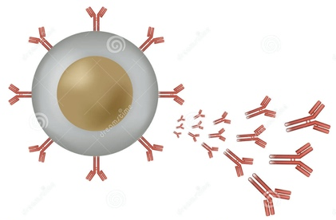
- Humoral immunity

B lymphocytes:
- Plasma B cells produce antibodies.
- Different shaped antibodies are produced by different B cells.
- B cells have surface receptors that are the same shape as the antibody that they make.
- Surface receptors are complementary to specific antigens.

B lymphocytes | Stage name | T lymphocytes
- Pathogen’s antigen presented to B-lymph  - Antigen binds to comp receptor on cell surface of B-lymph | Clonal selection | - APC/ infected cell presents antigen  - Antigen binds to comp receptor on cell surface of T-helper
- B-lymph reproduces by mitosis  - Produces B-lymph clones | Clonal expansion | - T-lymph reproduces by mitosis  - Produces T-lymph clones
- B-lymph differentiate into 1) Plasma cells  - Which secrete antibodies specific to pathogen’s antigen  - Into 2) B-Memory cells which remain in the body for many year | Differentiation | - T-lymph differentiate  - 1) T-helper cells  - Secrete cytokines which stimulate phagocytosis/B-lymph to mitosis  - 2) T-cytotoxic cells  - Secrete hydrogen peroxide to destroy body’s infected cells  - 3) T-memory cells which remain in the body for many year
- Large no. of clones (memory cells) of B-lymph with specific receptor to antigen  - Quicker clonal expansion  - More clones differentiate  - More plasma cells  - More antibodies secreted into blood | Immunological memory (response to same antigen) | - Large no. of clones (memory cells) of T-lymph with specific receptor to antigen  - Quicker clonal expansion  - More clones differentiate  - More T-helper to stimulate mitosis/ More T-cytotoxic to destroy infected cells
Response to Bacterial pathogen |  | Response to Viral pathogen

What are the similarities and differences between the different stages in the table?

Similarities | Differences
Antigen binds to complementary receptor on surface of T/B cell | Plasma cell only produced by B cells which lead to antibody production.
Reproduce by mitosis to form clones. | T lymphocytes response to viruses but B lymphocytes response to bacterial.
Memory cells produced which remain in the body for many a year. | T-lymphocytes can differentiate into cytotoxic T cells and T helper cells.
Large number of clones produced with specific antigen receptor.

_______________________________________________________________________________________
Exam Questions:

(a) The drawings show the changes in a B lymphocyte after stimulation by specific antigens.

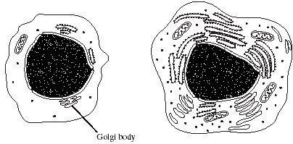

B lymphocyte before stimulation B lymphocyte after stimulation

Explain how the changes shown in the drawings are related to the function of B lymphocytes.

1. mitochondria provide (more) ATP / energy;
2. (more) RER / ribosomes synthesise proteins;
3. (more) Golgi body secretes / modifies or packages proteins / produces glycoproteins;
4. (B lymphocytes) produces antibodies;

(4)

(Total 7 marks)

Outcome:
- Define an antibody and describe the structure of an antibody.
- Explain how the formation of an antigen-antibody complex leads to the destruction of the antigen by agglutination and phagocytosis of bacterial cells.

- Antibodies

Definition:
A protein that is specific to an antigen that is produced by B cells.

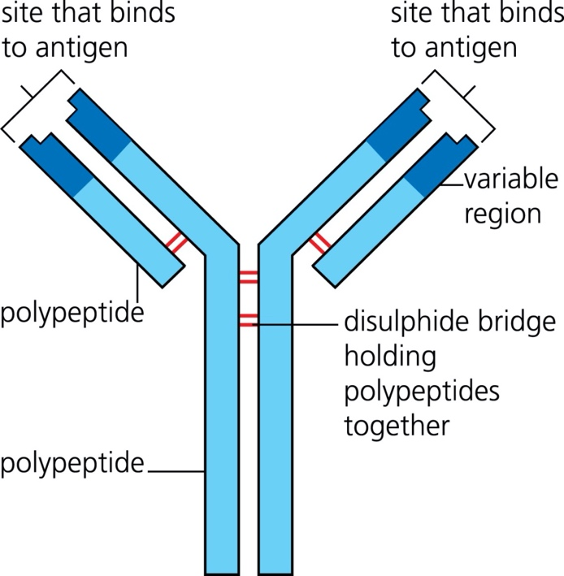

Structure of an antibody

Antibodies are proteins

They are made up of 4 polypeptide chains.
2 long, heavy chains

2 short, light chains

The variable region is specific to an antigen.

- Draw a picture of an antibody-antigen complex
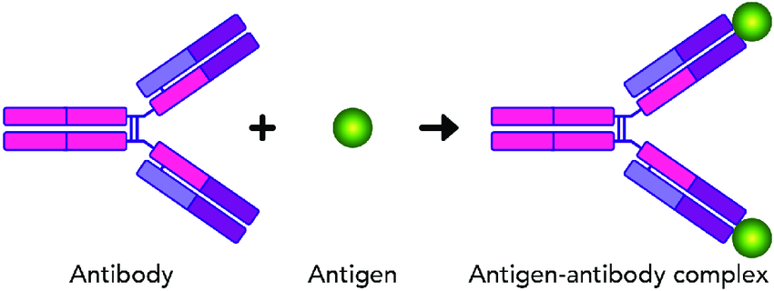

- What is agglutination?
Antibodies cause microbes to stick together, this makes it easier for phagocytes to engulf them.
Having antibodies attached also stimulates phagocytes to engulf the pathogen.

3. Suggest why antibodies are made from protein.
structure allows infinite number of forms
4. Why could a single type of bacterium stimulate many different B cells to divide and produce many different clones of antibody producing plasma cells?
bacterium has many different antigens on its surface, many different B cells activated to produce clone. Each clone produces a different antibody.

Monoclonal antibodies

When a pathogen enters the body it is likely to have many hundreds of different antigens which will all stimulate different B cells to multiple and form a clone of itself. Each clone will produce a different antibody. It is of large medical value to be able to produce antibodies outside of the body and if one type of antibody can be isolated and cloned. A single type of antibody produced from one type of plasma cell is called a monoclonal antibody.

Pages 112-113
Explain how monoclonal antibodies are used to:

1.Treat cancer
Direct Cancer treatment
- Monoclonal antibodies specific to antigens on a cancer cell are produced
- Antibody binds to cancer cell and block that chemical signal that stimulates growth
Indirect Cancer treatment
- A radioactive or cytotoxic drug is attached to the antibody
- When the antibody binds to the receptor on the cancer cell, the cell is killed.

2. In medical diagnosis
Using antibodies that are complimentary to specific pathogens or toxins in the blood, to detect their presence.
E.g. Influenza, hepititas, chlamidya, prostate cancer.

3.In pregnancy testing

1.Potential mother urinates on chromatography paper;
2.Chromatography paper contains free hCG antibodies with attached coloured particles;
3.If hCG is present, it will bind to the complementary antibodies and move up the chromatography paper;
4.hCG-antibody complexes with the dye bind to a fixed hCG antibodies;
5.build up in the test area causing a coloured band to appear (positive result);
6.no hCG present then the free hCG antibodies flow past the fixed hCG antibodies;
7.there is no build-up of dye, so no colour appears (negative result);

Ext: Application questions for antibodies (page 114).

_____________________________________________________________________________
Exam questions:

- The diagram shows an antibody molecule.

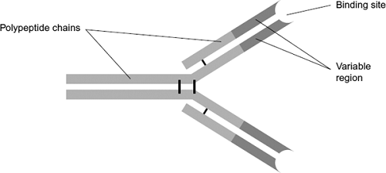

(a) What is the evidence from the diagram that this antibody has a quaternary structure?
Has more than one / four polypeptide chains / made up of polypeptide chains;

(1)

(b) Scientists use this antibody to detect an antigen on the bacterium that causes stomach ulcers. Explain why the antibody will only detect this antigen.

1. Antibody / variable region has specific amino acid sequence / primary structure;

2. The shape / tertiary structure of the binding site is complementary to / fits / binds with these antigens;

2. Do not accept active site for this point.

(3)

(Total 4 marks)

2. (a) NMO is a disease that leads to damage to nerve cells in the spinal cord.

A person with NMO produces anti-AQP4 antibody that attacks only these nerve cells.

Explain why the anti-AQP4 antibody only damages these cells.

1. (Anti-AQP4) antibody has a (specific) tertiary structure;

2. Has binding site / variable region that only binds to / complementary to one antigen;

3. Antigen to this antibody (only) found on these nerve cells;

4. So, antibody (only) binds to / forms antigen-antibody complex with these nerve cells (causing damage);

Reject “active site” (only penalise once if it occurs throughout)

3. / 4. Accept ‘receptor’ for antigen

(4)

(b) Scientists measured the concentration of anti-AQP4 antibody in the blood of people with NMO.

The spinal cord is surrounded by small bones called vertebrae. For each person, the scientists also determined the number of vertebrae surrounding damaged nerve cells.

Their results are shown in the graph.

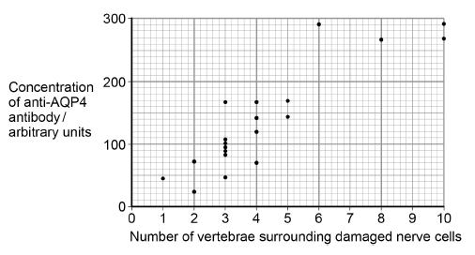

A scientist suggested that the concentration of anti-AQP4 antibody in a person’s blood could be used to predict the number of vertebrae surrounding damaged nerve cells they are likely to have.

Use the graph above to suggest reasons why this suggestion might not be valid.

1. Only 20 in the study;

OR

Only one study;

2. For some concentrations of antibody there is a range in the number of vertebrae surrounding damaged nerve cells;

3. No statistical test used;

4. Correlation is weak;

1. Accept small sample

2. Accept suitable use of data

2. Accept converse

(3)

(c) A new treatment for NMO involves using a monoclonal antibody. The structure of the variable region of this monoclonal antibody is identical to the variable region of an anti-AQP4 antibody, but the rest of its structure is different.

Use this information and your knowledge of antigen-antibody complexes to suggest how this monoclonal antibody prevents anti-AQP4 damaging nerve cells.

1. The monoclonal antibody binds to nerve cell antigen so less / no anti-AQP4 can bind;

OR

The monoclonal antibody forms antigen-antibody complex with nerve cell antigen so less / no anti-AQP4 can bind;

2. When monoclonal antibody binds it doesn’t cause damage to nerve cell;

It = monoclonal antibody

1. Reject “active site”

Ignore “competitive inhibitor”

Accept receptor for antigen

Do not credit responses in the context of enzymes

(2)

(Total 9 marks)

3. Malaria is a disease caused by parasites belonging to the genus Plasmodium. Two species that cause malaria are Plasmodium falciparum and Plasmodium vivax.

A test strip that uses monoclonal antibodies can be used to determine whether a person is infected by Plasmodium. It can also be used to find which species of Plasmodium they are infected by.

• A sample of a person’s blood is mixed with a solution containing an antibody, A, that binds to a protein found in both species of Plasmodium. This antibody has a coloured dye attached.

• A test strip is then put into the mixture. The mixture moves up the test strip by capillary action to an absorbent pad.

• Three other antibodies, B, C and D are attached to the test strip. The position of these antibodies and what they bind to is shown in Figure 1.

Figure 1

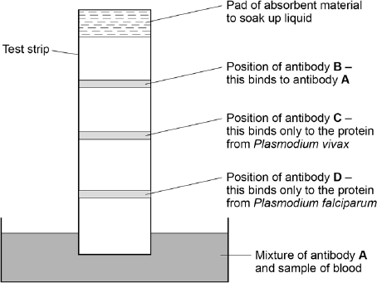

(a) Explain why antibody A attaches only to the protein found in species of Plasmodium.

1. Antibody has tertiary structure;

2. Complementary to binding site on protein.

(2)

(b) Antibody B is important if this test shows a person is not infected with Plasmodium.

Explain why antibody B is important.

1. Prevents false negative results;

2. (Since) shows antibody A has moved up strip / has not bound to any Plasmodium protein.

(2)

(c) One of these test strips was used to test a sample from a person thought to be infected with Plasmodium. Figure 2 shows the result.

Figure 2

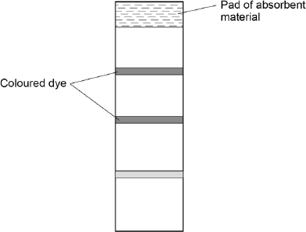

What can you conclude from this result?

Explain how you reached your conclusion.

1. Person is infected with Plasmodium / has malaria;

2. Infected with (Plasmodium) vivax;

3. Coloured dye where antibody C present;

4. That only binds to protein from vivax / no reaction with antibody for falciparum.

Person is infected with P. vivax / Plasmodium vivax = 2 marks (MP1 and MP2

(4)

(Total 8 marks)

Outcome:
- Explain how the use of vaccines provide protection for individuals and populations against disease. Describing the concept of herd immunity.
- Explain the differences between active and passive immunity.
- Discuss the ethical issues associated with the use of vaccines and monoclonal antibodies.

- Vaccinations

What is a vaccine?
Contains an antigen that stimulates the production of antibodies.

What is an attenuated vaccine?
A vaccine that contains a weakened pathogen

What is herd immunity?
Where most of the population are vaccinated to stop an infection from spreading
Describe how a vaccination can lead to the production of antibodies against a specific pathogen

- Vaccine contains antigen (from specific pathogen)
- Displayed on antigen-presenting cells (phagocytes, B cells)
- Specific helper T cell detects antigen and stimulates specific B cell.
- B cell divides and forms clones to give plasma cells.
- Plasma cells produce antibodies.

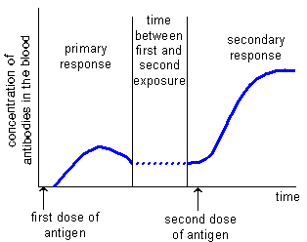
Describe the differences between the primary and secondary response.
Describe the differences between the primary and secondary response.
Primary response is slower and produces some antibodies.
Secondary response produces antibodies in a greater amount and more quickly.
Explain the differences.

1. before vaccination no antibody released because patients not yet encountered vaccine / antigen / virus;

2. Primary response there is clonal expansion of B cells into plasma cells;

3. Plasma cells release antibodies;

4. During the secondary response the memory cells produce more antibodies and produce antibodies more quickly;

What is antigenic variation?
When a pathogen changes its surface antigens. This means upon secondary infection the memory cells do not recognize the antigens.
Each year, the population is offered a flu vaccination. Why does this need to be given each year?
- The Flu antigens change every year, forming new strains of the virus.
- Memory cells produced from vaccination with one strain will not recognise any other strains
- So, every year a new vaccine has to be developed.

Types of immunity
What is active immunity?
Your immune system makes its own antibodies after being stimulated by antigens (this can be achieved naturally or artificially).
Natural: Immune response to presence of pathogen Artificial: Vaccination
What is Passive immunity?
Antibodies are made by another organism and then given to you.
Natural: Antibodies from breastmilk/placenta Artificial: Antivenom
Active Immunity | Passive Immunity
Requires exposure to the antigen | Doesn’t require exposure to the antigen
It takes time for the protection to develop | Protection is immediate
Memory cells are produced | Memory cells are not produced
Protection is long term | Protection is short term
Differences between active and passive immunity

Research the ethical uses of vaccines and antibodies and list them in the table below.
Ethical Issues Of Vaccines | Ethical Issues Of monoclonal Antibody Therapy
All vaccines are tested on animals before being used on humans. | Animals are used to produce the cells from which monoclonal antibodies are produced.
Testing vaccines on humans can be risky | Animals are used to produce the tumour cells – involves inducing cancer in mice
Some people do not want to take the risks or side effects of using vaccines | Testing on humans could result in other problems / death
If an epidemic occurred from a new disease……. Who would get the vaccine first?

_____________________________________________________________________________________
Exam questions:

(a) When a vaccine is given to a person, it leads to the production of antibodies against a disease-causing organism. Describe how.

1. Vaccine contains antigen from pathogen;

2. Macrophage presents antigen on its surface;

3. T cell with complementary receptor protein binds to antigen;

4. T cell stimulates B cell;

5. (With) complementary antibody on its surface;

6. B cell secretes large amounts of antibody;

7. B cell divides to form clone all secreting / producing same antibody.

(5)

(b) Describe the difference between active and passive immunity.

1. Active involves memory cells, passive does not;

2. Active involves production of antibody by plasma cells / memory cells;

3. Passive involves antibody introduced into body from outside / named source;

4. Active long term, because antibody produced in response to antigen;

5. Passive short term, because antibody (given) is broken down;

6. Active (can) take time to develop / work, passive fast acting.

(5)

(Total 10 marks

Whooping cough is a disease that affects some infants. Doctors collected data relating to whooping cough between 1965 and 1996.

They collected data for:

• the number of cases of whooping cough reported

• the percentage of infants vaccinated against whooping cough.

The graph shows the data collected by the doctors.

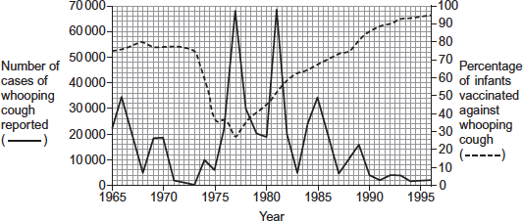

(a) Suggest two reasons why the percentage of infants vaccinated decreased between 1973 and 1975.

Any two from:

1. (Decrease linked to) few(er) cases of whooping cough;

2. (Decrease linked to) risk of / fear of side effects;

3. Insufficient vaccine available / too expensive to produce / distribute.

3. Too expensive unqualified is insufficient for mark

(2)

(b) Between 1980 and 1990, there were three peaks in the number of reported cases of whooping cough. After 1981, the number of cases of whooping cough in each peak decreased.

Use the information from the graph to suggest why.

1. Vaccination rate increases;

2. Fewer people to spread the disease / whooping cough / more people immune / fewer susceptible.

2. Neutral − greater herd effect

2. Allow description of immune

Q Reject ‘resistant’.

(2)

(c) The percentage of the population vaccinated does not need to be 100% to be effective in preventing the spread of whooping cough.

Suggest why.

1. More people are immune / fewer people carry the pathogen;

If neither point 1 or 2 awarded

Herd immunity = 1 mark

Unvaccinated does not mean infected

1. Q Do not accept disease for pathogen

2. So susceptible / unvaccinated people less likely to contact infected people

(2)

(Total 6 marks)

Outcomes:
- Describe the structure of the human immunodeficiency virus (HIV) and its replication in T helper cells.
- Explain how HIV causes the symptoms of AIDS. Why antibiotics are ineffective against viruses.
- Describe how antibodies are used in an ELISA test.

- HIV

You could be asked to identify components of a HIV virus in your exam. Add the functions around the diagram
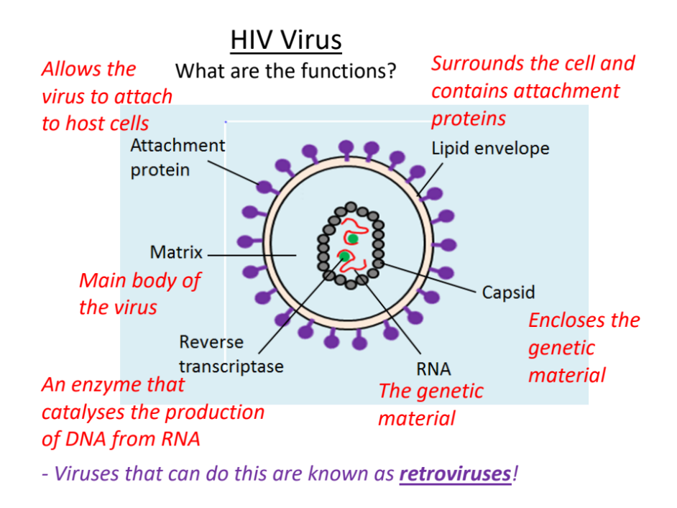

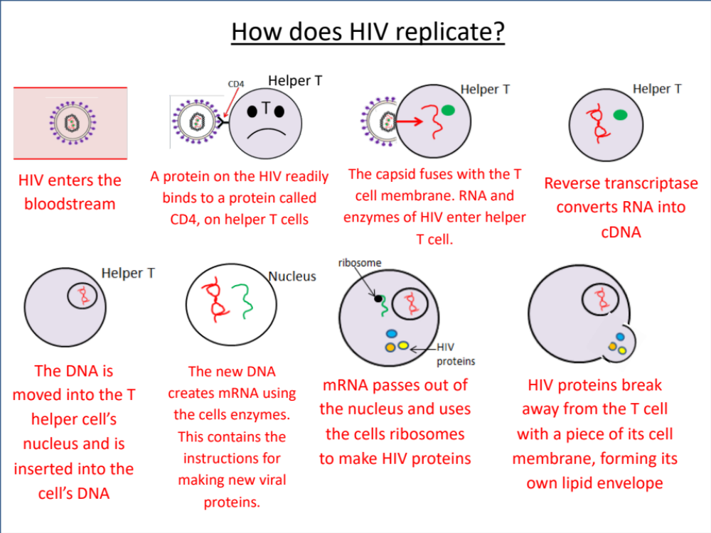

HIV kills or interferes with the normal functioning of T helper cells. What do you think is the consequence of this?
- Cytotoxic T cells cannot be made to destroy infected cells.
- Without enough T cells, B cells are not activated.
- B cells therefore don't produce antibodies.
- Memory cells can also be destroyed by HIV.
- The body becomes susceptible to infections.
When the T cell count is very low, and the body cannot fight infections – the person is said to have AIDS.
Why are antibiotics ineffective against viruses?
Antibiotics work by stopping cells walls been made in bacterial cells. As viruses do not have cells walls this won’t work. Also viruses enter body cells and antibiotics cannot do this.
ELISA (enzyme-linked immunosorbent assay)
In the space below draw out the process of an Elisa test and write stages.
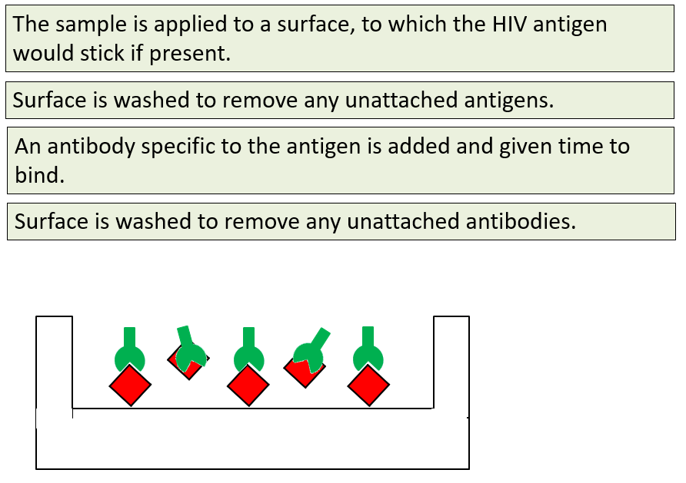
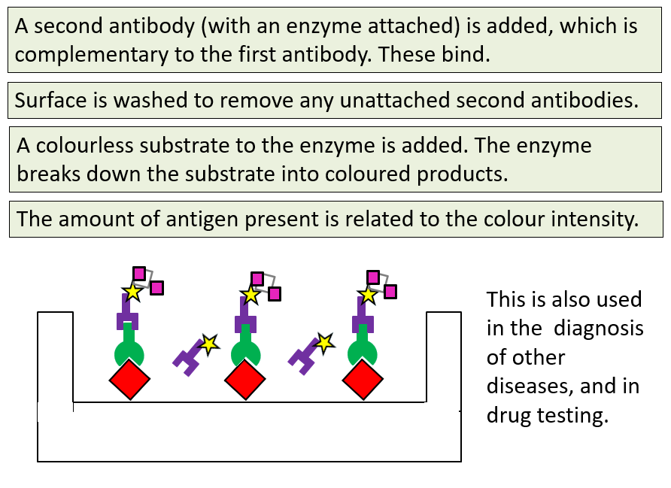
_____________________________________________________________________________________
Exam Questions:

Read the following passage.

Azidothymidine (AZT) is a drug used to treat people infected with human

immunodeficiency virus (HIV). It inhibits the enzyme that synthesises

DNA from HIV RNA. This does not destroy HIV in the body but stops or

slows the development of AIDS.

5 In the past, some people who took AZT on its own eventually developed

AIDS. Some of the HIV in their bodies had become resistant to AZT.

To prevent this from happening, people infected with HIV are now treated

with highly active antiretroviral therapy (HAART). This involves taking AZT

with other anti-HIV drugs at the same time.

10 AZT is taken in low doses. This is because people who took high doses

over long periods of time suffered muscle wastage. It was found that high

doses of AZT inhibit replication of mitochondria.

Use information from the passage and your own knowledge to answer the questions.

(a) Suggest and explain why AZT does not destroy HIV in the body but stops or slows the development of AIDS (lines 3–4).

1. Person (infected with HIV) has HIV DNA (in their DNA);

2. New HIV (particles) still made;

3. (AZT) inhibits reverse transcriptase;

4. (AZT) stops these (new HIV particles) from forming new HIV DNA;

OR

Slows / stops replication of HIV;

5. Stops destruction of more / newly infected T cells;

6. So immune system continues to work (and AIDS does not develop);

4. Context is important

4. Allow slows / stops (re)production of HIV

4. Reject (AZT) prevents DNA replication

(4)

(b) Suggest and explain two advantages of using HAART (lines 7–9).

1. Slows / stops the development of AIDS;

2. Because HIV resistant to AZT is damaged / destroyed / prevented from replicating (by other drugs);

OR

3. AZT continues to work as a drug;

4. Because HAART prevents the spread of AZT-resistant HIV to rest of the human population;

OR

5. No new HIV particles made;

6. Because HAART might interfere with viral protein synthesis;

Mark in pairs.

Do not mix and match.

2. Neutral HIV killed

2. Accept other drugs prevent HIV resistant to AZT from infecting new / more cells

6. Accept blocks transcription / translation / synthesis of lipid envelope / aspect of viral structure

(4)

(c) Suggest why high doses of AZT lead to muscle wastage (lines 10–11).

1. (Fewer mitochondria so) less (aerobic) respiration;

2. (Muscles receive) less ATP (so waste);

1. Ignore no respiration

2. Reject less energy produced

2. Ignore no ATP is made

(2)

(Total 10 marks)

The figure below shows a test that has been developed to find out if a person has antibodies to the human immunodeficiency virus (HIV) antigen.

Step 1 | HIV antigens are attached to a test well in a dish.
Step 2 | A sample of blood plasma is added to the well.  If HIV antibodies are present, they bind to the HIV antigen.
Step 3 | The well is washed.  A second antibody with an enzyme attached is then added.  This binds specifically to the HIV antibody.
Step 4 | The well is washed again.  A yellow solution is added, which changes to blue if the enzyme is present. A blue colour shows that the person has HIV antibodies.

(a) This test only detects the presence of HIV antibodies. Give two reasons why it cannot be used to find out if a person has AIDS.

(To diagnose AIDS, need to look for / at)

1. (AIDS-related) symptoms;

2. Number of helper T cells.

Neutral: ‘only detects HIV antibodies’ as given in the question stem

(2)

(b) The solution will remain yellow if a person is not infected with HIV. Explain why.

1. HIV antibody is not present;

Accept HIV antibodies will not bind (to antigen)

2. (So) second antibody / enzyme will not bind / is not present.

(2)

(c) A mother who was infected with HIV gave birth to a baby. The baby tested positive using this test. This does not prove the baby is infected with HIV.
Explain why.

1. Children receive (HIV) antibodies from their mothers / maternal antibodies;

2. (So) solution will always turn blue / will always test positive (before 18 months).

Allow 1 mark for the suggestion that the child does not produce antibodies yet so test may be negative

(2)

(d) A control well is set up every time this test is used. This is treated in exactly the same way as the test wells, except that blood plasma is replaced by a salt solution.

Use information from the figure above to suggest two purposes of the control well.

(Shows that)

1. Only the enzyme / nothing else is causing a colour change;

2. Washing is effective / all unbound antibody is washed away.

(2)

(Total 8 marks)

(a) The table below shows features of a bacterium and the human immunodeficiency virus (HIV) particle.

Complete the table by putting a tick (✔) where a feature is present.

Feature | Bacterium | Human immunodeficiency virus (HIV) particle
RNA | Y | Y
Cell wall | Y
Enzyme molecules | Y | Y
Capsid |  | Y

(2)

(b) When HIV infects a human cell, the following events occur.

• A single-stranded length of HIV DNA is made.

• The human cell then makes a complementary strand to the HIV DNA.

The complementary strand is made in the same way as a new complementary strand is made during semi-conservative replication of human DNA.

Describe how the complementary strand of HIV DNA is made.

1. (Complementary) nucleotides/bases pair

OR

A to T and C to G;

Ignore ‘(DNA polymerase) forms base pairs/nucleotide pairs’

2. DNA polymerase;

3. Nucleotides join together (to form new strand)/phosphodiester bonds form;

Ignore ‘(DNA polymerase) forms base pairs/nucleotide pairs’

If clearly writing rote answer about DNA replication 2 max e.g. helicase or separating strands

(3)

(c) Contrast the structures of DNA and mRNA molecules to give three differences.

1. DNA double stranded/double helix and mRNA single-stranded;

Contrast requires both parts of the statement

2. DNA (very) long and RNA short;

Accept ‛RNA shorter’ or ‛DNA bigger/longer’

3. Thymine/T in DNA and uracil/U in RNA;

4. Deoxyribose in DNA and ribose in RNA;

R Deoxyribonucleic/ ribonucleic acid

Ignore ref. to histones

Ignore ref. to helix and straight chain alone

5. DNA has base pairing and mRNA doesn’t/ DNA has hydrogen bonding and mRNA doesn’t;

6. DNA has introns/non-coding sequences and mRNA doesn’t;

Ignore ref to splicing

(3)

(Total 8 marks)

