3.1 Biological Molecules

Name: _Teacher
Reflection on Outcomes | or | Target
Explain what a monomer and polymer are

Explain the concept of condensation and hydrolysis reactions in forming/breaking down polymers.
Identify common monosaccharides and describe the monosaccharides from which lactose, maltose and sucrose are made.
Explain what is meant by a glycosidic bond and how they form through condensation
Describe and explain how polymerisation of α-glucose can form starch or glycogen and how this relates to their function and properties.
Present the structure of α -glucose and β –glucose diagrammatically

Explain why glycosidic bonds between β –glucose form cellulose and how this relates to its function and properties.
Describe the structure of triglycerides and explain how triglycerides form
Recognise, from diagrams, saturated and unsaturated fatty acids.

Describe the structure of phospholipids and explain their properties.

Contrast the different properties of triglycerides and phospholipids.

Describe the general structure of an amino acid and how dipeptides form.
Explain the variety of functions that proteins have and why they are so important to the body.
Explain how dipeptides and polypeptides form

Explain the hierarchical organisation of protein structure

Describe the types of bonds involved in protein structure and the weakness of H bonds
Relate the structure of proteins to the properties of proteins (required for proteins named throughout the spec)
Describe the Biuret test, the emulsion test, reducing and non-reducing sugar and starch test and how they can be interpreted.
Explain what is meant by qualitative testing and quantitative data.

Describe how the Benedict’s test can be adapted to provide quantitative data
Explain the usefulness of calibration curves or standards.

Describe the properties that are important in water

Explain the properties of water linked to the polar nature of the molecule
Explain the significance of these properties to living organisms and processes

Monomers and Polymers

Outcome:
- Explain what a monomer and polymer are

Definitions:
Monomer: One of many small repeating molecules that combine to form a polymer
Polymer: Large molecule made up of repeating smaller molecules
Polymerisation: Process of producing a polymer
Condensation: Addition of a monomer to another with the removal of water, forming a bond
Hydrolysis: Splitting of the polymer into its monomers with the addition of water, breaking a bond
Metabolism: All chemical processes that take place within the cells of an organism

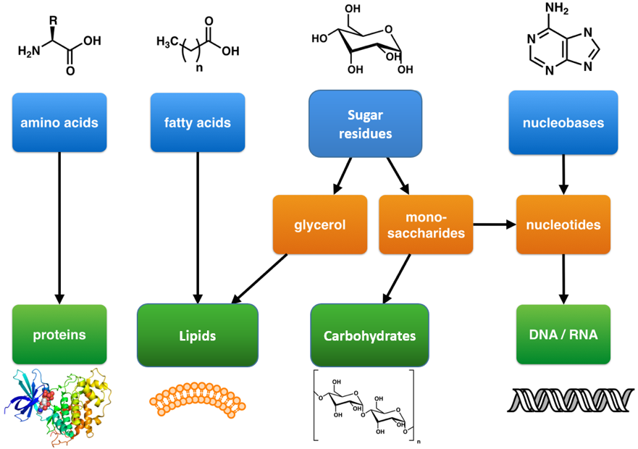

Biological molecule | Scientific name | Monomer | Polymer
Carbohydrate | Saccharides | Monosaccharide | Polysaccharide
Proteins | Peptides | Amino acids | Protein/Polypeptide
Nucleic acids | Nucleotides | Nucleotides | Nucleotides

Explain why are Lipids missing from the table?
Cannot form polymer
Made of two different monomers

Outcome
- Explain the concept of condensation and hydrolysis reactions in forming/breaking down polymers.
- Identify common monosaccharides and describe the monosaccharides from which lactose, maltose and sucrose are made.
- Present the structure of α -glucose and β –glucose diagrammatically
- Explain what is meant by a glycosidic bond and how they form through condensation
Carbohydrates
- Contain the elements C, H and O.
- General formula (CH₂O)_{n}
Carbohydrate name | No. of C’s
Triose | 3
Pentose | 5
Hexose | 6

Monosaccharides

Definition
Isomer: _Same Chemical formula, different structural formula ___________________

Properties
- Dissolve in water and are reducing sugars

- The monosaccharide we have to study all have the same chemical formula C6H12O6 and are therefore isomers.

- You need to know – Alpha glucose, beta glucose, fructose and galactose.

Structure:
Exam tip: Can you write yourself a method to remember how to draw these hexose sugars?
Diagram of Alpha glucose Diagram of Beta glucose

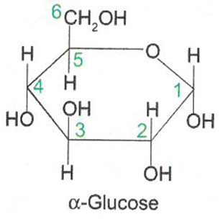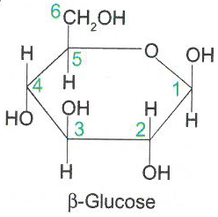

State the structural difference between alpha and beta glucose.
Alpha H Above C1, Beta H Below C1
Disaccharides
Properties:
- Dissolve in water and can be reducing or non-reducing sugars
- Made from two monomers joined by a condensation reaction
- Forming a covalent bond called a glycosidic bond.

Condensation reaction: Rules for drawing
- Always show the groups involved
- Always show water is released
- Always circle and label the bond formed

Structure:
Formation of the disaccharide Maltose (a reducing sugar):
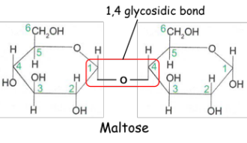
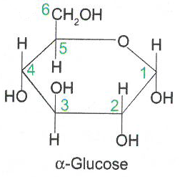
+

Formation of the disaccharide Sucrose (a non-reducing sugar):
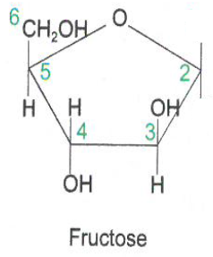
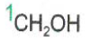
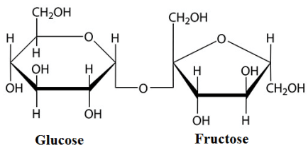
+
Draw out the formation of lactose (a reducing sugar) using α-glucose and galactose.
Exam tip: You do not need to remember this one for your exam but you might be asked to apply your knowledge to this example.

Hydrolysis reactions: Rules for drawing
- Always show the groups involved
- Always show where water is added
- Always circle and label the bond broken
- Name the monomers formed.
Disaccharides can be broken down by a hydrolysis reaction.
In the space below draw out the hydrolysis reaction of Maltose.
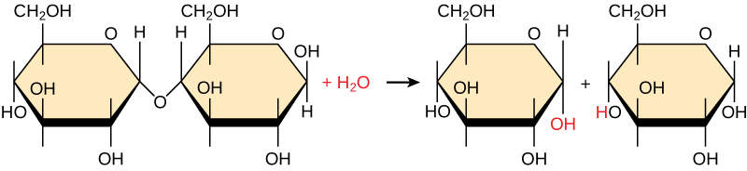
How does the structure of alpha and beta glucose change the bonding?
Every other B-glucose molecule is upside down.

Exam questions:
Q1.(a) What is a monomer?
(a) (a monomer is a smaller / repeating) unit / molecule from which larger molecules / polymers are made;
Reject atoms / elements / ’building blocks’ for units / molecules
Ignore examples
(b) Lactulose is a disaccharide formed from one molecule of galactose and one molecule of fructose. Other than both being disaccharides, give one similarity and one difference between the structures of lactulose and lactose.
Similarity 1. Both contain galactose / a glycosidic bond;
Ignore references to hydrolysis and / or condensation
Difference . Lactulose contains fructose, whereas lactose contains glucose;
Ignore alpha / beta prefix for glucose
Difference must be stated, not implied

Q2.Lactose is a disaccharide found in milk. In the human small intestine, the enzyme lactase catalyses the hydrolysis of lactose to the monosaccharides, galactose and glucose. These monosaccharides are then absorbed into the blood. Complete the diagram to show the hydrolysis of lactose to galactose and glucose.
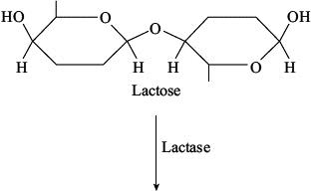
use of water;
must be above arrowhead
OH drawn correctly in place of glycosidic bond on
each monosaccharide;
[2]

Q3.(a) Name the monosaccharides of which the following disaccharides are composed.
(i) Sucrose
monosaccharides Glucose and fructose
(ii) Lactose
monosaccharides Glucose and galactose1

Outcomes:
- Describe and explain how polymerisation of α-glucose can form starch or glycogen and how this relates to their function and properties.
- Explain why glycosidic bonds between β –glucose form cellulose and how this relates to its function and properties.

Polysaccharides
1.Starch Structure:
- Polysaccharide of a-glucose
- 1-4 and 1-6 glycosidic bonds
- Branches and coiled shape held by H bonds within the molecule

2.Glycogen Structure:
- Polysaccharide of a-glucose
- 1-4 and 1-6 glycosidic bonds
- Branched and coiled shape held by H bonds within the molecule

Function/property of Starch and Glycogen:
Main role is as energy storage compound. Starch is in plants only, glycogen is in animals only.
Describe | Explain
Insoluble | Doesn’t affect WP
Branched | Compact/Can fit many in a small space
Polymer of a-glucose | Provides glucose for respiration
Branched | Many ends for enzymes to attach and hydrolyse
Large | Cannot leave cell.

Contrast Starch and Glycogen structure:
Starch structure | Glycogen structure
Less 1-6 glycosidic bonds | More 1-6 glycosidic bonds
Less branched | More branched.
3.Cellulose Structure:
- Polysaccharide of B-glucose
- Every other B--glucose upside down
- 1-4 glycosidic bonds only
- Molecule form long and straight chains
- Many H bonds between chains forming microfibrils.

Function/property of cellulose:
Describe | Explain
Long straight chains | Provides rigidity/strength to plant cell wall
Many H bonds forming microfibrils | Provides rigidity/strength to plant cell wall

Exam tip: Most polysaccharide exam question asking you to compare and contrast the functions or structures of the 3 polysaccharides. Compare and contrast questions should ALWAYS be done as a table.

Complete the revision poster below using the information about polysaccharides. Add information from your memory first to see what you can remember. Change colour and add information that you had forgotten,

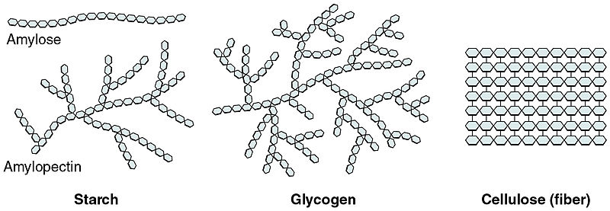

Exam questions:
Q1. Starch and cellulose are two important plant polysaccharides. The following diagram shows part of a starch molecule and part of a cellulose molecule.
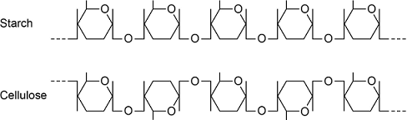
(a) Explain the difference in the structure of the starch molecule and the cellulose molecule shown in the diagram above.
1. Starch formed from α-glucose but cellulose formed from β-glucose;
2. Position of hydrogen and hydroxyl groups on carbon atom 1 inverted.
(b) Starch molecules and cellulose molecules have different functions in plant cells. Each molecule is adapted for its function. Explain one way in which starch molecules are adapted for their function in plant cells.
1. Insoluble;
2. Don’t affect water potential; OR
3. Helical; Accept form spirals
4. Compact; OR
5. Large molecule;
6. Cannot leave cell.
(c) Explain how cellulose molecules are adapted for their function in plant cells.
1. Long and straight chains;
2. Become linked together by many hydrogen bonds to form fibrils;
3. Provide strength (to cell wall).3
These are more challenging application and skills questions.
Q2.Scientists investigated the hydrolysis of sucrose in growing plant cells by an enzyme called SPS.
(a) Name the products of the hydrolysis of sucrose.
1. Glucose;
2. Fructose;
(b) The scientists grew plant cells in a culture for 12 days. At the start, there were only a few cells in the culture. Each day, they determined the mass of sucrose hydrolysed by SPS in the plant cells in 1 hour. The following table shows their results.
Day | Mass of sucrose hydrolysed by SPS in 1 hour / μg | Rate of hydrolysis of sucrose  by SPS
0 | 0.07
2 | 0.09
4 | 0.11
6 | 0.15
8 | 0.20
10 | 0.24
12 | 0.24
For each day, calculate the rate per minute of the reaction catalysed by SPS. Record the rates in standard form and plot a suitable graph of your processed data.
1. Line graph with rate on y axis and days/time in days on x axis and
linear scales;
Correct answers × 10⁻³ 1.17, 1.50, 1.83, 2.50, 3.33, 4.00, 4.00 (accept to 1DP)
2. Correct units of μg min⁻¹/per minute/minute⁻¹ × 10⁻³;
Reject m⁻¹
Reject if put 10⁻³ on axis for each point
‘/’ means separating units from what goes before i.e. accept sucrose hydrolysis per min / μgx10⁻³
3. Rates correctly calculated and plotted, with line connecting points/line
of best fit and no extrapolation;
Do not accept a ruled straight line of best fit
Accept y axis starting at 1

(3)
(c) What can you conclude about the growth of the plant cells from these data?
Explain how you reached your conclusions.
1. Sucrose hydrolysis linked to some aspect of growth;
Accept ‘breakdown
2. Greater the rate of/faster hydrolysis/more SPS activity as plant grows/cells
divide (up to 8/10 days);
Accept ‘breakdown
Accept converse of greater rate of growth, greater rate of hydrolysis
Reject ‘sucrose broken down’
3. Growth/division remains the same/slows after 8/10 days
(because SPS activity is levelling off);
Accept after 8 days/at 10 days growth rate maximum/growth stops
Q3.In mammals, in the early stages of pregnancy, a developing embryo exchanges substances with its mother via cells in the lining of the uterus. At this stage, there is a high concentration of glycogen in cells lining the uterus.
(a) Describe the structure of glycogen.
1. Polysaccharide of α-glucose; OR
polymer of α-glucose;
2. (Joined by) glycosidic bonds OR
Branched structure;
2 max
(b) During early pregnancy, the glycogen in the cells lining the uterus is an important energy source for the embryo.Suggest how glycogen acts as a source of energy. Do not include transport across membranes in your answer.
1. Hydrolysed (to glucose);
2. Glucose used in respiration;
1. Ignore ‘Broken down’
2. ‘Energy produced’ disqualifies mp2
(c) Suggest and explain two ways the cell-surface membranes of the cells lining the uterus may be adapted to allow rapid transport of nutrients.
) 1. Membrane folded so increased / large surface area; OR
Membrane has increased / large surface area for (fast) diffusion / facilitated diffusion / active transport / co-transport;
2. Large number of protein channels / carriers (in membrane) for facilitated diffusion;
3. Large number of protein carriers (in membrane) for active transport;
4. Large number of protein (channels / carriers in membrane) for co-transport;
1. Accept ‘microvilli to increase surface area’
1. Reject reference to villi.
Note feature and function required for each marking point and reference to large / many / more.
List rule applies.
(d) In humans, after the gametes join at fertilisation, every cell of the developing embryo undergoes mitotic divisions before the embryo attaches to the uterus lining.
• The first cell division takes 24 hours.
• The subsequent divisions each take 8 hours.
After 3 days, the embryo has a total volume of 4.2 × 10⁻³ mm³. What is the mean volume of each cell after 3 days? Express your answer in standard form.
Show your working.
3.3 × 10⁻⁵ OR 3.28 × 10⁻⁵ OR 3.281 × 10⁻⁵;
1 mark for
Evidence of 128 (cells)
Correct numerical calculation but not in standard form gains 1 mark (0.00003281 OR 0.0000328 OR 0.000033);
Accept any number of significant figures as long as rounding correct (3.28125 × 10 ⁻⁵ scores 2 marks)
Answer = ____________________ mm³ (2)

Outcomes:
- Describe the structure of triglycerides and explain how triglycerides form.
- Recognise, from diagrams, saturated and unsaturated fatty acids.

- Contain C, H, O
- Insoluble in water/non-polar
- Main groups of lipids are:
- Triglycerides - also known as fats (solid at room temperature) and oils (liquid at room temperature).
- Phospholipids – main component of plasma membranes.

Triglyceride Structure
Draw a molecule of glycerol and a fatty acid.
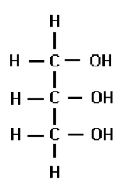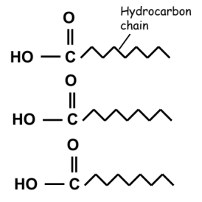
Draw the condensation of a triglyceride.
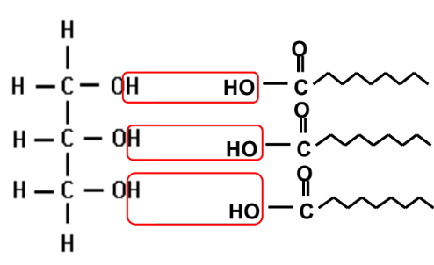

Saturated and unsaturated Fatty acids
Definition:
Saturated: Single C-C bonds in the hydrocarbon chain ______
Unsaturated: Double C=C bonds in the hydrocarbon chain cause kinks in the chain _______

Saturated – Unsaturated-
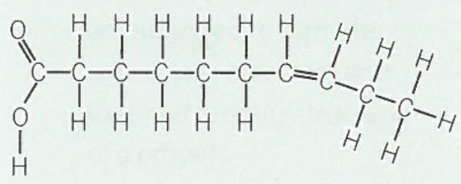
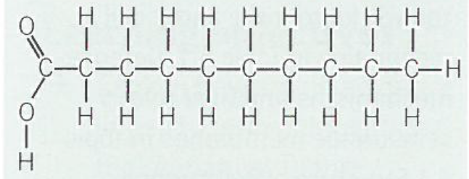

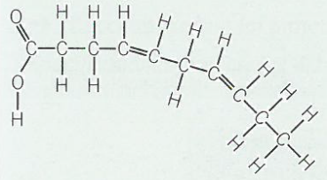

Circle and label the carboxyl group.
Circle and label the double C bonds.

Triglyceride Function:
Property | Function/Explanation
Energy store | Many C and H’s so more energy per g then carbohydrates
Large, insoluble and non-polar molecules | Doesn’t affect WP of cell
Storage below dermis of the skin in adipose tissue | Insulation
Metabolic source of water | From respiration due to high ratio of H’s to O
Buoyancy | Low density

Exam questions:
- The figure below shows a phospholipid.
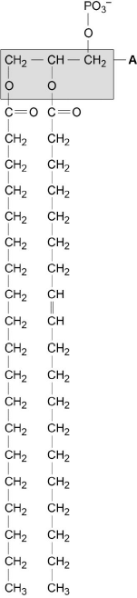
X Y
(b) The part of the phospholipid labelled A is formed from a particular molecule. Name this molecule.
Glycerol.
(c) Name the type of bond between A and fatty acid X.
Ester
(d) Which of the fatty acids, X or Y, in the figure above is unsaturated? Explain your answer.
Y (no mark)
Contains double bond between (adjacent) carbon atoms in hydrocarbon chain.

Scientists investigated the percentages of different types of lipid in plasma membranes from different types of cell. The table shows some of their results.

Type of lipid | Percentage of lipid in plasma membrane by mass
Type of lipid | Cell lining ileum of  mammal | Red blood cell of  mammal | The bacterium  Escherichia coli
Cholesterol | 17 | 23 | 0
Glycolipid | 7 | 3 | 0
Phospholipid | 54 | 60 | 70
Others | 22 | 14 | 30
(e) The scientists expressed their results as Percentage of lipid in plasma membrane by mass. Explain how they would find these values.
1. Divide mass of each lipid by total mass of all lipids (in that type of cell);
2. Multiply answer by 100.
Q2.(a) A triglyceride is one type of lipid. The diagram shows the structure of a triglyceride molecule.
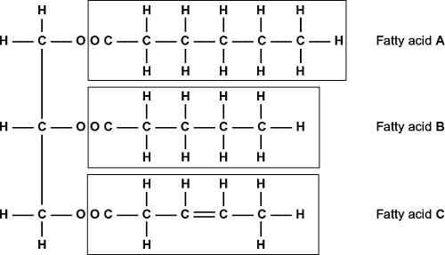
(i) A triglyceride molecule is formed by condensation. From how many molecules is this triglyceride formed?
(1) 4 / four;
(ii) Use the diagram to explain what is meant by an unsaturated fatty acid.
1. Double bonds (present) / some / two carbons with only one hydrogen / (double bonds) between carbon atoms / not saturated with hydrogen;
Answer refers to unsaturated unless otherwise clearly indicated.
May be shown in appropriate diagram.
2. In (fatty acid) C / 3;
Q3.(a) Omega-3 fatty acids are unsaturated. What is an unsaturated fatty acid?
(a) Double bond(s);
(Bonds) between carbon;
C=C bond(s) = 2 marks
‘No’ C=C bond(s) disqualifies 1 mark only
Accept: does not contain maximum number of H for 1 mark
Neutral: contains C=O bonds
(b) Scientists investigated the relationship between the amount of omega-3 fatty acids eaten per day and the risk of coronary heart disease. The graph shows their results.
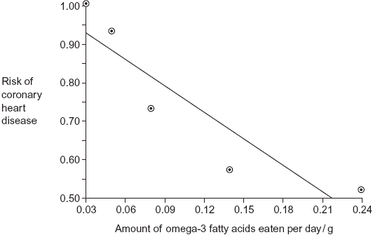
Do the data show that eating omega-3 fatty acids prevents coronary heart disease? Explain your answer.
Graph shows negative correlation / description given;
Correlation does not mean causation / prevention / shows lower risk not prevention;
May be due to another factor / example given;
Neutral: refs. to methodology e.g. sample size / line of best fit
(c) Olestra is an artificial lipid. It is made by attaching fatty acids, by condensation, to a sucrose molecule. The diagram shows the structure of olestra. The letter R shows where a fatty acid molecule has attached.
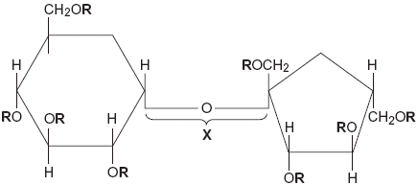
(i) Name bond X.
Glycosidic;
Reject: ester bond

(ii) A triglyceride does not contain sucrose or bond X. Give one other way in which the structure of a triglyceride is different to olestra.
Contains glycerol / three fatty acids / forms three ester bonds;
Neutral: contains less fatty acids
Answers must refer to a triglyceride
Neutral: olestra has eight fatty acids / R groups
Reject: contains three glycerols
(iii) Starting with separate molecules of glucose, fructose and fatty acids, how many molecules of water would be produced when one molecule of olestra is formed?
(iii) 9;
Q4.Omega-3 fatty acids are found in cows’ milk. Scientists investigated changes in the concentration of omega-3 fatty acids in milk when cows were moved from eating grass in fields to eating corn in cattle sheds. The following figure shows the results of one investigation.
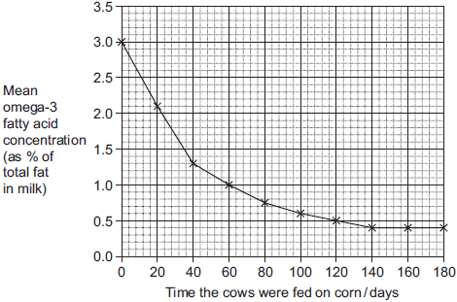
(a) The concentration of omega-3 fatty acids in milk changed when cows were fed on corn instead of grass. Describe how.
(a) (Omega-3 concentration) falls more rapidly at first;
Levels out at 140 days / concentration of 0.4%;
(b) (i) Calculate the rate of decrease in the mean omega-3 fatty acid concentration between 0 and 40 days.Show your working.
Two marks for correct answer of 0.04 or 0.043;;
One mark for incorrect answer which clearly identifies total fall of 1.7;

Outcome:
- Describe the structure of phospholipids and explain their properties.
- Contrast the different properties of triglycerides and phospholipids.
Phospholipids Structure
Definition:
Amphipathic: Have polar and non-polar regions
Fatty acids repel water and are referred to as being hydrophobic
Phosphate group is attracted to water and is referred to as being hydrophilic
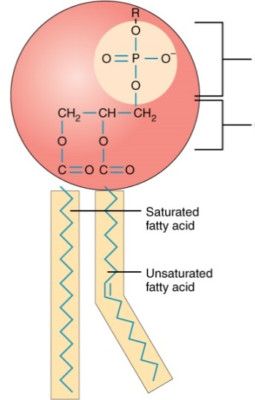
On the diagram label the hydrophilic phosphate head, the hydrophobic fatty acid tail and circle the C=C double bond.
Hydrophilic phosphate head

Hydrophobic fatty acid tail

Add details to the diagrams below showing how phospholipids arrange themselves when interacting with water.
When placed in water the phospholipid molecules arrange themselves either:

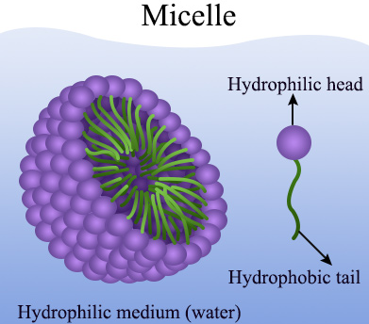
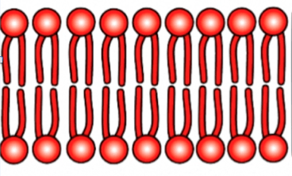

Phospholipid function:

Form a bilayer within a cell surface membrane so hydrophobic barrier formed between the inside and outside of cell
Forms membranes inside the cell e.g. mitochondria, to isolate metabolic reactions.
Controls exchange of substances

Compare and contrast triglycerides and phospholipids
 | Triglyceride | Phospholipid
Ester Bonds (S) | 3 | 2
Glycerol (S) | Yes | Yes
Fatty acid structure (S) | Saturated and unsaturated | Saturated and unsaturated
Fatty acid number (s) | 3 | 2
Elements (S) | C,H,O | C,H,O,P
Solubility (F) | Hydrophobic | Hydrophilic head, phobic tail
Bilayer (F) | No | Yes

Exam tip: ALWAYS do contrast questions as a table to get fully marks. Examiners notes always say “must be directly comparative statements, on the same line/same sentence”.
Exam questions:

(b) Mucus produced by epithelial cells in the human gas exchange system contains triglycerides and phospholipids. Compare and contrast the structure and properties of triglycerides and phospholipids.

1. Both contain ester bonds (between glycerol and fatty acid);

2. Both contain glycerol;

3. Fatty acids on both may be saturated or unsaturated;

4. Both are insoluble in water;

5. Both contain C, H and O but phospholipids also contain P; Must relate to element.

6. Triglyceride has three fatty acids and phospholipid has two fatty acids plus phosphate group;

7. Triglycerides are hydrophobic/non-polar and phospholipids have hydrophilic and hydrophobic region;

8. Phospholipids form monolayer (on surface)/micelle/bilayer (in water) but triglycerides don’t;
Outcome:
- Describe the general structure of an amino acid and how dipeptides form.
- Explain the variety of functions that proteins have and why they are so important to the body.
- Explain how dipeptides and polypeptides form

Proteins
Property:
- Contains C, H, O, N and sometimes S
Amino Acids
- 20 naturally occurring amino acids
- Same 20 amino acids found in almost all living organisms.
- Proteins can be:
  - Globular - spherical and soluble. Have a metabolic function e.g. haemoglobin, insulin, enzymes.
  - Fibrous – long, thin and insoluble. Have structural function e.g. collagen, keratin

Structure:
All amino acids have:
- An amine group = -NH₂
- A carboxyl group = -COOH
- A hydrogen atom = -H
- R group (side chain) = differs in all amino acids
Draw and label General Amino Acid
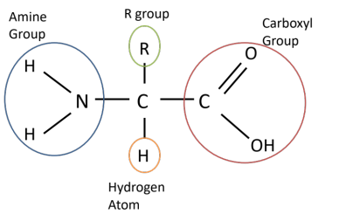

Dipeptides Structure:
- Polypeptides formed by condensation reactions
- Bond formed is called a peptide bond
- Forms between amine group of one amino acid and carboxyl group of the other
Draw and label General Dipeptide here.
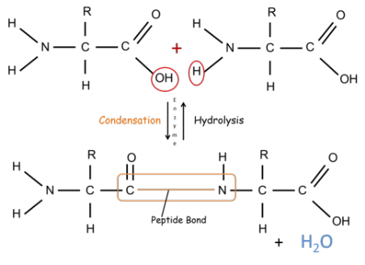
Outcome:
- Explain the hierarchical organisation of protein structure
- Describe the types of bonds involved in protein structure and the weakness of H bonds

Hierarchical protein structure
- Proteins can consist of a single polypeptide chain e.g. most enzymes, or 2 or more polypeptides e.g. haemoglobin, collagen.
Primary Structure
Definition:
Polymer of amino acids joined by condensation reaction in a specific order of amino acids in a polypeptide chain.

Bond:
Peptide

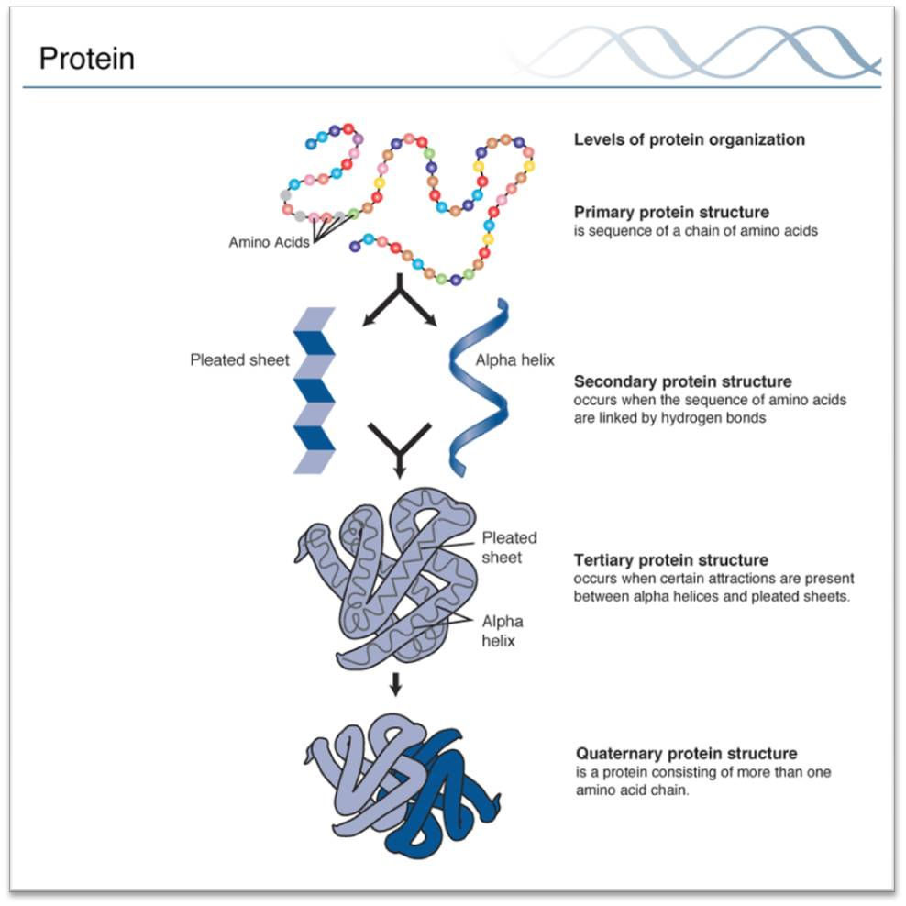
Tertiary Structure
Definition:
Polypeptide folds further to produce a specific 3D structure.

Bonds:
H bonds – between the polar R-groups of the amino acids. Easily broken by temperature and pH changes
Ionic bonds – between an amino acid with a positive charge and an amino acid with a negative charge if close enough. Easily broken by pH changes,
Disulphide bridges – between amino acids that contain Sulphur in the R-group. Strong covalent bonds but broken by reducing agents.

Tertiary structure is determined by where these bonds form which is determined by sequence of amino acids.
Tertiary structure determines 3D shape and function of the protein.

Secondary Structure
Definition:
Polypeptide chain folds into either:
- α-helix
- β – pleated sheets

Bond:
H bonds
Quaternary Structure
Definition:
More than one polypeptide chain.

Bonds:
Same as Tertiary
Exam questions:
Q1. (a) Draw the general structure of an amino acid.
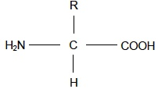
Accept other correct representations. (1)
Q2. (a) Glycine, an amino acid. In the space below, draw a diagram to show the dipeptide produced when two molecules of glycine are joined together.

(c) 1. Peptide bond shown correctly;
2. Rest of dipeptide structure shown correctly;

(b) Name the other molecule formed when two molecules of glycine are joined together.
Water

Q3. the structure of proteins.
1. Polymer of amino acids;
2. Joined by peptide bonds;
3. Formed by condensation;
4. Primary structure is order of amino acids;
5. Secondary structure is folding of polypeptide chain due to hydrogen bonding;
Accept alpha helix / pleated sheet
6. Tertiary structure is 3-D folding due to hydrogen bonding and ionic / disulfide bonds;
7. Quaternary structure is two or more polypeptide chains.
5 max

Outcomes:
- Describe the Biuret test, the emulsion test, reducing and non-reducing sugar and starch test and how they can be interpreted.
- Explain what is meant by qualitative testing and quantitative data.
- Describe how the Benedict’s test can be adapted to provide quantitative data
- Explain the usefulness of calibration curves or standards.

Testing for Biological Molecules

Biological molecule | Method | Result
Protein | Add Biuret | Blue to Lilac
Carbohydrates- Reducing sugar | Heat to 80c with Benedict’s | Blue to Brick red precipitate
Carbohydrates- Non-reducing sugar | Follow Benedict method but solution stays blue.  Fresh sample  Boil with acid then neutralise with alkali  Heat to 80c with Benedict’s | Blue to Brick red precipitate
Lipids | Shake with ethanol  Then add water | White/milky emulsion
Starch | Add iodine | Yellow to blue black

Testing for carbohydrates
Give an example of an acid and an alkali you would use in the non-reducing test.
Hydrochloric acid

Explain why an acid is added in the non-reducing test
Hydrolyse the glycosidic bond forming reducing sugars

Explain why an alkali is added after the acid in the non-reducing test.
Benedicts only works in alkaline conditions
Definition:
Quantitative data: Numerical measurement of a variable, can be statically analysed
Qualitative data: Judgement, cannot be statically analysed

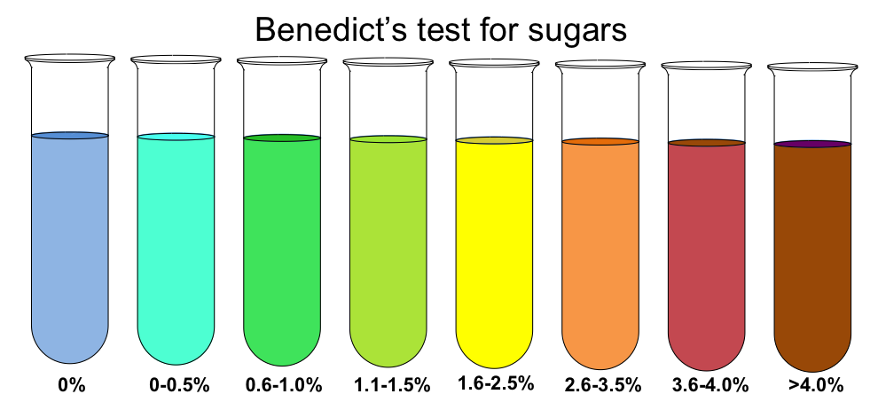
Describe the qualitative data
Lighter colours have a lower conc of glucose, the darker colours have a higher conc of glucose

Describe the method for quantitative Benedict’s test:
Add Benedict’s to different concentration of reducing sugar solution
Heat to 80c in water bath
Separate the coloured solution into cuvettes
Calibrate the colorimeter
Place the cuvette into the colourimeter
Measure the % absorption
Plot a graph.

Sketch a graph showing the % absorption using a colorimeter
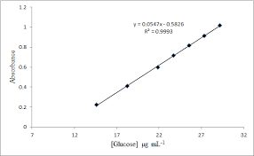

Describe how you could use this calibration curve to work out the glucose concentration of an unknown solution
Heat to 80c with Benedict’s
Place cuvette in colorimeter
Plot % absorption on calibration graph to work out concentration.
Water Structure
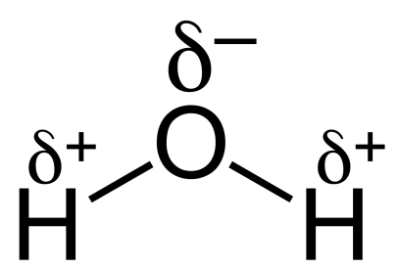
- Major component of cells
- Made up of 2 atoms of hydrogen and 1 atom of oxygen
- Hydrogens joined to oxygen by covalent bonds.

- Electrons are not shared equally – oxygen atom has
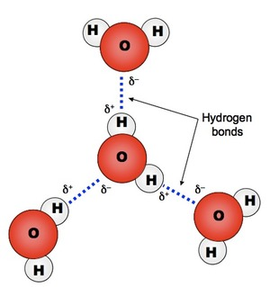
slight negative charge, hydrogen atoms have slight positive charge – polar- dipolar

- Each water molecule is attracted to each other
- Attractions called hydrogen bonds

Property | Explanation | Advantage to organisms
Polar molecule | Universal solvent | Transport ions around the body for faster reaction
Universal solvent | Water is polar allowing ions to dissolve | Transport ions around the body for faster reaction
Reactive | Involved in hydrolysis/condensation reactions | Allows metabolic reactions to occur
High heat capacity | Takes a lot of heat energy to break H bonds  Energy is used instead of changing temperature  Act as a buffer | External: Stable environment for organisms eg fish  Internal: Maintains stable temperature for enzymes and reactions.
Latent heat of vaporisation | Takes a lot of heat energy to break H bonds.  Energy is used to change liquid to gas when it evaporates carrying away the heat energy | Heat energy is lost through evaporation allowing animal to cool down.
Cohesion | Attraction between water molecules  Water forms a column for support  Water has a high surface tension when in contact with air | Column: Transport ions in plants  Surface tension: Habitat for insects.

Exam questions

a) State and explain the property of water that can help to buffer changes in temperature.

(a) 1. (water has a relatively) high (specific) heat capacity;

Ignore numbers relating to heat capacity

2. Can gain / lose a lot of heat / energy without changing temperature;

OR

Takes a lot of heat / energy to change temperature;

Accept due to H bonding between water molecules

2

Water and inorganic ions have important biological functions within cells.

(a) Give two properties of water that are important in the cytoplasm of cells.

For each property of water, explain its importance in the cytoplasm.

(a) 1. Polar molecule;

2. Acts as a (universal) solvent;

OR

3. (Universal) solvent;

4. (Metabolic) reactions occur faster in solution;

OR

5. Reactive;

6. Takes place in hydrolysis / condensation / named reaction;

Polar molecule so acts as (universal) solvent so (metabolic reactions are faster = 3 marks

Polysaccharides Summary Sheet
Name of Polysaccharide | Found in | Found as | Function/ Role | Monomer | Type of bond between monomer | Type of chain formed | Extra Notes
Starch

Glycogen

Cellulose |  | Fibres

