3.3.4.1 MASS TRANSPORT IN ANIMALS
Name__________Teacher ______________________________
Reflection on learning outcomes | or | Target
Explain what is meant by a double circulatory system

Describe the structure of the circulatory system, with particular reference to the blood vessels entering/leaving the heart, lungs and kidneys

link the structure of the circulatory system to its role in exchanging and transporting materials.

describe and label the structure of the heart

explain differences in the thickness of cardiac muscle between the atria and ventricles, and between different sides of the heart

explain the purpose of the atrio-ventricular and semilunar valves

explain the role of the coronary artery.

explain the cardiac cycle in terms of atrial systole, ventricular systole and diastole
explain the opening and closing of AV and semi-lunar valves in terms of differences in pressure at different stages of the cardiac cycle
analyse and interpret data relating to pressure and volume changes during the cardiac cycle.
describe the structure of arteries, arterioles, veins and capillaries
relate the structure of arteries, arterioles, veins and capillaries to their functions
compare and contrast the structure and function of different blood vessels
explain what tissue fluid is and which substances it contains
explain the formation of tissue fluid in terms of hydrostatic pressure
explain the reabsorption of some tissue fluid back into the capillaries, in terms of hydrostatic pressure and water potential

explain the role of the lymph system.
explain the features of good experimental design

process data to calculate rates

represent raw and processed data clearly using tables and graphs
apply knowledge of circulation to draw and explain conclusions

evaluate the quality of results and reliability of conclusions.
explain the causes and consequences of cardiovascular disease
analyse and interpret data associated with specific risk factors and the incidence of cardiovascular disease
recognise correlations and causal relationships
Relate knowledge of protein structure to the structure of haemoglobin.

Explain what is meant by the term “partial pressure”

Explain how the binding of one oxygen molecule changes the shape of haemoglobin, and how this affects the binding of further oxygen molecules

Explain the effect of carbon dioxide concentration on oxygen dissociation, relate this knowledge to explain oxygen loading and unloading in different tissues.

Explain differences between the dissociation curves of different species and relate these differences to the environment in which the organisms with to explain how these adaptations allow organisms to survive

Outcome:
- Explain what is meant by a double circulatory system
- Describe and label the structure of the heart

Task: Use the words to complete the gaps below:
Diffusion Decreases Transport Exchange Short
Environment Pump Absorb Remove
All organisms exchange materials between themselves & the Environment. Diffusion is fast enough for transport over short distances, so can be used in small organisms.
However, as size increases, SA:VOL ratio Decreases. and specialised Exchange surfaces are required to Absorb nutrients and respiratory gases and Remove excretory products and a Transport system is required to take materials from cells to exchange surfaces, from the exchange surfaces to cells, and between different parts of the organism. Whether or not there is a specialised transport medium and whether or not it is circulated by a pump depends on:
- SA:VOL ratio
- How active the organism is

External structure of The Heart
Task: Add labels using p.171 T & Toole and using the words below:
Aortic arch, Vena cava (superior), Right atrium, Right ventricle, Vena cava (inferior), Aorta, Pulmonary veins, Pulmonary arteries, Left atrium, Coronary artery, Left ventricle
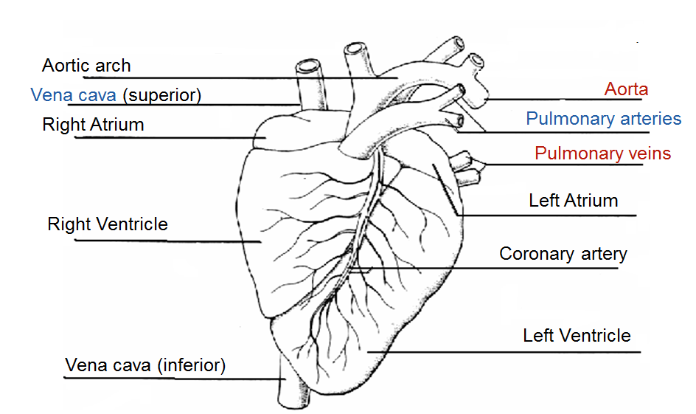
Internal Structure of the Heart
Task: Add labels using p.171 T & Toole and using the words below:
Aorta, Vena cava, Right atrium, Right atrio-ventricular valve, Tendon, Right ventricle, Septum, Apex, Thicker muscular wall of left ventricle, Left ventricle, Semi- lunar valve, Left Atrio-ventricular valve, Left atrium, Pulmonary vein, Oxygenated blood in, Deoxygenated blood out, Pulmonary artery, Oxygenated blood out, Deoxygenated blood in.
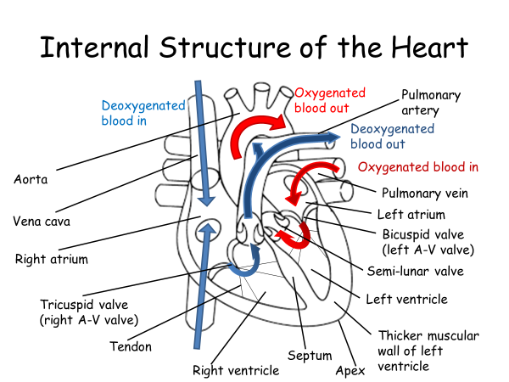

Outcome:
- describe the structure of the circulatory system, with particular reference to the blood vessels entering/leaving the heart, lungs and kidneys

Double circulatory system


Definitions
Mammals have a closed (blood is in vessels), double circulatory system (blood passes through heart twice for each circuit of the body)
Task: Write a description of the two systems and the advantage of a double circulatory system below using these words - Oxygenated, deoxygenated, blood, heart, increases, release, tissues, body, lung, blood pressure, blood flow
Pulmonary circulation – carries deoxygenated blood to the lungs, to take up oxygen & then returned to heart.
Systemic circulation – carries oxygenated blood to the rest of the body, to release oxygen & then returned to heart.
The main advantage of a double circulatory system for mammals is that it increases– blood pressure and therefore increases the rate of blood flow to the tissues.
Task:
- Label all blood vessels and heart chambers in the diagram below Use these words - Vena cava, Right atrium, Right ventricle, Aorta, Pulmonary veins, Pulmonary arteries, Left atrium, Left ventricle
- Add colour to show oxygenated (red) and deoxygenated (blue) blood and raw a line to show where the Renal artery is.
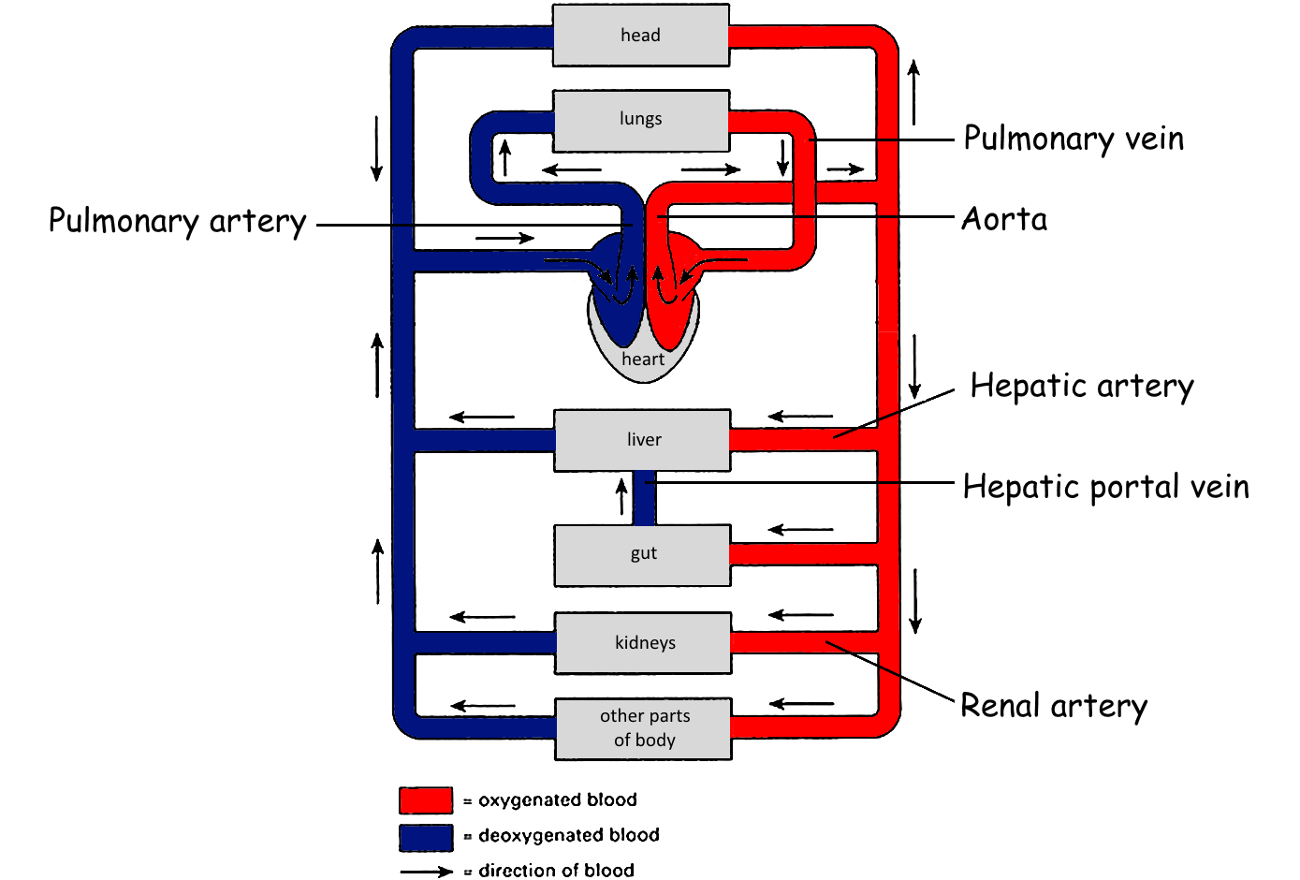

Outcome:
- explain the role of the coronary artery.

Blood supply to heart
- Heart muscle needs its own blood supply
- Therefore arteries branch off from aorta to form the coronary arteries which run through heart muscle, close to outer surfa
Explain the role of coronary arteries, and why a blockage in one of these causes a heart attack (Myocardial infarction) (4)
- Coronary arteries carry oxygen to the heart muscle
- A blockage such as a blood clot or build up of fatty acids can restrict the flow of blood/ oxygen to the heart muscle.
- If the clot blocks the coronary artery completely no oxygen is reaching the heart.
- The heart muscle can no longer respire so muscle cells may die.
- Resulting in a heart attack.
Exam Questions:
Answers on powerpoint
Q1.
(a) Figure 1 shows part of the blood circulation in a mammal.
Figure 1
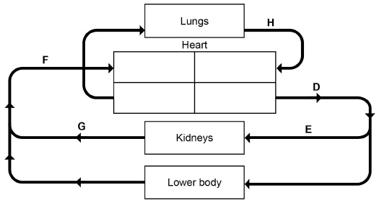
Use Figure 1 to give the letter that represents each of these blood vessels.

Aorta | 
Renal vein
Vena cava
(3)
(b) Name the blood vessels that carry blood to the heart muscle.
___________________________________________________________________
(1)
Outcome:
- Explain the purpose of the atrio-ventricular and semilunar valves
- Explain differences in the thickness of cardiac muscle between the atria and ventricles, and between different sides of the heart

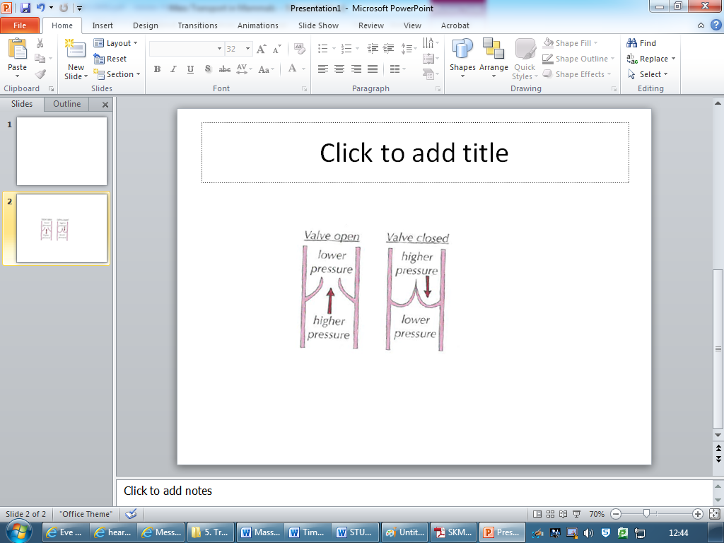
Heart valves
- They only open one way
- They prevent backflow of blood

Muscle and Valves
Task: Fill in the blanks using given words, and then use the information to annotate the diagram below
[direction, pressure, contract, relax, greater, higher, A-V, S-L, atria, ventricles, ventricles, ventricles, ventricles, stronger, stronger]
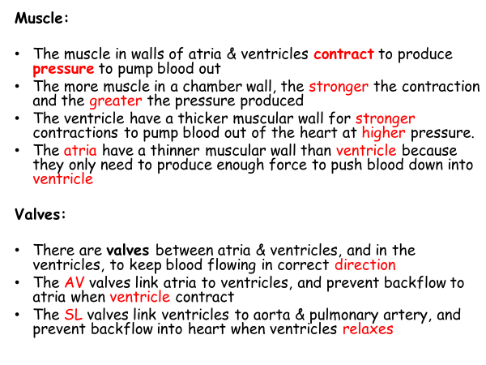
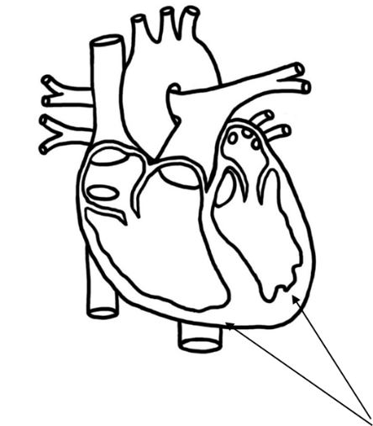

Exam Questions:
Answers on powerpoint

Q2.
In a healthy person, blood moves in one direction as it passes through the heart. Give two ways in which this is achieved.
1. _____________________________________________________________________
2. _____________________________________________________________________
Q3.The diagram shows a section through the heart. The main blood vessels are labelled A, B, C and D.
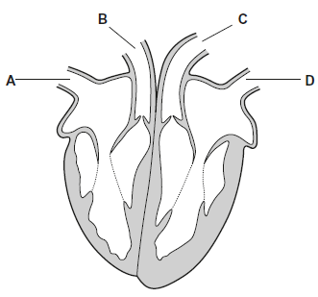
(a) Write a letter, A, B, C or D, in the box to represent the correct blood vessel.
(i) Which blood vessel carries oxygenated blood away from the heart?

(1)
(ii) Which blood vessel carries deoxygenated blood to the heart?
(1)
(b) Explain how the highest blood pressure is produced in the left ventricle.
___________________________________________________________________
___________________________________________________________________
(1)
(c) Some babies are born with a hole between the right and the left ventricles.
These babies are unable to get enough oxygen to their tissues.
Suggest why.
___________________________________________________________________
___________________________________________________________________
(2)

Outcome:
- Explain the opening and closing of AV and SL valves in terms of the pressure differences at different stages of the cardiac cycle.
- Explain the cardiac cycle in terms of atrial systole, ventricular systole and diastole
- Analyse and interpret data relating to pressure changes during the cardiac cycle

- The cardiac cycle is the ongoing sequence of contraction & relaxation of the atria and ventricles
- The 2 phases are contraction (SYSTOLE) and relaxation (DIASTOLE).
- Contraction occurs separately in the atria & ventricles
Exam tip: Note the pressure and volume changes throughout the cycle
Definitions
“SYSTOLE”: Contraction of the heart muscle
“DIASTOLE”: Relaxation of the heart muscle

Task: 1.Use red and blue to show oxy and deoxy blood, label first heart, fill in each box with name of the phase
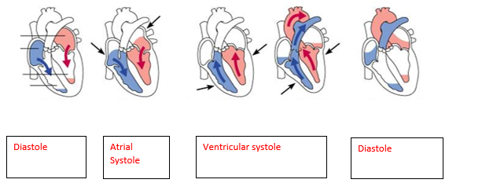
2.Use these prompts to fill in the blanks: Muscle, Pressure, Valve, Direction – My Parents are Very Delightful.
1. DIASTOLE
- Muscle is relaxed
- Pressure increases in atria
- Valves: bicuspid and tricuspid valves open slightly
- Direction: blood starts to enter ventricles
2. ATRIAL SYSTOLE
- Muscles in atrial walls contract
- Pressure in atria increases
- Valves: A-V valves are forced open when the pressure in atria is higher than in ventricles
- Direction: blood flows into ventricles
3. VENTRICULAR SYSTOLE
- Muscles in ventricle walls contract
- Pressure in ventricles increases
- Valves: A-V valves are forced closed when the pressure in ventricles is higher than in atria,
- Direction: valves prevent blood flowing back into atria
- Pressure in ventricles is also greater than in arteries
- Valves: S-L valves are therefore forced open
- Direction: blood flows out of arteries
4. DIASTOLE
- Muscle relaxes
- Pressure in all chambers decreases
- Pressure in arteries is now greater than in ventricles
- Valves: S-L valves are therefore forced closed
- Direction valves prevent blood flowing back into ventricles
- Direction: Blood enters L & R atria from veins
Outcome:
- process data to calculate rates

Calculations:
Heart rate = the number of beats per minute (bpm)
HR = 60 (s)
time taken for one heart beat (1 cardiac cycle = 1 heart beat)
Q: If your cardiac cycle is 0.9 seconds long, what is your heart rate?
………………………………66.67………………………………………………………
- Stroke volume = cardiac output ÷ heart rate
- Cardiac output = stroke volume x heart rate

Why does training lower the resting heart rate of an athlete?
- Size of the heart / ventricles increases
- Muscle size in the walls increases
- Strength of contractionincreases
- Stroke volumeincreases
- Cardiac output is the same

- If a person’s cardiac output is 4.9 dm³min⁻¹, and their heart rate is 70bpm, what is the stroke volume?

___________ dm³.

- If a person has a stroke volume of 0.065 dm³ and a cardiac output of 5.2 dm³min⁻¹, calculate their heart rate.

_________________ bpm
Exam Questions:
Q4.
(a) (i) The human heart has four chambers.
In which one of the four chambers of the human heart does pressure reach the highest value?
______________________________________________________________
(1)
(ii) Explain how the structure of this chamber causes this high pressure.
______________________________________________________________
______________________________________________________________
______________________________________________________________
(1)
The table shows the volume of blood in a man's right ventricle at different times during one cardiac cycle.

Time / s | Volume of blood / cm³
0.0 | 125
0.1 | 148
0.2 | 103
0.3 | 70
0.4 | 56
0.5 | 55
0.6 | 98
0.7 | 125
(b) (i) Use the data in the table to calculate the man’s heart rate.

Heart rate = ____________________ beats per minute
(ii) Use the data in the table and your answer to part (b) (i) to calculate the man’s cardiac output. Show your working.

Cardiac output = ____________________ cm³ per minute
(3)

(c) Use information from the table to complete the table below to show whether the valves are open or closed at each of the times shown. Write open or closed in the appropriate boxes.

Time / s | Valve between right  atrium and right  ventricle | Valve between right  ventricle and pulmonary  artery
0.2
0.6
(2)
(Total 7 marks)
Q5.
An electrocardiogram is made by attaching recording electrodes to a person’s chest. It shows the electrical changes that take place in a person’s heart each time it beats. A sports physiologist produced electrocardiograms for a fit adult male.
Chart X shows an electrocardiogram from this man after 10 minutes of complete rest.
A cardiac cycle consists of the filling time and the contraction time. The filling time and the contraction time for one cardiac cycle are shown on this chart.
Chart X
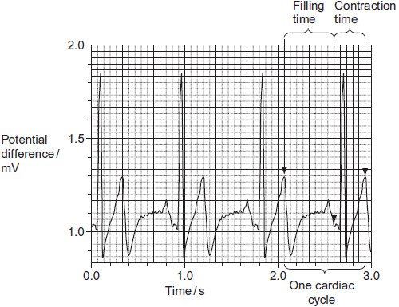
Chart Y shows an electrocardiogram from the same man immediately after a period of exercise.
Chart Y
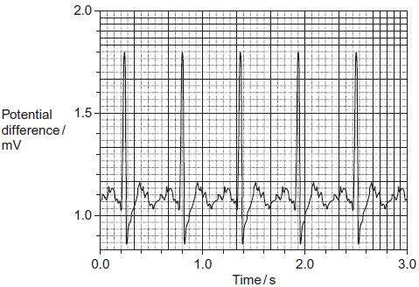
Answers on powerpoint

(a) Give one way in which an electrocardiogram could have produced more reliable results than counting the pulse.
___________________________________________________________________
___________________________________________________________________
___________________________________________________________________
(1)
(b) (i) Chart X shows that the man’s resting heart rate was 67 beats per minute. What was his pulse rate? Explain your answer.
______________________________________________________________
______________________________________________________________
______________________________________________________________
(2)
(ii) Use chart Y to calculate the man’s heart rate after the period of exercise.
Show your working.

Answer ____________________ beats per minute
(2)
(c) Use charts X and Y to describe how exercise affected filling time.
___________________________________________________________________
___________________________________________________________________
___________________________________________________________________
___________________________________________________________________
___________________________________________________________________
(2)
(d) The physiologist used electrocardiograms to investigate the effect of increasing heart rate on filling time.
Describe how she could have modified the method of exercising you used to produce a range of increases in heart rate.
___________________________________________________________________
___________________________________________________________________
___________________________________________________________________
(2)

Outcome:
- Analyse and interpret data relating to pressure changes during the cardiac cycle

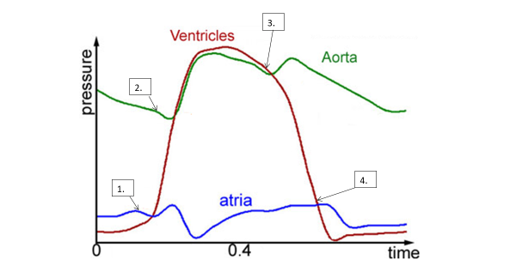
Pressure changes in left side of the heart during the cardiac cycle

- Ventricular systole increase in pressure in ventricle so it is higher than the pressure in atrium which pushes the A-V valve shut

- Ventricular systole increase in pressure in ventricles so it is higher than in arteries, which pushes the S-L valves open

- Ventricular diastole decrease in pressure in Ventricle, so it is lower than in the arteries which pushes the S-L valves shut

- Ventricular diastole decrease in pressure in ventricle, so it is lower than in the arteries which pushes the S-L valves open

- You do not need to learn this because once you understand why valves open and close, you can then just work it out

Exam Questions:
Answers on powerpoint

Q6. Relaxation of heart muscle is called diastole. Contraction is called systole. The diagram shows the periods of diastole and systole when the heart is beating.
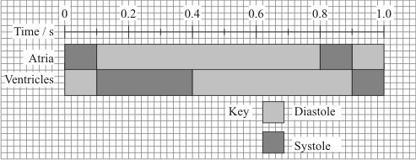
(a) At what time is the volume of blood in the ventricle at a maximum?
___________________________________________________________________ (1)
(b) Calculate the heart rate in beats per minute. Show your working.

Heart rate = ____________________ beats per minute(2)
(c) The valves between the atria and the ventricles are closed between 0.1 s and 0.4 s.
(i) Explain how pressure causes these valves to be shut.
______________________________________________________________
______________________________________________________________
(1)
(ii) Explain how closure of these valves is essential to the functioning of the heart.
______________________________________________________________
______________________________________________________________(1

The graph shows the effect of the pressure of blood in the veins on the stroke volume of the heart.
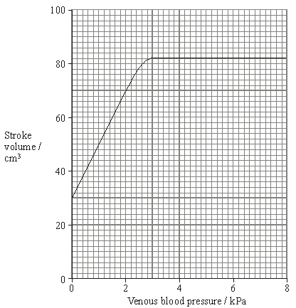
(d) Describe how venous blood pressure affects stroke volume.
___________________________________________________________________
___________________________________________________________________
___________________________________________________________________
___________________________________________________________________(2)
(e) At a venous pressure of 2 kPa, the cardiac output is 5600 cm³ per minute. Calculate the number of times the ventricle contracts in one minute. Show your working.

Answer ____________________(2

Outcome:
- Describe the structure of arteries, arterioles, veins and capillaries
- Relate the structure of arteries, arterioles, veins and capillaries to their functions
- Compare and contrast the structure and function of different blood vessels

Blood Vessels
Task: Match up the blood vessel with role: Arteries, Arterioles, Capillaries, Veins
Blood Vessel | Role
Capillaries | tiny vessels that link arterioles to veins; site of exchange between blood and cells
Arteries | carry blood away from heart, at high pressure, and into arterioles; blood travels in pulses
Veins | carry blood, at low pressure, from capillaries back to heart.
Arterioles | smaller arteries that control blood flow from arteries to capillaries

Blood vessels all have;
- Lumen = central cavity
- Endothelium = thin, smooth inner lining
- Wall = made of muscle, elastic tissue and collagen
- BUT… the relative proportions of each layer differ, and links to their different functions.

Exam tip: The examiner may ask you to label or recognise the features of the blood vessels from diagrams or optical/electron micrographs.

Task: Colour in muscle, elastic layer
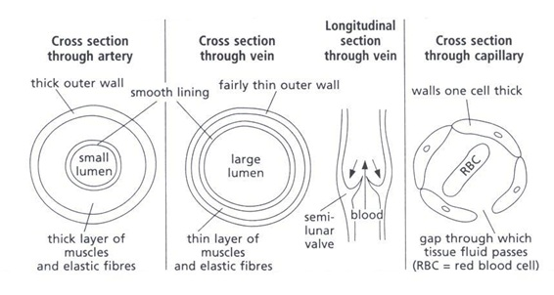

Vein:
- Thinner muscular layer
- Thinner elastic tissue layer
- Wall Thinner overall
- Lumen is relatively Wider
Capillary:
- Very thin wall, only 1 cell think
- Made of flattened Endothelium
- Spaces between the endothelial cells allow WBC to escape to get to site of tissue infection
Artery:
- Thicker muscular layer
- TThicker elastic tissue layer
- Wall Thicker overall
- Lumen is relatively narrow

Task: Complete the comparison of blood vessels table below.

Task: Complete the summary table below:

 | Arteries | Veins | Capillaries
Function | Blood from heart to body | Blood from body to heart | Site of exchange
Pressure | Higher | Lower | Lowest
Relative lumen diameter | Narrower | Wider | Extremely narrow (one red blood bell wide)
Relative wall thickness | Thicker | Thinner | Extremely thin (one cell thick)
Wall layers | Three layers:  Smooth endothelium  Muscle and elastic fibres  Epithelium | Three layers:  Smooth endothelium  Muscle and elastic fibres  Epithelium | One layer:  Endothelium
Amounts of muscle and elastic fibres | Large amounts | Small amounts | None
Presence of valves | No  (except in aorta and pulmonary artery) | Yes | No
Which type of blood vessel is the aorta? Artery
How is the structure of the aorta is adapted to its function?
- Elastic tissue allows stretch and recoil to maintain blood pressure
- Elastic tissue stretches when ventricles contract
- Muscle allows contraction, vasoconstriction
- Thick walls stop bursting
- Smooth endothelium reduces friction
- Semi-lunar valves prevent backflow

Outcome:
- Explain what tissue fluid is and which substances it contains
- Explain the formation of tissue fluid in terms of hydrostatic pressure
- Explain the reabsorption of some tissue fluid back into the capillaries, in terms of hydrostatic pressure and water potential
- Explain the role of the lymph system.

Tissue Fluid and lymphatic system

- Environment of the cells
- Substances move out of the capillaries to form tissue fluid supplying all required substances
- Tissue fluid then receives carbon dioxide and other waste materials and is returned to the circulatory system
- Tissue fluid is how exchange of gases & nutrients between blood and cells occurs

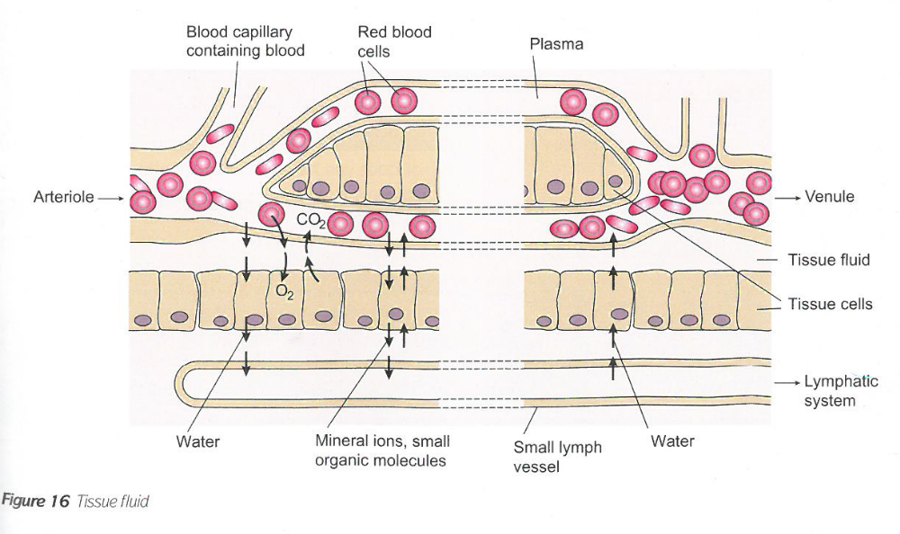

At venule end:
- The loss of water from the capillaries reduces the HP inside
- So the HP is now lower than the issue fluid outside
- The water potential is lower inside the capillary than outside in the TF due to the water loss and the larger proteins still in the capillary
- Therefore water re-enters the capillaries from the tissue fluid by osmosis down a water potential gradient.

At arteriole end:
- There is a high hydrostatic pressure (HP) in the capillaries created by contraction of the ventricles.
- This is greater than the HP of tissue fluid outside the capillaries
- Therefore water to move OUT of capillaries and into the spaces around cells, forming the tissue fluid (TF)
- Small molecules are also forced out
- Cells and the larger plasma proteins, are too large to cross the membrane = ultrafiltration.

Lymphatic System
- Not all 100% of the tissue fluid can return to the capillaries.
- The remaining fluid (10%) enters the lymphatic system, into a lymph vessel, and is now called lymph
- Eventually the vessels drain back into the bloodstream

Exam questions
Q7. The diagram shows a cross-section of a blood vessel.
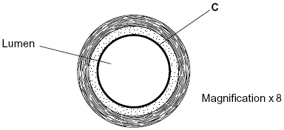
(a) Name layer C.
___________________________________________________________________ (1)

(b) Calculate the actual diameter of the lumen of this blood vessel in millimetres. Show your working.

Answer ____________________ mm(2)

(c) The aorta has many elastic fibres in its wall. An arteriole has many muscle fibres in its wall.
(i) Explain the importance of elastic fibres in the wall of the aorta.
______________________________________________________________
______________________________________________________________
______________________________________________________________(2)

(ii) Explain the importance of muscle fibres in the wall of an arteriole.
______________________________________________________________
______________________________________________________________
______________________________________________________________ (2)

(d) The graph shows the rate of blood flow in different blood vessels. It also shows the total cross-sectional area of these blood vessels.
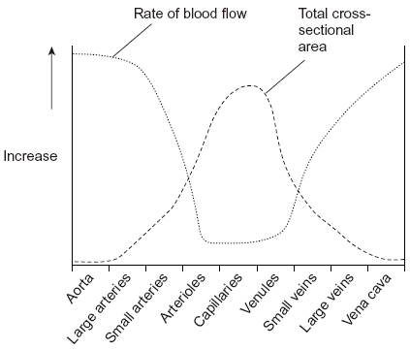
(i) The rate of blood flow decreases from the aorta to the capillaries. Use information from the graph to explain why.
______________________________________________________________
_____________________________________________________________(1)

(ii) Efficient exchange of substances in the capillaries is linked to the rate of blood flow. Explain how.
______________________________________________________________
_______________________________________________________________(1)

(e) Explain how blood in a vein in the leg is returned to the heart.
___________________________________________________________________
___________________________________________________________________
___________________________________________________________________
___________________________________________________________________
___________________________________________________________________
___________________________________________________________________
___________________________________________________________________
___________________________________________________________________
___________________________________________________________________
__________________________________________________________________(6)
Q8. (a) (i) An arteriole is described as an organ. Explain why.
______________________________________________________________
______________________________________________________________(1)

(ii) An arteriole contains muscle fibres. Explain how these muscle fibres reduce blood flow to capillaries.
______________________________________________________________
______________________________________________________________
______________________________________________________________(2)

(b) (i) A capillary has a thin wall. This leads to rapid exchange of substances between the blood and tissue fluid. Explain why.
______________________________________________________________
______________________________________________________________(1)

(ii) Blood flow in capillaries is slow. Give the advantage of this.
______________________________________________________________
______________________________________________________________(1)

(c) Kwashiorkor is a disease caused by a lack of protein in the blood. This leads to a swollen abdomen due to a build up of tissue fluid. Explain why a lack of protein in the blood causes a build up of tissue fluid.
___________________________________________________________________
___________________________________________________________________
___________________________________________________________________
___________________________________________________________________
___________________________________________________________________
___________________________________________________________________ (3)

Oxygen Transport in Mammals
Outcome:
- Relate knowledge of protein structure to the structure of haemoglobin
- Explain what is meant by the term “partial pressure”
- Explain how the binding of one oxygen molecule changes the shape of haemoglobin, and how this affects the binding of further oxygen molecules

Blood
Consists of a liquid called plasma, containing RBC (oxygen transport), WBC (immune system), and platelets (blood clotting).
Haemoglobin Structure
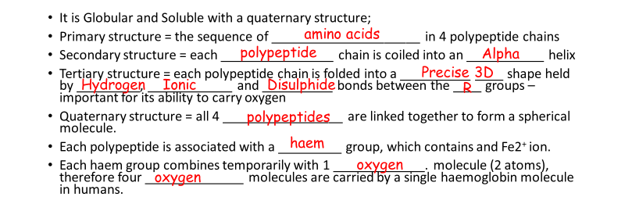
It is Globular and Soluble with a quaternary structure;
- Primary structure = the sequence of _____________________ in 4 polypeptide chains
- Secondary structure = each ________________ chain is coiled into an ___________ helix
- Tertiary structure = each polypeptide chain is folded into a __________ ____ shape held by _________, ____________ and __________ bonds between the ____ groups – important for its ability to carry oxygen
- Quaternary structure = all 4 _________________ are linked together to form a spherical molecule.
- Each polypeptide is associated with a _________ group, which contains and Fe2⁺ ion.
- Each haem group combines temporarily with 1 _____________. molecule (2 atoms), therefore four ______________ molecules are carried by a single haemoglobin molecule in humans.

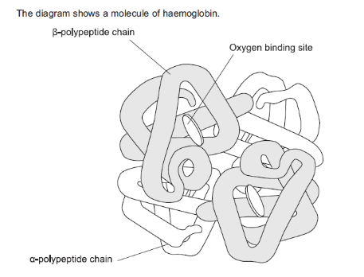
What is the evidence from diagram that haemoglobin has a quaternary structure?

Multiple Polypeptide chains joined together

Haemoglobin Role
- To LOAD oxygen in a high O₂ concentration, where it has a high affinity for oxygen, to form oxyhaemoglobin
- This occurs in lungs
- UNLOAD oxygen in a low pO₂ conditions and high pCO_{2,} where it has a low affinity for oxygen
- This occurs in the respiring cells / tissues
Use this information to complete the table
Affinity of haemoglobin for oxygen under different conditions
Region of Body | Oxygen concentration  (high/low) | Carbon dioxide concentration  (high/low) | Affinity of haemoglobin for oxygen (high/low) | Result  (oxygen is associated/dissociated)
Gas exchange surface | High | low | high | Associated
Respiring tissues | low | high | low | dissociated

Oxygen Dissociation Curves
When haemoglobin is exposed to different partial pressures (concentrations) of oxygen (pO₂), it does not bind oxygen evenly, giving a sigmoid shape to the curve.
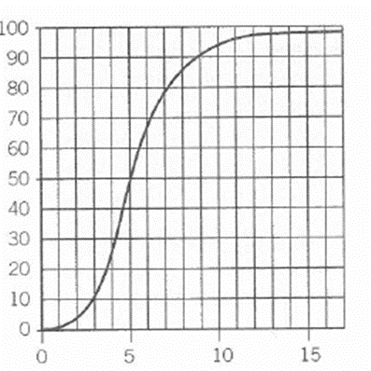
When every molecule of Hb is combined with 8 atoms of oxygen, then it is 100% saturated, etc.
The graph shows the relationship between the saturation of haemoglobin with oxygen and the partial pressure of oxygen (pO₂), and is called the OXYGEN DISSOCIATION CURVE
What is % saturation of Hb with O₂ at:
- 6 kPa- 65%
- 8 kPa- 85%
- 15 kPa- 98 %

Why is the curve sigmoid?
Starting from the bottom
- Describe: Bigger increase in pO₂ smaller increases in % sat (quote values from graph)
Curve is shallower
Explain: The shape of the Hb molecule makes it difficult for 1st oxygen molecule to bind

- Describe: Smaller increase in pO₂ bigger increases in % sat (quote values from graph)
Steeper gradient.
Explain: Binding of the first oxygen changes the quaternary structure shape of Hb molecule which makes it much easier for other oxygen molecules to bind.

- Describe: Bigger increase in pO₂ smaller increases in % sat (quote values from graph)
% saturation flattens out
Explain: Binding of 4th is harder because it is less likely that a single oxygen molecule will find an empty binding site
In reverse – loss of one oxygen makes it easier for the next one to be lost, and so on.

What is the Relevance?
- In the lungs
√ Blood leaving the lungs is almost always completely saturated with oxygen.
√ Even if pO₂ in lungs drops a bit below normal, Hb can still pick up a lot of oxygen

- In the body tissues, respiration in the cells is using up the oxygen
√ A slight decrease in pO₂ of tissues produces a large increase in oxygen release from Hb.
√ O₂ is very effectively delivered to the tissues that need it
Exam Questions
Q9.(a) Binding of one molecule of oxygen to haemoglobin makes it easier for a second oxygen molecule to bind. Explain why.
___________________________________________________________________
___________________________________________________________________
___________________________________________________________________
___________________________________________________________________ (2)

A haemocytometer is a special microscope slide which can be used to count the numbers of blood cells in a sample of blood.
• The surface of the slide has many small, equal-sized squares marked on it.
• The depth of the liquid under each square is 0.1 mm
• When counting, cells that touch top or left lines are counted but cells that touch right or bottom lines are not counted.
A doctor used a haemocytometer to determine the number of red blood cells per mm³ in a blood sample. He diluted the original blood sample by a factor of 200 times before putting some on a haemocytometer. The diagram shows the distribution of cells in a typical small square.
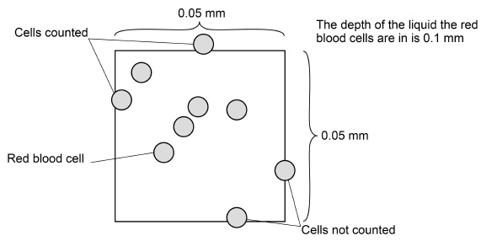
(b) The doctor counted the red blood cells in many small squares. The mean number of red blood cells per small square was 7. The original blood sample was diluted by a factor of 200 times.
Calculate the number of red blood cells per mm³ in the original blood sample. Give your answer in standard form.
Answers on powerpoint

Answer = ____________________ red blood cells per mm³ (2)

(c) When counting, cells that touch top or left lines are counted but cells that touch right or bottom lines are not counted. Suggest two reasons for this rule.
1. _________________________________________________________________
___________________________________________________________________
Answers on powerpoint
2. _________________________________________________________________
___________________________________________________________________(2)

The doctor also wanted to know how many white blood cells per mm³ there were in a different sample of blood. To do this he first diluted the sample by a factor of 20 times. He then made the white blood cells clearly visible by using a stain that makes nuclei appear dark blue.

(d) When counting white blood cells, the doctor only diluted the blood sample by a factor of 20 times, instead of 200 times when counting red blood cells. Suggest why he only diluted the sample by a factor of 20 times.
___________________________________________________________________
Answers on powerpoint
___________________________________________________________________ (1)
(e) Explain how the stain allowed the doctor to count the white blood cells amongst all the red blood cells.
___________________________________________________________________
___________________________________________________________________
Answers on powerpoint
__________________________________________________________________(1)
The BOHR SHIFT - The Effect of Carbon Dioxide concentration on Oxygen Transport:
Outcome:
- Explain the effect of carbon dioxide concentration on oxygen dissociation
- Relate this knowledge to explain oxygen loading and unloading in different tissues.

pCO₂ is the concentration of carbon dioxide. In respiring body tissues CO₂ is produced. When we exercise, more CO₂ is produced; therefore the pCO₂ in the tissues increases
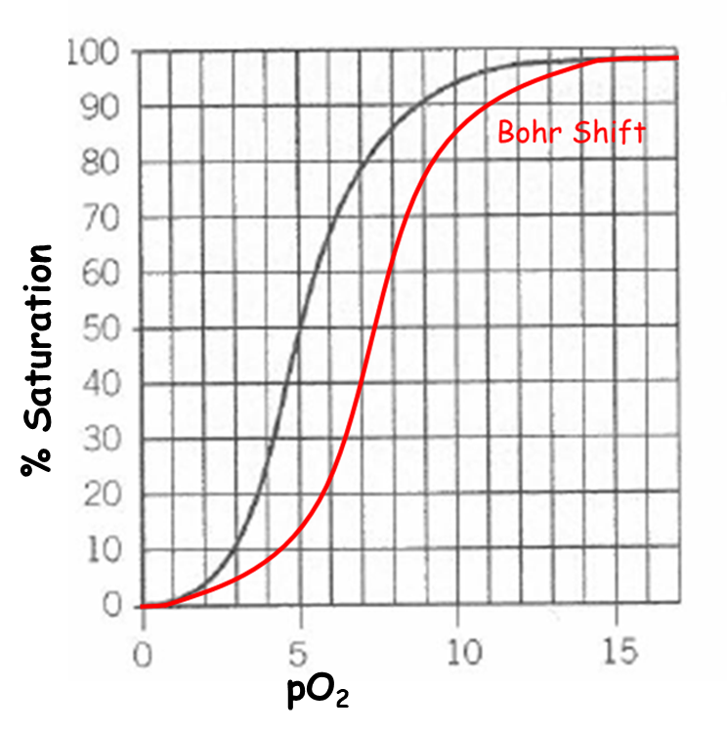
TASK: Write out equation for aerobic respiration: Oxygen + Glucose Carbon Dioxide + Water +ATP
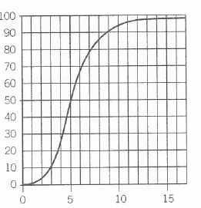
Exam tip: When you are asked to draw a curve:
- Make sure it begins and ends at the SAME point as the one given
- Then draw to the left or right, as appropriate
- The higher the pCO₂, the more readily the oxygen is unloaded from Hb
- So more oxygen is released for cells during activity.
- So, the dissociation curve shifts to the RIGHT
- Hb has a LOWER AFFINITY for O₂
= the BOHR SHIFT

Task: Draw the curve for the Bohr Shift, and label “high pCO₂ “
What causes the Bohr Shift?
- In the tissues, CO₂ is released by respiring cells
- Forms Carbonic acid which dissociates into H+ lowering pH
- Acidity changes shape of Hb so now has a lower affinity for oxygen
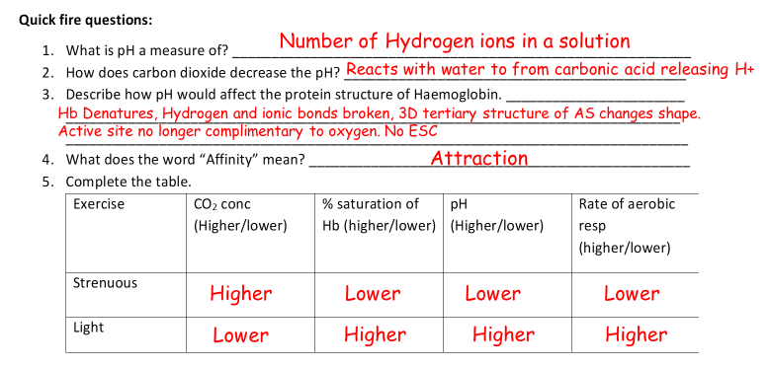
- O₂ is more readily released to respiring tissues.
- What is pH a measure of? ___________________________________________________________
- How does carbon dioxide decrease the pH? ____________________________________________
- Describe how pH would affect the protein structure of Haemoglobin. _______________________
_______________________________________________________________________________
________________________________________________________________________________
- What does the word “Affinity” mean? _________________________________________________
- Complete the table.

Different Species-
Outcome:
- Explain differences between the dissociation curves of different species
- Relate these differences to the environment in which the organisms with to explain how these adaptations allow organisms to survive

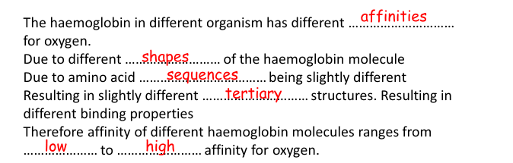
Why are there different haemoglobins?
- The haemoglobin in different organisms have different _______________ for oxygen.
- Due to different______________ of the haemoglobin molecule.
- Due to amino acid ________________ being slightly different.
- Resulting in slightly different tertiary and ___________________ structures
- Resulting in different binding properties
- Therefore, affinity of different haemoglobin molecules ranges from ____________ to __________ affinity for oxygen.
Words for gap fill:

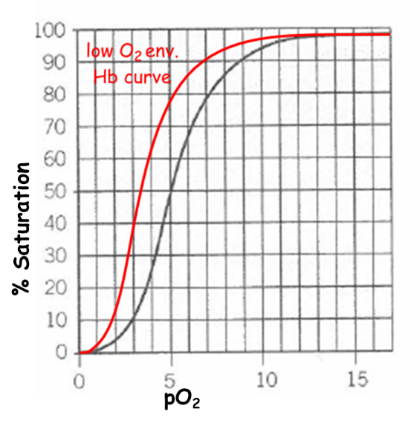
1. Low oxygen environments, low pO₂
- pO₂ is lower where they live
- So the Hb has a higher affinity for O₂
- So it can load more of the available oxygen,
- Be saturated at a lower pO₂
- Dissociation curve is shifted to the LEFT
Examples:
- foetus
- In uterus, low pO2
- So needs to be able to load more O₂ than mother at same pO₂.
- Enables oxygen to move from mother to foetus.

- lugworms
- Live in burrows beneath the sand - low pO₂.
- So need to load as much oxygen as possible

- llama
- Lives at high altitudes, low atmospheric pO₂
- So has to be able to load with more oxygen

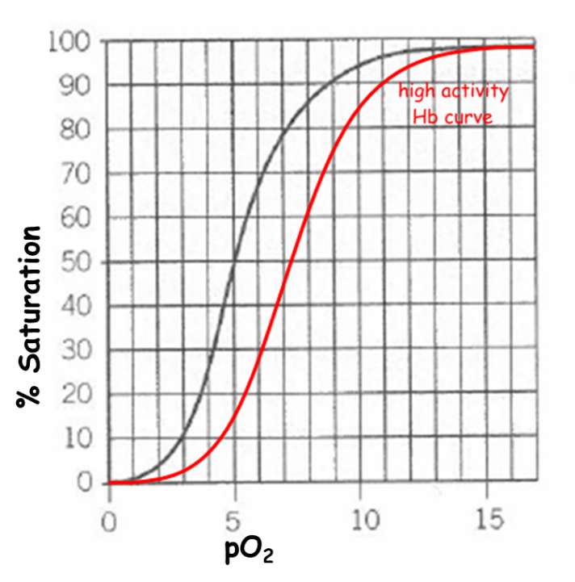
2. Different Activity levels
- Organisms that are very active have a higher O₂ demand
- They need their Hb to unload oxygen more readily
- To supply more oxygen to tissues
- For a faster respiration
- Therefore have a Hb with a lower affinity
- In all these cases, the dissociation curve is shifted to the RIGHT
Examples:
- Hawk
- Very high respiratory rate
- Lives where there is plenty of oxygen

Note: Most animals that are small, are also very active! So, the examiner will usually give examples of small active animals
- Small animals
- Have a higher SA:VOL ratio
- Therefore lose heat more quickly,
- So have a higher metabolic rate to keep warm.
- Therefore have a higher oxygen demand
- So need the Hb to unload oxygen more easily.

Mark scheme perfect answers:
The larger the animal:
- The more to the Left the curve is,
- The Steeper the curve is,
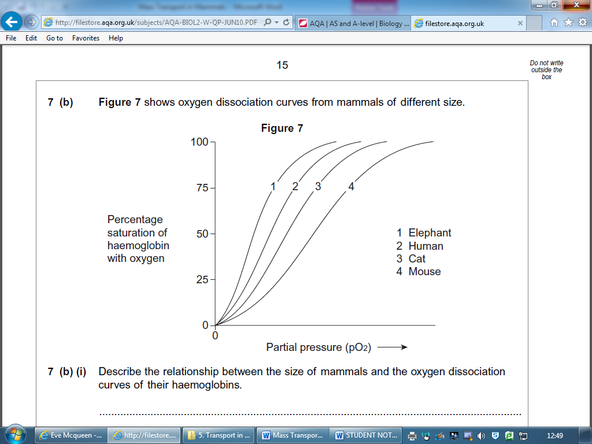
- The higher the affinity for oxygen.
Why does the Hb of smaller mammals have a lower affinity for oxygen?
- SA:VOL ratio is larger
- Heat loss is quicker
- Rate of respiration higher (if SA:Vol is greater)
- Requirement of O2 for respiration higher
- Haemoglobin has a lower affinity for oxygen / it releases O2 more readily

Exam Questions
Q10. The graph shows the oxyhaemoglobin dissociation curves for fetal haemoglobin (HbF) and adult haemoglobin (HbA).

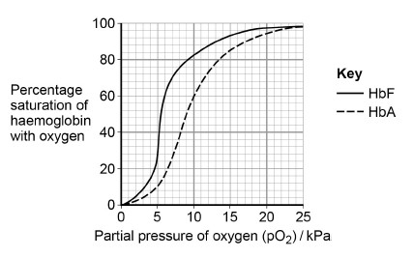
(a) Explain how changes in the shape of haemoglobin result in the S-shaped (sigmoid) oxyhaemoglobin dissociation curve for HbA.

_________________________________________________________________

_________________________________________________________________
Answers on powerpoint

________________________________________________________________

_________________________________________________________________

__________________________________________________________________(2)
(b) At birth 98% of the haemoglobin is HbF. By the age of 6 months, the HbF has usually completely disappeared from the baby’s blood and been replaced by HbA. Use the graph above to explain why this change is an advantage for the baby.

_________________________________________________________________

_________________________________________________________________

_________________________________________________________________
Answers on powerpoint

_________________________________________________________________

_______________________________________________________________(2)

(c) Sickle cell disease (SCD) is caused by production of faulty HbA. This results in a reduced ability to transport oxygen to tissues. Scientists investigated the use of a substance called hydroxyurea to treat babies with SCD. Hydroxyurea changes the concentration of HbF in the blood.
The scientists carried out an investigation with 122 babies who had SCD. Each baby was given hydroxyurea for 41 months. The scientists then found the mean change in the concentration of HbF in the babies’ blood. Their results are shown in the table.

Mean concentration of HbF in the babies’ blood / arbitrary units
Before treatment with hydroxyurea (± 1 standard deviation) | After treatment with hydroxyurea (± 1 standard deviation)
7.6  (± 4.5) | 19.1  (± 6.5)
The scientists concluded that treatment with hydroxyurea would increase the concentration of oxygen in the blood of babies with SCD. Suggest how the graph and table above support this conclusion.

________________________________________________________________

________________________________________________________________

_______________________________________________________________
Answers on powerpoint

_________________________________________________________________

_________________________________________________________________

______________________________________________________________(3)

Q 11 a) The haemoglobin in one organism may have a different chemical structure from the haemoglobin in another organism. Describe how.
Answers on powerpoint
_________________________________________________________________
_______________________________________________________________(1)
(b) The graph shows oxygen dissociation curves for horse haemoglobin and for llama haemoglobin. Horses are adapted to live at sea level and llamas are adapted to live in high mountains.
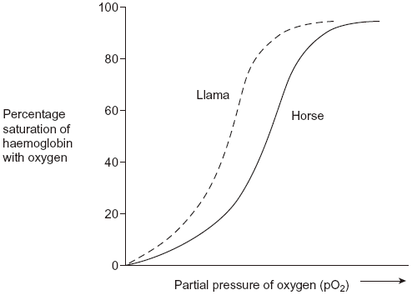
Answers on powerpoint
Use the graph to explain why llamas are better adapted to live in high mountains than horses.
________________________________________________________________
______________________________________________________________(3)
Outcomes
- Apply knowledge of circulation to draw and explain conclusions
- Evaluate the quality of results and reliability of conclusions.
- Explain the causes and consequences of cardiovascular disease
- Analyse and interpret data associated with specific risk factors and the incidence of cardiovascular disease and recognise correlations and causal relationships

Causes and Consequences of Cardiovascular disease (CVD)
Definition:
Cardiovascular disease covers a range of different problems that can develop in the blood vessels and the heart, usually when the vessels become blocked

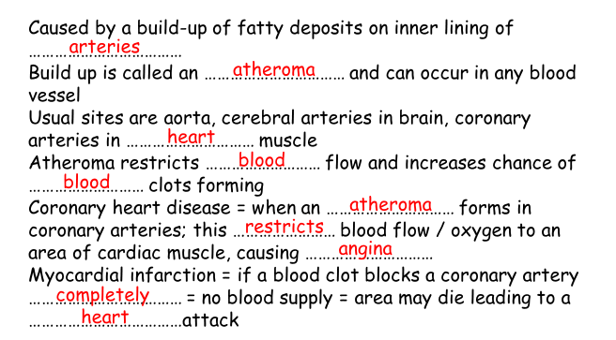
Atherosclerosis

Task: Research activity
- Choose one cardiovascular disease e.g. stroke, heart disease
- Prepare a short presentation in word or PPT.
- Include research on the causes, risk factors, consequences and incidence of the disease.

Application Exam Questions
Q1. The graph shows dissociation curves for human oxyhaemoglobin at rest and during exercise. Table 1 gives information about conditions in the body at rest and during exercise.
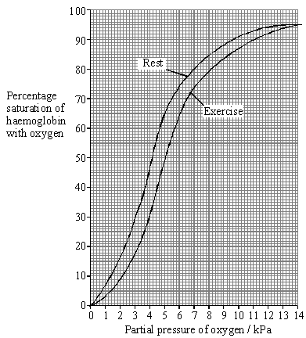

 | Rest | Exercise
Plasma pH | 7.4 | 7.2
Blood temperature / °C | 37.0 | 39.0
Alveolar partial pressure of oxygen / kPa | 13.3 | 13.3
Tissue partial pressure of oxygen / kPa | 5.0 | 4.0

(a) What is meant by the term partial pressure?
Answers on powerpoint
___________________________________________________________________
___________________________________________________________________(1)

(b) Use Table 1 and the graph to calculate the difference in the percentage saturation of haemoglobin in the tissues between rest and exercise.

Answer ____________________ %(1)
Answers on powerpoint

(c) Explain the differences between the figures shown in Table 1 for rest and exercise.
___________________________________________________________________
Answers on powerpoint
___________________________________________________________________
___________________________________________________________________
___________________________________________________________________
___________________________________________________________________
___________________________________________________________________
___________________________________________________________________
__________________________________________________________________(4)

(d) Explain the advantage of the difference in position of the dissociation curve during exercise.
___________________________________________________________________
Answers on powerpoint
___________________________________________________________________
___________________________________________________________________
___________________________________________________________________(2)

Table 2 shows how the oxygen concentration in the blood going to and from a muscle changes from rest to heavy exercise.

Oxygen concentration / cm³ per 100 cm³
blood
 |  | Blood in arteries | Blood in veins
At rest | In solution | 0.3 | 0.2
At rest | As oxyhaemoglobin | 19.5 | 15.0
At rest | Total oxygen | 19.8 | 15.2
During heavy exercise | In solution | 0.3 | 0.1
During heavy exercise | As oxyhaemoglobin | 20.9 | 5.3
During heavy exercise | Total oxygen | 21.2 | 5.4

(e) By how many times is the volume of oxygen removed from the blood by the muscle in Table 2 during heavy exercise greater than the volume removed at rest? Show your working.
Answers on powerpoint
Answer ____________________ times (2)

(f) Does enriching inspired air with oxygen have any effect on the amount of oxygen reaching the tissues? Support your answer with evidence from the graph and Table 2.
___________________________________________________________________
Answers on powerpoint
___________________________________________________________________
___________________________________________________________________
_________________________________________________________________ (3)

(g) The change to the dissociation curve is one of a number of ways in which the total oxygen supplied to muscles is increased during exercise. Give two other ways in which the total oxygen supplied to muscles during exercise is increased.
Answers on powerpoint
1. _________________________________________________________________
___________________________________________________________________
2. ________________________________________________________________ (2)
Q2. Some people have a form of heart failure where their heart is not pumping blood as well as it used to. Some people with heart failure are given an artificial heart to improve circulation of blood from the left ventricle. Figure 1 shows where this type of artificial heart is connected.
Figure 1
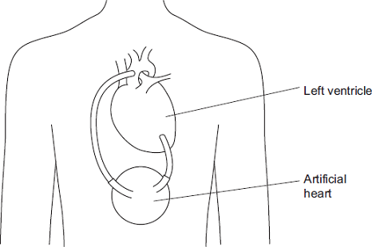
(a) Name the blood vessel to which the artificial heart is connected.
___________________________________________________________________(1)

(b) In these patients, the right ventricle still produces sufficient blood flow to keep the patient alive. Suggest why the left ventricle requires the help of the artificial heart but the right ventricle does not.
___________________________________________________________________
Answers on powerpoint
___________________________________________________________________
___________________________________________________________________
___________________________________________________________________(2)

(c) Figure 2 shows the internal structure of this type of artificial heart.
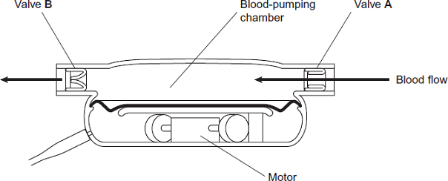

Valves A and B have the same functions as heart valves involved in the cardiac cycle. Name the heart valve that has the same function as:
valve A ____________________________________________________________
valve B ___________________________________________________________(2)
Answers on powerpoint

(d) There are different designs of artificial heart. Doctors compared results for patients who received two different types of artificial heart, X and Y. They recorded information 2 years after the artificial hearts were implanted. Their results are shown in Figure 3.

 | Information recorded 2 years after artificial heart implanted
Type of artificial heart | Number of patients surviving without replacement of artificial heart | Number of patients surviving but who required repair or replacement of artificial heart | Number of patients who died
X  (119 patients) | 62 | 13 | 44
Y  (58 patients) | 7 | 24 | 27
Which type of artificial heart was the more successful? Use calculations to support your answer.
___________________________________________________________________
Answers on powerpoint
___________________________________________________________________
___________________________________________________________________
____________________________________________________________________ (3)
Q3. (a) Describe and explain four ways in which the structure of a capillary adapts it for the exchange of substances between blood and the surrounding tissue.
___________________________________________________________________
Answers on powerpoint
___________________________________________________________________
___________________________________________________________________
___________________________________________________________________
___________________________________________________________________
___________________________________________________________________
___________________________________________________________________
__________________________________________________________________(4)

(b) Explain how tissue fluid is formed and how it may be returned to the circulatory system.
___________________________________________________________________
___________________________________________________________________
Answers on powerpoint
___________________________________________________________________
___________________________________________________________________
___________________________________________________________________
___________________________________________________________________
___________________________________________________________________
___________________________________________________________________
___________________________________________________________________
______________________________________________________ (6)

